

Jose Rizal University

College of Computer Studies Engineering

Computer Engineering Department

**Laboratory Activity No. 4**

**CPE C308 – COGNATE/TRACK COURSE 2**

**Submitted by:**

Exiquiel John A. Pines

**Submitted to:**

Ms. Barbra Ianne Embile

**Date Submitted:**

May 24, 2023

**Output:**

 

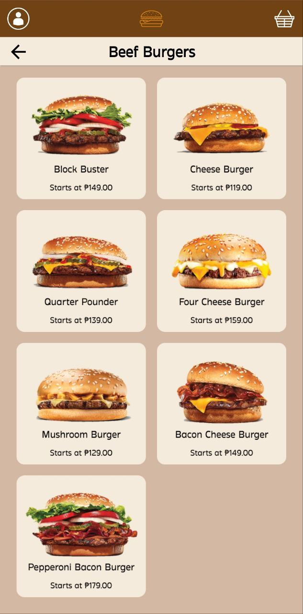 

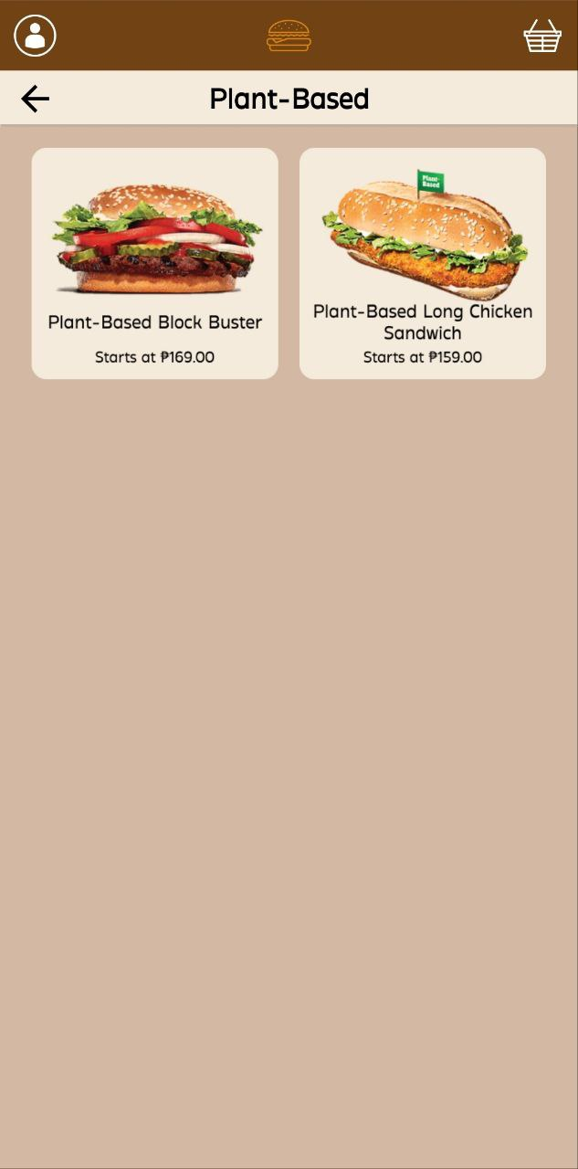

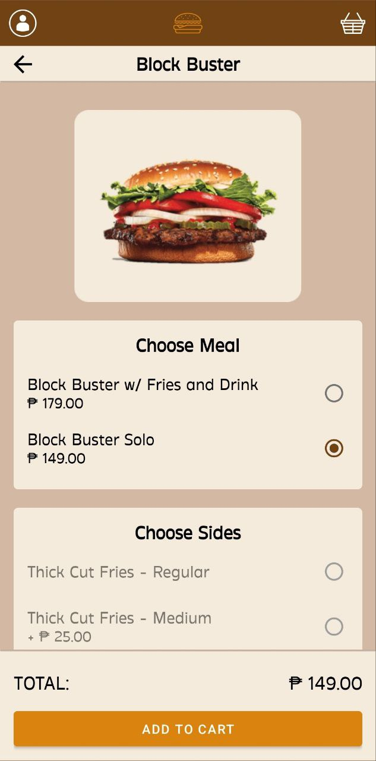 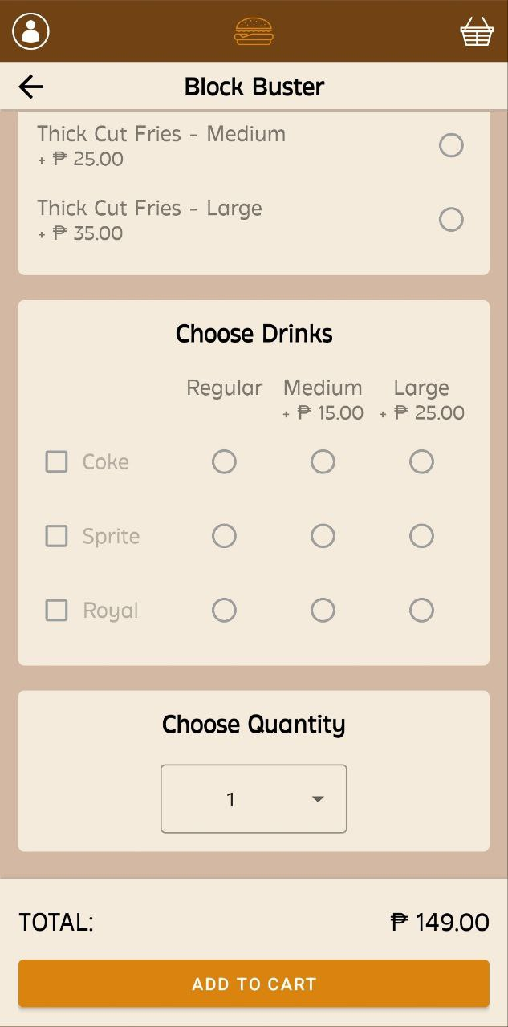

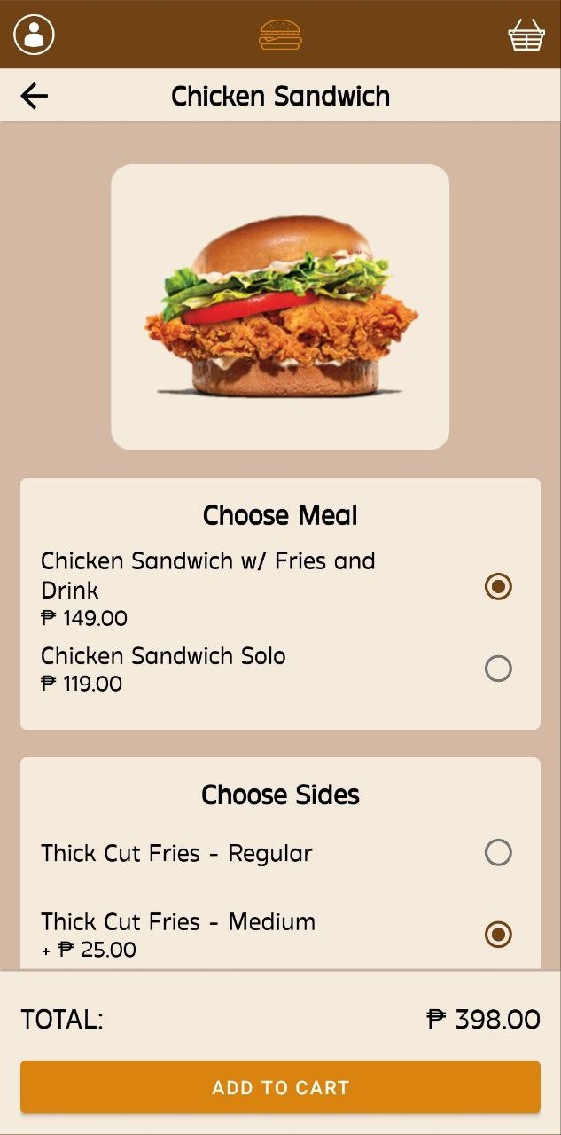 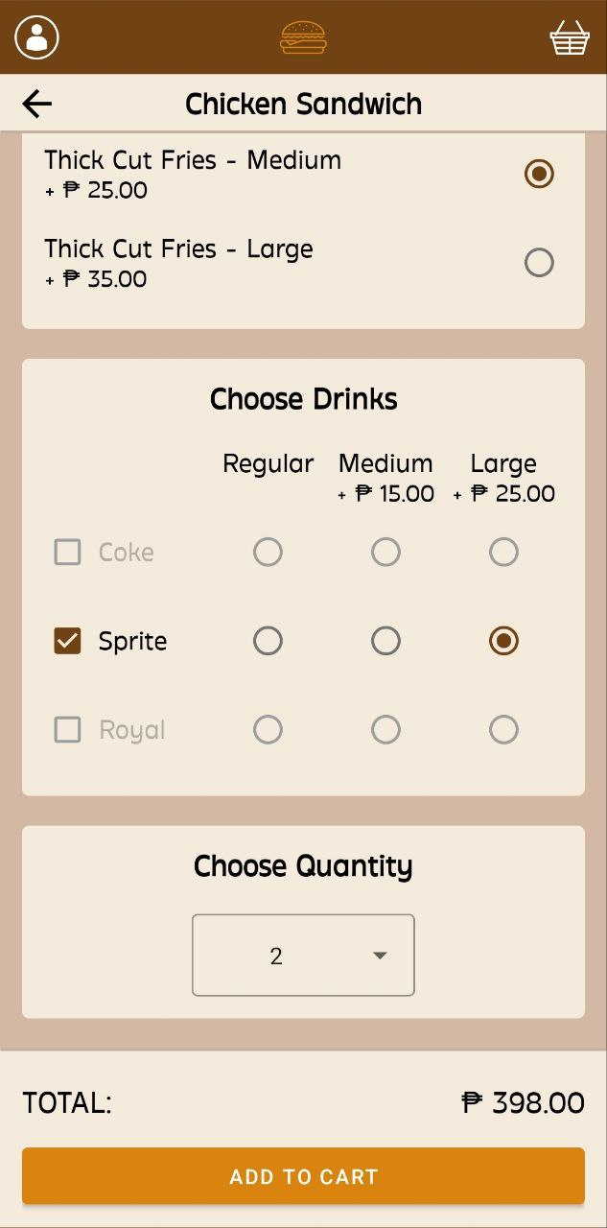

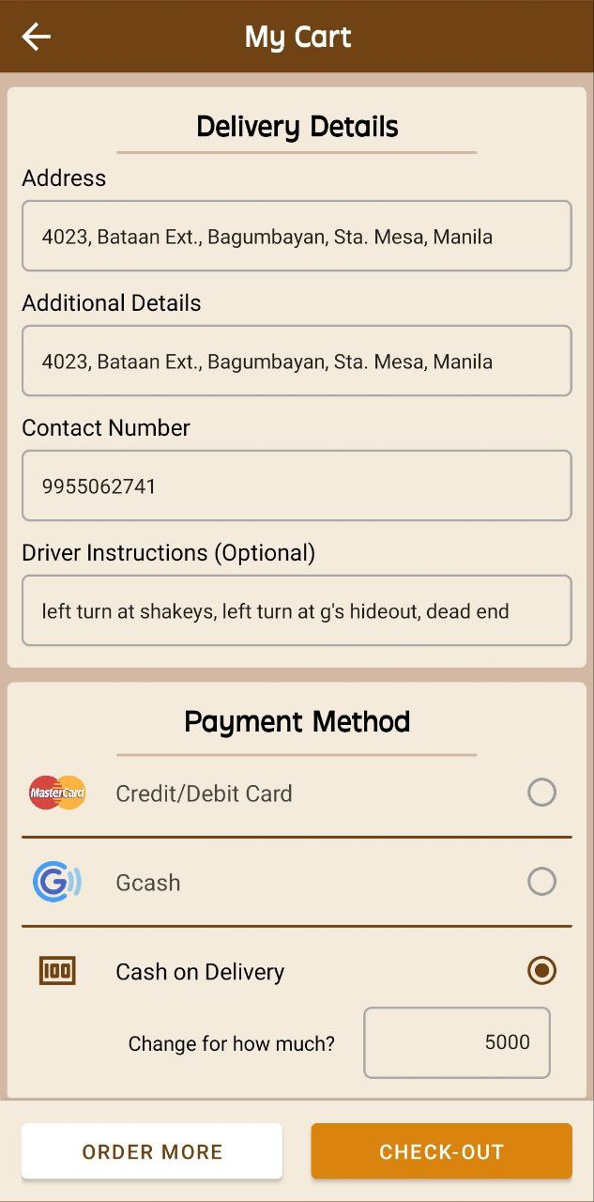 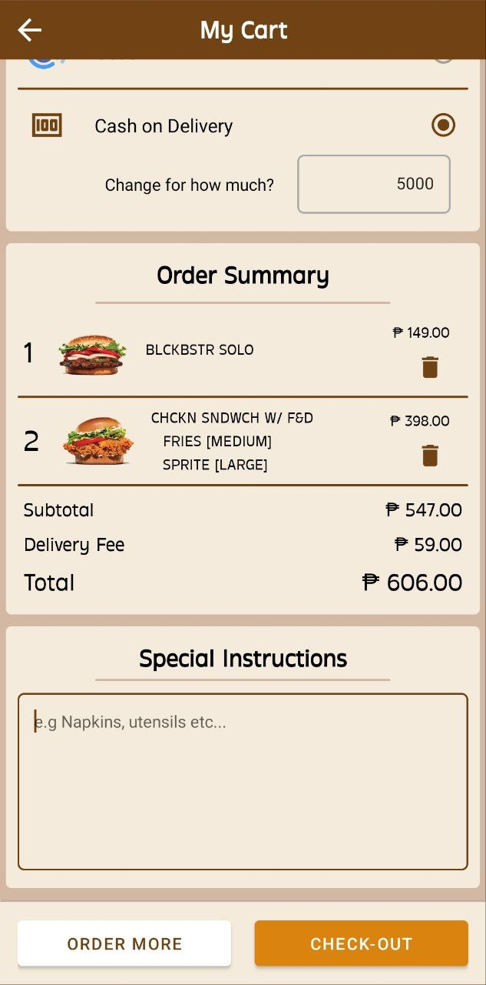

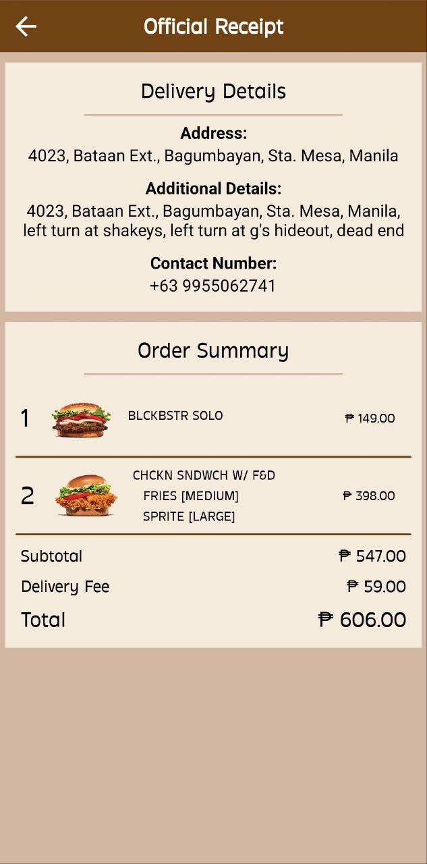

**Conclusion:**

The ordering app developed using Android Studio demonstrates effective utilization of Android widgets and programming techniques. It provides a user-friendly interface for ordering food items, allowing customization and dynamic updates based on user selections.

Through this exercise, I have gained practical experience in implementing various Android components. Additionally, I've learnt how to manipulate these widgets programmatically by changing images, enabling/disabling checkboxes, and performing computations based on user selections.

By successfully completing this exercise, I have developed important skills in Android app development, including user interface design, event handling, and data manipulation. These skills can be further enhanced and applied to create more complex and feature-rich applications in the future.