Group 9 Final Project Proposal
LIS 4761 Intro to Data and Text Mining
11/15/2025

Contributors
Patrick Aabram – Project Manager
Christine Jacob – Data Engineer
Colin Holm – Additional Data Engineer/Text Mining Analyst
Omar Eltannir – Text Mining Analyst
Zachary Wright – Visualization and Reporting Lead

- Goal
Our aim is to develop a model which can reliably differentiate fake news articles from legitimate ones. We will also investigate the qualities of these fake articles, determining what associations and sentiments dominate their content with the goal of equipping readers to better identify fake articles by these standards.

- Data Overview
The dataset for this investigation is the fake-and-real-news-dataset available from Kaggle. This consists of two tables: one of 23,502 fake news articles, and another of 21,417 legitimate articles. Both have the same column schema, having the article title, its body text, a topic descriptor, and the date of publish. The fake articles range in body length from one word to 8,135, with an average length around 435 words. We will plan to remove articles beneath a certain length threshold. True articles span from 22 to 5,172 words, with an average of 386. We believe the dimensions and qualities of this dataset will be sufficient for valuable analysis and an effective model.

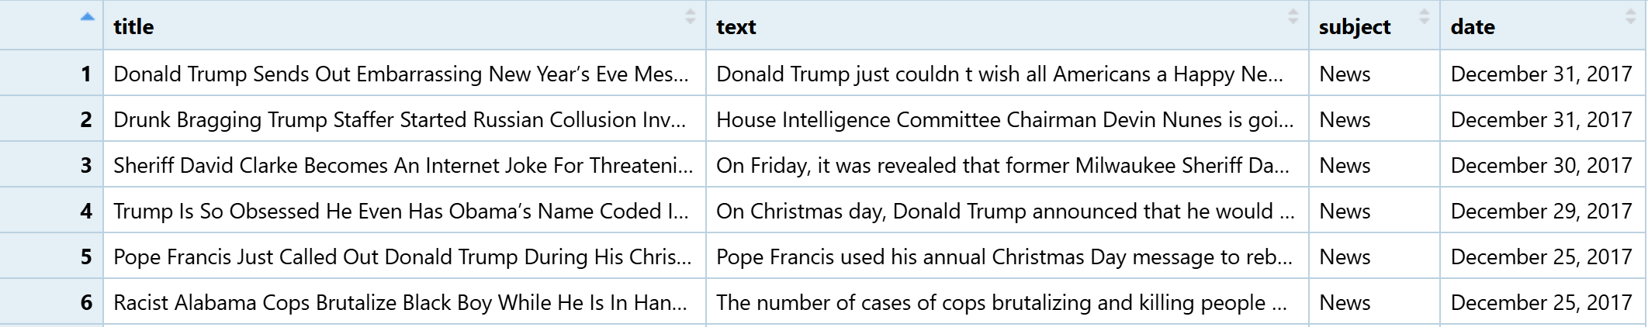
Head of the Fake table
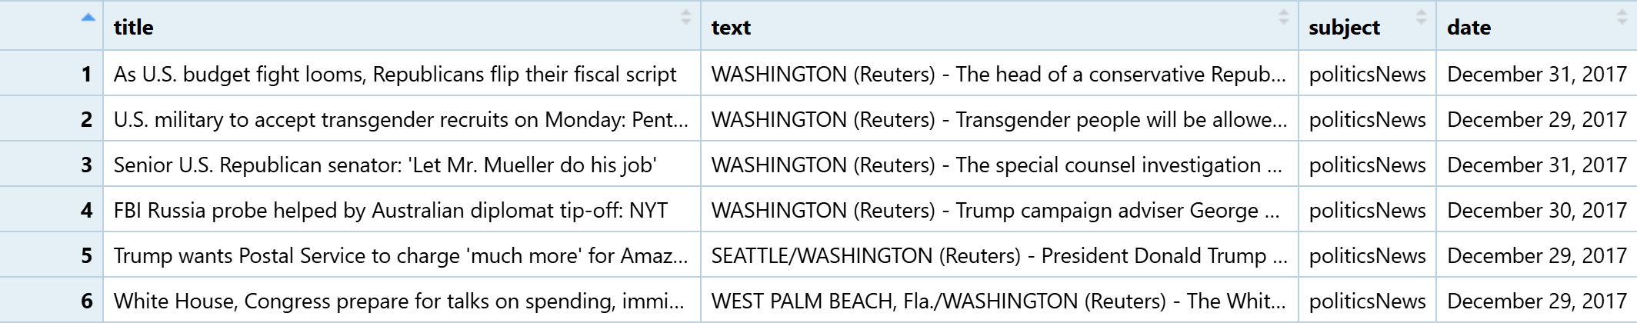
Head of the True table

- Analysis Techniques
As discussed, we intend to build a binary classifier able to distinguish fake news articles from legitimate ones. This will consist of a support vector machine (SVM) trained on the article bodies from the dataset in document-term matrix format, cleaned and labeled. Additionally, we intend to perform a comparison of word and n-gram frequencies between the two corpuses, identifying what terms are most prevalent in fake articles. Finally, we will join this dataset with a sentiment dictionary so that we can contrast the mood and tone of each type of article, gaining insight into what emotions the authors of fake articles use to spread their content.
For a preliminary analysis of this dataset, we conducted a basic word frequency count of terms in both datasets. After tokenizing and removing stop words, we generated frequency tables words in each corpus. We then joined these and calculated a frequency difference, giving an indicator of which words were most strongly skewed to fake or real articles. We feel this provides valuable early insights into the data and proves its viability for further analysis.

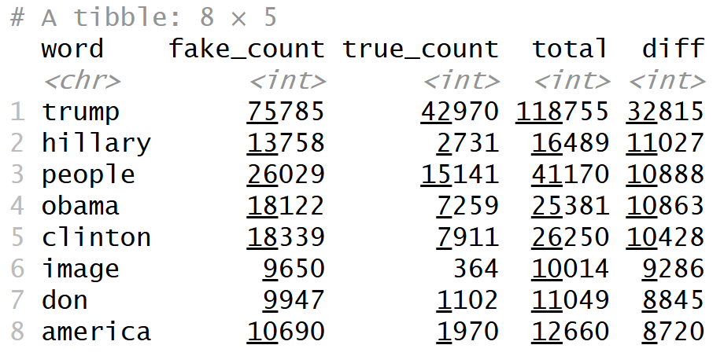
Words skewed most toward fake articles (strongly positive difference)
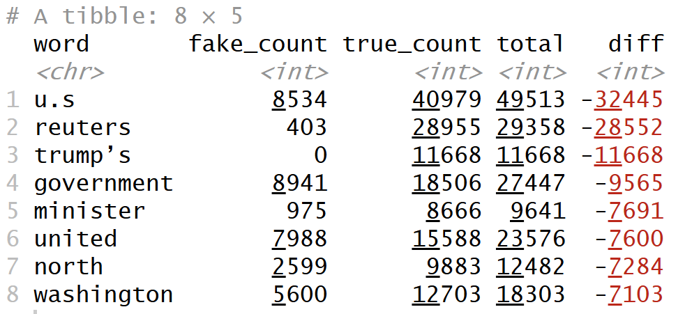
Words skewed most toward legitimate articles (strongly negative difference)

