PROJECT REPORT
House Price Prediction System
Using Machine Learning with a Python Backend and a Streamlit Frontend
Submitted by
Paakhee
[Course / Department] | [Institution Name]
[Guide / Supervisor Name] | [Academic Year]
Technology stack: Python · pandas · scikit-learn · Matplotlib · Seaborn · Streamlit

Abstract
Estimating the price of a house is a task that affects buyers, sellers, banks and real-estate agents. Manual valuation is slow and subjective, so data-driven prediction systems are increasingly used. This project builds a complete house price prediction system in Python using a dataset of 1,000 houses described by seven attributes: square footage, number of bedrooms, number of bathrooms, year built, lot size, garage size and neighbourhood quality.
The backend cleans the data, engineers three additional features and trains four regression models (Linear Regression, Ridge Regression, Random Forest and Gradient Boosting) inside scikit-learn pipelines. Models are compared using a hold-out test set and 5-fold cross-validation, and the best model is selected automatically. The frontend is an interactive Streamlit web application that provides data exploration, model-performance dashboards, single-house price prediction with a 95% estimate range, batch prediction from CSV files, and a USD/INR currency view. Both backend and frontend are implemented in a single Python file.
The selected model, Linear Regression, achieved an R² of 0.9984, a mean absolute error of about 8,160 and a root-mean-squared error of about 10,052 on unseen data. Square footage was found to be the dominant price driver (correlation ≈ 0.99).
Keywords: house price prediction, regression, scikit-learn, Streamlit, feature engineering, cross-validation.

Contents
1. Introduction
2. Technologies and Literature Background
3. Dataset Description
4. System Design
5. Methodology
6. Implementation
7. Results and Analysis
8. Testing
9. Limitations and Future Scope
10. Conclusion
References
Appendix A: How to Run the Project

1. Introduction

1.1 Background
The real-estate market is one of the largest sectors of any economy, and the price of a house depends on many interacting factors such as size, age, number of rooms and the quality of the surrounding neighbourhood. Traditional valuation relies on the judgement of experts and on comparing similar properties, which is time-consuming and can vary from person to person. Machine learning offers a way to learn the relationship between house characteristics and price directly from historical data and to produce instant, consistent estimates.

1.2 Problem Statement
Given the physical and locality attributes of a house, predict its market price as accurately as possible and present the prediction through an easy-to-use interface that a non-technical person can operate.

1.3 Objectives
- Analyse the dataset and identify which attributes influence house prices.
- Clean the data and engineer additional meaningful features.
- Train and compare multiple regression algorithms using standard evaluation metrics.
- Automatically select the best model and use it for prediction.
- Build a Python-based web interface for exploration, evaluation and prediction.
- Deliver the entire application as a single, well-documented Python file with a requirements file and README.

1.4 Scope
The system predicts a single numeric value (price) for a house using the seven attributes available in the dataset. It supports one-by-one and batch (CSV) prediction and works on any CSV that has the same columns. The project does not use location coordinates, images or market-trend data.

2. Technologies and Literature Background

2.1 Technologies used
Technology | Purpose in the project
Python 3 | Programming language for both backend and frontend
pandas, NumPy | Loading, cleaning and manipulating tabular data; numerical computing
scikit-learn | Pipelines, scaling, regression models, cross-validation, metrics, permutation importance
Matplotlib, Seaborn | Statistical charts (histograms, heatmap, scatter, residual plots)
Streamlit | Interactive web frontend written entirely in Python
joblib | Saving the trained model to disk

2.2 Regression algorithms
- Linear Regression: models price as a weighted sum of the features. It is fast, interpretable and works very well when the relationship is close to linear.
- Ridge Regression: linear regression with an L2 penalty that shrinks coefficients and reduces over-fitting (Hoerl and Kennard, 1970).
- Random Forest: an ensemble of decision trees trained on random subsets of data; predictions are averaged (Breiman, 2001).
- Gradient Boosting: builds trees sequentially, each one correcting the errors of the previous ones (Friedman, 2001).

2.3 Evaluation metrics
Metric | Meaning
R² (coefficient of determination) | Proportion of price variance explained by the model; 1.0 is perfect
MAE (mean absolute error) | Average absolute difference between predicted and actual price
RMSE (root mean squared error) | Square root of the mean squared error; penalises large errors more
Cross-validated RMSE | RMSE averaged over 5 folds of the training data; measures stability

3. Dataset Description
The dataset file house_price_regression_dataset.csv contains 1,000 records and 8 columns. There are no missing values and no duplicate rows. The target variable is House_Price.
Column | Type | Description | Min | Mean | Max
Square_Footage | int | Built-up area (sq. ft) | 503 | 2,815 | 4,999
Num_Bedrooms | int | Number of bedrooms | 1 | 2.99 | 5
Num_Bathrooms | int | Number of bathrooms | 1 | 1.97 | 3
Year_Built | int | Construction year | 1950 | 1986.6 | 2022
Lot_Size | float | Lot size (acres) | 0.51 | 2.78 | 4.99
Garage_Size | int | Garage capacity (cars) | 0 | 1.02 | 2
Neighborhood_Quality | int | Rating 1-10 | 1 | 5.62 | 10
House_Price | float | Target: sale price | 111,627 | 618,861 | 1,108,237

3.1 Exploratory data analysis
House prices range from about 111,600 to 1,108,200 with a mean of 618,900 and a standard deviation of 253,600. The distribution is fairly spread out with no extreme outliers (Figure 1).
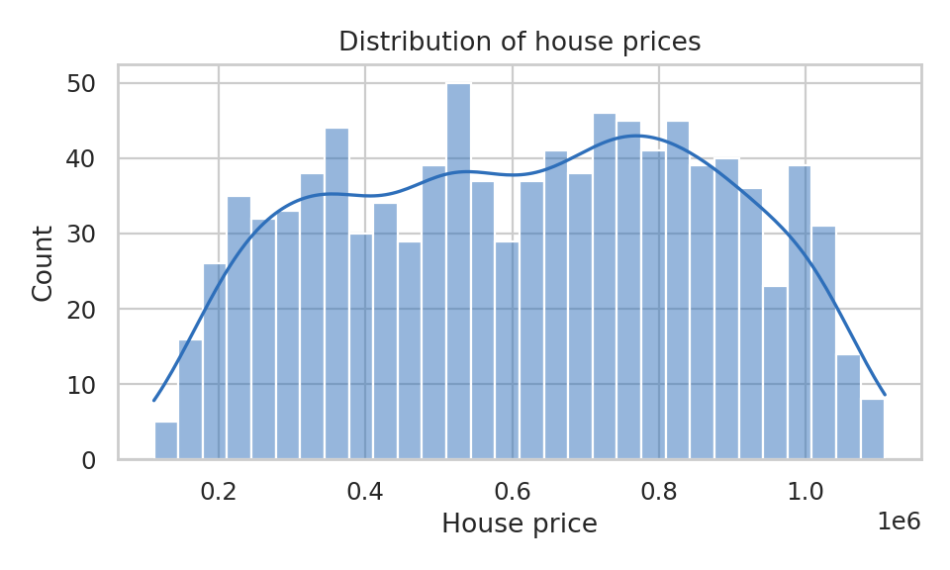
Figure 1: Distribution of house prices
The correlation matrix (Figure 2) shows that Square_Footage has an almost perfect positive correlation with price (0.991). Lot_Size (0.160), Garage_Size (0.052) and Year_Built (0.052) have weak positive correlations, while Num_Bedrooms, Num_Bathrooms and Neighborhood_Quality are close to zero when considered individually. Figure 3 confirms that price grows linearly with area.
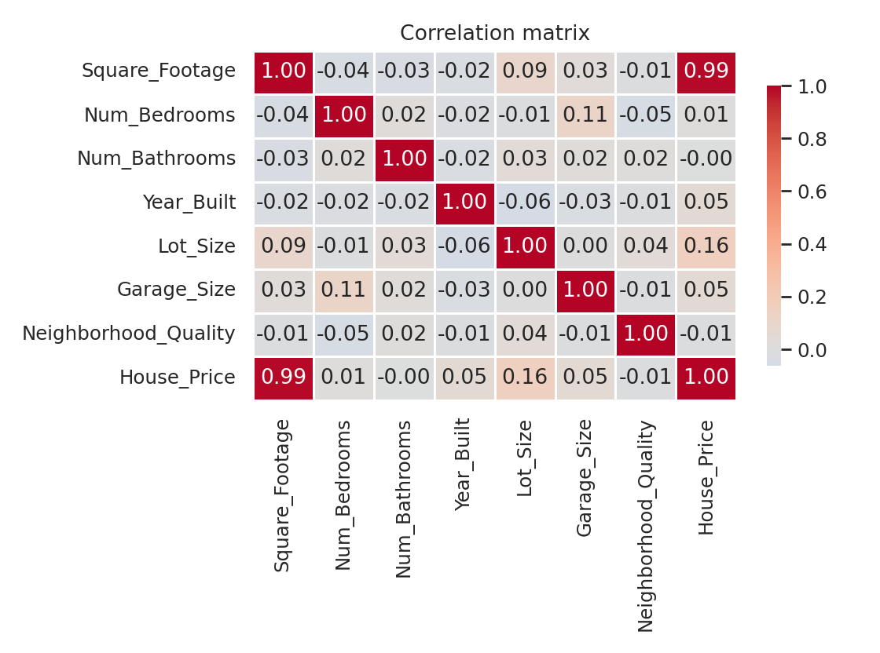
Figure 2: Correlation matrix of all features
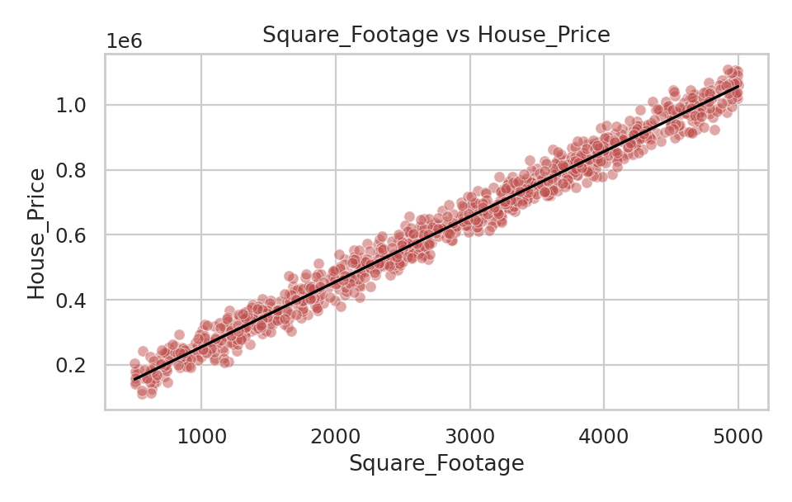
Figure 3: Square footage versus house price with fitted line
Observation: the near-zero influence of Neighborhood_Quality is unusual for real housing markets and suggests that this dataset is simplified or synthetic. The conclusions of this report therefore apply to this dataset and should not be generalised to real markets without retraining on real data.

4. System Design

4.1 Architecture
The application follows a layered design. All layers live in one file, but they are separated into clearly labelled sections so that each one can be understood, tested and replaced independently.
Layer | Responsibility | Key functions
Configuration | Constants such as file names, feature list, split ratio, random seed | BASE_FEATURES, TARGET, TEST_SIZE
Backend: data | Load, validate and clean data; engineer features | load_data, clean_data, add_features
Backend: ML | Build pipelines, train, evaluate and select models; predict | build_pipeline, train_and_evaluate, predict_price, predict_batch
Backend: charts | Create Matplotlib figures | fig_correlation, fig_actual_vs_pred, fig_importance, ...
Frontend | Streamlit pages, navigation, forms, downloads, caching | page_home, page_data, page_model, page_predict, main

4.2 Data flow
- CSV file (bundled or uploaded in the sidebar) is read and validated.
- The data is cleaned and cached, so it is not reloaded on every interaction.
- The four candidate models are trained once and cached; the best model is saved as house_price_model.joblib.
- The user chooses a page in the sidebar. Pages read the cached data and models.
- For a prediction, the form values are placed in a one-row table, passed through the pipeline (feature engineering, scaling, model) and the price and its 95% range are displayed.

4.3 Frontend pages
Page | Content
Home | Key numbers (records, features, average price, best R²) and a project overview
Data Explorer | Raw data table with download, summary statistics, histograms, correlation heatmap, scatter and box plots
Model Performance | Comparison table and chart, actual-vs-predicted plot, residual histogram, feature importance
Predict Price | Single-house form with estimate, range, comparison with the market and price per sq. ft; batch CSV prediction with template and download
About | Technology stack, models, engineered features and limitations

5. Methodology

5.1 Data preprocessing
The loader checks that all required columns exist. The cleaning step removes duplicate rows, rows with missing values and impossible records (non-positive price or area). For this dataset no rows were removed, so all 1,000 records were used.

5.2 Feature engineering
New feature | Formula | Rationale
House_Age | 2024 − Year_Built | Age is easier to interpret than a calendar year
Total_Rooms | Num_Bedrooms + Num_Bathrooms | Overall room count
Sqft_per_Bedroom | Square_Footage / Num_Bedrooms | Measures spaciousness

These features are created inside the scikit-learn pipeline using a FunctionTransformer. This guarantees that exactly the same transformation is applied during training and prediction and prevents training/serving mismatch. A fixed reference year (2024) is used so results are reproducible.

5.3 Training and evaluation
- The data is split 80% training (800 houses) and 20% testing (200 houses) with a fixed random seed of 42.
- Each model is wrapped in a pipeline: feature engineering → StandardScaler → regressor.
- Each pipeline is evaluated using 5-fold cross-validation on the training set (RMSE).
- The pipeline is then fitted on the full training set and scored on the unseen test set using R², MAE and RMSE.
- The model with the lowest cross-validated RMSE is selected as the active model.
- Permutation importance is calculated on the test set to find which raw inputs matter most.

5.4 Prediction range
Alongside the point estimate, the app shows an approximate 95% range computed as the prediction ± 1.96 × the standard deviation of the test-set residuals (about 10,052 for the selected model, i.e. roughly ± 19,700). This is a simple guide to the typical error and assumes residuals are roughly normal and similar across the price range.

6. Implementation

6.1 Project files
File | Description
house_price_app.py | Complete application: backend and frontend in one file
house_price_regression_dataset.csv | Dataset (1,000 rows)
requirements.txt | Python package dependencies
README.md | Installation, usage and troubleshooting guide
House_Price_Prediction_Report.docx | This report
house_price_model.joblib | Trained model, created automatically on first run

6.2 Core backend code
The pipeline builder below shows how feature engineering, scaling and the regressor are chained:
def build_pipeline(estimator) -> Pipeline:
return Pipeline(steps=[
("features", FunctionTransformer(add_features, validate=False)),
("scale", StandardScaler()),
("model", estimator),
])

6.3 Performance considerations
Streamlit re-runs the script on every interaction. To keep the interface responsive, data loading uses st.cache_data and model training uses st.cache_resource, so training happens only once per dataset. The trained model is also persisted with joblib.

6.4 Input validation and safety
- Uploaded datasets and batch files are checked for the required columns and a clear error message is shown if any are missing.
- Input widgets restrict values to sensible ranges taken from the training data.
- A warning appears when the entered square footage lies outside the range seen in training, because predictions there are extrapolations.
- Predicted prices are never displayed below zero.

7. Results and Analysis

7.1 Model comparison
Model | R² (test) | MAE (test) | RMSE (test) | RMSE (5-fold CV)
Linear Regression | 0.9984 | 8,160 | 10,052 | 9,772
Ridge Regression | 0.9984 | 8,247 | 10,130 | 9,790
Gradient Boosting | 0.9965 | 12,136 | 14,927 | 15,637
Random Forest | 0.9941 | 15,902 | 19,498 | 21,848

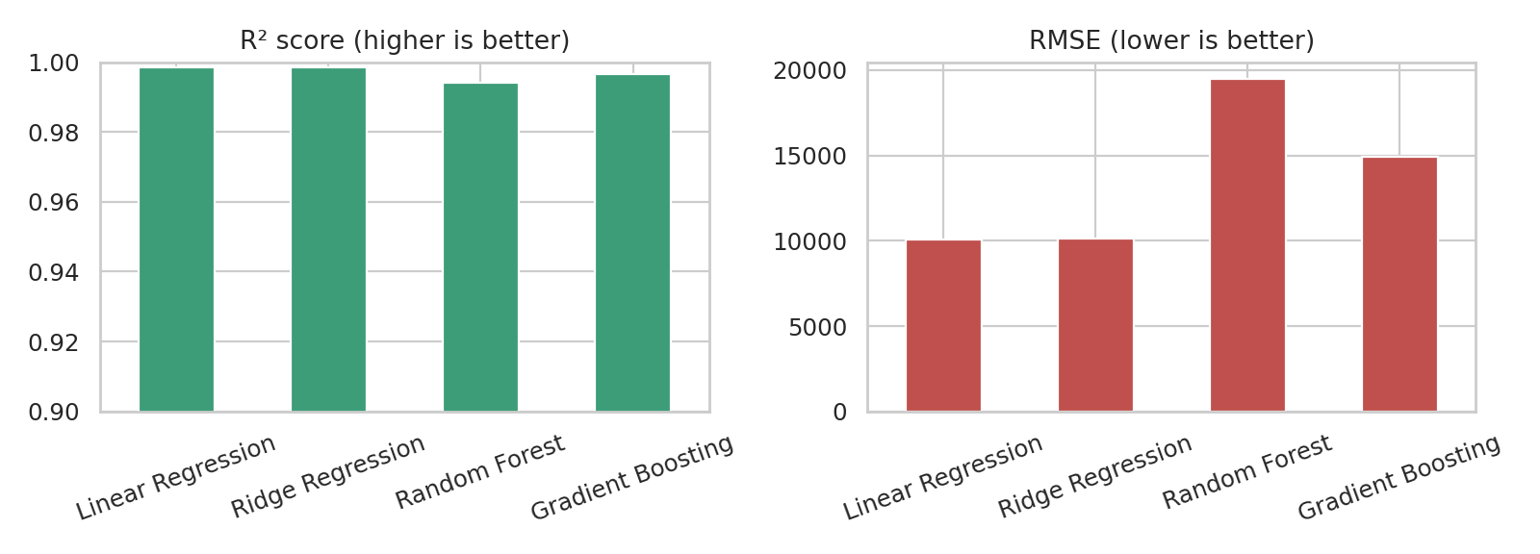
Figure 4: R² and RMSE of the four models on the test set
Linear Regression was selected because it has the lowest cross-validated RMSE. Ridge Regression performs almost identically, which shows that over-fitting is not a problem in this dataset. The tree-based models are slightly less accurate: price depends almost linearly on area, and decision trees approximate a straight line with steps and cannot extrapolate beyond the values seen in training.

7.2 Prediction quality
Figure 5 shows predictions lying very close to the ideal diagonal line, and Figure 6 shows residuals centred on zero with a roughly symmetric, bell-shaped distribution. This indicates that the model is unbiased and that errors are small relative to prices (mean absolute error is about 1.3% of the average price).
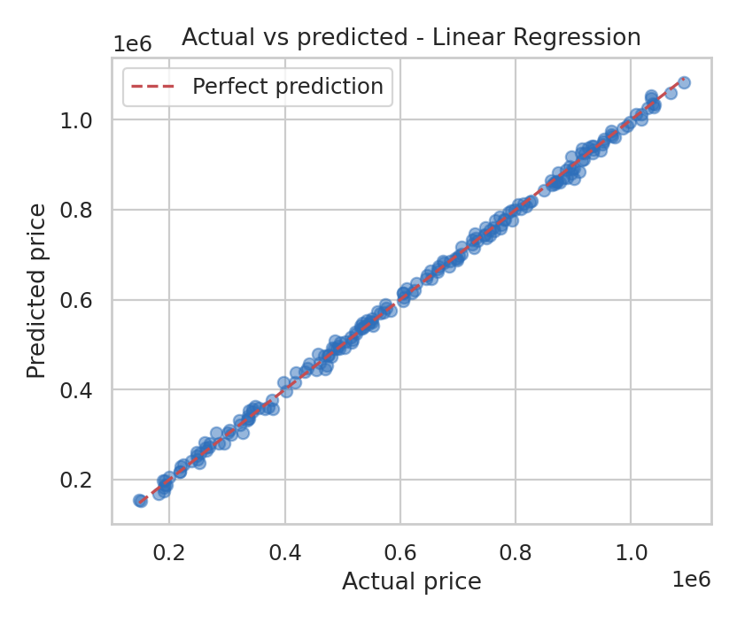
Figure 5: Actual versus predicted prices (test set)
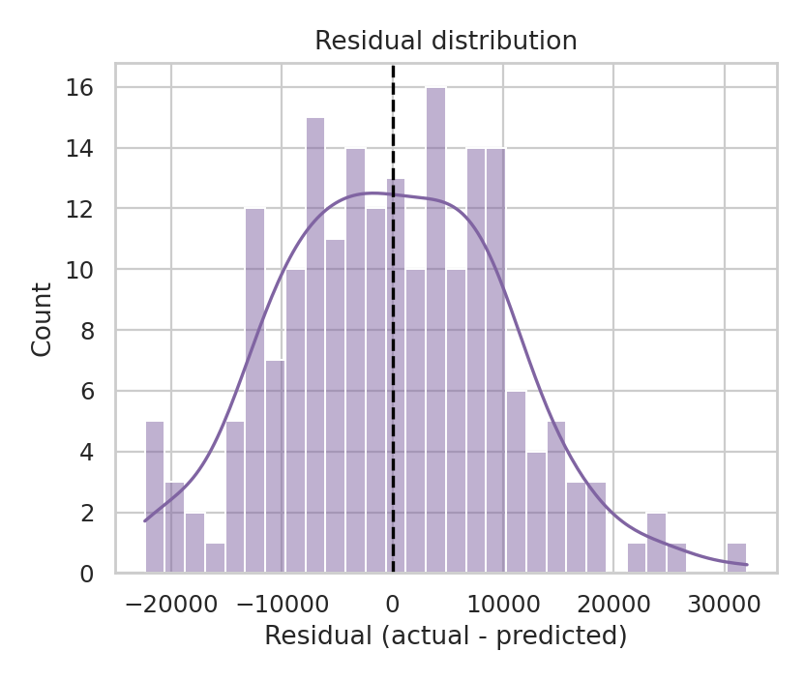
Figure 6: Distribution of residuals

7.3 Feature importance
Permutation importance (Figure 7) confirms that Square_Footage overwhelmingly drives the prediction. Lot_Size and Year_Built contribute small amounts, and Neighborhood_Quality has effectively no influence in this dataset.
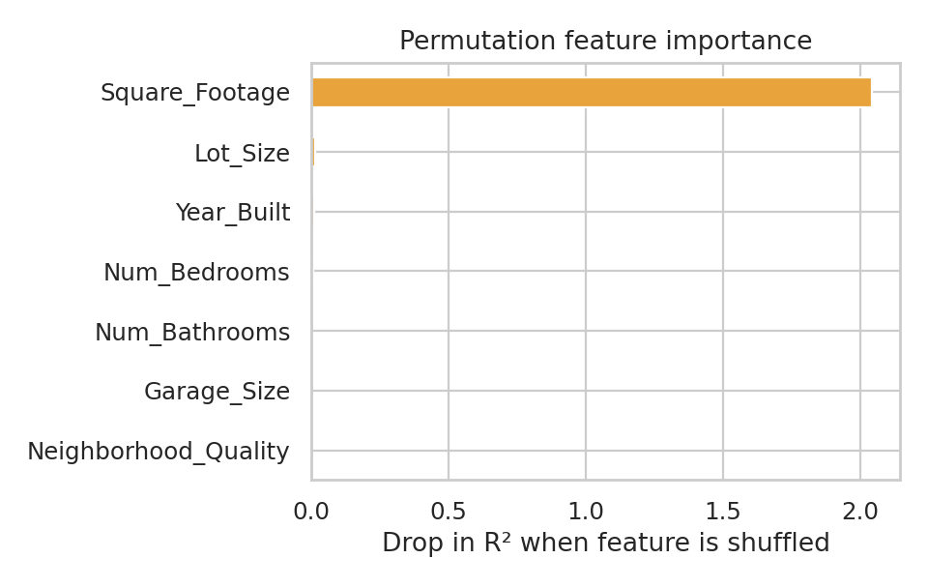
Figure 7: Permutation feature importance

7.4 Example prediction
For a house with 2,500 sq. ft, 3 bedrooms, 2 bathrooms, built in 2000, a 2.5-acre lot, a one-car garage and a neighbourhood rating of 6, the system predicts a price of about 565,600, with a 95% range of roughly 545,900 to 585,300.

8. Testing
The project was verified with an automated smoke-test script that exercises the backend functions and executes every frontend page function and the main() entry point.
Test | Expected result | Outcome
Load dataset and validate columns | 1,000 rows and 8 columns loaded | Passed
Cleaning step | No missing values or duplicates remain | Passed
Train and evaluate all models | Results table with 4 models; best model selected | Passed
Single prediction | Positive price close to the training range | Passed
Batch prediction | Predicted_Price column added; values close to actual prices | Passed
Save and reload model | Reloaded model returns identical predictions | Passed
Currency formatting | USD shown with $; INR shown in lakh / crore | Passed
All five page functions and main() | Run without raising errors | Passed

Recommended manual test: start the app with streamlit run house_price_app.py, visit every page, submit a prediction, upload the downloadable CSV template and confirm the results.

9. Limitations and Future Scope

9.1 Limitations
- Small dataset (1,000 records); results may not generalise to larger or real markets.
- No location information (city, ZIP code, coordinates), which is the most important factor in real housing prices.
- The dataset appears simplified, so very high accuracy should not be expected on real data.
- The currency is assumed to be US dollars; the INR view relies on a user-entered exchange rate.
- The prediction range is an approximation based on average test error.

9.2 Future scope
- Train on larger real-world data that includes location, amenities and market trends.
- Add hyper-parameter tuning (GridSearchCV / RandomizedSearchCV) and additional models such as XGBoost.
- Use explainability tools such as SHAP to explain individual predictions.
- Expose the model through a REST API (FastAPI) and deploy to Streamlit Community Cloud or a cloud server.
- Add user accounts and a history of saved predictions.

10. Conclusion
This project delivered a complete, working house price prediction system. The backend cleans the data, engineers features and compares four regression models using a reproducible, cross-validated process. The selected Linear Regression model explains 99.84% of the variance in unseen prices with an average error of about 8,160. The Streamlit frontend makes the model accessible through visual data exploration, performance dashboards and an easy prediction form with batch support. The entire solution is contained in one Python file with a requirements file and README, so it can be installed and run in minutes.
The study also showed that model choice should follow the structure of the data: when the target is almost linearly related to one dominant feature, a simple linear model can outperform more complex ensembles while remaining fast and interpretable.

References
- Pedregosa, F. et al. (2011). Scikit-learn: Machine Learning in Python. Journal of Machine Learning Research, 12, 2825-2830.
- Breiman, L. (2001). Random Forests. Machine Learning, 45(1), 5-32.
- Friedman, J. H. (2001). Greedy Function Approximation: A Gradient Boosting Machine. Annals of Statistics, 29(5), 1189-1232.
- Hoerl, A. E. and Kennard, R. W. (1970). Ridge Regression: Biased Estimation for Nonorthogonal Problems. Technometrics, 12(1), 55-67.
- McKinney, W. (2010). Data Structures for Statistical Computing in Python. Proceedings of the 9th Python in Science Conference.
- Streamlit documentation. https://docs.streamlit.io
- scikit-learn user guide. https://scikit-learn.org/stable/user_guide.html

Appendix A: How to Run the Project
- Install Python 3.9 or later.
- Place house_price_app.py, house_price_regression_dataset.csv and requirements.txt in one folder.
- Open a terminal in that folder and run: pip install -r requirements.txt
- Start the application with: streamlit run house_price_app.py
- Open http://localhost:8501 in a browser if it does not open automatically.

