Genu MCOE Data Processing at CPS side

Overview: Genu MCOE data is from source system (app download system) to datalike on daily basis. Feed in Datalike is export to ODS on daily basis and this data will be used for reporting in ODS side.
BDPaas

ODS
Sqoop Job
App Download
UMR Tenant
stats API

ETL Processing Name:
- Airflow scheduling Frequency – Everyday
- Run Time & Duration: 3:00 AM GMT
- DAG Name: dag_umr_bgt_s_93_cps_genu_mcoe

We can invoke data from source system below is swagger screenshot.
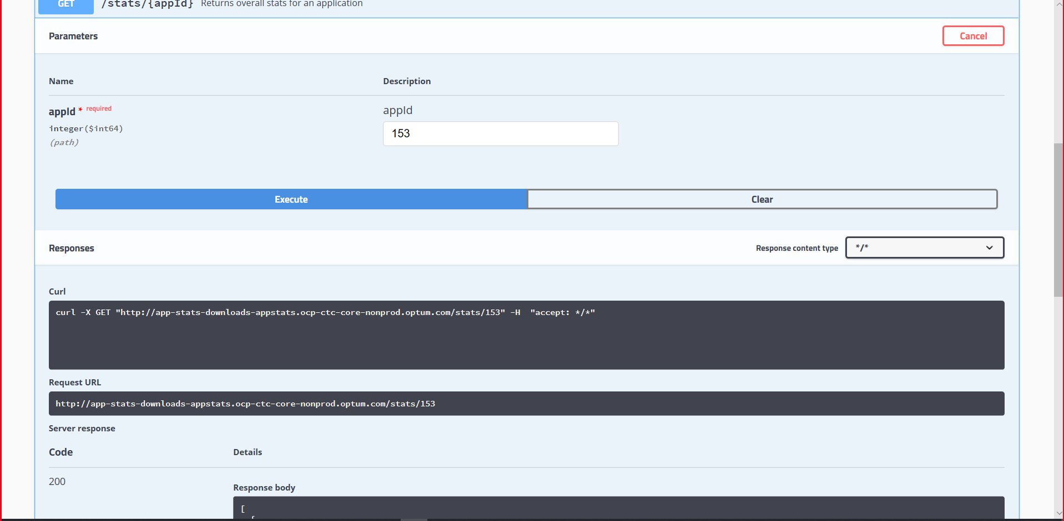
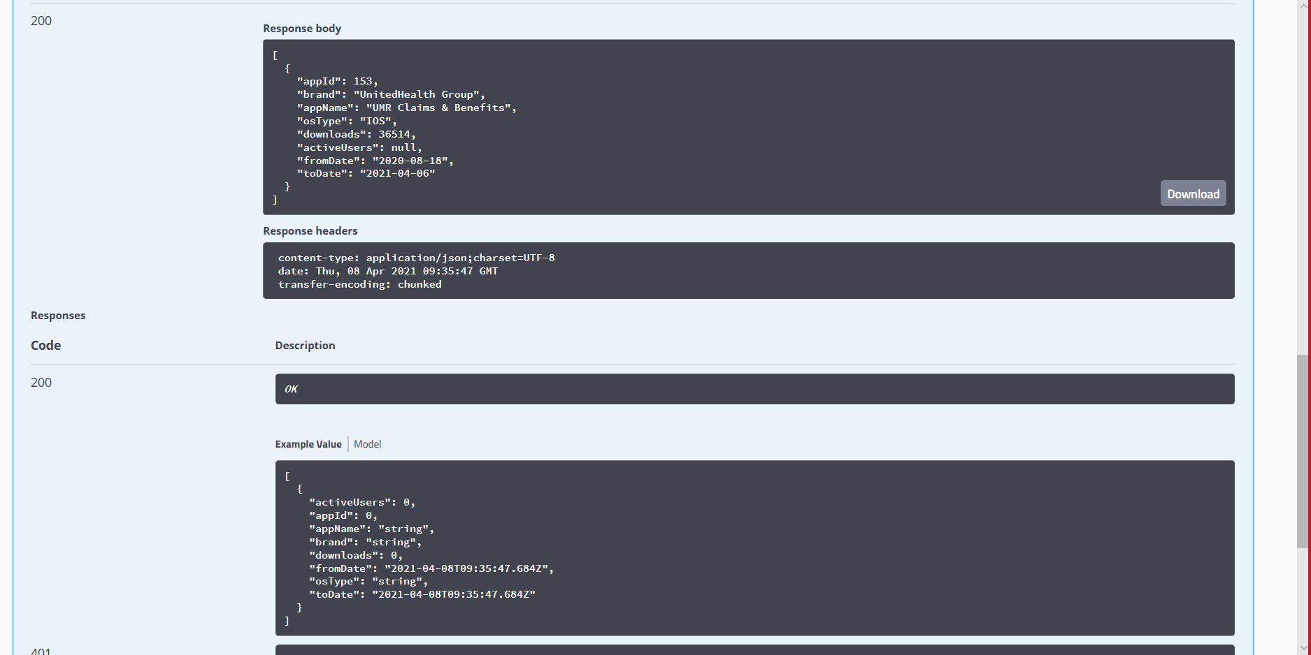

Java code setup for the consuming and loading into hive.
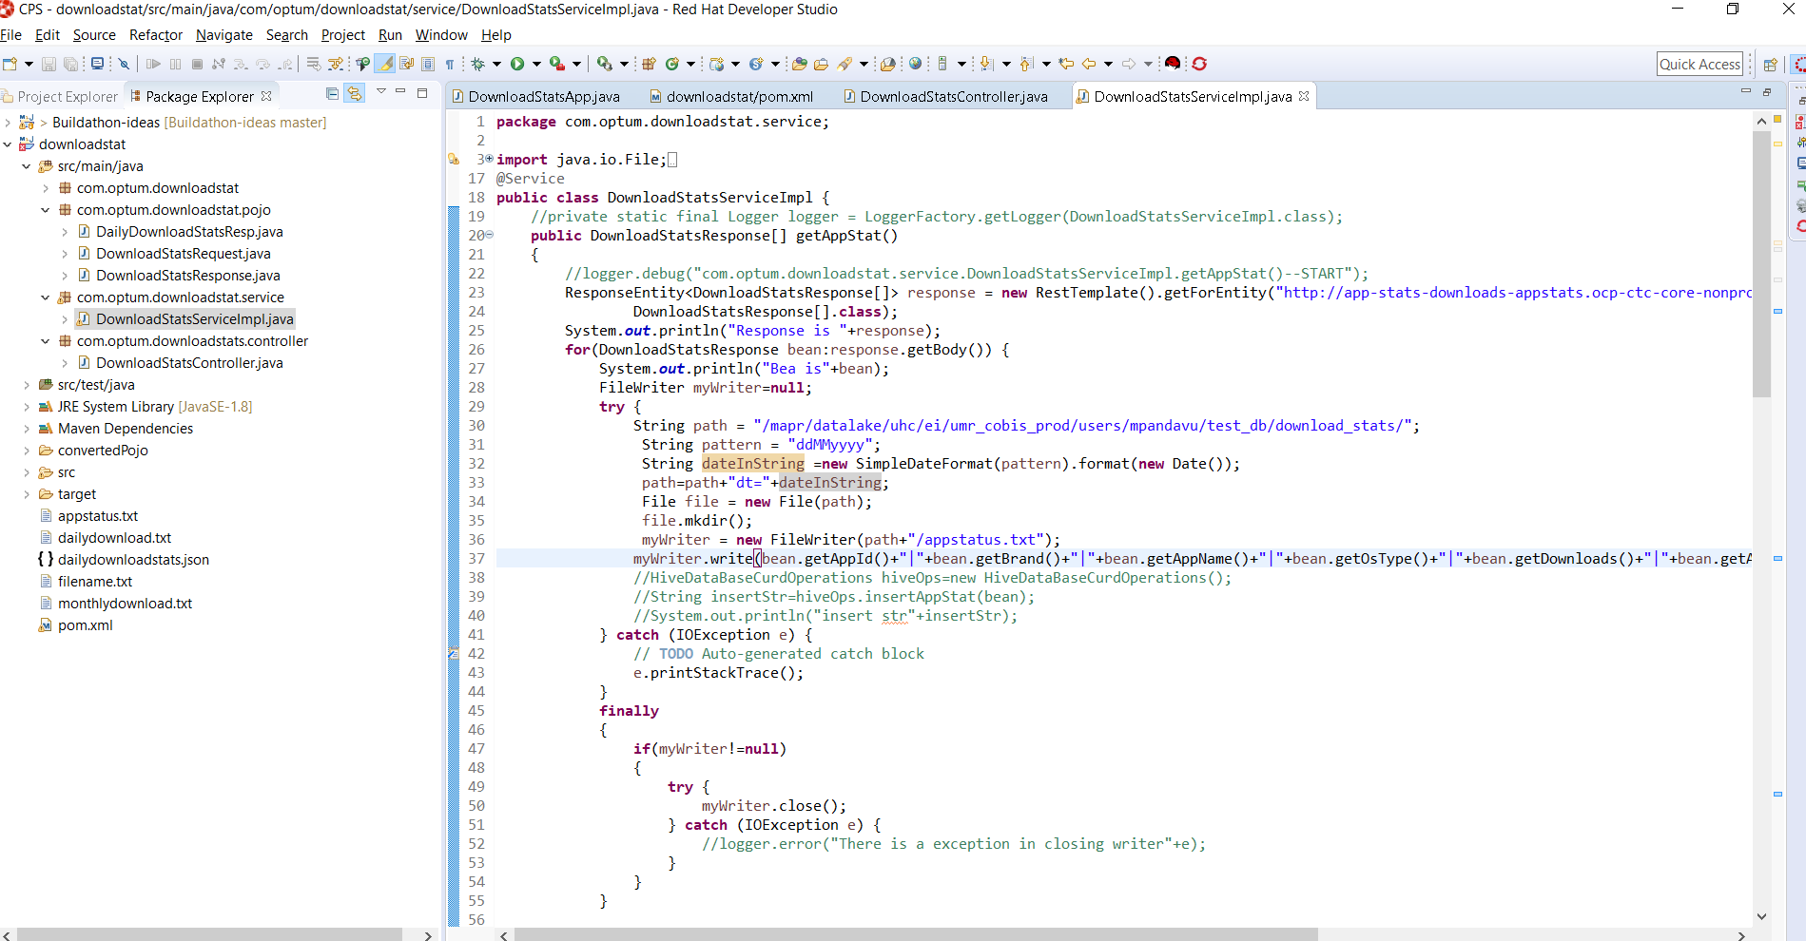

Below high lighted is the spring boot application jar in data lake.

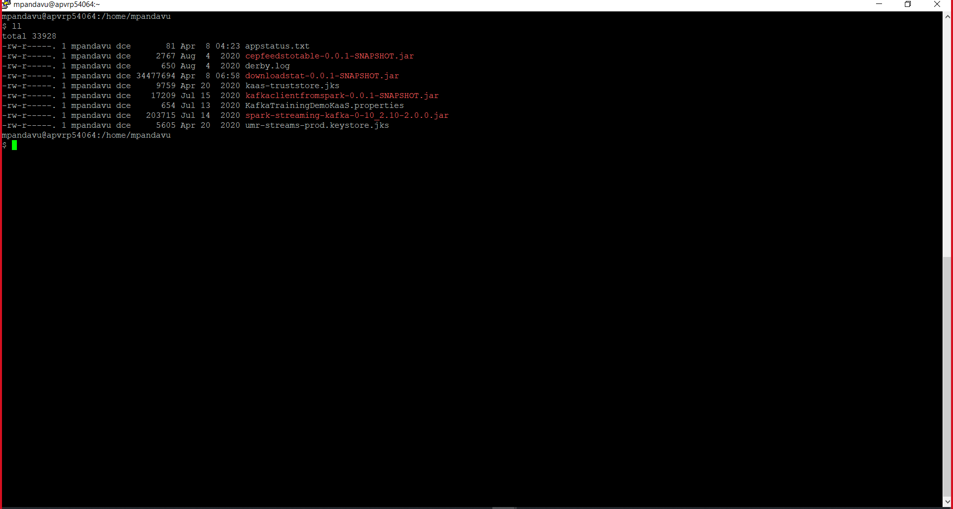

Spring boot application running in data lake
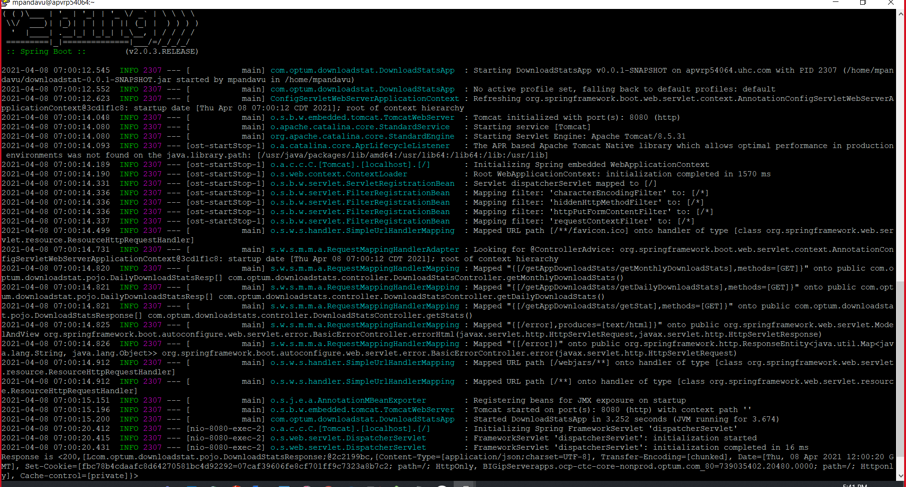

File created in Hdfs location
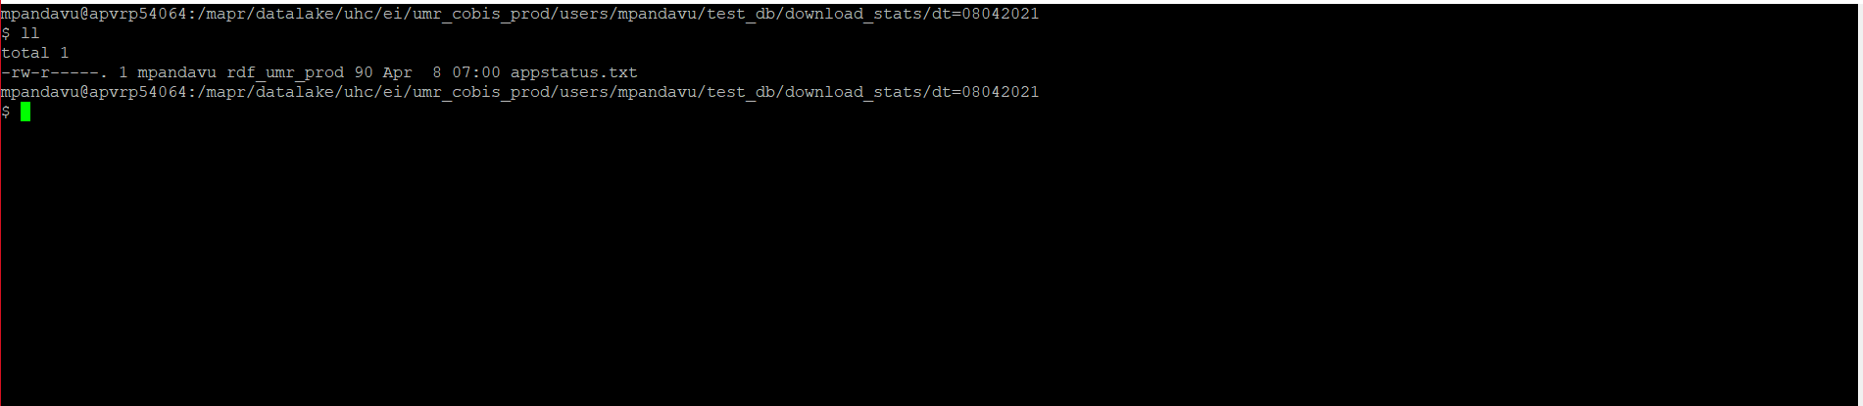

Data visualization using DBeaver
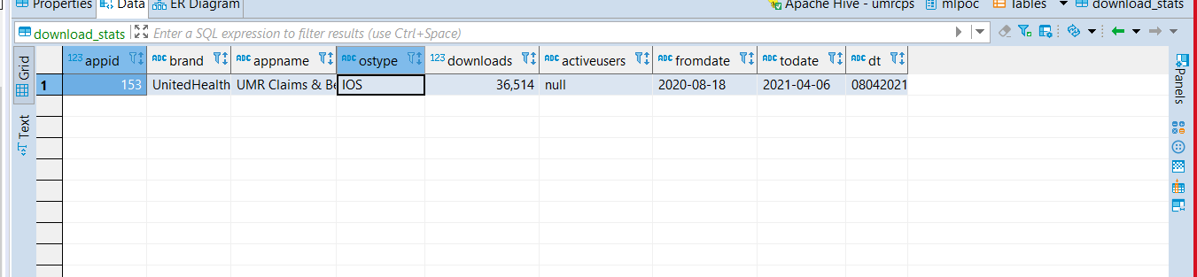

Table Details:
Table Name: mcoe_app_download_stats_tb
Description: This table loads with app downloads data.

On Error:
If there job fails with any Error, it will send out the mail to below and stops the execution flow.
- ITCPSTeamPearl_DL@ds.uhc.com
We have to find the root cause of the issue and fix it.

If mcoe_app_download_stats_tb table having empty data then check incoming data with swagger url below.
Swagger UI (optum.com)

Rerun:
If data not pushed to ODS the rerun the DAG from the airflow.

