Add management.endpoints.web.exposure.include=*
To display all urls.

$ docker pull prom/prometheus

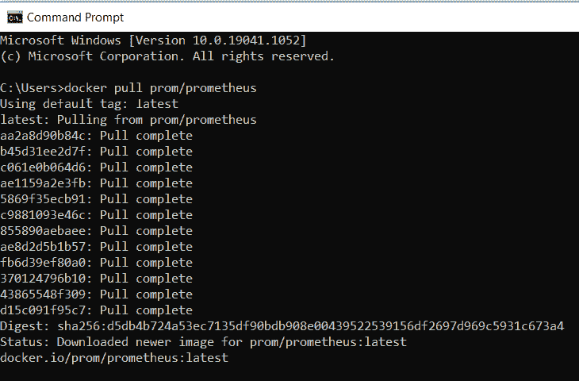
docker run -d --name=prometheus -p 9090:9090 -v <PATH_TO_prometheus.yml_FILE>:/etc/prometheus/prometheus.yml prom/prometheus --config.file=/etc/prometheus/prometheus.yml

docker run -d --name=prometheus -p 9090:9090 -v C:/Users/mpandavu/CPS/cpsimdmconsumer-/src/main/resources/prometheus.yml:/etc/prometheus/prometheus.yml prom/prometheus --config.file=/etc/prometheus/prometheus.yml

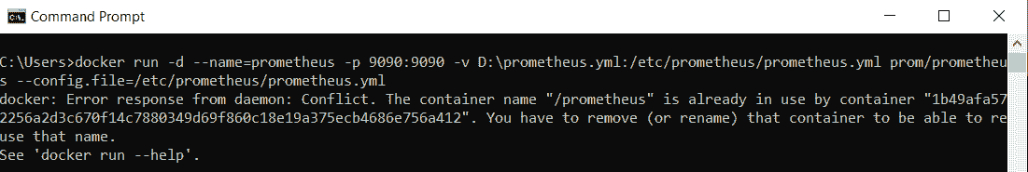
To resolve above error use below command to Force to remove one or more containers.

docker rm -f prometheus

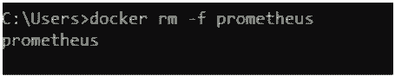

Now, use below docker command to run Prometheus.

docker run -d --name=prometheus -p 9090:9090 -v D:\prometheus.yml:/etc/prometheus/prometheus.yml prom/prometheus --config.file=/etc/prometheus/prometheus.yml

Prometheus.yaml:

global:
scrape_interval: 15s
scrape_configs:
- job_name: 'prometheus'
scrape_interval: 5s
static_configs:
- targets: ['localhost:9090']
- job_name: 'spring-actuator'
metrics_path: '/actuator/prometheus'
scrape_interval: 5s
static_configs:
- targets: ['localhost:8080']

Monitoring tools configuration in Kubernetes:

Config-map.yaml
apiVersion: v1
kind: ConfigMap
metadata:
name: prometheus-server-conf
labels:
name: prometheus-server-conf
namespace: umrcps-k8-stg
data:
prometheus.rules: |-
groups:
- name: devopscube demo alert
rules:
- alert: High Pod Memory
expr: sum(container_memory_usage_bytes) > 1
for: 1m
labels:
severity: slack
annotations:
summary: High Memory Usage
prometheus.yml: |-
global:
scrape_interval: 5s
evaluation_interval: 5s
rule_files:
- /etc/prometheus/prometheus.rules
alerting:
alertmanagers:
- scheme: http
static_configs:
- targets:
- "alertmanager.monitoring.svc:9093"

scrape_configs:
- job_name: 'node-exporter'
kubernetes_sd_configs:
- role: endpoints
relabel_configs:
- source_labels: [__meta_kubernetes_endpoints_name]
regex: 'node-exporter'
action: keep

- job_name: 'kubernetes-apiservers'

kubernetes_sd_configs:
- role: endpoints
scheme: https

tls_config:
ca_file: /var/run/secrets/kubernetes.io/serviceaccount/ca.crt
bearer_token_file: /var/run/secrets/kubernetes.io/serviceaccount/token

relabel_configs:
- source_labels: [__meta_kubernetes_namespace, __meta_kubernetes_service_name, __meta_kubernetes_endpoint_port_name]
action: keep
regex: default;kubernetes;https

- job_name: 'kubernetes-nodes'

scheme: https

tls_config:
ca_file: /var/run/secrets/kubernetes.io/serviceaccount/ca.crt
bearer_token_file: /var/run/secrets/kubernetes.io/serviceaccount/token

kubernetes_sd_configs:
- role: node

relabel_configs:
- action: labelmap
regex: __meta_kubernetes_node_label_(.+)
- target_label: __address__
replacement: k8s-dash-nonprod-ctc.optum.com:443
- source_labels: [__meta_kubernetes_node_name]
regex: (.+)
target_label: __metrics_path__
replacement: /api/v1/node/${1}/proxy/metrics

- job_name: 'kubernetes-pods'

kubernetes_sd_configs:
- role: pod

relabel_configs:
- source_labels: [__meta_kubernetes_pod_annotation_prometheus_io_scrape]
action: keep
regex: true
- source_labels: [__meta_kubernetes_pod_annotation_prometheus_io_path]
action: replace
target_label: __metrics_path__
regex: (.+)
- source_labels: [__address__, __meta_kubernetes_pod_annotation_prometheus_io_port]
action: replace
regex: ([^:]+)(?::\d+)?;(\d+)
replacement: $1:$2
target_label: __address__
- action: labelmap
regex: __meta_kubernetes_pod_label_(.+)
- source_labels: [__meta_kubernetes_namespace]
action: replace
target_label: kubernetes_namespace
- source_labels: [__meta_kubernetes_pod_name]
action: replace
target_label: kubernetes_pod_name

- job_name: 'kube-state-metrics'
static_configs:
- targets: ['localhost:9090']

- job_name: 'spring-actuator'
metrics_path: '/actuator/prometheus'
scrape_interval: 5s
static_configs:
- targets: ['ctc2hz1-04-s18.uhc.com:28002']

- job_name: 'kubernetes-cadvisor'

scheme: https

tls_config:
ca_file: /var/run/secrets/kubernetes.io/serviceaccount/ca.crt
bearer_token_file: /var/run/secrets/kubernetes.io/serviceaccount/token

kubernetes_sd_configs:
- role: node

relabel_configs:
- action: labelmap
regex: __meta_kubernetes_node_label_(.+)
- target_label: __address__
replacement: k8s-dash-nonprod-ctc.optum.com:443
- source_labels: [__meta_kubernetes_node_name]
regex: (.+)
target_label: __metrics_path__
replacement: /api/v1/node/${1}/proxy/metrics/cadvisor

- job_name: 'kubernetes-service-endpoints'

kubernetes_sd_configs:
- role: endpoints

relabel_configs:
- source_labels: [__meta_kubernetes_service_annotation_prometheus_io_scrape]
action: keep
regex: true
- source_labels: [__meta_kubernetes_service_annotation_prometheus_io_scheme]
action: replace
target_label: __scheme__
regex: (https?)
- source_labels: [__meta_kubernetes_service_annotation_prometheus_io_path]
action: replace
target_label: __metrics_path__
regex: (.+)
- source_labels: [__address__, __meta_kubernetes_service_annotation_prometheus_io_port]
action: replace
target_label: __address__
regex: ([^:]+)(?::\d+)?;(\d+)
replacement: $1:$2
- action: labelmap
regex: __meta_kubernetes_service_label_(.+)
- source_labels: [__meta_kubernetes_namespace]
action: replace
target_label: kubernetes_namespace
- source_labels: [__meta_kubernetes_service_name]
action: replace
target_label: kubernetes_name

Prometheus-deployment.yml

apiVersion: apps/v1
kind: Deployment
metadata:
name: prometheus-deployment
namespace: umrcps-k8-stg
labels:
app: prometheus-server
spec:
replicas: 1
selector:
matchLabels:
app: prometheus-server
template:
metadata:
labels:
app: prometheus-server
spec:
securityContext:
fsGroup: 53134
runAsUser: 60217
containers:
- name: prometheus
image: docker.repo1.uhc.com/umrcps-kubernetes/prom/prometheus:v2
args:
- "--config.file=/etc/prometheus/prometheus.yml"
- "--storage.tsdb.path=/prometheus/"
ports:
- containerPort: 9090
volumeMounts:
- name: prometheus-config-volume
mountPath: /etc/prometheus/
- name: prometheus-storage-volume
mountPath: /prometheus/
volumes:
- name: prometheus-config-volume
configMap:
defaultMode: 420
name: prometheus-server-conf

- name: prometheus-storage-volume
emptyDir: {}

Prometheus-service.yml:

apiVersion: v1
kind: Service
metadata:
name: prometheus-service
namespace: umrcps-k8-stg
annotations:
prometheus.io/scrape: 'true'
prometheus.io/port: '9090'

spec:
selector:
app: prometheus-server
type: NodePort
ports:
- port: 8082
targetPort: 9090
nodePort: 30000

imdm-service.yml

apiVersion: v1
kind: Service
metadata:
name: imdm-service
namespace: umrcps-k8-stg
annotations:
prometheus.io/scrape: 'true'
prometheus.io/port: '8080'

spec:
selector:
app: cpsimdmconsumer
type: NodePort
ports:
- port: 8082
targetPort: 8080
nodePort: 28002

Oc create -f .yaml
Granfana:

Grafana (optum.com)
Add rules

