Create clusterRoles if roles not defined:
Step 1: Create a file named clusterRole.yaml and copy the following RBAC role.
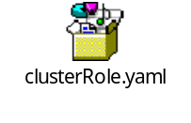
Step 2: Create the role using the following command.

kubectl create -f clusterRole.yaml

Create a Config Map To Externalize Prometheus Configurations:
All configurations for Prometheus are part of prometheus.yaml file and all the alert rules for Alert manager are configured in prometheus.rules.

Prometheus.yaml:
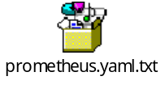

prometheus.rules:

Need to work on this file for custom alerts.

The config map with all the Prometheus scrape config and alerting rules gets mounted to the Prometheus container in /etc/prometheus location as prometheus.yaml and prometheus.rules files.

Step 1: Create a file called config-map.yaml and copy the file contents from this
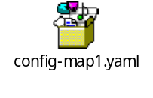

Step 2: Execute the following command to create the config map in Kubernetes.
kubectl create -f config-map.yaml

Create a Prometheus Deployment:
prometheus-deployment.yaml:

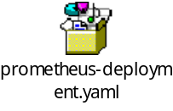

Step 2: Create a deployment on monitoring namespace using the above file.
kubectl create -f prometheus-deployment.yaml

Exposing Prometheus as a Service [NodePort & LoadBalancer]:

prometheus-service.yaml:
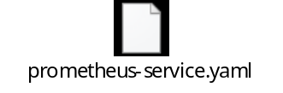

Once created, you can access the Prometheus dashboard using any of the Kubernetes nodes IP on port 30000. If you are on the cloud, make sure you have the right firewall rules to access port 30000 from your workstation.
Exposing Prometheus Using Ingress:

