WEB DEVELOPMENT LAB

Name: Ch.Paardhu sai kumar
Roll No: 26001202
Section:CSM-6

EXPERIMENT 1: FITNESS CENTER AND GYM WEBSITE
Aim : A responsive gym website named ARNOLD GYM. It displays workout programs, trainers, facilities, membership plans, class schedules and a registration form.

Source Code
<!DOCTYPE html>
<html lang="en">
<head>
<meta charset="UTF-8">
<meta name="viewport" content="width=device-width, initial-scale=1.0">
<title>Fitness Center and Gym</title>
<link rel="stylesheet" href="s.css">
</head>
<body>
<!-- Navigation -->
<header>
<h1>ARNOLD GYM</h1>
<nav>
<a href="#home">Home</a>
<a href="#programs">Programs</a>
<a href="#trainers">Trainers</a>
<a href="#plans">Membership</a>
<a href="#schedule">Schedule</a>
<a href="#register">Register</a>
</nav>
</header>
<!-- Home Section -->
<section id="home" class="hero">
<h2>BUILD YOUR STRENGTH</h2>
<p>Train Hard. Stay Strong. Be Healthy.</p>
<a href="#plans" class="btn">Join Now</a>
</section>
<!-- Workout Programs -->
<section id="programs">
<h2>Workout Programs</h2>
<div class="container">
<div class="card">
<h3>Strength Training</h3>
<p>Build strength with weight training exercises.</p>
</div>
<div class="card">
<h3>Cardio Training</h3>
<p>Improve stamina and heart health.</p>
</div>
<div class="card">
<h3>Yoga & Fitness</h3>
<p>Improve flexibility and relaxation.</p>
</div>
</div>
</section>
<!-- Trainers -->
<section id="trainers">
<h2>Our Trainers</h2>
<div class="container">
<div class="card">
<h3>Rahul</h3>
<p>Strength Training Coach</p>
</div>
<div class="card">
<h3>Priya</h3>
<p>Yoga Instructor</p>
</div>
<div class="card">
<h3>Arjun</h3>
<p>Fitness Trainer</p>
</div>
</div>
</section>
<!-- Facilities -->
<section id="facilities">
<h2>Our Facilities</h2>
<div class="container">
<div class="card">Modern Gym Equipment</div>
<div class="card">Cardio Machines</div>
<div class="card">Personal Training</div>
</div>
</section>
<!-- Membership Plans -->
<section id="plans">
<h2>Membership Plans</h2>
<div class="container">
<div class="card price">
<h3>Basic</h3>
<h2>₹999/month</h2>
<p>Gym Access</p>
<p>Basic Equipment</p>
<a href="#register" class="btn">Choose Plan</a>
</div>
<div class="card price">
<h3>Standard</h3>
<h2>₹1499/month</h2>
<p>Gym Access</p>
<p>Group Classes</p>
<a href="#register" class="btn">Choose Plan</a>
</div>
<div class="card price">
<h3>Premium</h3>
<h2>₹2499/month</h2>
<p>All Facilities</p>
<p>Personal Trainer</p>
<a href="#register" class="btn">Choose Plan</a>
</div>
</div>
</section>
<!-- Class Schedule -->
<section id="schedule">
<h2>Class Schedule</h2>
<table>
<tr><th>Day</th><th>Class</th><th>Time</th></tr>
<tr><td>Monday</td><td>Strength Training</td><td>7:00 AM</td></tr>
<tr><td>Wednesday</td><td>Yoga</td><td>8:00 AM</td></tr>
<tr><td>Friday</td><td>Cardio</td><td>6:00 PM</td></tr>
</table>
</section>
<!-- Registration Form -->
<section id="register">
<h2>Register Now</h2>
<form>
<input type="text" placeholder="Enter Your Name" required>
<input type="email" placeholder="Enter Your Email" required>
<input type="tel" placeholder="Enter Phone Number" required>
<select required>
<option value="">Select Membership</option>
<option>Basic</option>
<option>Standard</option>
<option>Premium</option>
</select>
<button type="submit">Submit Registration</button>
</form>
</section>
<!-- Footer -->
<footer>
<p>&copy; 2026 ARNOLD GYM. All Rights Reserved.</p>
</footer>
</body>
</html>

CSS Code
/* General Styling */
* {
margin: 0;
padding: 0;
box-sizing: border-box;
}
body {
font-family: Arial, sans-serif;
background-color: #f4f4f4;
color: #222;
line-height: 1.6;
}
/* Header */
header {
background-color: #111;
color: white;
padding: 20px;
text-align: center;
}
header h1 {
color: #ff4500;
font-size: 35px;
font-weight: bold;
}
nav { margin-top: 15px; }
nav a {
color: white;
text-decoration: none;
margin: 10px;
font-weight: bold;
transition: color 0.3s;
}
nav a:hover { color: #ff4500; }
/* Hero Section */
.hero {
background: linear-gradient(to right, #222, #555);
color: white;
text-align: center;
padding: 100px 20px;
}
.hero h2 { font-size: 45px; font-weight: bold; }
.hero p { margin: 15px 0; font-size: 20px; }
/* Buttons */
.btn {
display: inline-block;
background-color: #ff4500;
color: white;
padding: 10px 20px;
text-decoration: none;
border-radius: 5px;
margin-top: 10px;
transition: background-color 0.3s, transform 0.3s;
}
.btn:hover {
background-color: #cc3700;
transform: scale(1.05);
}
/* Sections */
section { padding: 50px 20px; text-align: center; }
section > h2 { font-size: 32px; margin-bottom: 30px; color: #ff4500; }
/* Cards */
.container {
display: flex;
justify-content: center;
flex-wrap: wrap;
gap: 20px;
}
.card {
background-color: white;
padding: 25px;
width: 280px;
border-radius: 10px;
box-shadow: 0 4px 10px #ccc;
transition: transform 0.3s, box-shadow 0.3s;
}
.card:hover {
transform: translateY(-8px);
box-shadow: 0 8px 18px #aaa;
}
.card h3 { color: #ff4500; margin-bottom: 10px; }
.price h2 { font-size: 25px; color: #222; margin: 15px 0; }
/* Class Schedule Table */
table {
width: 90%;
max-width: 800px;
margin: auto;
border-collapse: collapse;
background-color: white;
}
th, td { border: 1px solid #ddd; padding: 15px; }
th { background-color: #ff4500; color: white; }
tr:hover { background-color: #ffe5dc; }
/* Registration Form */
form {
max-width: 450px;
margin: auto;
display: flex;
flex-direction: column;
gap: 15px;
}
input, select, button {
padding: 12px;
font-size: 16px;
border: 1px solid #ccc;
border-radius: 5px;
}
button {
background-color: #ff4500;
color: white;
font-weight: bold;
cursor: pointer;
transition: background-color 0.3s;
}
button:hover { background-color: #cc3700; }
/* Footer */
footer {
background-color: #111;
color: white;
text-align: center;
padding: 20px;
}
/* Responsive Design */
@media (max-width: 600px) {
header h1 { font-size: 28px; }
nav a { display: inline-block; margin: 5px; }
.hero h2 { font-size: 30px; }
.container { flex-direction: column; align-items: center; }
.card { width: 100%; max-width: 350px; }
table { width: 100%; font-size: 14px; }
th, td { padding: 8px; }
}
OUTPUT
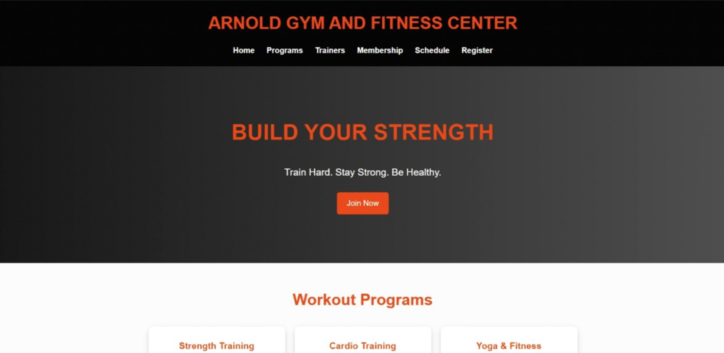

EXPERIMENT 2: BAKERY AND CAKE SHOP WEBSITE
Aim: A bakery website named SWEET MOMENTS. It displays cakes, pastries, cookies, custom cake designs, seasonal offers and contact information.

Source Code
<!DOCTYPE html>
<html lang="en">
<head>
<meta charset="UTF-8">
<meta name="viewport" content="width=device-width, initial-scale=1.0">
<title>Bakery and Cake Shop</title>
<link rel="stylesheet" href="web.css">
</head>
<body>
<!-- Header -->
<header>
<h1>SWEET MOMENTS</h1>
<nav>
<a href="#home">Home</a>
<a href="#cakes">Cakes</a>
<a href="#pastries">Pastries</a>
<a href="#cookies">Cookies</a>
<a href="#offers">Offers</a>
<a href="#contact">Contact</a>
</nav>
</header>
<!-- Home Section -->
<section id="home" class="hero">
<h2>Freshly Baked Happiness</h2>
<p>Delicious Cakes, Pastries and Cookies</p>
<a href="#cakes" class="btn">Explore Products</a>
</section>
<!-- Cakes Section -->
<section id="cakes">
<h2>Our Delicious Cakes</h2>
<div class="container">
<div class="card">
<img src="https://images.unsplash.com/photo-1578985545062-69928b1d9587?w=500" alt="Chocolate Cake">
<h3>Chocolate Cake</h3>
<p>Rich and delicious chocolate cake.</p>
<h4>₹600</h4>
</div>
<div class="card">
<img src="https://images.unsplash.com/photo-1565958011703-44f9829ba187?w=500" alt="Strawberry Cake">
<h3>Strawberry Cake</h3>
<p>Fresh strawberry cream cake.</p>
<h4>₹750</h4>
</div>
<div class="card">
<img src="https://images.unsplash.com/photo-1571115177098-24ec42ed204d?w=500" alt="Cream Cake">
<h3>Vanilla Cake</h3>
<p>Soft and creamy vanilla cake.</p>
<h4>₹550</h4>
</div>
</div>
</section>
<!-- Pastries Section -->
<section id="pastries">
<h2>Our Pastries</h2>
<div class="container">
<div class="card">
<img src="https://images.unsplash.com/photo-1488477181946-6428a0291777?w=500" alt="Cream Pastry">
<h3>Cream Pastry</h3>
<p>Fresh and soft cream pastry.</p>
<h4>₹80</h4>
</div>
<div class="card">
<img src="https://images.unsplash.com/photo-1509440159596-0249088772ff?w=500" alt="Bakery Bread">
<h3>Fresh Pastry</h3>
<p>Delicious freshly baked treat.</p>
<h4>₹100</h4>
</div>
</div>
</section>
<!-- Cookies Section -->
<section id="cookies">
<h2>Our Cookies</h2>
<div class="container">
<div class="card">
<img src="https://images.unsplash.com/photo-1499636136210-6f4ee915583e?w=500" alt="Chocolate Cookies">
<h3>Chocolate Cookies</h3>
<p>Crunchy chocolate cookies.</p>
<h4>₹120</h4>
</div>
<div class="card">
<img src="https://images.unsplash.com/photo-1558961363-fa8fdf82db35?w=500" alt="Butter Cookies">
<h3>Butter Cookies</h3>
<p>Fresh and tasty butter cookies.</p>
<h4>₹100</h4>
</div>
</div>
</section>
<!-- Custom Cake Designs -->
<section id="custom">
<h2>Custom Cake Designs</h2>
<div class="container">
<div class="card"><h3>Birthday Cakes</h3><p>Beautiful cakes for birthday celebrations.</p></div>
<div class="card"><h3>Wedding Cakes</h3><p>Special cakes for wedding occasions.</p></div>
<div class="card"><h3>Theme Cakes</h3><p>Customized cakes with creative designs.</p></div>
</div>
</section>
<!-- Seasonal Offers -->
<section id="offers">
<h2>Special Seasonal Offers</h2>
<div class="container">
<div class="card offer"><h3>Festival Special</h3><p>Get 20% discount on selected cakes.</p></div>
<div class="card offer"><h3>Birthday Special</h3><p>Get special offers on birthday cakes.</p></div>
<div class="card offer"><h3>Cookie Combo</h3><p>Buy 2 cookie packs and get a discount.</p></div>
</div>
</section>
<!-- Contact Section -->
<section id="contact">
<h2>Contact Us</h2>
<div class="contact">
<p><b>Bakery Name:</b> Sweet Bakery</p>
<p><b>Address:</b> Main Road, Vijayawada</p>
<p><b>Phone:</b> 9876543210</p>
<p><b>Email:</b> sweetbakery@gmail.com</p>
<p><b>Opening Hours:</b> 9 AM - 9 PM</p>
</div>
</section>
<!-- Footer -->
<footer><p>&copy; 2026 SWEET MOMENTS. All Rights Reserved.</p></footer>
</body>
</html>

CSS Code
/* General Styling */
* { margin: 0; padding: 0; box-sizing: border-box; }
body {
font-family: Arial, sans-serif;
background-color: #fff8f0;
color: #442c2e;
line-height: 1.6;
}
/* Header */
header {
background-color: #6f3028;
color: white;
padding: 20px;
text-align: center;
}
header h1 { font-size: 35px; color: #ffd6a5; }
nav { margin-top: 15px; }
nav a {
color: white;
text-decoration: none;
margin: 10px;
font-weight: bold;
transition: color 0.3s;
}
nav a:hover { color: #ffd6a5; }
/* Hero Section */
.hero {
background: linear-gradient(to right, #8d493a, #d69b78);
color: white;
text-align: center;
padding: 100px 20px;
}
.hero h2 { font-size: 42px; font-weight: bold; }
.hero p { font-size: 20px; margin: 15px 0; }
/* Buttons */
.btn {
display: inline-block;
background-color: #f4a261;
color: #442c2e;
padding: 12px 25px;
text-decoration: none;
border-radius: 5px;
margin-top: 10px;
transition: background-color 0.3s, transform 0.3s;
}
.btn:hover { background-color: #ffd6a5; transform: scale(1.05); }
/* Sections */
section { padding: 50px 20px; text-align: center; }
section h2 { color: #8d493a; font-size: 32px; margin-bottom: 30px; }
/* Product Container */
.container {
display: flex;
justify-content: center;
flex-wrap: wrap;
gap: 20px;
}
/* Product Cards */
.card {
background-color: white;
width: 280px;
padding: 20px;
border-radius: 12px;
box-shadow: 0 4px 10px #ddd;
transition: transform 0.3s, box-shadow 0.3s;
}
.card:hover { transform: translateY(-8px); box-shadow: 0 8px 18px #bbb; }
.card img { width: 100%; height: 180px; object-fit: cover; border-radius: 8px; }
.card h3 { color: #8d493a; margin: 10px 0; }
.card h4 { color: #d2691e; font-size: 20px; margin-top: 10px; }
/* Seasonal Offers */
.offer { background-color: #ffe0b2; }
/* Contact Section */
.contact {
background-color: white;
max-width: 600px;
margin: auto;
padding: 25px;
border-radius: 10px;
box-shadow: 0 4px 10px #ddd;
text-align: left;
}
.contact p { padding: 8px; }
/* Footer */
footer {
background-color: #6f3028;
color: white;
text-align: center;
padding: 20px;
}
/* Responsive Design */
@media (max-width: 600px) {
header h1 { font-size: 28px; }
nav a { display: inline-block; margin: 5px; }
.hero h2 { font-size: 30px; }
.container { flex-direction: column; align-items: center; }
.card { width: 100%; max-width: 350px; }
.contact { width: 100%; }
}
OUTPUT
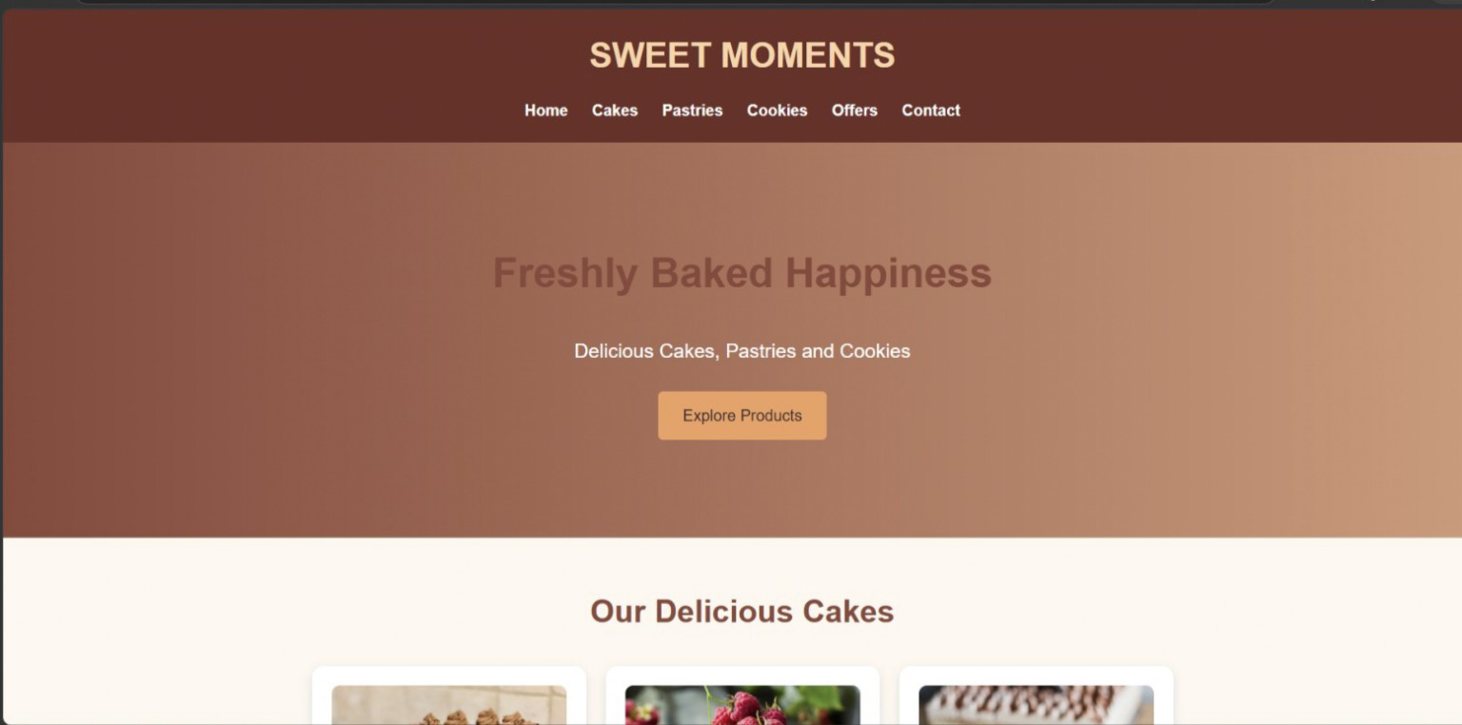

EXPERIMENT 3: TOURISM AND HERITAGE WEBSITE
Aim: A tourism website named INCREDIBLE INDIA. It presents historical monuments, destinations, cultural festivals, Indian cuisine, travel tips and contact information.

Source Code
<!DOCTYPE html>
<html lang="en">
<head>
<meta charset="UTF-8">
<meta name="viewport" content="width=device-width, initial-scale=1.0">
<title>Tourism and Heritage Website</title>
<link rel="stylesheet" href="style.css">
</head>
<body>
<!-- Header -->
<header>
<h1>INCREDIBLE INDIA</h1>
<nav>
<a href="#home">Home</a>
<a href="#monuments">Monuments</a>
<a href="#destinations">Destinations</a>
<a href="#festivals">Festivals</a>
<a href="#cuisine">Cuisine</a>
<a href="#tips">Travel Tips</a>
<a href="#contact">Contact</a>
</nav>
</header>
<!-- Home Section -->
<section id="home" class="hero">
<h2>Explore the Beauty of India</h2>
<p>Discover Historical Places, Culture and Traditions</p>
<a href="#destinations" class="btn">Explore Now</a>
</section>
<!-- Historical Monuments -->
<section id="monuments">
<h2>Historical Monuments</h2>
<div class="container">
<div class="card">
<img src="https://images.unsplash.com/photo-1564507592333-c60657eea523?w=500" alt="Taj Mahal">
<h3>Taj Mahal</h3>
<p>Located in Agra, famous for its beautiful architecture.</p>
</div>
<div class="card">
<img src="https://images.unsplash.com/photo-1598434192043-71111c1b3f41?w=500" alt="Red Fort">
<h3>Red Fort</h3>
<p>A famous historical monument in Delhi.</p>
</div>
<div class="card">
<img src="https://images.unsplash.com/photo-1606293926075-69a00dbfde81?w=500" alt="Hawa Mahal">
<h3>Hawa Mahal</h3>
<p>A beautiful palace located in Jaipur.</p>
</div>
</div>
</section>
<!-- Famous Destinations -->
<section id="destinations">
<h2>Famous Destinations</h2>
<div class="container">
<div class="card">
<img src="https://images.unsplash.com/photo-1512343879784-a960bf40e7f2?w=500" alt="Goa">
<h3>Goa</h3>
<p>Famous for beaches and beautiful scenery.</p>
</div>
<div class="card">
<img src="https://images.unsplash.com/photo-1602216056096-3b40cc0c9944?w=500" alt="Kerala">
<h3>Kerala</h3>
<p>Known for backwaters and green landscapes.</p>
</div>
<div class="card">
<img src="https://images.unsplash.com/photo-1599661046827-dacff0c0f09a?w=500" alt="Jaipur">
<h3>Jaipur</h3>
<p>Known for palaces and cultural heritage.</p>
</div>
</div>
</section>
<!-- Cultural Festivals -->
<section id="festivals">
<h2>Cultural Festivals</h2>
<div class="container">
<div class="card"><h3>Diwali</h3><p>The festival of lights celebrated across India.</p></div>
<div class="card"><h3>Holi</h3><p>The festival of colors celebrated with joy.</p></div>
<div class="card"><h3>Pongal</h3><p>A traditional harvest festival of Tamil Nadu.</p></div>
</div>
</section>
<!-- Local Cuisine -->
<section id="cuisine">
<h2>Famous Indian Cuisine</h2>
<div class="container">
<div class="card">
<img src="https://images.unsplash.com/photo-1589302168068-964664d93dc0?w=500" alt="Biryani">
<h3>Biryani</h3>
<p>A popular rice dish with rich spices.</p>
</div>
<div class="card">
<img src="https://images.unsplash.com/photo-1630383249896-424e482df921?w=500" alt="Dosa">
<h3>Dosa</h3>
<p>A traditional South Indian food.</p>
</div>
<div class="card">
<img src="https://images.unsplash.com/photo-1601050690597-df0568f70950?w=500" alt="Samosa">
<h3>Samosa</h3>
<p>A popular crispy Indian snack.</p>
</div>
</div>
</section>
<!-- Travel Tips -->
<section id="tips">
<h2>Travel Tips</h2>
<div class="container">
<div class="card"><h3>Plan Your Trip</h3><p>Prepare your travel schedule before starting.</p></div>
<div class="card"><h3>Carry Essentials</h3><p>Carry water, medicines and important documents.</p></div>
<div class="card"><h3>Respect Culture</h3><p>Respect local traditions and cultural values.</p></div>
</div>
</section>
<!-- Contact Section -->
<section id="contact">
<h2>Contact Us</h2>
<div class="contact">
<p><b>Website:</b> Incredible India Tourism</p>
<p><b>Address:</b> New Delhi, India</p>
<p><b>Email:</b> tourism@gmail.com</p>
<p><b>Phone:</b> 9876543210</p>
</div>
</section>
<!-- Footer -->
<footer><p>&copy; 2026 INCREDIBLE INDIA. All Rights Reserved.</p></footer>
</body>
</html>

CSS Code
/* General Styling */
* { margin: 0; padding: 0; box-sizing: border-box; }
body {
font-family: Arial, sans-serif;
background-color: #fff8ed;
color: #333;
line-height: 1.6;
}
/* Header */
header {
background-color: #704214;
color: white;
padding: 20px;
text-align: center;
}
header h1 { color: #ffd166; font-size: 35px; font-weight: bold; }
nav { margin-top: 15px; }
nav a {
color: white;
text-decoration: none;
margin: 10px;
font-weight: bold;
transition: color 0.3s;
}
nav a:hover { color: #ffd166; }
/* Hero Section */
.hero {
background: linear-gradient(to right, #8b5e34, #d4a373);
color: white;
text-align: center;
padding: 100px 20px;
}
.hero h2 { font-size: 42px; font-weight: bold; }
.hero p { font-size: 20px; margin: 15px 0; }
/* Buttons */
.btn {
display: inline-block;
background-color: #ffb703;
color: #333;
padding: 12px 25px;
text-decoration: none;
border-radius: 5px;
margin-top: 10px;
transition: background-color 0.3s, transform 0.3s;
}
.btn:hover { background-color: #fb8500; transform: scale(1.05); }
/* Sections */
section { padding: 50px 20px; text-align: center; }
section h2 { color: #704214; font-size: 32px; margin-bottom: 30px; }
/* Cards Container */
.container {
display: flex;
justify-content: center;
flex-wrap: wrap;
gap: 20px;
}
/* Cards */
.card {
background-color: white;
width: 280px;
padding: 20px;
border-radius: 12px;
box-shadow: 0 4px 10px #ddd;
transition: transform 0.3s, box-shadow 0.3s;
}
.card:hover { transform: translateY(-8px); box-shadow: 0 8px 18px #aaa; }
.card img { width: 100%; height: 180px; object-fit: cover; border-radius: 8px; }
.card h3 { color: #a0522d; margin: 10px 0; }
/* Contact Section */
.contact {
background-color: white;
max-width: 600px;
margin: auto;
padding: 25px;
border-radius: 10px;
box-shadow: 0 4px 10px #ddd;
text-align: left;
}
.contact p { padding: 8px; }
/* Footer */
footer {
background-color: #704214;
color: white;
text-align: center;
padding: 20px;
}
/* Responsive Design */
@media (max-width: 600px) {
header h1 { font-size: 28px; }
nav a { display: inline-block; margin: 5px; }
.hero h2 { font-size: 30px; }
.container { flex-direction: column; align-items: center; }
.card { width: 100%; max-width: 350px; }
.contact { width: 100%; }
}
OUTPUT
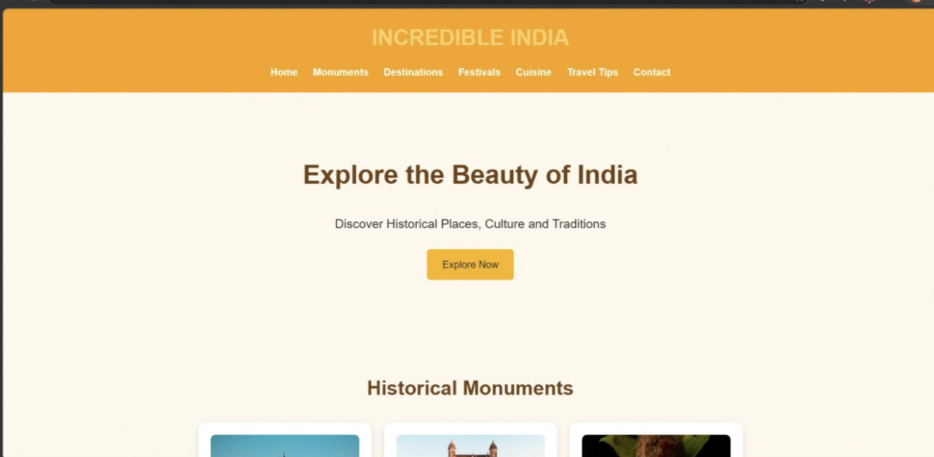

OVERALL CONCLUSION
These three web development projects demonstrate the use of HTML and CSS to create structured, attractive and responsive websites. The Fitness Center website presents gym programs and membership details, the Bakery website displays food products and special offers, and the Tourism website highlights Indian heritage and travel destinations. HTML is used to organize the content, while CSS is used for colors, layouts, cards, buttons, tables, hover effects and responsive design. Together, these projects provide practical experience in basic front-end web development.

