**Name: Paarth Sharma Roll no: 102103505 Group: 2CO29**

**Name:** Paarth Sharma **Roll no:** 102103505 **Group:** 2CO29



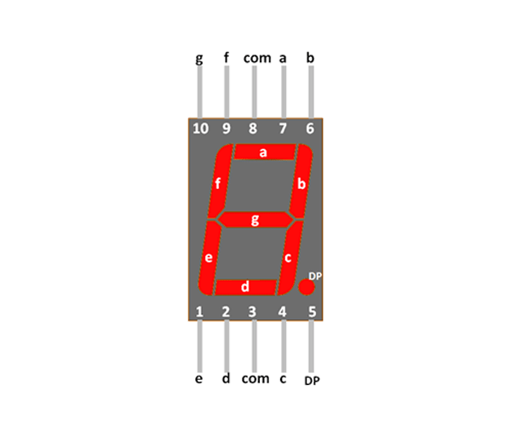**Assignment Tasks:**

* **Use Tinkercad to redesign Exercise 2 and display the last digit of your Roll Number on the 7-segment display.**

**Fig1(a):** Figure representing the circuit to display the last digit (8) on 7-segment display

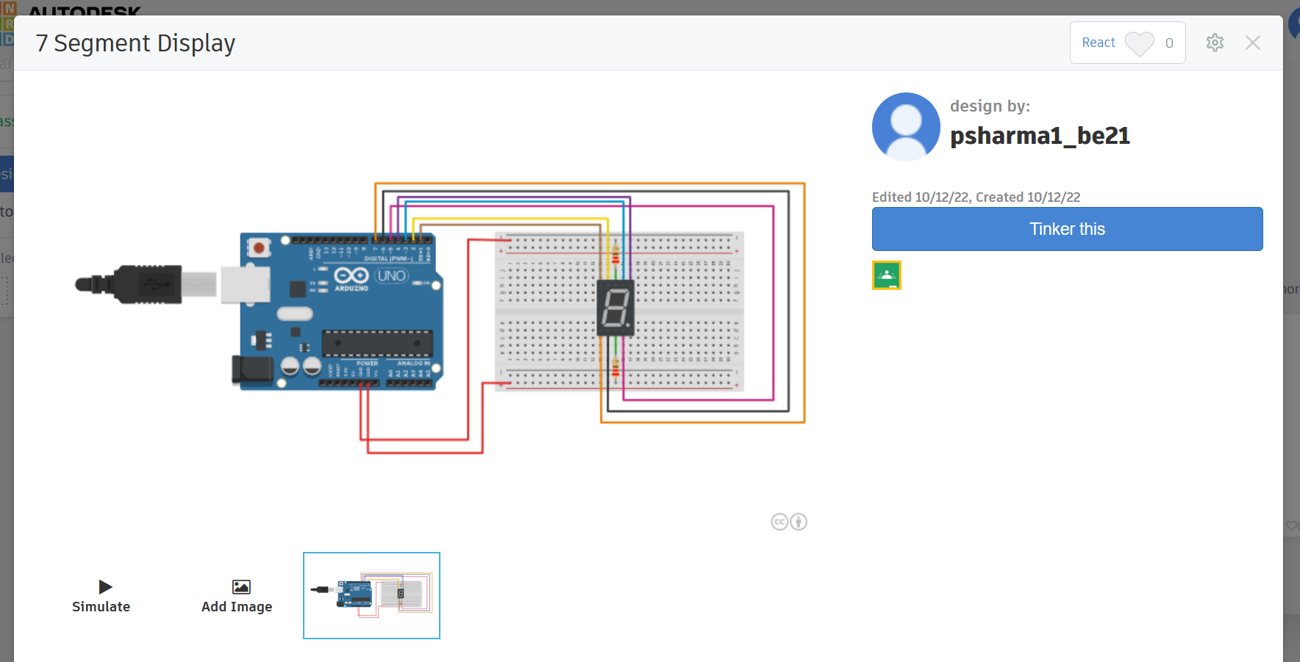

**Fig1(b):** Figure representing the working simulation of the 7-segment display

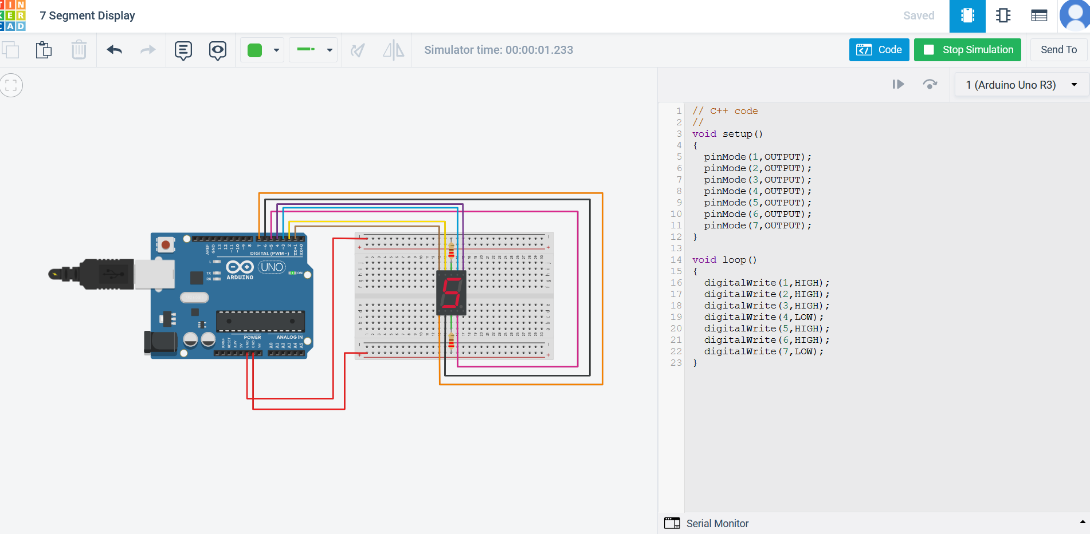

* **Using Tinkercad, write an Arduino sketch to make an up counter which counts from 0 to 9 & repeat it infinitely using Tinkercad**

**Fig 2(a):** Figure representing the Circuit for the up counter to count digits from 0 to 9

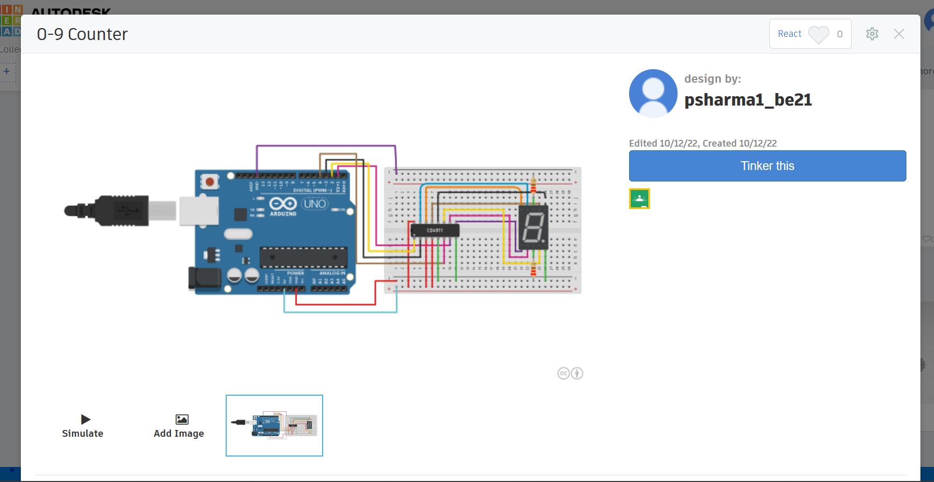

**Fig 2(b):** Figure representing the working simulation of the up counter.

