

# ASSIGNMENT – 2 (A)STUDY OF ICs

**Exercise 2A– Study of ICs**

To verify the function tables of CD4027 and CD4081 ICs.

## Hardware Required

* Breadboard
* CD 4027 and CD 4081
* Single core connecting wires

## Theory

The data sheet of CD4027 and CD4081 is given below.

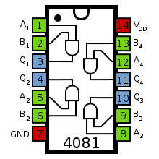

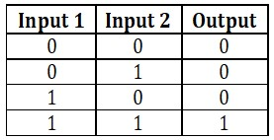

**(a) (b)**

Figure 1: Datasheet of CD4081 IC (a) pin diagram (b) functional truth table

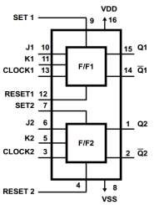

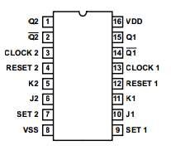 **(a)**

**(b)**

Figure 2: CD4027 IC (a) pin diagram (b) Internal architecture

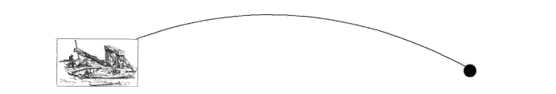 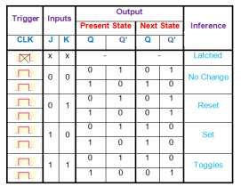

**Schematic:**

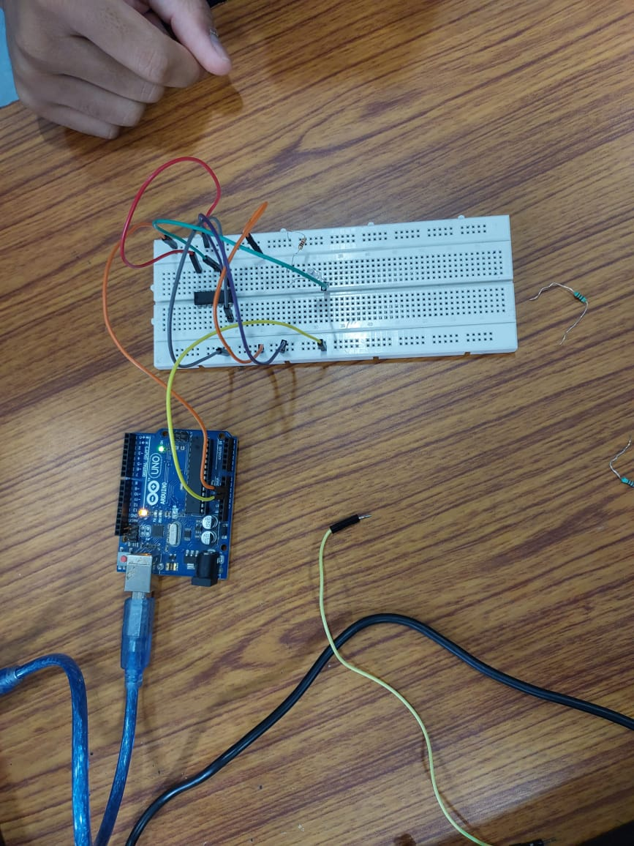 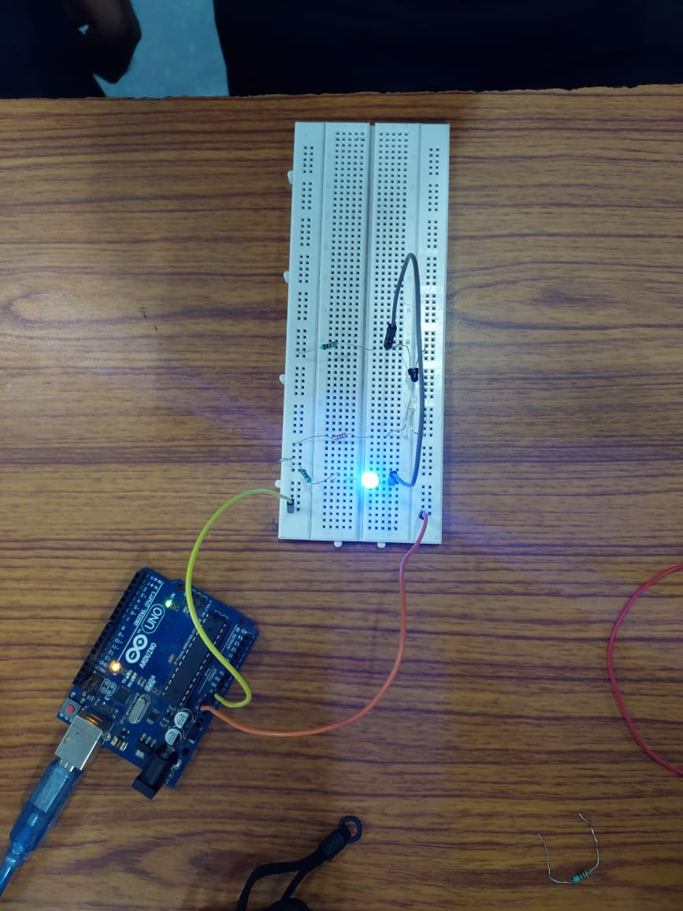

**Reflections (Conclusions):**



# ASSIGNMENT – 2 (A)STUDY OF IR SENSORS

## Exercise 2B– IR Sensor

1. Demonstrate the working of IR sensors and receiverand display output using LED.
2. Use the two pair IR sensors of Mangonel to combine the two sensors output into one signal.

## Hardware

* Bread Board, Power supply
* Resistances and LED
* IR transmitter and Receiver (Photodiode), Single core connecting wires

## Theory

The figure below shows an IR pair in which IR LED emits infrared light which is received by photo diode D1 and the output voltage across resistor R1 is high. When we block the flow of light then the output voltage becomes low.

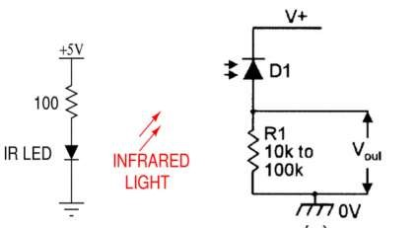

**Reflections (Conclusions):**



**Assignment Tasks:**

***Note: Each student must attach separate sheet for submitting the below mentioned Assignment Task A.***

A. Using Tinkercad, Illustrate the pin configuration and verify the truth table of IC 74HC08 and IC 74H73