**Name: Paarth Sharma Roll no: 102103505 Group: 2CO29**



1. **Obtain the required signal for Arduino shown in figure 2 using at least two different logic gates (explain using waveforms).**

**Assignment Tasks:**

1. **Using Tinkercad, design the following sensor based micro-projects to:**
2. Detect the motion of an object.

**Fig1(a):** Figure representing the circuit to detect the motion of an object

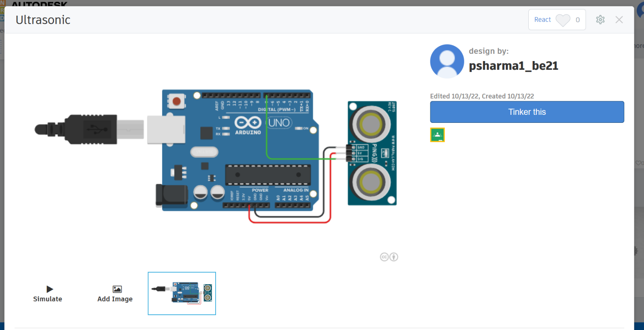

**Fig1(b):** Figure representing the working of circuit to detect the motion of an object

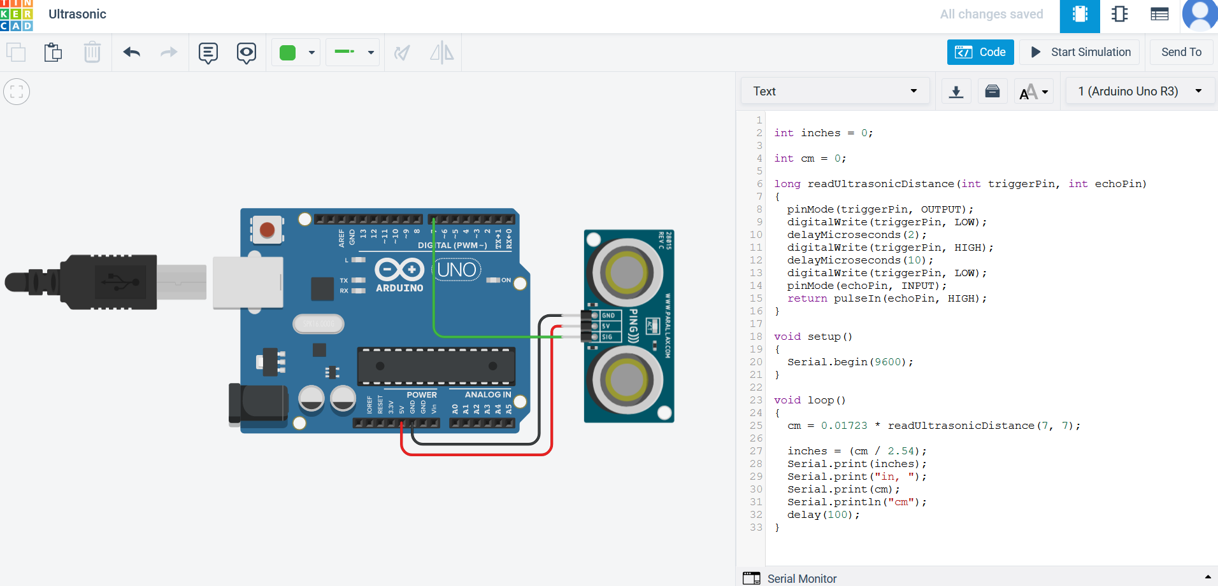

1. Measure the distance between an object and the sensor itself**.**

**Fig 2(a):** Circuit to measure distance between object and the sensor itself

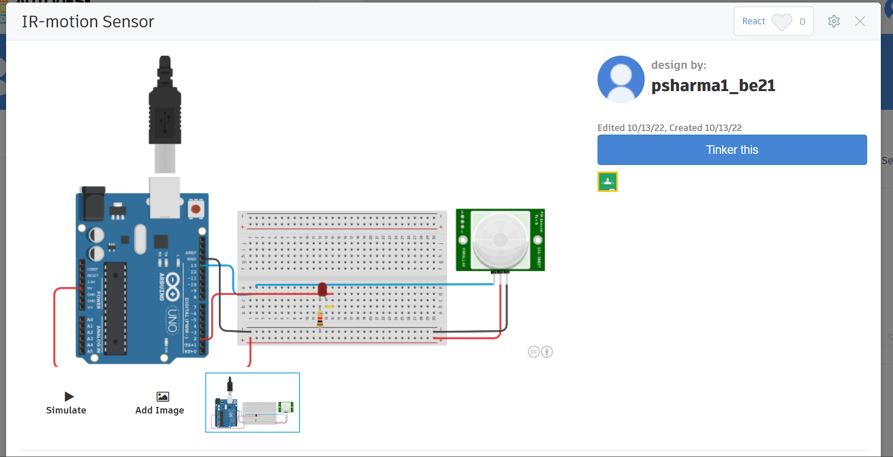

**Fig 2(b):** Figure representing the working of circuit to measure distance between object and the sensor itself

