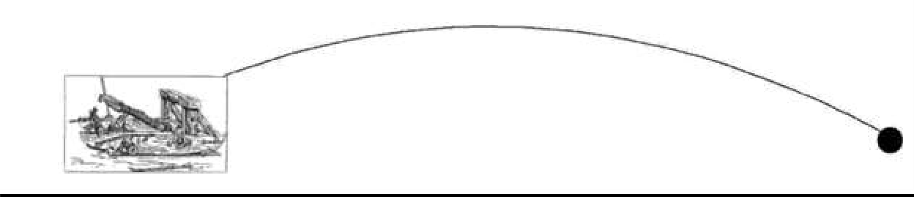





## Exercise 1 (C) – Tinkercad

Tinkercad is a free, online collection of software tools for 3D design, electronics, and coding

## Software Required

* Tinkercad Software tool (<https://www.tinkercad.com/>)

## Getting Started:

* 1. Visit <https://www.tinkercad.com/>
  2. Sign in through your google account (Thapar Email ID only)
  3. On the Dashboard, select **Circuits** from the drop box and click on **Create new Circuit**



***Fig :*** *Tinkercad Account Profile Page*

# Assignment Tasks:

1. Using Tinkercad, hook up 5 LEDs to pins 2 through 6 (with resistors). Modify the code toturn on each one in order and then extinguish them in order.

(HINT: hook them up one additional LED at a time and make sure the new one works before youadd the next one.)

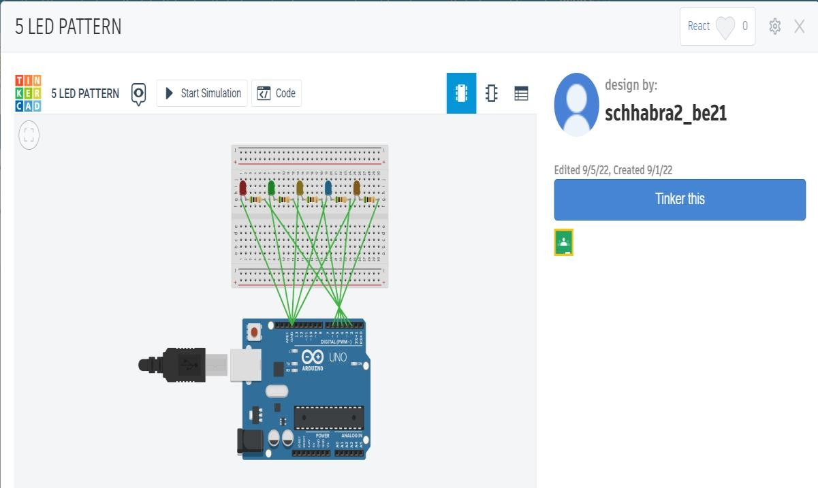

**Fig 1(a):** Figure representing the circuit for 5 LED connections from pin 2 to 6 of Arduino

**CODE:**

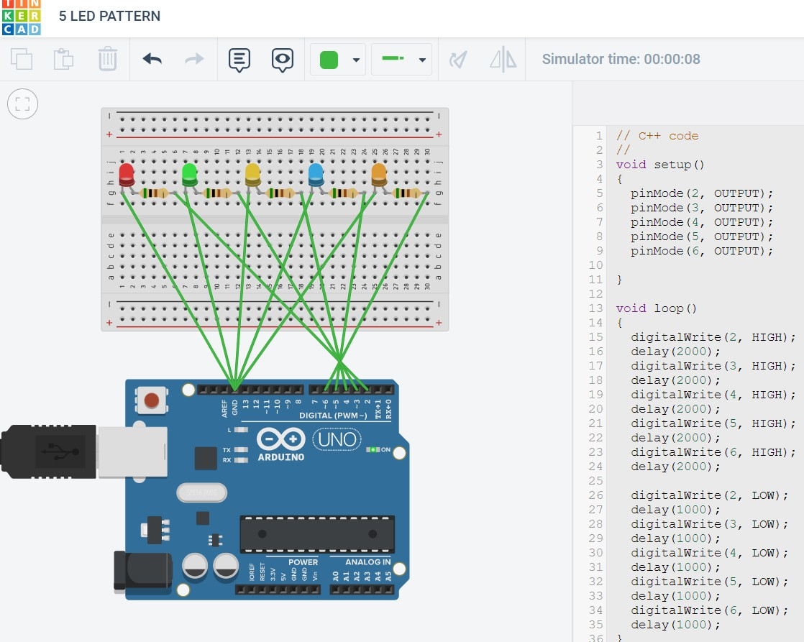

**Fig 1(b):** Figure representing the working simulation of 5 LED circuit with code

1. With the help of Tinkercad, use push buttons to simulate the behaviour of listed logicgates (Without using ICs of logic gates)
   1. Logic gates: AND, NAND, XOR for students with odd numbered Roll Number.

**MAIN CIRCUIT:**

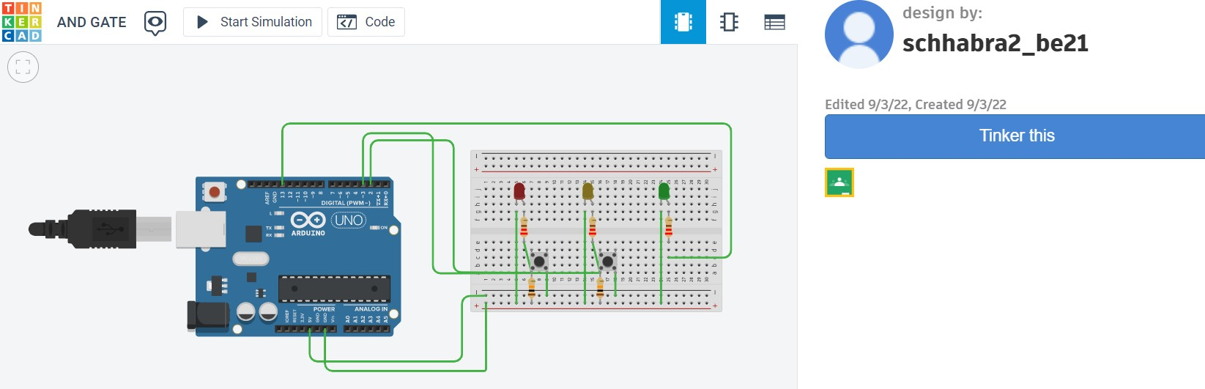

# AND GATE:

**Fig 2(a):** Figure representing the Basic Circuit for different gates

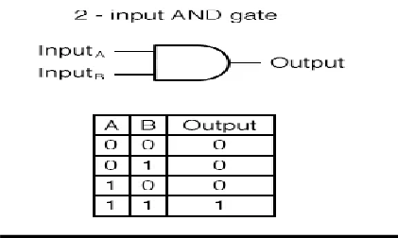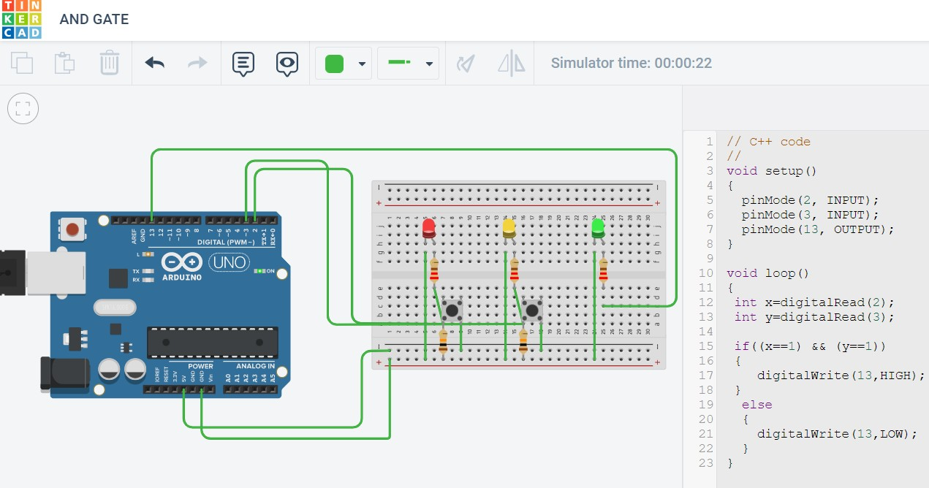

**Fig 2(b):** Figure representing working simulation of AND gate, case **(1|1)** with code.

# NAND GATE:

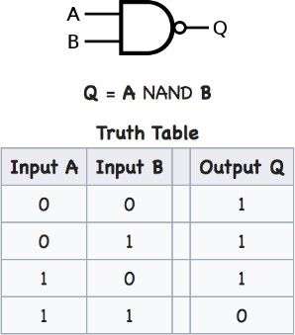

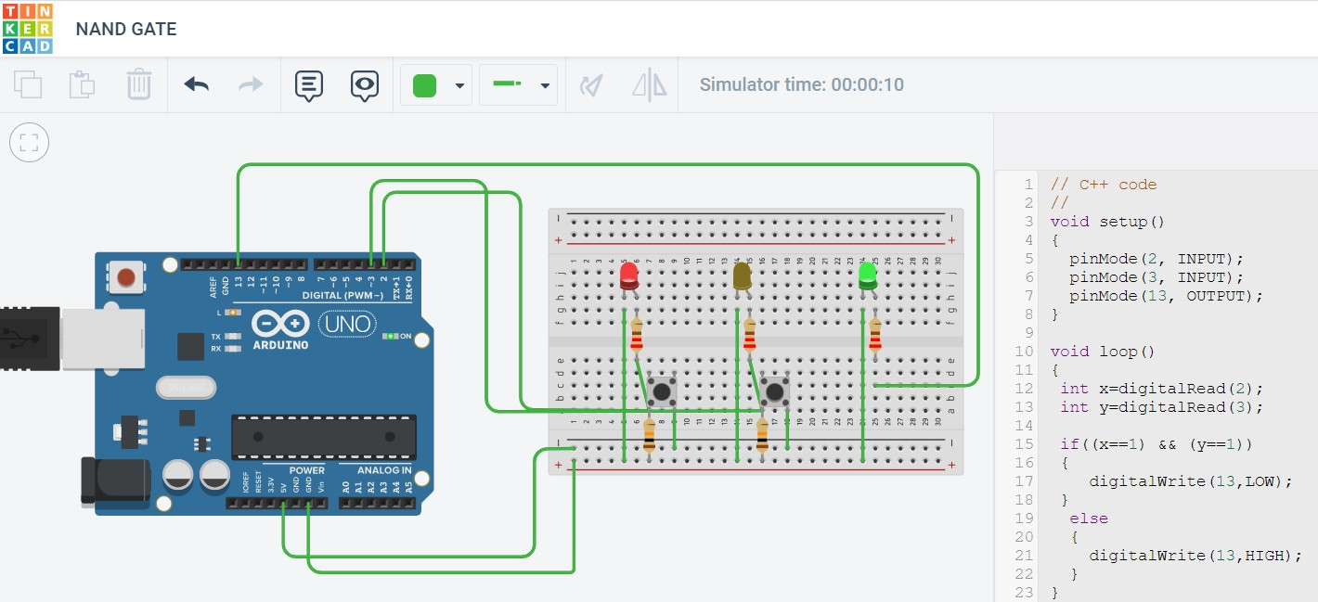

**Fig 2(c):** Figure representing working simulation of NAND gate, case **(1|0)** with code.

# XOR GATE:

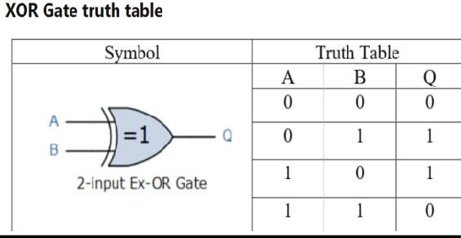

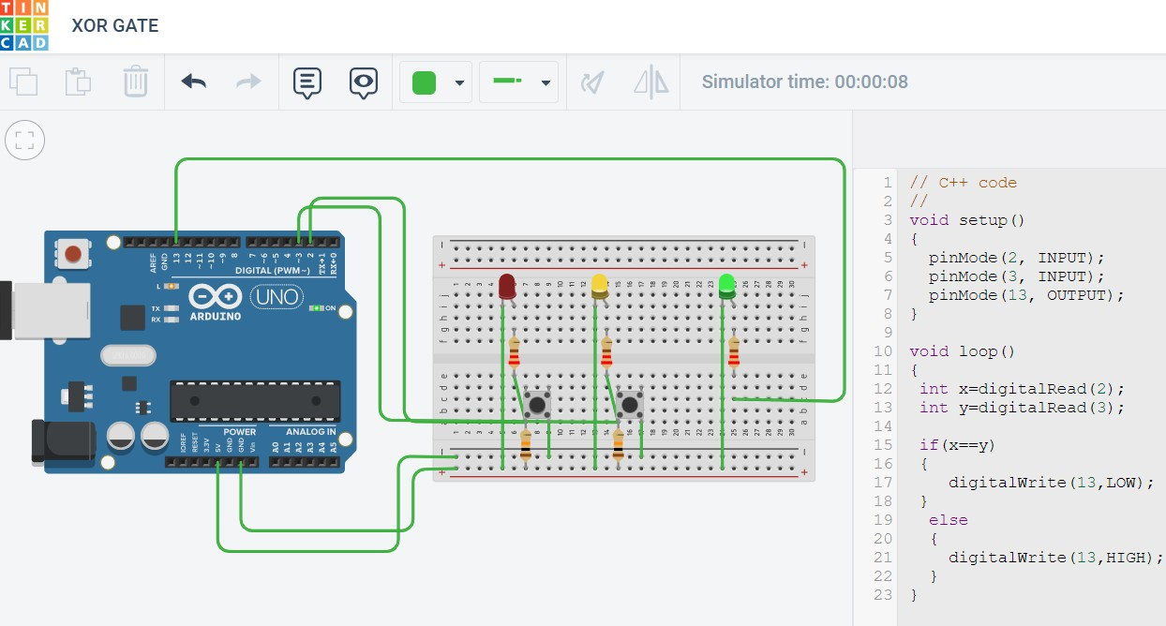

**Fig 2(d):** Figure representing working simulation of XOR gate, case **(0|1)** with code.