Hospital E-Procurement
System Overview
A one-look guide to how vendors, hospital staff, and the system itself work together. For full technical detail (data model, API functions per module), see IMPLEMENTATION-SPEC.md.

The Big Picture
Nine steps, start to finish. Every box is color-coded by who's acting — vendor, hospital staff, or the system itself — and the two dashed red loops are the spec's rejection/rework cycles: a rejection doesn't end the process, it just creates a new numbered round.

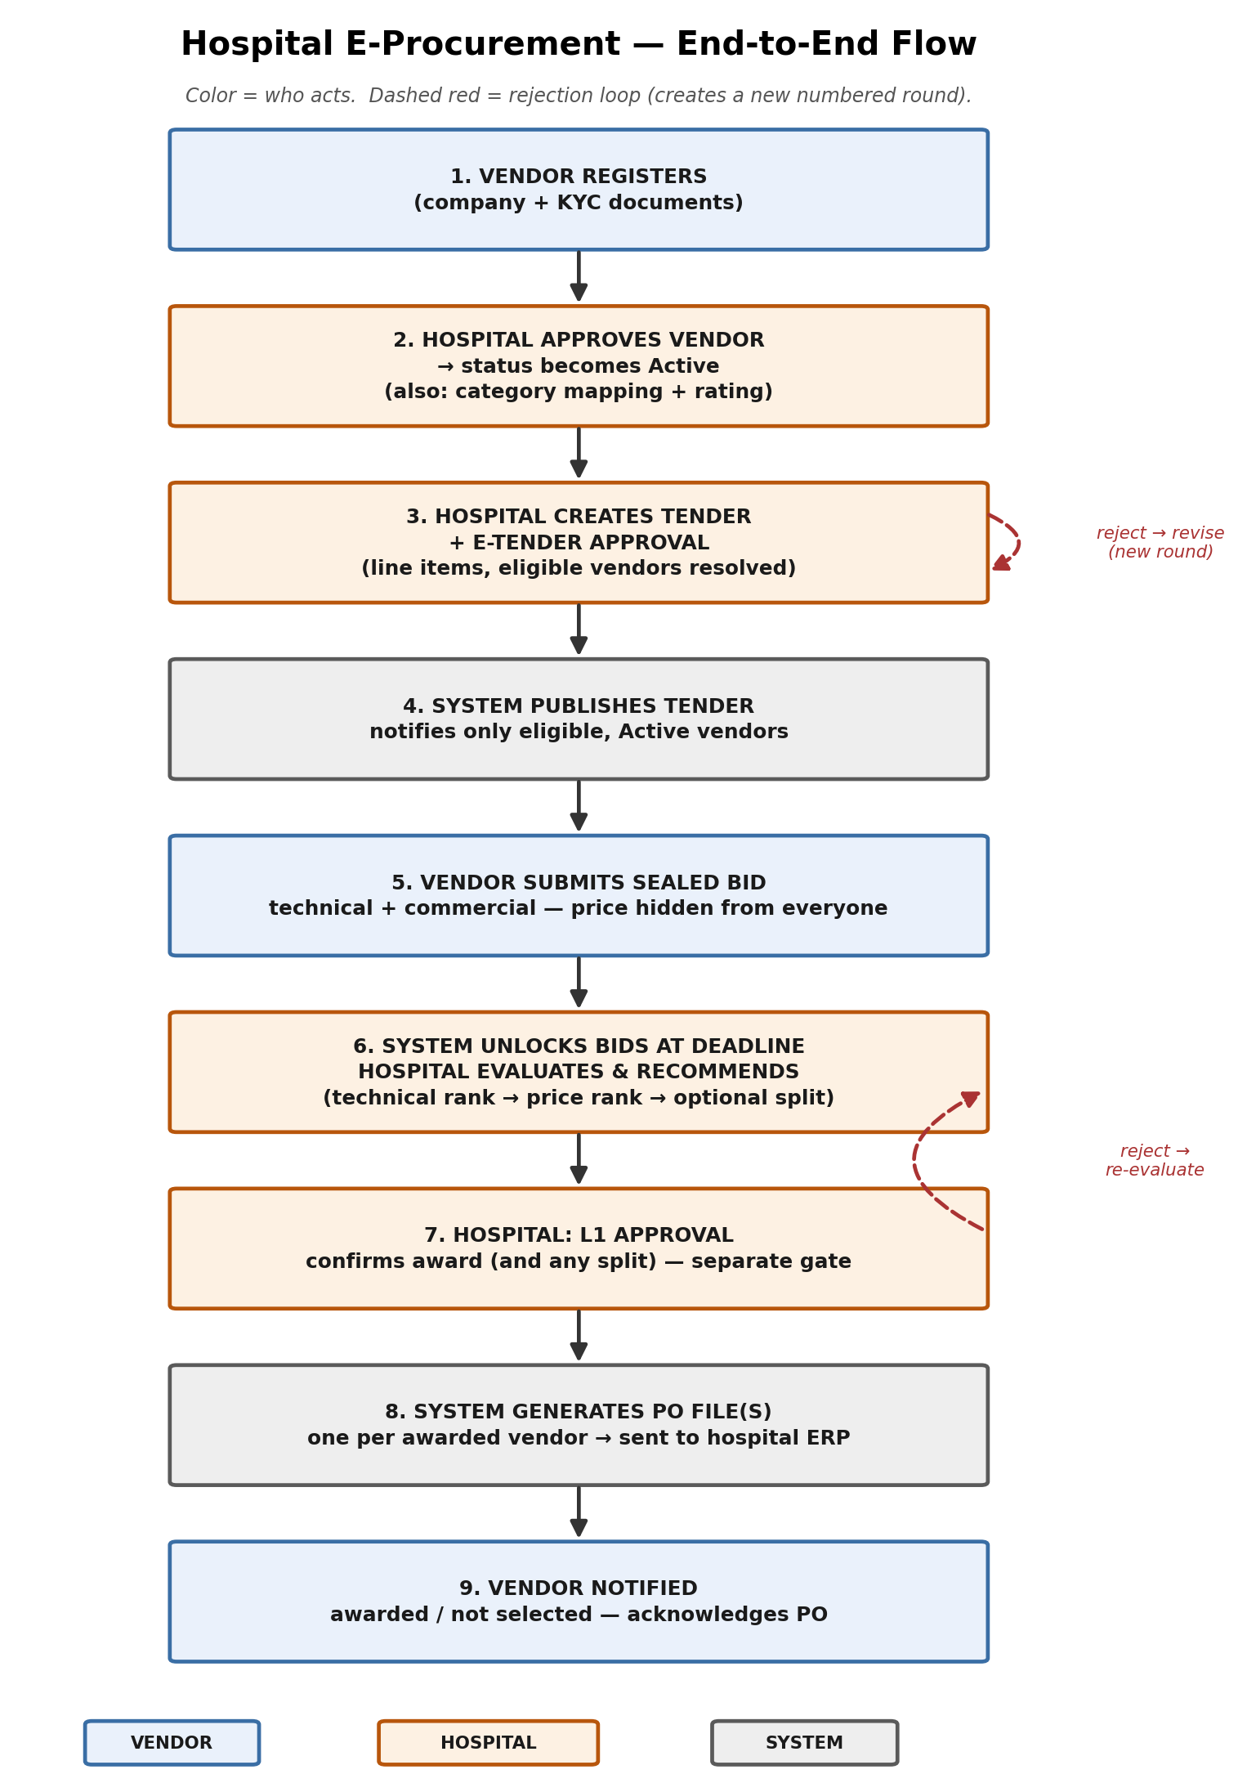

Three Modules
The system is organized around who's acting, not around the lifecycle stage — this maps directly to how the codebase should be split.
1. VENDOR
- Registers the company and uploads KYC/statutory documents — same form whether they came in through a normal signup or an Open Tender link.
- Hard rule: Cannot view or bid on anything until Hospital approves them as Active. No exceptions — not for guest invites, not for Open Tenders.
- Requests mapping to item/asset/service categories.
- Sees only the tenders — and only the specific line items — they're eligible for.
- Submits a sealed bid (technical details + price) per line item; price stays hidden from literally everyone, including hospital staff, until the deadline passes.
- Gets notified of award or regret, and acknowledges the resulting purchase order.

2. HOSPITAL
- Five internal roles: Procurement Officer, Procurement Admin, Category Manager, Approving Authority, System Admin — each with a distinct slice of permissions.
- Approves vendor registrations and category mappings.
- Creates tenders (draft) — but a tender can never publish itself. It has to pass a separate, explicit approval gate first.
- Evaluates bids technically, then commercially, and recommends an award — which is still just a recommendation, not the award itself.
- A second, separate approval (by an authority resolved from the deal's value — bigger deals need higher sign-off) actually confirms the award and releases the PO data.
- Resolves every override/exception request (see below) through one shared queue.

3. SYSTEM
- Nobody clicks a button for these — they just run.
- Works out which vendors are actually eligible for a given tender line (active + mapped + rated high enough + not suspended).
- Computes the one auto-calculated part of a vendor's rating (price competitiveness, from this system's own bid history) — everything else is entered by hand by Procurement Admin.
- Ranks bids — technical score first, then price, with an optional combined ranking when both matter.
- Runs the shared override/exception engine, sends every notification, generates the PO data files, and writes the permanent audit trail.

Two Things Worth Understanding Well

Split-Award
Normally one line item goes to one vendor. If a line is flagged to allow it, the Procurement Officer can instead propose splitting it across two vendors by percentage — and the Approving Authority has the final say on the exact split before it's confirmed. Each vendor still gets their own, separate purchase order.
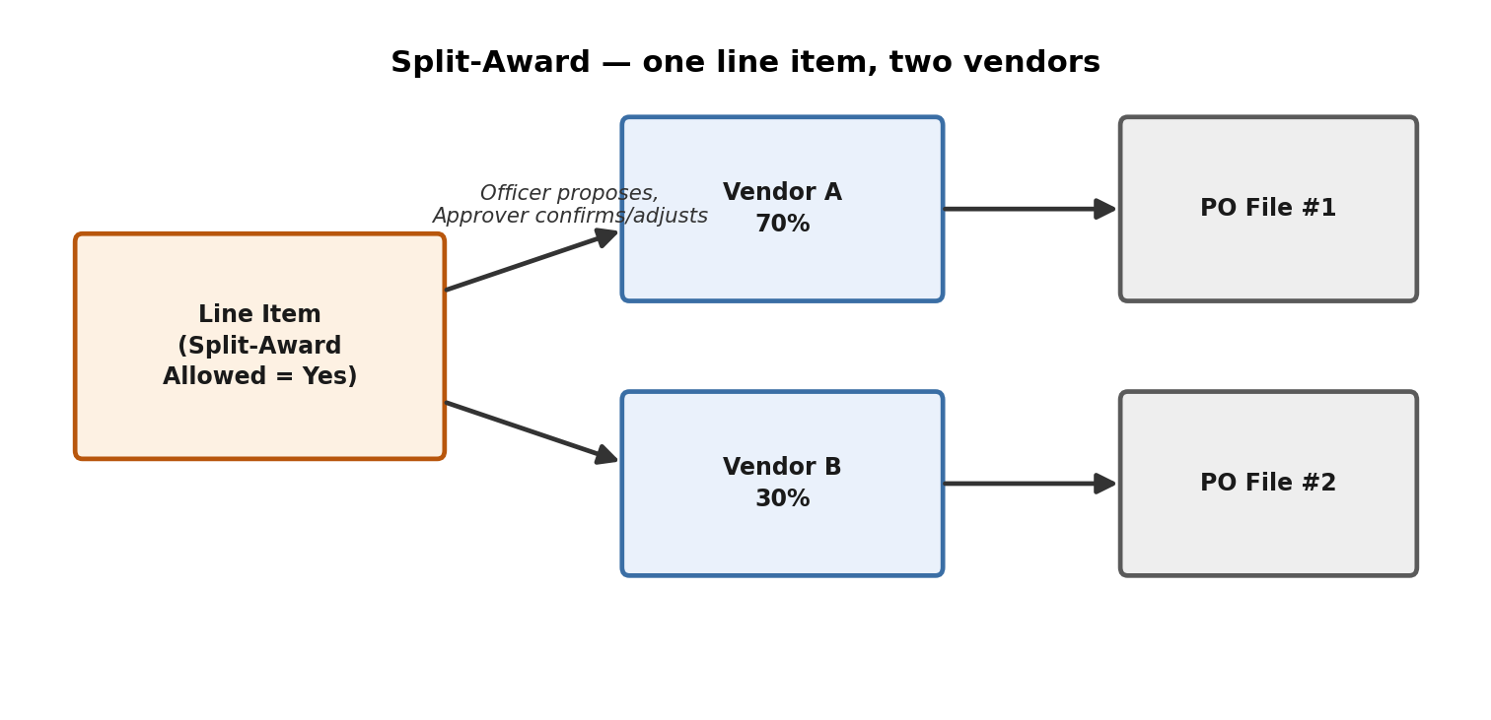

The Override Engine
Every exception in the system — adding a vendor by hand, overriding a rating, accepting a late bid, awarding someone other than the top-ranked bid, re-issuing a purchase order — runs through this exact same cycle. Nothing changes on the underlying record until it reaches Approved. This is one engine reused everywhere, not separate logic bolted on per screen.
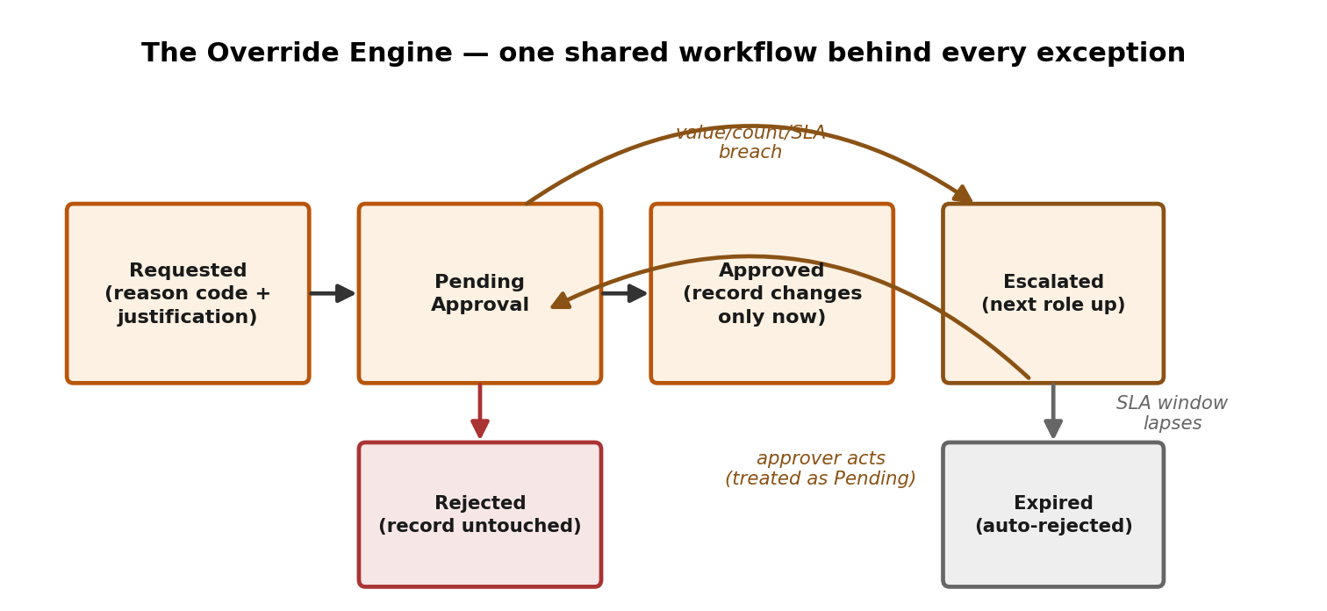

Rules Worth Remembering
- A vendor must be fully approved (Active) before they can view or bid on anything — including Open Tenders. There is no “bid now, verify later” path in this project.
- Creating a tender and approving a tender are two different people, two different steps. Same for recommending an award and approving it.
- Bid prices are invisible to everyone — including hospital staff — until the deadline passes. This is enforced by the system itself, not just hidden in the screen.
- This system's job ends at generating the purchase-order data file. Creating the actual PO, issuing it, and everything after (deliveries, invoices, payment) happens in the hospital's own ERP.
- Every approval, override, and rejection is written to a permanent audit trail — nothing here can be quietly undone.

