Explainable Preoperative Risk Prediction on the MOVER Surgical Database: Logistic Regression versus XGBoost with Calibration, Explanation Stability and External Validation
Raghav Goel  Department of CSE  Amity University  Noida, India  [email] | Bhavya Mansharamani  Department of CSE  Amity University  Noida, India  [email] | Subhash Chand Gupta  Department of CSE  Amity University  Noida, India  [email]

Prakhar Chandra  Department of CSE  Amity University  Noida, India  prakharchandra018@gmail.com | Shipra Saraswat  Department of CSE  Amity University  Noida, India  sshipra1510@gmail.com

Abstract—Gradient-boosted trees explained with Shapley additive explanations (SHAP) are increasingly proposed for preoperative risk prediction, but their advantage over logistic regression (LR), the calibration of their probabilities, the reproducibility of their explanations and their transportability are rarely examined together. We executed the leakage-controlled PreOp-XAI protocol on the MOVER EPIC database: one operation per adult patient, age, sex, ASA class and seven laboratory values collected 30 days to 24 hours before anaesthesia, a 70/15/15 patient-level split, training-only tuning, validation-only recalibration, exact interventional SHAP with ten paired bootstrap refits, 100 repeated splits and external validation of the frozen models on VitalDB. Among 37,196 patients, 314 (0.84%) died in hospital and 13,646 (36.7%) were admitted to an intensive care unit (ICU). Over 100 splits, median test AUROCs of LR and XGBoost were 0.925 and 0.927 for mortality and 0.743 and 0.745 for ICU admission, with paired differences within 0.018 in 95% of splits. Recalibrated risks were well calibrated internally, and ASA class dominated both models’ explanations, whose mortality rankings were reproducible across refits (mean Spearman 0.80 and 0.83). On 6,019 VitalDB patients, AUROCs fell to 0.671–0.687 for mortality and 0.659–0.688 for ICU admission, with marked miscalibration linked to differences in case mix and laboratory-testing patterns. Boosting offered no measurable advantage, and internal discrimination and calibration did not transfer to another health system.
Keywords—preoperative risk prediction, explainable artificial intelligence, SHAP, XGBoost, logistic regression, calibration, external validation, MOVER

Introduction
Estimating the risk of death or of a need for intensive care before anaesthesia supports consent, planning of postoperative care and allocation of critical-care beds. Machine-learning models built from routinely available electronic health record (EHR) data predict postoperative mortality [1], with areas under the receiver operating characteristic curve (AUROC) above 0.9 in large cohorts [2]–[4], and multi-outcome systems such as MySurgeryRisk extend this to major complications [5]. Gradient-boosted trees such as XGBoost [6] are usually paired with SHapley Additive exPlanations (SHAP) [7], [8] so that clinicians can see which inputs drive a prediction [9].
Four questions are often left open: whether boosting outperforms a regularised logistic regression (LR) built from the same inputs [10]; whether predicted probabilities are calibrated, since good ranking does not imply good calibration [11]; whether explanations are reproducible when the model is refitted on a slightly different sample [12], [13]; and whether a model and its explanation transfer to another hospital, where case mix and the processes that generate EHR data differ [14], [15].
This paper executes the PreOp-XAI pipeline, a fixed, leakage-controlled protocol, on the database for which it was designed, the Medical Informatics Operating Room Vitals and Events Repository (MOVER) [16], and validates the frozen models on the independent VitalDB cohort [17]. The contributions are: (i) a paired comparison of LR and XGBoost for in-hospital mortality and ICU admission covering discrimination, calibration and fixed-threshold performance over 100 repeated splits; (ii) exact interventional SHAP values for both model families with a paired-refit analysis of explanation stability; (iii) external validation of the frozen models, recalibration and thresholds in another country’s health system; and (iv) an execution in which patient-level data never left the data holder’s computer.

Related Work
Lee et al. predicted in-hospital mortality with a deep neural network from features available at the end of surgery [1], and Hill et al. reached an AUROC of 0.932 in 53,097 patients with an automated model on readily extractable preoperative EHR data [2]. In a four-centre study of 454,404 adults, XGBoost models with 12–18 preoperative variables reached AUROCs of up to 0.942 internally and 0.941 externally for 30-day mortality and were explained with SHAP [3]. Hadaya et al. found similar discrimination for boosting and LR in predicting respiratory failure after emergency surgery [18].
The apparent advantage of machine learning over LR largely disappears in comparisons at low risk of bias [10]. Riley and Collins showed that models developed on small samples are unstable across bootstrap refits [12], sample size should be planned from the number of events [19], and Nogueira et al. formalised stability measures for selected feature sets [13]. Calibration should be assessed with intercepts and slopes, not only discrimination [11], [20], [21], and external validation results depend on how related the validation sample is to the development sample [14]. In EHR data, whether and when a test is ordered carries information about the patient [15], [22], and reporting should follow TRIPOD+AI [23].

Data and Methods

Development Cohort and Outcomes
MOVER contains EHR and monitoring data from the University of California, Irvine Medical Center [16]; under the data use agreement we used its EPIC EHR tables, whose patient-information table lists 39,685 patients and 64,354 operations. After removing 1,367 exact duplicate rows, operations were eligible if their identifier was not in conflict (14 excluded), the patient was an adult (34), the ASA class was valid and not VI (41), and anaesthesia end followed its start (7,317). The first eligible operation of each patient was indexed (38,194 patients). The primary endpoint, in-hospital death, was defined from the discharge disposition (expired or coroner); transfers to another acute hospital, hospice and missing dispositions were labelled unknown, not survival, as were stays whose admission and discharge did not span the anaesthetic, leaving 37,196 modelled patients (Fig. 1). The secondary endpoint was ICU admission during the index hospitalisation, from MOVER’s ICU flag, which is not time-stamped, so preoperative ICU stays cannot be excluded. The protocol’s optional respiratory endpoint was not feasible: among the modelled patients, 52 operations had consistent documentation of a respiratory complication in the anaesthesia quality-improvement record, 111 had contradictory entries and 34,103 were documented as complication-free.
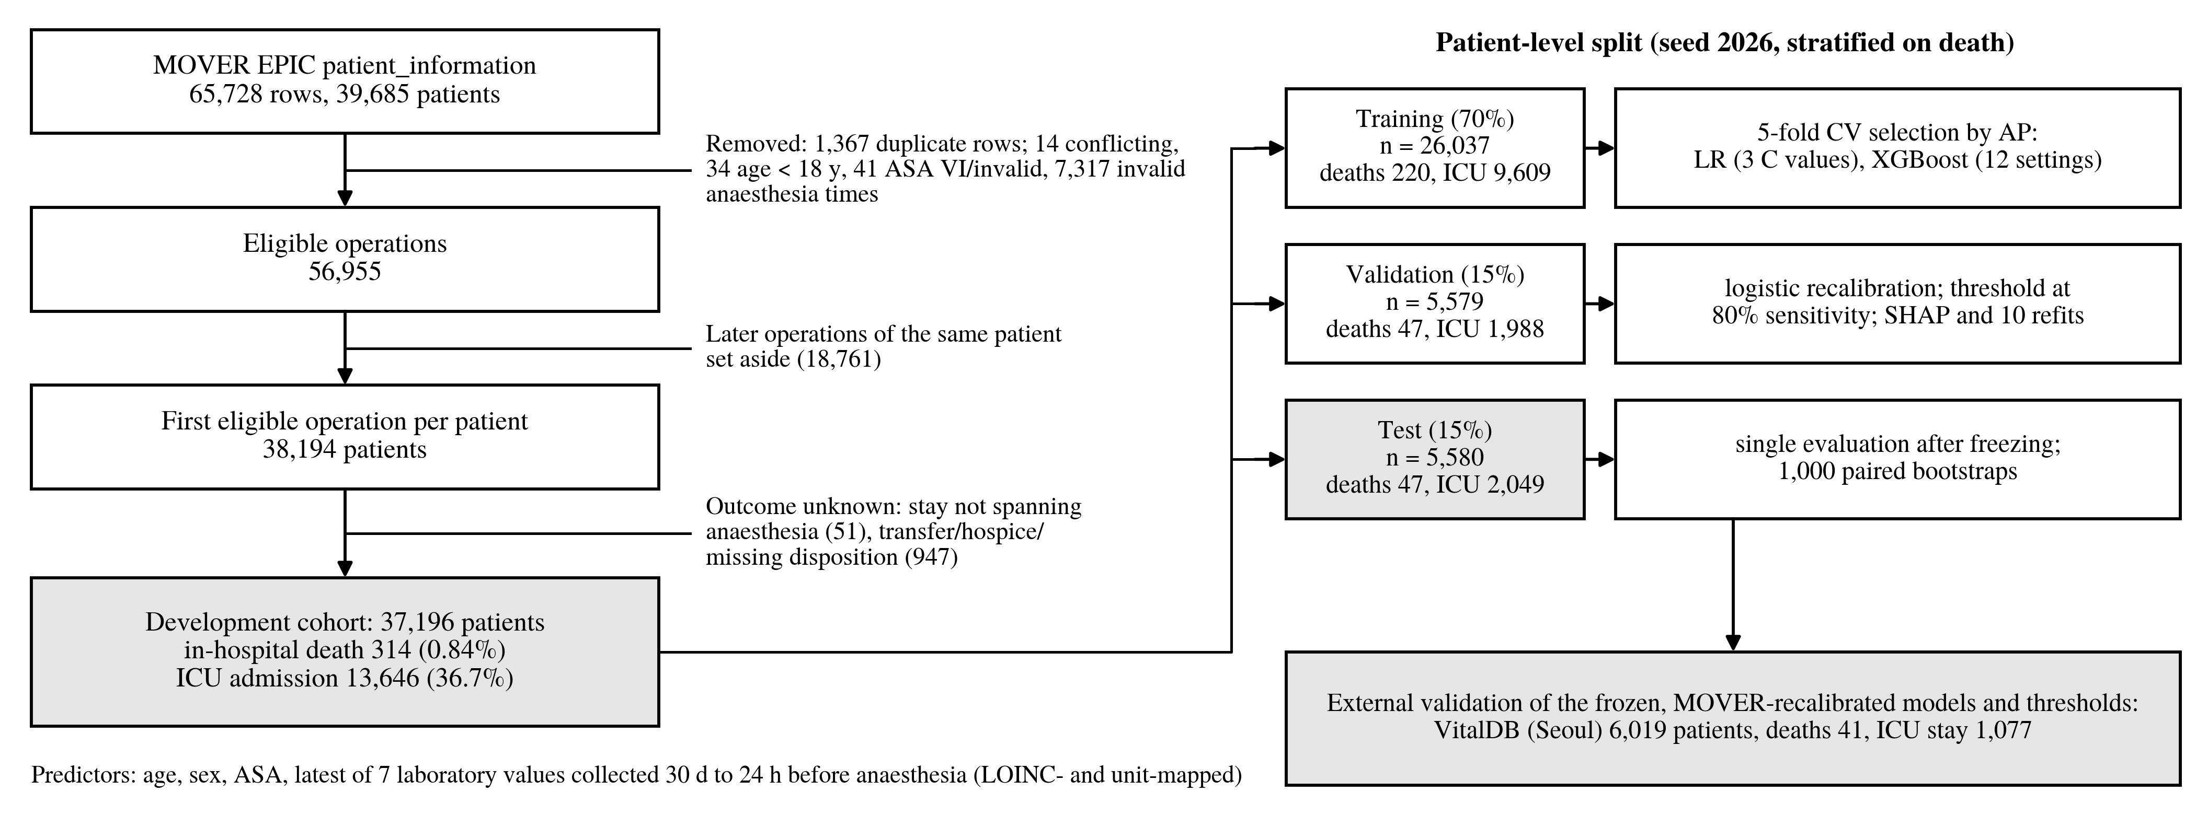
- Development cohort selection from MOVER EPIC, the PreOp-XAI evaluation protocol and external validation on VitalDB. Event counts per partition are shown for both endpoints; the split was stratified on in-hospital death.

Predictors and Preprocessing
The ten concepts were age, sex, ASA physical status I–V [24] (missing coded as a separate category) and the most recent preoperative haemoglobin, platelet count, creatinine, blood urea nitrogen (BUN), sodium, potassium and glucose. Laboratory results were identified by LOINC code and unit, values outside physiologically plausible ranges were discarded, and, because MOVER provides collection but not result-release times, results were used only if collected between 30 days and 24 hours before anaesthesia start, a conservative proxy for availability at the time of prediction. Of 1,407,549 candidate results for modelled operations, 33,888 had an unmapped code or unit, 188,088 met this rule and 1,060,502 were collected after anaesthesia start. Inside every training fold, numeric values were median-imputed, missingness indicators were added for the seven laboratory values, sex and ASA were one-hot encoded, and, for LR only, numeric values were standardised [25], giving 23 model inputs. No identifiers, procedure or intraoperative data entered the models.

Models, Selection and Recalibration
Patients were split 70/15/15 into training (26,037), validation (5,579) and test (5,580) sets with the repository’s default seed (2026), stratified on death; both endpoints used the same patients. L2-penalised LR models the log-odds as
$s\left(x\right)=β_{0}+β^{⊤}x, p\left(x\right)=σ\left(s\left(x\right)\right),$ (1)
with $C∈\{0.1,1,10\}$. XGBoost [6] used 12 settings (depth 2 or 3; 100, 200 or 300 trees; learning rate 0.03 or 0.1; minimum child weight 5; $λ=5$). Each family was tuned by mean average precision (AP) over five stratified training folds and refitted on the full training set, without class weighting or resampling. A logistic recalibration [20]
$p_{cal}\left(x\right)=σ\left(a+b s\left(x\right)\right)$ (2)
was fitted on the validation set, where the operating threshold was also fixed as the highest threshold retaining at least 80% sensitivity. Test data were used once, after these choices were frozen.

Evaluation and External Validation
We report AUROC, AP [26], the Brier score with the reference of a constant training-prevalence prediction, calibration-in-the-large (CITL; intercept with the logit as offset), the calibration slope [11], [20] and threshold metrics. Uncertainty was estimated with 1,000 bootstrap resamples of test patients shared by both models, giving percentile intervals for paired differences [27]. To quantify split dependence, the entire protocol (splitting, selection, recalibration, thresholding and testing) was repeated for split seeds 1–100. For external validation, the frozen MOVER models, recalibration maps and thresholds were applied without any update to 6,019 adult VitalDB patients from Seoul National University Hospital with a known in-hospital outcome (one operation per patient; ICU admission defined as an ICU stay of at least one day) [17], whose laboratory values are the most recent preoperative results recorded by VitalDB. A sensitivity analysis repeated the primary analysis with laboratory results collected up to anaesthesia start.

Explanations and Stability
SHAP values were computed on the raw log-odds of the validation patients against 64 training patients drawn with a fixed seed, under the interventional convention [8], [28]. The players $D$ are the model inputs. For a background row $z$, the value $v_{z}\left(S\right)$ of a coalition $S$ is the model output on the hybrid row that takes $x$ on $S$ and $z$ elsewhere, and
ϕjx=1Bz∈B​S⊆D\{j}​S! D−S−1!D!vzS∪{j}−vzS. (3)
For LR this reduces to $β_{j}\left(x_{j}−{\overset{‾}{z}}_{j}\right)$. For trees, each leaf defines a product game with closed-form Shapley values, so the values were computed exactly from the XGBoost tree dump; they matched brute-force enumeration to within ${10}^{−6}$ and satisfied additivity on every model. As in the repository, values of the one-hot and missingness columns were summed per concept; because these columns are perturbed independently, the sums are not concept-level Shapley values. For stability, both models were refitted on ten bootstrap samples of the training patients with fixed hyperparameters [12]; from the concept importances (mean absolute SHAP) we computed the Spearman correlation between refits and the Jaccard overlap of the five most important concepts,
$J\left(A,B\right)=\frac{\left|A∩B\right|}{\left|A∪B\right|},$ (4)
averaged over the 45 refit pairs [13].

Implementation, Privacy and Deviations
The PreOp-XAI repository (commit 6baa665) was used unchanged for model fitting, recalibration, evaluation, explanation and stability, with scikit-learn 1.8.0 and XGBoost 2.1.4. All computation on MOVER ran on the data holder’s computer; only aggregate results were exported, with calibration cells of fewer than 11 patients suppressed. A second run of the primary mortality analysis reproduced every exported value. Cohort and label rules were ported to pandas, and missing ASA was encoded as an explicit category because the repository’s explanation step bypasses its training-time handling of missing categories. Relative to the protocol, this study (i) used collection time as a proxy for result availability, (ii) replaced the infeasible respiratory endpoint with ICU admission, and (iii) added the repeated-split, sensitivity and external analyses.

Results

Cohort
The median age was 56 years, 50.8% were women and 55.0% were ASA III–V (Table I). Patients who died were older and mostly ASA IV–V (74.5% versus 7.6%). Under the 24-hour rule, each laboratory value was missing for 84.3–84.4% of patients, but for only 62.4–63.1% of those who died. The VitalDB cohort was healthier (87.7% ASA I–II versus 45.0%) and almost completely tested (5.4–9.9% missing). Each test set held 47 deaths; the primary test set held 2,049 ICU admissions, a typical value among 1,000 alternative splits (range 1,932–2,157).
- Characteristics of the Development (MOVER) and External (VitalDB) Cohorts
Variable | MOVER all (n = 37,196) | Died (n = 314) | Survived (n = 36,882) | ICU (n = 13,646) | VitalDB (n = 6,019)
Age, y | 56 (40–68) | 62 (49–75) | 56 (40–68) | 58 (43–69) | 59 (48–68)
Female, % | 50.8 | 34.7 | 51.0 | 44.2 | 49.6
ASA I / II, % | 7.0 / 38.0 | 0.0 / 1.6 | 7.1 / 38.3 | 3.0 / 22.7 | 29.0 / 58.7
ASA III / IV / V, % | 46.9 / 7.3 / 0.8 | 23.9 / 40.4 / 34.1 | 47.1 / 7.1 / 0.5 | 56.1 / 16.1 / 2.0 | 9.8 / 0.4 / 0.0
Haemoglobin, g/dL | 11.9 (10.0–13.4) | 9.9 (8.4–11.7) | 12.0 (10.1–13.5) | 11.6 (9.7–13.3) | 13.1 (11.8–14.2)
Platelets, 10⁹/L | 234 (181–304) | 168 (114–256) | 234 (182–305) | 227 (175–301) | 235 (192–283)
Creatinine, mg/dL | 0.80 (0.60–1.00) | 1.00 (0.70–1.80) | 0.80 (0.60–1.00) | 0.80 (0.60–1.10) | 0.78 (0.66–0.94)
BUN, mg/dL | 15 (11–22) | 26 (17–51) | 15 (11–21) | 16 (11–24) | 14 (11–17)
Sodium / potassium, mmol/L | 137 / 3.9 | 138 / 4.0 | 137 / 3.9 | 137 / 4.0 | 140 / 4.2
Glucose, mg/dL | 115 (98–143) | 141 (108–179) | 114 (98–142) | 118 (100–149) | 103 (94–121)
Lab missing (range), % | 84.3–84.4 | 62.4–63.1 | 84.5–84.6 | 69.9–70.1 | 5.4–9.9
Medians (interquartile range) of available values; sodium and potassium as medians. Missing ASA: 0.02% (MOVER), 2.1% (VitalDB). MOVER laboratory values collected 30 days to 24 hours before anaesthesia. Lab missing: range over the seven laboratory values.

Discrimination
For mortality, LR and XGBoost had test AUROCs of 0.916 (95% CI 0.865–0.958) and 0.923 (0.871–0.961), a paired difference of 0.007 (−0.013 to 0.027), and AP of 0.242 and 0.236 against a prevalence of 0.0084 (Table II, Fig. 2). For ICU admission, AUROCs were 0.752 (0.738–0.765) and 0.754 (0.740–0.768), with a difference of 0.002 (−0.001 to 0.006). Over the 100 repeated splits, median mortality AUROCs were 0.925 and 0.927, 95% of paired differences lay between −0.017 and 0.018, and XGBoost was ahead in 46% of splits; LR had the higher AP in 71%. For ICU admission, XGBoost had a higher AUROC in 88% of splits, but by a median of only 0.0018 (95% of splits −0.001 to 0.005), and AP did not differ (median −0.0003).
- Discrimination: MOVER Test Set, Repeated Splits, Sensitivity Analysis and External Validation
End-point | Model | MOVER test AUROC (95% CI) | MOVER test AP (95% CI) | AUROC, 100 splits: median (2.5–97.5th pct.) | AUROC, labs to t₀ | VitalDB AUROC (95% CI) | VitalDB AP (95% CI)
Death | LR | 0.916 (0.865–0.958) | 0.242 (0.141–0.401) | 0.925 (0.882–0.952) | 0.935 | 0.671 (0.567–0.758) | 0.049 (0.015–0.137)
Death | XGB | 0.923 (0.871–0.961) | 0.236 (0.142–0.384) | 0.927 (0.884–0.951) | 0.939 | 0.687 (0.594–0.768) | 0.033 (0.013–0.081)
Death | Δ | 0.007 (−0.013 to 0.027) | −0.006 (−0.078 to 0.057) | −0.001 (−0.017 to 0.018) | 0.004 | 0.016 (−0.015 to 0.059) | −0.016 (−0.070 to 0.005)
ICU | LR | 0.752 (0.738–0.765) | 0.668 (0.648–0.690) | 0.743 (0.733–0.756) | 0.771 | 0.688 (0.670–0.708) | 0.375 (0.346–0.405)
ICU | XGB | 0.754 (0.740–0.768) | 0.670 (0.649–0.692) | 0.745 (0.736–0.758) | 0.782 | 0.659 (0.639–0.680) | 0.343 (0.312–0.372)
ICU | Δ | 0.002 (−0.001 to 0.006) | 0.002 (−0.003 to 0.007) | 0.002 (−0.001 to 0.005) | 0.011 | −0.029 (−0.042 to −0.017) | −0.033 (−0.049 to −0.017)
Δ: XGBoost minus LR with paired bootstrap interval (or 2.5th–97.5th percentile over splits). Labs to t₀: sensitivity analysis with laboratory results collected up to anaesthesia start. Prevalence: 0.0084 (death) and 0.367 (ICU) in the MOVER test set; 0.0068 and 0.179 in VitalDB.
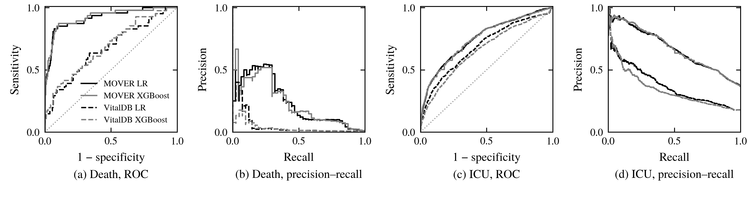
- ROC and precision–recall curves on the MOVER test set (solid) and in external validation on VitalDB (dashed) for LR (black) and XGBoost (grey), from raw model scores (recalibration preserves ranking); AUROC and AP values are given in Table II. Dotted line: chance.
When laboratory results collected up to anaesthesia start were allowed, missingness fell to 63.8–65.0% and AUROCs rose to 0.935 (LR) and 0.939 (XGBoost) for mortality and to 0.771 and 0.782 for ICU admission, where XGBoost was ahead by 0.011 (0.006–0.015). Part of this gain uses same-day tests that may not be resulted before induction.

Calibration and Operating Points
Validation recalibration slopes were close to one (1.01 and 1.01 for mortality, 1.07 and 1.08 for ICU admission), so the raw models were already well calibrated. On the test set, recalibrated CITL was 0.10–0.12 for mortality and 0.05 for ICU admission, slopes were 0.97–1.04 (Table III, Fig. 3a, c), and all Brier scores were below the prevalence reference. No validation slope was non-positive in any repeated split, and 95% of recalibrated mortality test slopes lay between 0.79 and 1.24 (LR). At the validation-fixed thresholds, LR flagged 545 test patients (9.8%) and detected 39 of 47 deaths, a positive predictive value (PPV) of 7.2%; XGBoost detected 41 while flagging 611. For ICU admission, both models detected about 80% of admissions with a specificity near 54%. Because the threshold is set at the target on validation data, test sensitivity reached 80% in 44%–47% of splits for mortality.
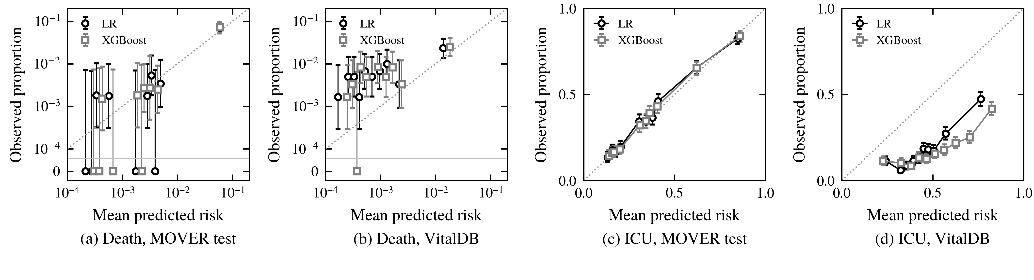
- Observed outcome proportion against mean recalibrated risk in deciles of predicted risk, with 95% Wilson intervals. Mortality panels use logarithmic axes; deciles without a death are drawn on the row labelled 0. Dotted line: perfect calibration.
- Calibration of Recalibrated Risks and Performance at the Validation-Fixed Threshold
End-point | Model | MOVER CITL / slope | MOVER sens. / spec. / PPV | VitalDB CITL / slope | VitalDB sens. / spec. / PPV
Death | LR | 0.10 / 1.03 | 0.830 / 0.909 / 0.072 | 1.29 / 0.55 | 0.171 / 0.953 / 0.024
Death | XGB | 0.12 / 1.04 | 0.872 / 0.897 / 0.067 | 1.03 / 0.54 | 0.220 / 0.956 / 0.033
ICU | LR | 0.05 / 0.97 | 0.797 / 0.542 / 0.502 | −1.45 / 1.01 | 0.941 / 0.097 / 0.185
ICU | XGB | 0.05 / 0.97 | 0.804 / 0.539 / 0.503 | −1.75 / 0.72 | 0.922 / 0.133 / 0.188
CITL: calibration-in-the-large (0 is ideal); slope: calibration slope (1 is ideal). Thresholds were fixed on the MOVER validation set at 80% sensitivity and applied unchanged to VitalDB.

External Validation on VitalDB
In VitalDB (41 deaths, 1,077 ICU admissions), mortality AUROCs were 0.671 (0.567–0.758) for LR and 0.687 (0.594–0.768) for XGBoost, and ICU AUROCs were 0.688 (0.670–0.708) and 0.659 (0.639–0.680); for ICU admission LR was better by 0.029 (paired interval for XGBoost minus LR −0.042 to −0.017). Calibration failed in opposite directions (Fig. 3b, d): mortality was underestimated (CITL 1.29 and 1.03, slopes 0.55 and 0.54), whereas ICU admission was overestimated (CITL −1.45 and −1.75), reflecting a lower admission rate (17.9% versus 36.7%). The MOVER thresholds detected only 7 (LR) and 9 (XGBoost) of 41 deaths but 94% and 92% of ICU admissions at specificities of 10% and 13%, and the recalibrated ICU Brier scores (0.210 and 0.253) were worse than that of a constant prediction at the development prevalence (0.183). A test patient had on average 5.9 of seven laboratory values missing in MOVER but 0.5 in VitalDB.

Explanations and Their Stability
ASA class had the largest mean absolute SHAP value for both endpoints and both models, in the primary fits and in every refit, accounting for 68% of the summed importance for mortality and 49%–51% for ICU admission (Fig. 4). In the primary fits, sex and age followed, except that glucose ranked second for XGBoost for ICU admission; the laboratory concepts contributed little individually, possibly because their missingness, which is shared across tests, is split between seven concepts. Mortality rankings were reproducible across the ten paired refits, with mean Spearman correlations of 0.80 (LR) and 0.83 (XGBoost) and top-five Jaccard overlaps of 0.81 and 0.76; age, sex, ASA, haemoglobin and platelets were in the top five in at least 90% of LR refits and age, sex, ASA and haemoglobin in at least 90% of XGBoost refits. ICU-admission rankings were less stable (Spearman 0.46 and 0.61, Jaccard 0.48 and 0.65): beyond ASA, the order of the low-importance laboratory concepts changed between refits, and glucose was in the top five in only 40% of XGBoost refits.
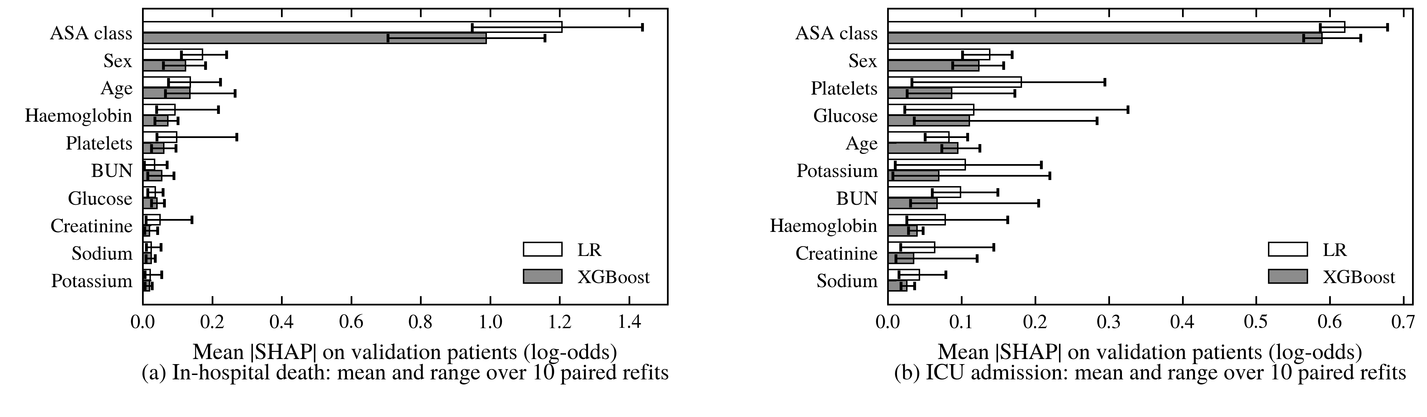
- Grouped mean absolute SHAP values (raw log-odds) on the MOVER validation patients over ten paired bootstrap refits; bars show the mean and whiskers the range across refits. Concepts are ordered by their mean normalised importance across the two models.

Discussion
With ten routinely available preoperative concepts, XGBoost did not discriminate better than regularised LR for in-hospital mortality, and its advantage for ICU admission was consistent across splits but around 0.002 in AUROC, too small to matter clinically and reversed in external validation [10]. Mortality AUROCs above 0.9 were achieved by both models, comparable with larger studies using richer predictors [2], [3], with ASA class separating the few high-risk patients: ASA IV–V patients made up 8.1% of the cohort but 74.5% of deaths.
External validation changed the picture. Discrimination fell to AUROCs near 0.7 and probabilities were miscalibrated in opposite directions for the two outcomes, so neither the MOVER risk estimates nor its operating thresholds could be used in Seoul without local updating [14]. Two differences plausibly contribute: VitalDB patients were mostly ASA I–II, and their laboratory values were almost always present, whereas in MOVER the presence of a test at least a day before surgery marked patients at higher risk (Table I). Missingness indicators thus encode care processes that differ between hospitals [15], [22], and an explanation that is stable internally can attribute risk to such process signals. Explanation stability, split dependence and external performance should therefore be reported alongside SHAP figures.
The study has limitations. MOVER and VitalDB are single-centre cohorts with different outcome definitions; ICU admission is not time-stamped in either and partly reflects planned care pathways. Laboratory availability was approximated by collection time. Transfers and hospice discharges were treated as unknown, which may bias mortality estimates. Grouped SHAP values are summaries, not concept-level Shapley values, and SHAP describes model behaviour, not causal effects.

Conclusion
On 37,196 MOVER patients, a leakage-controlled comparison found no meaningful advantage of XGBoost over regularised logistic regression for predicting in-hospital mortality or ICU admission from ten preoperative concepts. Both were well calibrated internally and their mortality explanations, dominated by ASA class, were reproducible, but discrimination and calibration deteriorated on an independent cohort with a different case mix and laboratory-testing pattern. Explainable preoperative models should be judged on external calibration and explanation stability, not only on internal AUROC.

References
- C. K. Lee, I. Hofer, E. Gabel, P. Baldi, and M. Cannesson, “Development and validation of a deep neural network model for prediction of postoperative in-hospital mortality,” Anesthesiology, vol. 129, no. 4, pp. 649–662, 2018, doi: 10.1097/ALN.0000000000002186.
- B. L. Hill et al., “An automated machine learning-based model predicts postoperative mortality using readily-extractable preoperative electronic health record data,” Br. J. Anaesth., vol. 123, no. 6, pp. 877–886, 2019, doi: 10.1016/j.bja.2019.07.030.
- S. W. Lee, H.-C. Lee, J. Suh, K. H. Lee, H. Lee, S. Seo, T. K. Kim, S.-W. Lee, and Y.-J. Kim, “Multi-center validation of machine learning model for preoperative prediction of postoperative mortality,” npj Digit. Med., vol. 5, Art. no. 91, 2022, doi: 10.1038/s41746-022-00625-6.
- B. Choi, A. R. Oh, S.-H. Lee, D. Y. Lee, J.-H. Lee, K. Yang, H. Y. Kim, R. W. Park, and J. Park, “Prediction model for 30-day mortality after non-cardiac surgery using machine-learning techniques based on preoperative evaluation of electronic medical records,” J. Clin. Med., vol. 11, no. 21, Art. no. 6487, 2022, doi: 10.3390/jcm11216487.
- A. Bihorac et al., “MySurgeryRisk: Development and validation of a machine-learning risk algorithm for major complications and death after surgery,” Ann. Surg., vol. 269, no. 4, pp. 652–662, 2019, doi: 10.1097/SLA.0000000000002706.
- T. Chen and C. Guestrin, “XGBoost: A scalable tree boosting system,” in Proc. 22nd ACM SIGKDD Int. Conf. Knowl. Discov. Data Min., San Francisco, CA, USA, 2016, pp. 785–794, doi: 10.1145/2939672.2939785.
- S. M. Lundberg and S.-I. Lee, “A unified approach to interpreting model predictions,” in Adv. Neural Inf. Process. Syst. 30 (NIPS), Long Beach, CA, USA, 2017, pp. 4765–4774.
- S. M. Lundberg et al., “From local explanations to global understanding with explainable AI for trees,” Nat. Mach. Intell., vol. 2, no. 1, pp. 56–67, 2020, doi: 10.1038/s42256-019-0138-9.
- S. M. Lundberg et al., “Explainable machine-learning predictions for the prevention of hypoxaemia during surgery,” Nat. Biomed. Eng., vol. 2, no. 10, pp. 749–760, 2018, doi: 10.1038/s41551-018-0304-0.
- E. Christodoulou, J. Ma, G. S. Collins, E. W. Steyerberg, J. Y. Verbakel, and B. Van Calster, “A systematic review shows no performance benefit of machine learning over logistic regression for clinical prediction models,” J. Clin. Epidemiol., vol. 110, pp. 12–22, 2019, doi: 10.1016/j.jclinepi.2019.02.004.
- B. Van Calster, D. J. McLernon, M. van Smeden, L. Wynants, and E. W. Steyerberg, “Calibration: The Achilles heel of predictive analytics,” BMC Med., vol. 17, Art. no. 230, 2019, doi: 10.1186/s12916-019-1466-7.
- R. D. Riley and G. S. Collins, “Stability of clinical prediction models developed using statistical or machine learning methods,” Biom. J., vol. 65, no. 8, Art. no. 2200302, 2023, doi: 10.1002/bimj.202200302.
- S. Nogueira, K. Sechidis, and G. Brown, “On the stability of feature selection algorithms,” J. Mach. Learn. Res., vol. 18, no. 174, pp. 1–54, 2018.
- T. P. A. Debray, Y. Vergouwe, H. Koffijberg, D. Nieboer, E. W. Steyerberg, and K. G. M. Moons, “A new framework to enhance the interpretation of external validation studies of clinical prediction models,” J. Clin. Epidemiol., vol. 68, no. 3, pp. 279–289, 2015, doi: 10.1016/j.jclinepi.2014.06.018.
- D. Agniel, I. S. Kohane, and G. M. Weber, “Biases in electronic health record data due to processes within the healthcare system: Retrospective observational study,” BMJ, vol. 361, Art. no. k1479, 2018, doi: 10.1136/bmj.k1479.
- M. Samad, M. Angel, J. Rinehart, Y. Kanomata, P. Baldi, and M. Cannesson, “Medical Informatics Operating Room Vitals and Events Repository (MOVER): A public-access operating room database,” JAMIA Open, vol. 6, no. 4, Art. no. ooad084, 2023, doi: 10.1093/jamiaopen/ooad084.
- H.-C. Lee, Y. Park, S. B. Yoon, S. M. Yang, D. Park, and C.-W. Jung, “VitalDB, a high-fidelity multi-parameter vital signs database in surgical patients,” Sci. Data, vol. 9, Art. no. 279, 2022, doi: 10.1038/s41597-022-01411-5.
- J. Hadaya, A. Verma, Y. Sanaiha, R. Ramezani, N. Qadir, and P. Benharash, “Machine learning-based modeling of acute respiratory failure following emergency general surgery operations,” PLoS ONE, vol. 17, no. 4, Art. no. e0267733, 2022, doi: 10.1371/journal.pone.0267733.
- R. D. Riley et al., “Calculating the sample size required for developing a clinical prediction model,” BMJ, vol. 368, Art. no. m441, 2020, doi: 10.1136/bmj.m441.
- D. R. Cox, “Two further applications of a model for binary regression,” Biometrika, vol. 45, no. 3/4, pp. 562–565, 1958, doi: 10.1093/biomet/45.3-4.562.
- E. W. Steyerberg and Y. Vergouwe, “Towards better clinical prediction models: Seven steps for development and an ABCD for validation,” Eur. Heart J., vol. 35, no. 29, pp. 1925–1931, 2014, doi: 10.1093/eurheartj/ehu207.
- R. H. H. Groenwold, “Informative missingness in electronic health record systems: The curse of knowing,” Diagn. Progn. Res., vol. 4, Art. no. 8, 2020, doi: 10.1186/s41512-020-00077-0.
- G. S. Collins et al., “TRIPOD+AI statement: Updated guidance for reporting clinical prediction models that use regression or machine learning methods,” BMJ, vol. 385, Art. no. e078378, 2024, doi: 10.1136/bmj-2023-078378.
- D. Mayhew, V. Mendonca, and B. V. S. Murthy, “A review of ASA physical status – historical perspectives and modern developments,” Anaesthesia, vol. 74, no. 3, pp. 373–379, 2019, doi: 10.1111/anae.14569.
- F. Pedregosa et al., “Scikit-learn: Machine learning in Python,” J. Mach. Learn. Res., vol. 12, pp. 2825–2830, 2011.
- T. Saito and M. Rehmsmeier, “The precision-recall plot is more informative than the ROC plot when evaluating binary classifiers on imbalanced datasets,” PLoS ONE, vol. 10, no. 3, Art. no. e0118432, 2015, doi: 10.1371/journal.pone.0118432.
- B. Efron and R. J. Tibshirani, An Introduction to the Bootstrap. New York, NY, USA: Chapman & Hall, 1993.
- M. Sundararajan and A. Najmi, “The many Shapley values for model explanation,” in Proc. 37th Int. Conf. Mach. Learn. (ICML), PMLR, vol. 119, 2020, pp. 9269–9278.

