Summary of unit tests (sprint 1)
Frontend (src/tests/):
1. useSocket.test.ts
- Real-time connection and event handling logic
- Tests the Socket.io Hook that powers real-time collaboration.
- Verifies it connects on mount, disconnects on unmount, and correctly routes incoming events (like stroke-drawn to your React callbacks.
2. ProtectedRoute.test.tsx
- Tests the Routing Guard component.
- Ensures unauthenticated users are redirected to /auth, while authenticated users can see the protected content (Dashboard).
3. MeetingRenderer.test.tsx
- Tests the Whiteboard Display component to ensure it renders sticky notes and text items from data.
- Verifies the onReady callback is fired after the canvas and images have finished loading.
4. Button.test.tsx and Input.test.tsx
- Verifies these basic UI components render correctly with different props (variants, sizes).
- Ensures they handle user interactions like clicks and typing correctly.
5. useCanvas.test.ts
- Tests the complex Undo/Redo stack and tool switching logic (Pen vs Eraser).
- Ensures drawing a stroke correctly updates the local state array.
6. utils.test.ts
- Tests small utility functions (like random ID generation or color formatting).
- Ensures helper logic is bug-free and handles edge cases (empty inputs, etc.).

Backend (server/tests/)
1. auth.route.test.js
- Registration, Login, Google Auth flow
- Tests the Registration (checks duplicates), Login (checks password hashing), and Google Auth endpoints.
- It mocks the database and JWT signing to ensure user accounts are created and tokens are issued correctly without hitting a real DB.
2. meetings.route.test.js
- CRUD operations for meetings
- Tests the core CRUD operations for meetings: Creating a new board, getting details, updating title, and deleting.
- Ensures that only the owner of a meeting can modify or delete it (Authorization check).
3. invites.route.test.js
- Generating and validating invite tokens
- Tests generating invite links for a meeting and validates them when a guest clicks the link.
- Checks if the invite is enabled/disabled and ensures guests get the correct Room ID to join the socket session.
4. ai.route.test.js
- AI generation and image proxying (with extensive mocking)
- Tests the AI Chat endpoint by mocking the GoogleGenerativeAI service to simulate responses.
- Verifies that if the main AI fails, it falls back to generating an image (Pollinations AI) or returns a graceful error instead of crashing.
5. user.route.test.js
- User profile and activity reports
- Tests the User Activity Report endpoint which calculates total meetings, strokes, and time spent.
- Ensures the "High Water Mark" logic works: it updates the user's historical stats only if the current activity is higher than before.
6. auth.middleware.test.js
- Protection middleware logic
- Tests the protect middleware function directly to ensure it blocks requests without a valid token.
- Verifies it attaches the req.user object correctly when a valid JWT is provided.
7. health.test.js –
- Basic server health check
- A simple sanity check that pings the /api/health endpoint.
- Ensures the server is up and running and responding with status 200.

Frontend testing results:
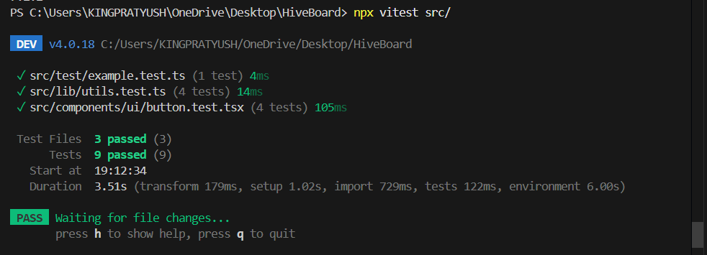
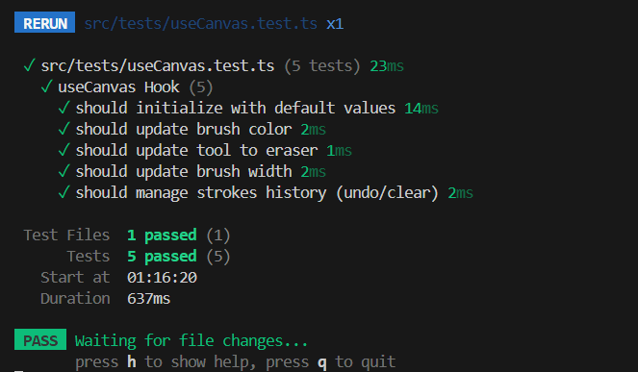
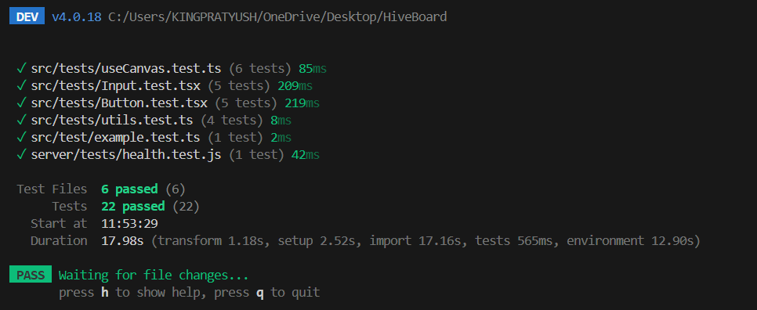

Backend testing
