进入官网https://docs.docker.com/install/#server

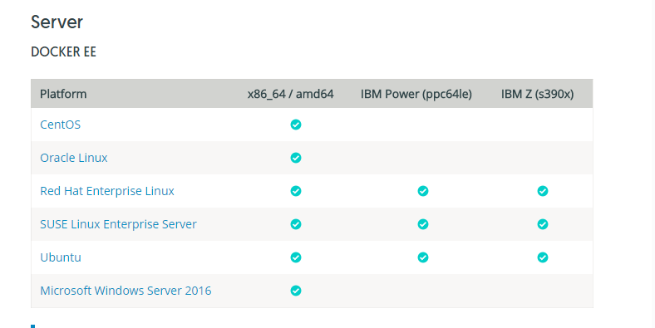

点击指定平台的docker 如CentOS进入安装页面

找到安装命令

**sudo yum -y install docker-ee**

安装完毕后启动docker

**sudo systemctl start docker**

执行命令查看是否成功

**docker -v**

**进入docker-compose 的安装界面**

[**https://docs.docker.com/compose/install/#install-compose**](https://docs.docker.com/compose/install/#install-compose)

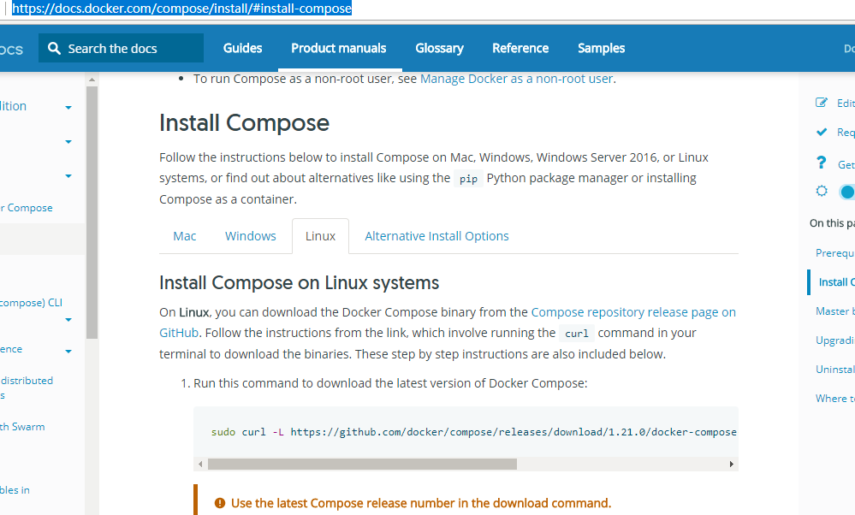

选择你要安装的平台如linux

第一步，下载

**sudo curl -L https://github.com/docker/compose/releases/download/1.21.0/docker-compose-$(uname -s)-$(uname -m) -o /usr/local/bin/docker-compose**

第二步 ，添加权限

**sudo chmod +x /usr/local/bin/docker-compose**

1. ，测试安装是否成功

**sudo docker-compose --version**

docker-compose.yml 文件

**version:** '3.3'  
**services:  
 mysql:  
 image:** mysql:5.6  
 **container_name:** mysql  
 **ports:** - "3306:3306"  
 **volumes:** - /var/lib/mysql/my.cnf:/etc/mysql/conf.d/my.cnf  
 - /var/lib/mysql/initdb:/docker-entrypoint-initdb.d  
 - /var/lib/mysql/data:/var/lib/mysql  
 - /etc/localtime:/etc/localtime:ro  
 **environment:** - MYSQL_ROOT_PASSWORD=123456  
 **restart:** always  
 **redis:  
 image:** docker.io/redis:latest  
 **container_name:** redis  
 **ports:** - "6379:6379"  
 **restart:** always  
 **command:** redis-server  
 **nginx:  
 image:** nginx  
 **container_name:** nginx  
 **ports:** - "80:80"  
 **user:** root  
 **environment:** - NGINX_PORT=80  
 **restart:** always  
 **volumes:**  
 - /var/lib/nginx/nginx.conf:/etc/nginx/nginx.conf  
 **command:** /bin/bash -c "nginx -g 'daemon off;'"  
 **zk_server:  
 image:** zookeeper  
 **restart:** always  
 **container_name:** zookeeper  
 **configs:** - **source:** ./zoo.cfg  
 **target:** /conf/zoo.cfg  
 **ports:** - "2181:2181"  
 **volumes:** - /usr/local/volumes/zookeeper/data:/data   
 **rmq-namesrv:  
 image:** study/rocketmq-namesrv:4.2.0  
 **container_name:** rmq-namesrv  
 **volumes:** - /var/lib/rocketmq/namesrv/logs:/opt/logs *# 保留日志到宿主机* - /var/lib/rocketmq/namesrv/store:/opt/store  
 - /etc/localtime:/etc/localtime:ro *# 修改容器内的时区和宿主机一样* **ports:** - "9876:9876"  
 **rmq-broker:  
 image:** study/rocketmq-broker:4.2.0  
 **container_name:** rmq-broker  
 **environment:  
 NAMESRV_ADDR:** 10.33.80.114:9876  
 **volumes:** - /var/lib/rocketmq/broker/logs:/opt/logs *# 保留日志* - /var/lib/rocketmq/broker/store:/opt/store *# 保留数据到宿主机* - /var/lib/rocketmq/broker/conf/broker.properties:/opt/broker.properties  
 - /etc/localtime:/etc/localtime:ro  
 **ports:** - "10911:10911"  
 - "10909:10909"  
 - "10912:10912"  
 **restart:** always  
 **command:** ./bin/mqbroker -c "/opt/broker.properties"  
  
 **rabbit:  
 container_name:** rabbit  
 **hostname:** rabbit  
 **image:** rabbitmq:3.6.6-management  
 **environment:** - RABBITMQ_DEFAULT_USER = user  
 - RABBITMQ_DEFAULT_PASS = user  
 **ports:** - "5672:5672"  
 - "15672:15672"

由于rocketmq 镜像官网没有需要自行安装rocketmq 镜像，教程地址

<https://my.oschina.net/u/2299686/blog/1618531>

把docker-compose.yml 文件放到linux 机器上

启动容器

docker-compose up -d

启动成功后 查看结果 docker ps

