OS Lab 5
Reg No: 180905416
Name: Paawan Kohli

Q1. Write a producer and consumer program in C using the FIFO queue. The producer should write a set of 4 integers into the FIFO queue and the consumer should display the 4 integers.

producer.c:

#include <unistd.h>
#include <stdlib.h>
#include <stdio.h>
#include <string.h>
#include <fcntl.h>
#include <limits.h>
#include <sys/types.h>
#include <sys/stat.h>

#define FIFO_NAME "/tmp/my_fifo"
#define BUFFER_SIZE PIPE_BUF
#define TEN_MEG (1024 * 1024 * 10)

int main() {
if (access(FIFO_NAME, F_OK) == -1) {
int status = mkfifo(FIFO_NAME, 0777);

if (status != 0) {
printf("Could not create fifo %s\n", FIFO_NAME);
exit(EXIT_FAILURE);
}
}

printf("Enter 4 integers: ");
int buffer[BUFFER_SIZE + 1];
for (int i = 0; i < 4; i++) {
scanf("%d", &buffer[i]);
}

int pipe_fd = open(FIFO_NAME, O_WRONLY);
printf("Process %d result %d\n", getpid(), pipe_fd);

int bytes_sent = 0;

if (pipe_fd != -1) {
while (bytes_sent < TEN_MEG) {

int status = write(pipe_fd, buffer, BUFFER_SIZE);

if (status == -1) {
fprintf(stderr, "Write error on pipe\n");
exit(EXIT_FAILURE);
}

bytes_sent += status;
}
close(pipe_fd);
}
else {
exit(EXIT_FAILURE);
}

printf("Process %d finished\n", getpid());
exit(EXIT_SUCCESS);
}

consumer.c:

#include <unistd.h>
#include <stdlib.h>
#include <stdio.h>
#include <string.h>
#include <fcntl.h>
#include <limits.h>
#include <sys/types.h>
#include <sys/stat.h>

#define FIFO_NAME "/tmp/my_fifo"
#define BUFFER_SIZE PIPE_BUF

int main() {
int pipe_fd = open(FIFO_NAME, O_RDONLY);
int bytes_read = 0;

if (pipe_fd != -1) {

int buffer[BUFFER_SIZE + 1];
memset(buffer, '\0', sizeof(buffer));

int status;

do {
status = read(pipe_fd, buffer, BUFFER_SIZE);
bytes_read += status;
} while (status > 0);

close(pipe_fd);

for (int i = 0; i < 4; i++) {
printf("%d ", buffer[i]);
}
printf("\n");
}
else {
exit(EXIT_FAILURE);
}

printf("Process %d finished, %d bytes read\n", getpid(), bytes_read);
exit(EXIT_SUCCESS);
}

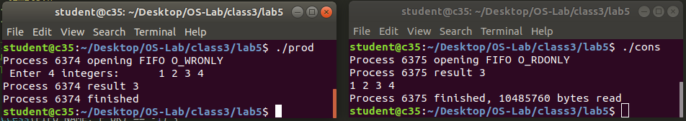

Q2. Demonstrate creation, writing to and reading from a pipe.

#include <sys/wait.h>
#include <assert.h>
#include <stdio.h>
#include <stdlib.h>
#include <unistd.h>
#include <string.h>

char msg1[] = "this is message #1";
char msg2[] = "this is message #2";
char msg3[] = "this is message #3";

int main() {

// creating a pipe
int fd[2];
if (pipe(fd) == -1) {
printf("Pipe failed\n");
exit(EXIT_FAILURE);
}

pid_t pid = fork();

if (pid == -1) {
printf("Fork failed\n");
exit(EXIT_FAILURE);
}

// parent writes to the pipe
if (pid != 0) {
sleep(1);
write(fd[1], msg1, 100);
sleep(1);
write(fd[1], msg2, 100);
sleep(1);
write(fd[1], msg3, 100);

wait(NULL);
}
// child reads from the pipe
else {
char buff[100];

for (int i = 0; i < 3; ++i) {
printf("Message recieved: \n");
read(fd[0], buff, 100);
printf("%s\n", buff);
}

exit(0);
}
}

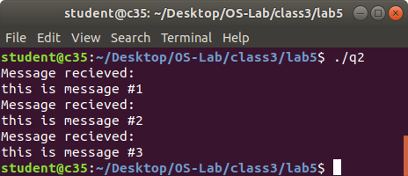

Q3. Write a C program to implement one side of FIFO.

#include <unistd.h>
#include <stdlib.h>
#include <stdio.h>
#include <string.h>
#include <fcntl.h>
#include <limits.h>
#include <sys/types.h>
#include <sys/stat.h>
#include <sys/wait.h>

#define FIFO_NAME "/tmp/myfifo"
#define BUFFER_SIZE 20

int main() {

int mode;
printf("Enter 1 for write first, 2 for read first: ");
scanf("%d", &mode);

if (mode == 1) {
if (access(FIFO_NAME, F_OK) == -1) {
int status = mkfifo(FIFO_NAME, 0777);
if (status != 0) {
printf("Could not create fifo %s\n", FIFO_NAME);
exit(EXIT_FAILURE);
}
}
}

int pipe_fd;

while (mode != 0) {
if (mode == 1) {

char buffer1[BUFFER_SIZE + 1];
printf("Enter msg: ");
scanf("%s", buffer1);

pipe_fd = open(FIFO_NAME, O_WRONLY);
if (pipe_fd != -1) {

int status = write(pipe_fd, buffer1, BUFFER_SIZE);

if (status == -1) {
printf("Error! Can't write to pipe\n");
exit(EXIT_FAILURE);
}

close(pipe_fd);
mode = 2;

if (strcmp(buffer1, "quit") == 0) {
mode = 0;
}
}
else {
printf("Can't open the pipe\n");
exit(EXIT_FAILURE);
}
}

else if (mode == 2) {

char buffer2[BUFFER_SIZE + 1];
memset(buffer2, '\0', sizeof(buffer2));

pipe_fd = open(FIFO_NAME, O_RDONLY);

if (pipe_fd != -1) {
int status;
do {
status = read(pipe_fd, buffer2, BUFFER_SIZE);
} while (status > 0);

close(pipe_fd);
mode = 1;
printf("%s \n", buffer2);

if (strcmp(buffer2, "quit") == 0) {
mode = 0;
}
}
else {
printf("Can't open the pipe\n");
exit(EXIT_FAILURE);
}
}
}

exit(EXIT_SUCCESS);
}

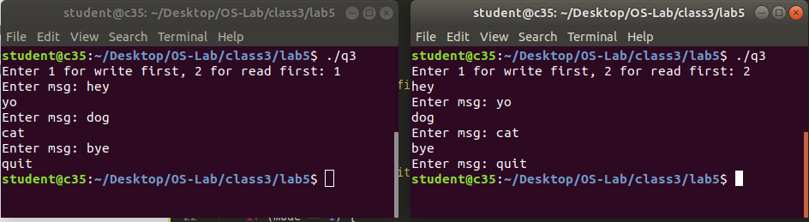

Q4. Write a C program for reading and writing binary files in C.

#include <stdio.h>
#include <stdlib.h>

int main() {
// open a binary file in wb mode
FILE *fptr = fopen("hey.bin", "wb");

if (fptr == NULL) {
printf("Error! opening file");
exit(1);
}

int n = 5;
int num[3];

num[0] = 34;
num[1] = 21;
num[2] = 65;

fwrite(num, sizeof(num), 1, fptr);
fclose(fptr);

// open the same binary file in rb mode
FILE* fptr2 = fopen("hey.bin", "rb");

if (fptr2 == NULL) {
printf("Error! opening file");
exit(1);
}

fread(num, sizeof(num), 1, fptr2);
fclose(fptr2);

printf("n1: %d\tn2: %d\tn3: %d\n", num[0], num[1], num[2]);

return 0;
}

