OS Lab 6
Reg No: 180905416
Name: Paawan Kohli

Q1. Process A wants to send a number to Process B. Once recieved, Process B has to check whether the number is palindrome or not. Write a C program to implement this interprocess communication using a message queue.

sender.c:

#include <stdlib.h>
#include <stdio.h>
#include <string.h>
#include <errno.h>
#include <unistd.h>
#include <sys/types.h>
#include <sys/ipc.h>
#include <sys/msg.h>

#define MAX_TEXT 512

struct message {
long int msgType;
char msgData[BUFSIZ];
};

int main() {
struct message m1;
char buffer[BUFSIZ];

int msgid = msgget((key_t)1234, 0666 | IPC_CREAT);

if (msgid == -1) {
printf("msgget failed with error: %d\n", errno);
exit(EXIT_FAILURE);
}

int run = 1;

while (run) {

printf("Enter a number:\t");
fgets(buffer, BUFSIZ, stdin);

m1.msgType = 1;
strcpy(m1.msgData, buffer);

if (msgsnd(msgid, (void *)&m1, MAX_TEXT, 0) == -1) {
printf("msgsnd failed\n");
exit(EXIT_FAILURE);
}

if (strncmp(buffer, "quit", 3) == 0) {
run = 0;
}
}

exit(EXIT_SUCCESS);
}

reciever.c:

#include <stdlib.h>
#include <stdio.h>
#include <string.h>
#include <errno.h>
#include <unistd.h>
#include <sys/types.h>
#include <sys/ipc.h>
#include <sys/msg.h>

struct mesage {
long int msgType;
char msgData[BUFSIZ];
};

int main() {
struct mesage m1;
long int msg_to_recieve = 0;

int msgid = msgget((key_t)1234, 0666 | IPC_CREAT);
if (msgid == -1) {
printf("msgget failed with error: %d\n", errno);
exit(EXIT_FAILURE);
}

int run = 1;
while (run) {
if (msgrcv(msgid, (void*)&m1, BUFSIZ, msg_to_recieve, 0) == -1) {
printf("msgrcv failed with error: %d\n", errno);
exit(EXIT_FAILURE);
}

if (strncmp(m1.msgData, "quit", 3) == 0) {
run = 0; break;
}

// check for palindrome
char rev[BUFSIZ];
int i;

for (i = 0; m1.msgData[i] != '\n'; i++);

for (int j = 0; j < i; j++)
rev[j] = m1.msgData[i - j - 1];

rev[i] = '\0';
m1.msgData[i] = '\0';

if (strcmp(m1.msgData, rev) == 0) {
printf("%s is a Pallindrome\n", m1.msgData);
} else {
printf("%s is not a Pallindrome\n", m1.msgData);
}
}

if (msgctl(msgid, IPC_RMID, 0) == -1) {
printf("msgctl(IPC_RMID) failed\n");
exit(EXIT_FAILURE);
}

exit(EXIT_SUCCESS);
}
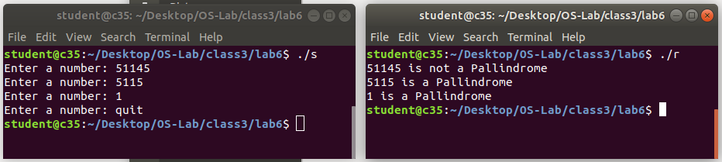

Q2. Implement a parent process, which sends an english alphabet to a child process using shared memory. The child process responds with the next english alphabet to the parent. The parent displays the reply from the child.

#include <stdlib.h>
#include <stdio.h>
#include <string.h>
#include <errno.h>
#include <unistd.h>
#include <sys/types.h>
#include <sys/ipc.h>
#include <sys/shm.h>
#include <sys/wait.h>

struct shared_use {
int status;
char c;
char cnext;
};

int main() {
void *shared_memory = (void *)0;
struct shared_use *commonptr;
commonptr->status = 0;

pid_t pid = fork();

if (pid == -1) {
printf("Fork failed!!\n");
exit(EXIT_FAILURE);
}

// child
if (pid == 0) {
int shmid = shmget((key_t)1234, sizeof(struct shared_use), 0666 | IPC_CREAT);

if (shmid == -1) {
printf("shmget failed!!\n");
exit(EXIT_FAILURE);
}

shared_memory = shmat(shmid, (void *)0, 0);

if (shared_memory == (void *) - 1) {
printf("shmat failed\n");
exit(EXIT_FAILURE);
}

commonptr = (struct shared_use *)shared_memory;

// wait for the parent to write to shared memory
while(commonptr->status == 0);

// child does work
commonptr->cnext = commonptr->c + 1;

if (shmdt(shared_memory) == -1) {
printf("shmdt failed\n");
exit(EXIT_FAILURE);
}

if (shmctl(shmid, IPC_RMID, 0) == -1) {
printf("shmctl(IP_RMID) failed\n");
exit(EXIT_FAILURE);
}

exit(EXIT_SUCCESS);
}

// parent
else {
int shmid = shmget((key_t)1234, sizeof(struct shared_use), 0666 | IPC_CREAT);

if (shmid == -1) {
printf("shmget failed!!\n");
exit(EXIT_FAILURE);
}

shared_memory = shmat(shmid, (void *)0, 0);

if (shared_memory == (void *) - 1) {
printf("shmat failed\n");
exit(EXIT_FAILURE);
}

commonptr = (struct shared_use *)shared_memory;

char ch;
printf("Enter character: ");
scanf("%c", &ch);

commonptr->c = ch;

// indicates that parent has written to shared memory
commonptr->status = 1;

printf("Current char: %c\n", commonptr->c);

// wait for the child to finsh its work
wait(NULL);
printf("New char: %c\n", commonptr->cnext);

if (shmdt(shared_memory) == -1) {
printf("shmdt failed\n");
exit(EXIT_FAILURE);
}

exit(EXIT_SUCCESS);
}
}
