ME 4773/5493 Fundamental of Robotics
Fall 2016
December 5th 2016, San Antonio, TX, USA

Validation and testing of IROS Robot reachability package

Ahmed Abdelmawgoud
Dept. of Electrical Engineering
San Antonio, TX, USA 78249
Asct82@hotmail.com

Abstract
The use of robotics arm has been increased in the past two decades. Performance of the arm heavily depends on its kinematic structure and mounting point on the robot body. The reachable workspace of the robot can be modeled as a discretized map called Reachability map. Another map called Capability map can be obtained by including some quality measure for the local dexterity of the robot. Once the maps are obtained, they can be used for numerous analysis tasks such as robot kinematics and workspace quality assessment, robot mounting point analysis or redundancy and failure analysis.
This project ruminates on basic aspects of the Reachability and Capability map generation then apply these maps to determine the optimum locations for the robot base using Reuleux software package. Industrial Robotic Operating system (IROS) has been used in this project as a base software. Reuleux package has been tested by identifying unit tests for the programing code using a known kinematics robot, Universal Robot (UR5). From the system analysis we were able to identify some areas of improvements to optimize the computational complexity of this package along with the overall performance of it.
- InTRODUCTION
In the past 20 years industrial robots has been limited to a set of tasks such as painting, dispensing, welding, and material handling. Robots are not cost effective especially for lower volume mixed part production. However, it is cost effective for high volume repetitive parts production. Furthermore, Robots are flexible enough to accomplish a wide variety of automation tasks, but until the return on investment becomes attractive, robots will continue to be deployed in only limited applications, and opportunities for greater productivity will be lost. Advances in robotics research require economical pathways to application to realize their full potential. As a result, IROS was founded by Shawn Edwards in January 2012 to create reliable tools for industrial robots and provide the economical pathway abovementioned. IROS is the industrial version of the Robotics Operating System (ROS). IROS is Open-Source software which provides a common framework for robotics applications. Currently, the software repository is hosted on GitHub. The ROS-Industrial repository includes interfaces for common industrial manipulators, grippers, sensors, and device networks. It also provides software libraries for automatic 2D/3D sensor calibration, and process path/motion planning.
One of the main problems that face each roboticist nowadays is to find the optimum location to place the robot base. The ability of a robotic manipulator to grasp and manipulate objects depends on the kinematic structure of the arm, location of the arm in the physical space, relative location of the objects with respect to the arm, and also environmental restrictions [1]. As a result, a Google Summer intern, Abhijit Makhal, created a package called “Realuex” which is a basic package for Robot Reachability and Base Placement. It provides tools for creating various types of robot reachability maps and tries to find optimal base locations for a given task specified by poses through those reachability maps. Mekhal named his package after famous roboticist Franz Reuleaux whom was the president of Berlin Royal Technical Academy. Reuleaux relied deeply on the concept of kinematic chain which could be abstracted in kinematic pairs- chains of elementary links. Constraints on each kinematic pairs can lead to constraints on whole machine. He is best remembered for Reuleaux triangle and the development of compact symbolic notion to describe the topology of very wide variety of mechanisms.

Reuleux package is highly dependent of “ikfast” package as the Inverse Kinematics solutions of the workspace are obtained by ikfast which is a powerful inverse kinematics solver provided within Rosen Diankov’s OpenRAVE motion planning software. Unlike most inverse kinematics solvers, IKFast can analytically solve the kinematics equations of any complex kinematics chain, and generate language-specific files (like C++) for later use. The end result is extremely stable solutions that can run as fast as 5 microseconds on recent processors.
- METHODS
In this project we aimed to test and validate the Reuleux package to make sure that it is a reliable tool to be used. Then, we checked the solutions for some known manipulator chains universal robot 5 (UR5) in figure 1. Finally, we submitted the checks back as automated unit tests.
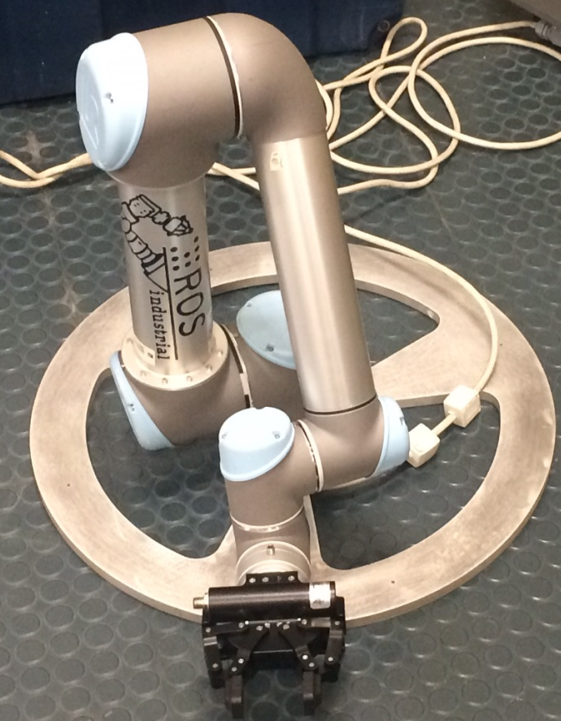
Figure 1 Universal Robot 5
We started by generating maps using map creator package. This package is capable of generating three different maps Reachability map, Capability map, and Inverse Reachability map. First of which is the Reachability map, figure 2, which describes the reachability of a given robot model by discretizing its environment, creating poses in the environment and calculating valid IK solutions for the poses. The poses which are reachable by robot are associated with discretized spheres. The reachability of each sphere in the environment is parameterized, by a Reachability index. The output is saved as an hdf5 file (link for hdf5 file) which has details about all the reachable poses and discretized spheres. The first step of the map generation process is discretization of the environment by voxelization. The resolution determines how much small the boxes need to be. Using smaller voxels increases the number of poses per spheres. If the user does not provide any resolution, the default resolution is 0.08. At that point, the user decides the map file name. If the user does not provide an output filename, the program will automatically decide a map name with the robot name and provided resolution. When the process finishes, the output reachability map will be stored.

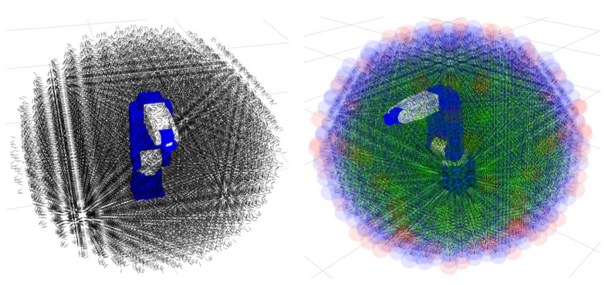
Figure 2 Reachability map color coded

The second map is the Capability map, figure 3, which is an extension of reachability map where the outer spheres of the reachability map, is set as cones. So the reachability limit of the robot is well visualized. All the outer spheres are decided for a principal axes and iterates over different values for opening angles for cones. The suitable opening angle that correctly accumulates all the poses on that sphere is picked up. The map Generation process is the same as creating reachability map.

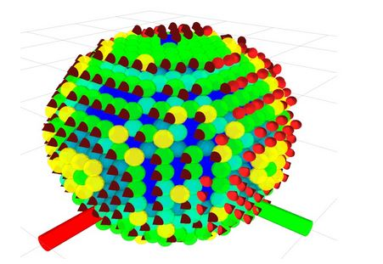
Figure 3 Capability map

Finally, the Inverse Reachability Map which finds suitable base positions for a robot with given task poses. The inverse reachability map is a general inverse transformation of all the reachable poses of the reachability map of the robot. The user has to provide the reachability map as an argument. The desired name of the output file can also be provided. If no output file name is provided, the system will automatically generate a map file with the robot name and resolution provided in the reachability map.

After generating all three maps abovementioned, the user needs to create workspace visualization using RVIZ. All maps can be visualized by just providing the map filename. The Inverse reachability map would mostly look like a sphere with color variation based on reachability index. Moreover, the inverse reachability map has an uneven shape as it is the transformation of the reachability map. The blue spheres are the most reachable. The red spheres are mostly located at the outer space of the workspace. The size of the spheres can be altered by changing the values in the display. The default shape is sphere. It can also be changed to cone, cylinder and boxes. The workspace can be cut in halves from the display panel. The reachable poses can also be visualized by checking the checkbox in the display.
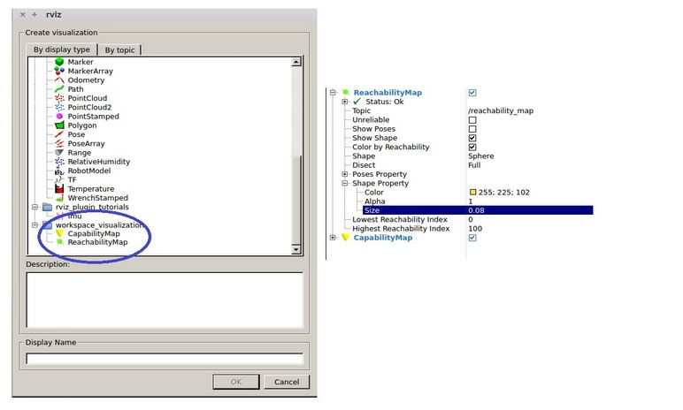
Figure 4 Loading Reachability and Capability map to workspace visualization

To that end, the user is ready to run the Base Placement plugin in RViz. There are two types of interactive markers in the Base Placement plugin: The red arrow acts as a pointer which the user can move around the RViz environment. Furthermore, by clicking on the arrow another magenta arrow is added to the RViz environment. This arrow acts as task poses for base placement planner. The magenta arrow is the task poses for the base placement planner. The orientation of the arrow can be changed by holding the CTRL key and moving it with the mouse. Each arrow has a menu where the user can either delete the selected arrow or it can change its position and orientation by using the 6DOF marker control as in figure 5.

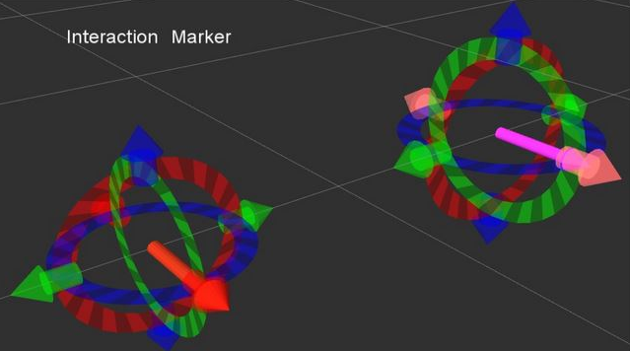
Figure 5 Interactive Marker

At this point, the user need to load all maps created earlier as in figure 4. The reachability map may take some time to show up as the command runs through the whole database file, searches for all the spheres and associated poses and then renders them. When the map shows up, the whole workspace would most likely show up as sphere with variation of colors ranging from blue to red. The blue spheres are indicating the most reachable sections in the workspace, while the red ones are sections where the robot can hardly reach. If the user is not satisfied with the position and orientation it could be fine-tuned by clicking on the task pose. A panel will appear indicating "fine adjustment". Clicking on the fine adjustment button will bring a 6DOF control for the task pose. Undesired task pose can be deleted by indicating its number and press the remove pose button. Also a new pose can be added by indicating its position and orientation by changing the values and pressing the add point button as in figure 6.
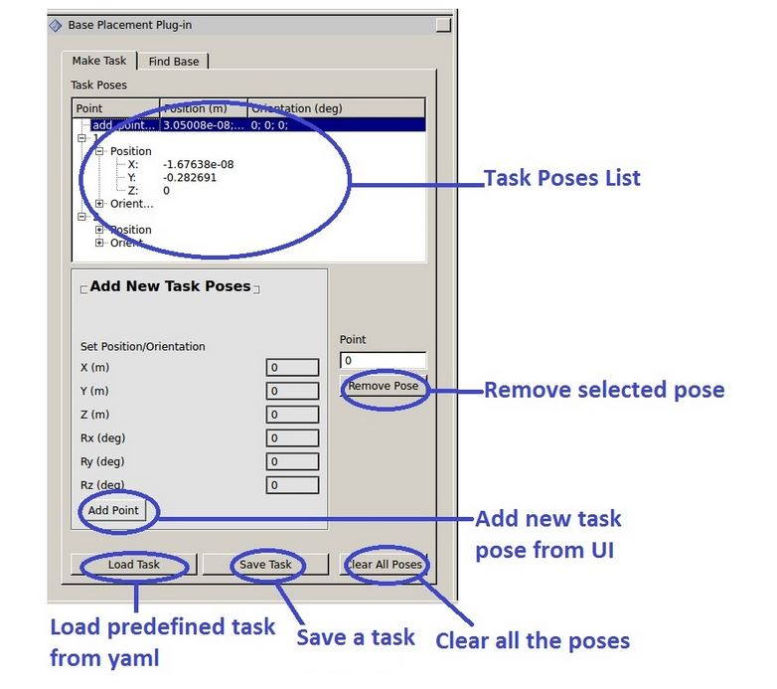
Figure 6 Base Placement plugin task modifications

There are three base placement methods Principal Component Analysis, Grasp Reachability Score, and IK Solution Score which can be changed by the user. First of all, the Principal Component Analysis as the planner takes desired number of high scoring spheres and implements PCA for finding optimal orientations from all the poses correspond to that sphere. One poses from one sphere. Secondly, the Grasp Reachability Score Method as The planner takes desired number of high scoring spheres and collects all the poses from them then calculates reachability of that poses with all the grasp points. The poses that can reach all the grasp poses can be considered as optimal base locations. Finally, IK Solution Score Method as the planner takes desired number of high scoring spheres and collects all the poses from them. Then calculates number of Ik solutions of that poses with all the grasp points. The poses that have the highest score can be considered as optimal base locations.
- RESULTS
After installing the required packages we were able to simulate the universal robot UR5 in the work space. However, the robot can’t reach the given solutions after carefully measured. We analyzed the base placement calculations and try to identify the issue. We were able to find a few programming bugs and we attempt to fix it. For example, the code didn’t specify the correct dependencies for each package installed on it. That prevents the program from showing the correct robot in the workspace visualization tool. We were able to correct these bug by identifying the sequence of programming load and modify the make list, and package XML files in the package. The code also written in a pure C++ code with all executables included in the main function which make the code tracking difficult. We attempt to correct some of that by creating functions whenever it make sense and reuse them as needed. That approach will make the troubleshooting and development much easier in the future.

Finally, when all the parameters are setup, we ran the plugin and pressed the Find Base button which finds the proposed optimal base locations for the given tasks. Based on the selected visualization output, the output shows as an arrow. It also creates a union map based on the inverse reachability solution of all the grasp poses. The union map visualized by pressing the show union map button and the result shown in figure 7.
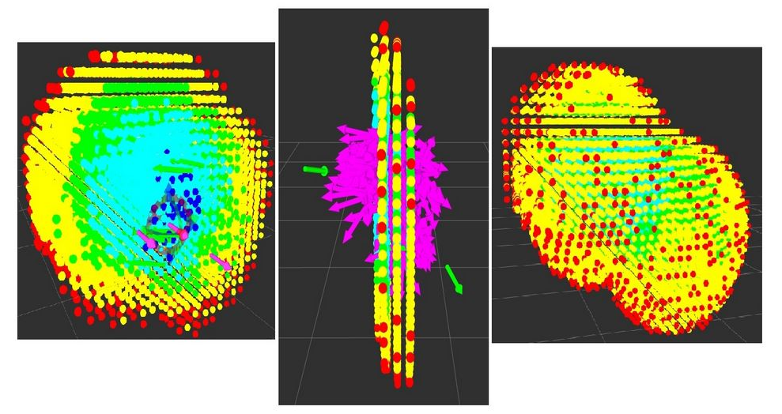
Figure 7 Robot Base Locations

- DISCUSSION
After applying all the above mentioned steps on the known robot kinematics UR5 we were able to observe that the package has several issues and areas for future developments. By inspecting the code we observed that the creator of this package creates several vectors without reserve which resulted in using more memory allocations than necessary. Additionally he makes multiple copies of the vector inside multi-map which can be easily done by just pointing to it. This improvement will decrease the computational time by almost half.

The package also didn’t comply with ROS CPP style guide in several areas. Furthermore, the package adds no constraint on where to place the robot base. For future development of that package we will need to specify a region where we need the robot to be or a region where we can’t place the robot in. These constraints must be added for facility and process limitation. Moreover, the package doesn’t specify an orientation of the robot base which is essential to eliminate final base locations that are not within a given constraint.

The visualization needs a lot of improvements as it will be useful to overlay the robot on the final base instead of just an arrow. Moreover, showing the IK solutions for the given robot pose will be more useful. The scoring methods, the base locations are taken from the high scoring spheres. All the poses from high scoring spheres are collected in a container. From that first number of Final Base poses are considered as final output. So the outputs mostly come from the same sphere. So it looks like a poses clustered from the same origin. Create a random function which will take poses randomly from the containers will be also useful.

Currently, the map creation process does not take into account the final rotation of all the poses and discretize based on the rotation. So a single pose considered. As a result, the output has multiple poses rotated by in z axis. For six degrees of freedom (DOF) robot it should not cause any issue. However, for more than 6DOF robot, rotation parameter has to be included. Also, the reachability map and capability maps have the functionality built into the ROS node. The core functionality, which takes in file arguments and outputs or saves a map, needs to be separated from the ROS node. As a result, the map generation can be compiled as a library and used in any C++ project. The ROS node should create an instance of the create_capability_map class, read the appropriate ROS parameters, and generate the map.

- Conclusion and FUTURE work
In this project, we demonstrate our understanding of Robot Kinematics by using it in a robot reachability study. We propose solutions for improving the robot reachability study package Reuleux. This project also demonstrates our understanding of ROS as we used it to perform the Robot base placement. Overall, it was a successful project as we were able to assess some of the programming bugs and evaluate the software in a real robot. Finally, our future goal will be to use the proposed methods abovementioned to improve the result.

Acknowledgments
I would like to express my deepest appreciation to my advisor, Professor Pranav Bhounsule, for his encouragement, support, and engagement through the learning process of this project. In addition, I would like to sincerely thank Mr. Paul Hvass for his help and collaboration. Finally, I would like to thank South West Research institute for allowing me to use their facility and equipment for testing during this project.
References
[1] F. Zacharias and C. Borst and G. Hirzinger, Capturing Robot Workspace Structure: Representing Robot Capabilities, IEEE-RAS Int. Conf. Intelligent Robots and Systems - IROS 2007, pp.3229-3236.

