ME 5493 Robotics
Fall 2017
December 19th 2017, San Antonio, TX, USA

animation of a short story using matlab

Md Monimul Haque
Dept. of Mechanical Engineering
San Antonio, TX, USA 78249

Abstract
Animation is now an important part of almost of all project work, presentation and for making things understandable to people, colleagues easily. I have tried to make an animation of a short story ‘The Roadrunner and a pitcher ‘for my project work. The reason for choosing this is to learn and utilize matlab as a tool for almost all kind of animation as well as doing technical and mathematical data calculation in my project work. This job will help us presenting some animation of technical data and manipulation.

- InTRODUCTION
In the Robotics class we learnt animation of plotting differential drive car and figure drawing, manipulator workspace, figure drawing with two/three link manipulator etc. So, animation is very important to represent data in a technical manner.
This project aims at creating a movie on a short story, learning techniques to set pictures and maintaining motion in the movie.
- METHODS
In this project I took data that Professor Dr. Pranav gave me for drawing a rowdy.

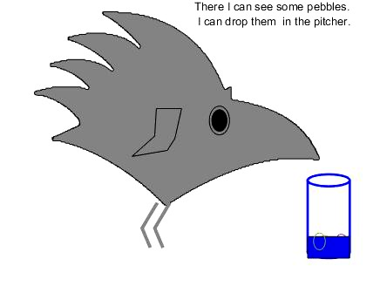

Using plot and patch command I made a rowdy. I set up data for wings, eyes, pupils, legs and using for loop I have shown that the rowdy is flying. Then at somewhere rowdy get to see a pitcher. He flies to there to get water, but water is so little that his beak can barely reach there. So, he devises a plan to do more work on it and looking for some pebbles.

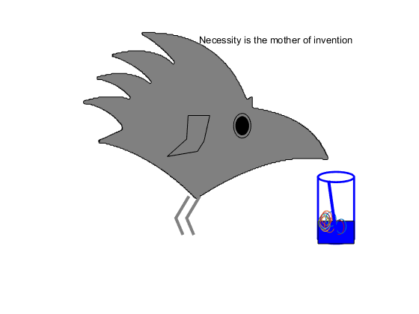

Figure 2 Rowdy

He drops pebbles in the pitcher. Still his beak could not reach to get water. Disappointed roadrunner (rowdy) then collects a straw so that he can suck water through it. Finally he uses the straw and drink water from the pitcher. The rowdy teaches us ‘Necessity is the mother of invention’.

- RESULTS
After running the matlab file I get to know there are some issues with the animation movie. Sometimes I see the issues, sometimes not. The reason is that for the animation it does not get all the frames that I draw in the matlab files. Then I used several places set (file Name, getframe) function. Also there are some issues with visibility options in figure/ plot/line/patch commands. I tried to make a group of pictures visible off while keeping other pictures on. Sometimes I have got problem in movie files. I also tried ‘delete’ function instead of set (‘Visible ’,’off/ on’) function, sometimes it works. Sometimes I did not get optimum results that I expected.

Finally, working on an animation is a fun project to do and it gives me an understanding of working with animation.

- DISCUSSION

Drawing some pictures and making an animation with them give me a knowledge of working stuffs together to make a project. Drawing a rowdy, flying, get to a pitcher, dropping pebbles in it, and finally having water using a straw – all were portrayed in a sequence. I could have drawn some colored window, but I didn’t.

- Conclusion and FUTURE work

In this project, I demonstrate my understanding of doing animation in matlab. I tried to do more work on it. It is really interesting to do animation, create a story, make a movie, having fun with animation in matlab. For future work, I can say that we need to work on flying in a different path with angular movement, crowing, chirping sound, sitting, walking, running, drawing some trees, sitting on the trees in the project.

Acknowledgments
I would like to express my deepest appreciation to my professor, Dr. Pranav Bhounsule, for his encouragement, support, giving efforts and time and engagement through the learning process of this project.
References
Matlab files for Robotics class provided by Dr. Pranav Bhounsule

