**Mechatronic Final Hardware Project Report**

**ANIMATRONICS FACE: Brendy Rincon Troconis**

<https://www.youtube.com/watch?v=00ckqVzZ6wg>

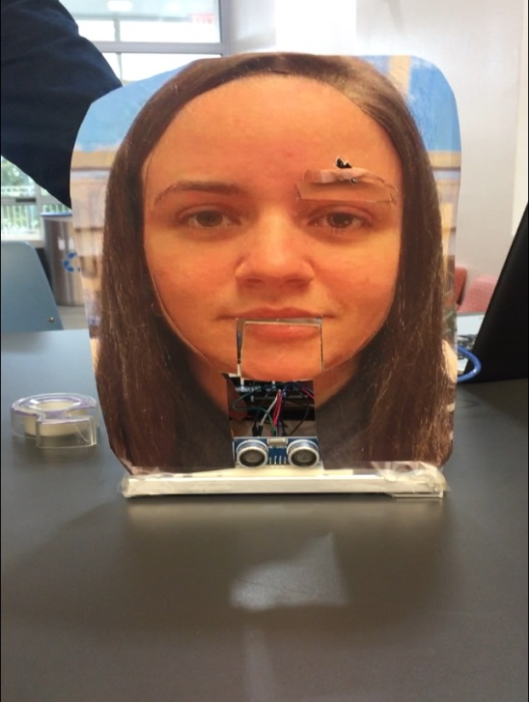

Canyon Headrick

Dept. of Mechanical Engineering

San Antonio, TX, USA 78249

Opo513@my.utsa.edu

Sergio Rios

Dept. of Mechanical Engineering

San Antonio, TX, USA 78249

ern476@my.utsa.edu

Nick Haney

Dept. of Mechanical Engineering

San Antonio, TX, USA 78249

nickhaney2@yahoo.com

TABLE OF CONTENTS

|  |  |
| --- | --- |
| Topic (remove this line in the final report) | Page number |
| Abstract | 3 |
| Literature Review | 4-5 |
| Brainstorming | 5-6 |
| Supporting Structure | 6 |
| Joints and Motors | 6 |
| Sensors | 6 |
| Programming | 6 |
| Lesson learnt and suggestions | 6-7 |
| Personnel and Bill of Materials | 7-8 |
| Acknowledgements | 8 |

**ABSTRACT**

The purpose of this project is to make an animatronics face of a UTSA ME professor. We researched possible design models and chose one that we felt was the best and most applicable. Using the hardware provided and bought, multiple sensors and motors were interfaced using an Arduino Mega. The frame was built using inexpensive materials; the frame served not only as support but as a way to mount the hardware. To complete the project, a picture of the professor was glued to the frame, and audio of the professor was recorded and played in sync with a moving mouth.

**Section 1: Literature review**

Face 1:  SSU-1 Robot Head

           SSU-1 is an animatronic puppet that is animated by means of electromechanical devices. A frame is needed to support any mechanical mechanisms for eyes, eyebrows, mouth and other facial gestures. Actuators such as solenoids, servo motors, stepper motors and the frame supports others. These actuators are responsible for the actual movement of the eye, mouth and other face mechanisms. The head of the SSU-1 is made of Styrofoam and two Ping-Pong balls were used for the eyes. Springs are used in conjunction with DC motors to control the eyes position up, down, left and right. Class 2 levers can be used to increase the speed of movement of a facial gesture if connected between the actuator and control of the facial gesture. The hardware section of SSU-1 uses Cypress PSOC microcontroller. The microcontroller is programmed in C language to control different facial mechanism of the SSU-1.

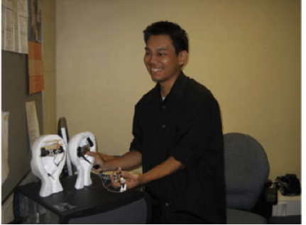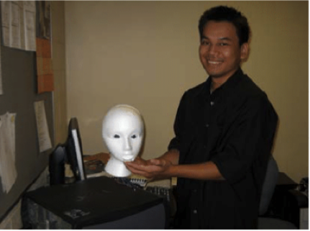

Link: <https://www.researchgate.net/publication/228712974_Animatronics_and_Emotional_Face_Displays_of_Robots>

Face 2: Servo Actuated Mouth by Pyroelectro:

           The animatronic face described was created as a tutorial on how to create an animatronic mouth. The animatronic mouth consists of a HS-485HB Servo Motor, PIC 18F452 controller, 7805+5V regulator, jumper wire and breadboard. The mouth schematic consists of a power circuit, microcontroller circuit and servo motors as shown in the schematic below. The extra servo motors are for the eyebrows and eyes.  The face is made of cardboard while the eyes are made of Ping-Pong balls.

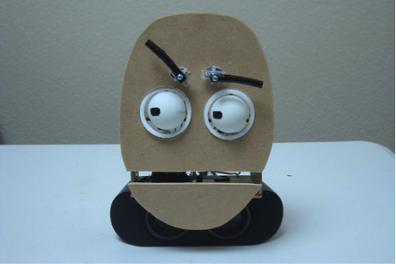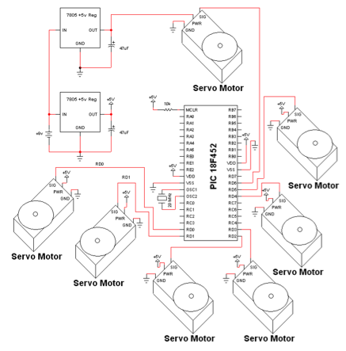

Link: <http://www.pyroelectro.com/tutorials/animatronic_mouths/conclusion.html>

Face 3: Animatronic robot By Brainergiser

           The face is made of aluminum channels and sheets while the eyes are made from rubber balls. The mouth and eyes are controlled by two servo motors. The control circuit was based to 555 timer IC to provide pulses to the servo. A multi-turn variable resistor/potentiometer was used to vary the pulse width thus the angle of rotation.

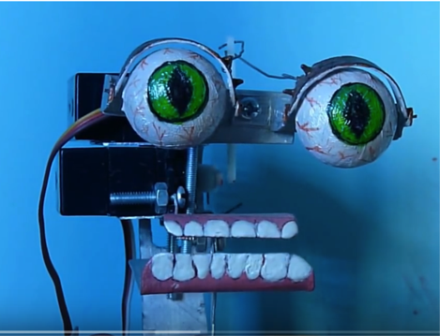

Link: <https://www.youtube.com/watch?v=2bN3ZSUr-QQ>

**Section 2: Brainstorming (initial planning)**

Ideally, we would like our animatronics to have multiple facial features move. The main moving part is the mouth, with secondary movement in the eyebrows. The mouth’s movement will mimic that of a nutcrackers’. A small rectangular section will be cut that includes the lower lip. A servo motor will move the mouth via some sort of connection (piece of cardboard, small wooden dowel, paper clip). To activate the servo, a touch sensor will be used. For the eyebrows, more servos would control the movement to imitate eyebrows raising. An ultrasonic sensor will be used to move the servo. The supporting structure will be made out of something rigid like wood or metal. It will be held together with hot glue. The picture of the face will be glued to a piece of cardboard which will be glued to the frame. We plan to record a sentence or two when we visit Brendy during her office hours. If possible, an SD shield will be used to play the audio when the touch sensor is activated. The project will receive power from a laptop via the USB cable that connects to the Arduino.

**Section 3: Supporting structure**

The supporting structure was constructed of aluminum tile trim. The trim was cut to size and then hot glues together creating a base that resembles that of a catapult. The face frame was made out of cardboard and cut into the general size and shape of the face that was going to be used. The jaw joint was cut out of the face, similar to the form of a nutcracker. A photo of the face was then overlaid on top of the face frame.

**Section 4: Joints and motors**

For our project, we are creating an animatronic face with three moving joints, the mouth and a set of eyebrows. We will be using a total of three servo motors, one for the mouth and one for each eyebrow. The group will be using three Longrunner LKY62 Digital Servo Motors to move each joint on the animatronic face. These servo motors will be used to move the jaw in the vertical direction to simulate the motion of a mouth. The eyebrows will also move in the vertical direction to simulate the motion of eyebrows raising and lowering.

**Section 5: Sensors**

The group’s animatronic face will consist of two different sensors, a touch sensor as well as an ultrasonic sensor. The touch sensor will be used to initialize the jaw and voice of the face, will the ultrasonic sensor will be used to control the motion of the eyebrows. The ultrasonic sensor will be used to raise the eyebrows to make the animatronic face seem surprised when someone walks by or sets off the sensor. The touch sensor will be used to interact with the face. Once touched, the jaw will move up and down as if it is talking due to the servo motor. We will be using a TTP223B Digital Touch Sensor as well as a HC-SR04 Ultrasonic Sensor Distance Measuring Module.

**Section 6: Programming for interaction**

Since Arduino coding isn’t our strong suit, we relied heavily on Arduino libraries and codes from other people’s home projects. The main library we used was the servo sweep library. This allowed us to determine the angle range for the mouth’s movement. This is important because we could make the mouth look a little more real. Also, we were able to control the speed the mouth moved. This along with a ‘i++’ command allowed us to move the mouth faster and multiple times to help with syncing to the audio.

**Section 7: Lessons learnt and suggestions (1 page)**

1. Learned how to interface sensors
2. Learned more about how to properly wire circuits
3. Learned how to modify Arduino base code to meet needs
4. Coding the ultrasonic sensor and servo took a little while because we have never used one before. To help, we researched how to do it and used a little trial and error to finish the loop
5. Suggestion: Help a little more with incorporating the audio into the project. It was very challenging, and we didn’t ever figure it out.
6. Suggestion: Maybe give us a little more time if possible. There were a lot of students struggling because of how much we had to do in Senior Design, and this project just added onto the To-Do list. It was a fun and interesting project, but I feel like mostly those not in Senior got to fully enjoy the project.

**Section 8: Personnel and bill of materials**

**(a) Personnel**

We know there is supposed to be a table here; however, all three of us contributed to everything. At the demo, our TA asked us who did what, and we explained to him that everyone was involved with everything. The project and this report were truly a team effort.

**(b) Bill of materials**

|  |  |  |  |  |  |
| --- | --- | --- | --- | --- | --- |
| No. | Description | Website/comment | Qty. | Unit $ | Total $ |
| 1 | Arduino MEGA 2560 | Provided | 1 | $0 | $0 |
| 2 | Breadboard | Provided | 1 | $0 | $0 |
| 3 | Servo motors | Owned | 2 | $0 | $0 |
| 4 | Metal Frame | Bought at Home Depot | 1 | $2.35 | $2.35 |
| 5 | Heavy Duty Dikes | Owned | 1 | $0 | $0 |
| 6 | Hot Glue Gun | Owned | 1 | $0 | $0 |
| 7 | Glue | Owned | 1 | $0 | $0 |
| 8 | Ultrasonic Sensor | <https://www.amazon.com/gp/product/B004U8TOE6/ref=oh_aui_detailpage_o04_s00?ie=UTF8&psc=1> | 1 | $2.69 | $2.69 |
| 9 | Touch Sensor | Owned | 1 | $0 | $0 |
| 10 | Cardboard | Box Bought at Walmart | 1 | $0.67 | $0.67 |
| 11 | Wires | Owned | 13 | $0 | $0 |
| **Total** | | | | | **$5.71** |

The total price for this project excluding the Arduino MEGA and breadboard was **$5.71**.

**Acknowledgements**

Special thanks to Brendy for being very easy to work with. She is a great professor, and we were very happy with the results.

**References:**

[1]Animatronics Face of UTSA's President, Dr. Ricardo Romo, <https://youtu.be/xkze1_hnam0>

[2] ROMOBOT - ANIMATRONIC FACE ROBOT

<https://www.instructables.com/id/RomoBOT-Animatronic-Face-Robot/>