ANIMATRONICS FACE: Prof Ruijie Liu

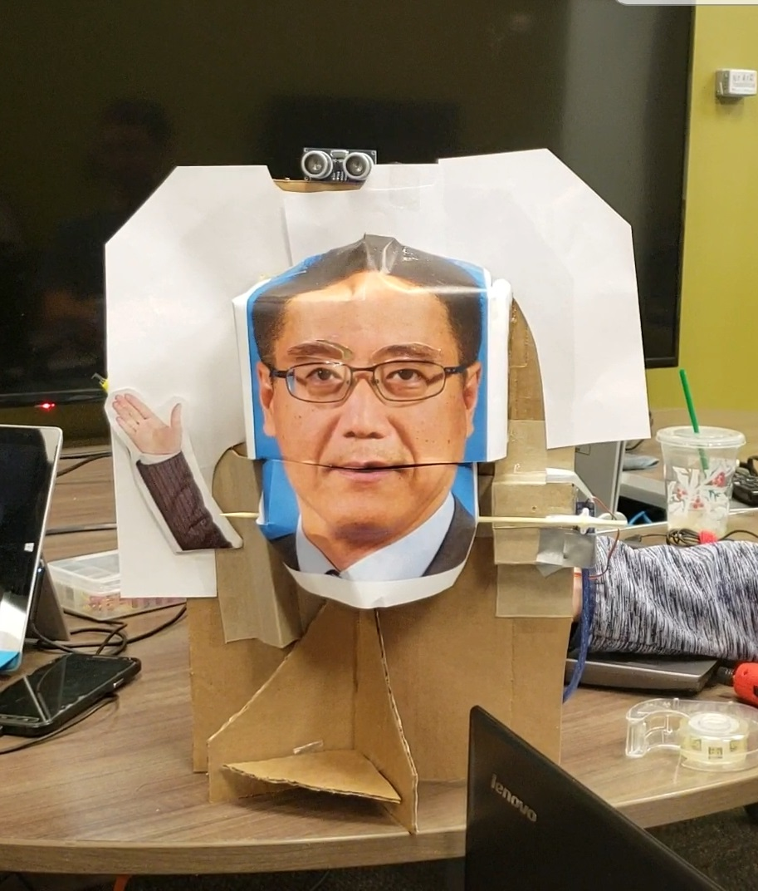

<https://youtu.be/ELYfBUr8vaI>

Ryan Thornberg

Dept. of Mechanical Engineering

San Antonio, TX, USA 78249

[thornberg.ryan@gmail.com](mailto:thornberg.ryan@gmail.com)

Jacob Thornbury

Dept. of Mechanical Engineering

San Antonio, TX, USA 78249

jacob.thornbury@gmail.com

Sean Lambert

Dept. of Mechanical Engineering

San Antonio, TX, USA 78249

[silcan.lambert@gmail.com](mailto:silcan.lambert@gmail.com)

Submitted as part of project for ME4543 Mechatronics, Fall 2018

TABLE OF CONTENTS

|  |  |
| --- | --- |
| Abstract | 2 |
| Literature Review | 3 |
| Brainstorming | 4 |
| Supporting Structure | 4 - 5 |
| Joints and Motors | 6 |
| Sensors | 6 - 7 |
| Programming | 7 - 8 |
| Lesson learnt and suggestions | 8 - 9 |
| Personnel and Bill of Materials | 9 |
| Appendix A: Code | 11 |

**ABSTRACT**

The purpose of this project was to have undergraduate engineers experience designing and constructing a project in a team setting. The team’s objective was to construct an interactive animatronic face resembling a faculty member currently employed at UTSA. The project required encompassing two sensors and corresponding movements in response to their input. To do so, an Arduino microcontroller and its software were implemented into the design to communicate between the sensors and outputs. After a successful development of the product, it will be presented and tested to meet the basic project requirements described in the syllabus. Throughout its duration, the group was able to learn and apply their skills in constructing the structure, configuring the hardware, and coding the software. In doing so, the group delivered a successful product.

**Section 1: Literature review**

The animatronics of the RomoBot were inspired by the past UTSA President, Doctor Ricardo Romo (**Figure 1**). The purpose of this animatronic was to demonstrate the president speaking by emitting a voice recording of Dr. Romo while moving its face to match the president’s motion. A list of materials is provided and amongst them is the Arduino Mega, but could easily be replaced with the Arduino Mega 2560. As for the structure, a total of 6 servo motors and numerous push-rods were used to allow for movement of the face. The face is a mask that is cut and connected to the push rods to allow certain facial parts to move independently of one another. An erector set was used but can be replaced with wood or Legos, and speaker was wired to the Arduino to emit the audio recording. <https://www.instructables.com/id/RomoBOT-Animatronic-Face-Robot/>

A close up of a person wearing glasses

Description generated with high confidence

**Figure 1**. The RomoBot

The animatronic face seen in Figure 2 was created to mimic not only the facial expressions of an individual, but to also incorporate the tilting of the head. The team purchased a mannequin to model the form of the robot and incorporated a total of 8 degrees of freedom- 5 in the face and 3 in the neck (for each axial motion). The robot was created by consulting many kinesiology references to ensure the motions closely resembled those of a human. In regards to hardware, Arduino was used in conjunction with servo motors to move each part separately (expect for the eyes, eyebrows, and eyelids). SolidWorks was a key resource utilized in the creation of the various mechanisms. Overall, this animatronic face is a great example of what can be accomplished if more time is provided. <https://web.wpi.edu/Pubs/ETD/Available/etd-050112-072212/unrestricted/Fitzpatrick.pdf>

A picture containing wall, person, indoor

Description generated with very high confidence

Figure 2. Animatronic Mannequins created by Robert Fitzpatrick

**Section 2: Brainstorming**

The animatronic face will be able to make mouth and eyebrow movements and will incorporate eye movements if time allows us. The eyebrows will move via a shaft and rotate from the center edge of the brow using servo motors. The jaw will use a stepper motor to operate a hinge for the lower jaw. All of which will be powered by a 3s lipo battery. The assembly will consist of light wood parts and cardboard with a photo glued on.  The sensors that will be used are an ultrasonic sensor or a distance sensor to move the eyebrows, and a motion or noise sensor to activate the speech of the animatronic. The animatronic face will be constructed using a mask reinforced with thin wooden planks- similar to popsicle sticks- to provide more structural stability. A picture of the professor will be adhered to the mask. The motors will be mounted to a large wooden block to provide structural stability to the project as well as limit the time spent on designing a frame. These motors will control the jaw of the mask and move it in sync with the audio recording obtained from the professor.

**Section 3: Supporting structure**

The supporting structure was created using recycled cardboard from various sources- mostly boxes that were utilized to retain food (i.e. bags of chips, sod cans, etc.). First, a photo of Liu Ruijie (Jerry) was taken from the UTSA website [3] and printed out. Professor Ruijie is the faculty member the group is responsible for modeling the animatronic face after. The cardboard was cut and folded to mimic the jaw and forehead of a human skull. The cardboard skull was then cut to isolate the jaw from the rest of the structure.

With the jaw separated, the photo was then cut horizontally to also separate Professor Ruijie’s jaw from the rest of his head. The photo and cardboard representation of the jaw were adhered together. The eyebrows of Professor Ruijie’s photo were removed as they will be acting independently from the cardboard skull. Therefore, the rest of the eyebrow-less photo was adhered to the cardboard skull (Figure 3).

**Figure 3.** Cardboard Skull of Professor Ruijie

Now that the skull had been created, the group was able to work on the structure that the skull will be supported by. For this, a backplate is required to mount the skull and motors to. A solid piece of cardboard was used as the backplate because it would support the weight of the motor and skull. The servo motors were adhered to the backplate via a hot glue gun, and a cardboard motor housing was made and placed over them. The skull was elevated off the backplate and supported by adhering it to the motor housing. Lastly, the back plate was supported using another piece of cardboard that was inserted into a slot made at the base of the plate (Figure 4). The resulting structure can be seen in Figure 4.

**Figure 4.** Bare Supporting Structure of the Animatronic Face

**Section 4: Joints and motors**

For this project, the animatronic face needed only three joints- each of which was controlled by a servo motor. The first two joints were for the eyebrows. The face of our professor had his eyebrows removed so that they could be attached to the servomotors. This way, they can be easily programmed to move simultaneously as well as have a rotational degree of freedom. They were secured to the shafts of the motors by using attachable fins the motor came with. The eyebrows and fins were adhered to one another by using double-sided tape.

The shafts of the motors were then placed into slots that existed where the eyebrows were. This allowed the animatronic face to maintain its proportions. To provide a realistic appearance while moving the eyebrows, the pivot points were placed at the outermost ends of the face- the shaft’s fin allowed this placement. Figure 3 shows the inserts and how they aligned with the face.

The last joint for the animatronic face was, of course, the jaw. As part of the minimum design criteria, the jaw of the model must move synchronous with the voice recording of the professor. Initially, the group was using a stepper-motor with connections to an H-bridge. The stepper motor would allow the group to change the rate and position of the jaw very accurately by using the motor’s increments. However, the speed of the motor was too slow to move from its open and closed positions to match with the voice recording.

Therefore, the group introduced a third servo motor. The servo motor fin (connected to its shaft) was adhered to two long wooden skewers located at one side of the mouth. The skewers were attached to the prefabricated jaw. Ultimately, this configuration allowed the jaw to have a rotational degree of freedom that was minimized to allow the deflection to be visualized as linear rather than rotational.

**Section 5: Sensors**

One Thermistor TMP36GZ, one HC-SR04 ultrasonic sensor, and a button were used for this project. A thermistor is used to record and interpret changes in temperature. This is done by placing two highly conductive materials in series with one another. When current flows into one material it is transferred to the next one. However, both materials’ conductive properties change as their surrounding temperatures change. This allows the output signal to change as the temperature changes- ultimately enabling the software to read the temperature as an analog output. This further allowed the group to designate target temperatures that will trigger certain function in Arduino.

Utilizing the thermistor, the group attached it to the left side of the model behind a paper cut out of an image of a hand. When an individual comes in contact with the thermistor for approximately 25 seconds, the person’s body conducts heat to the thermistor- changing the voltage and current flow between the conducting materials. Once the thermistor reaches a temperature of 80 degrees Fahrenheit, the Arduino sends a signal for the position of the eyebrows to change. Ultimately, it’s designed to have the professor look uncomfortable as someone “holds his hand”.

The ultrasonic sensor was mounted at the top of the plate above the face. An ultrasonic sensor is used to determine the distance objects are from itself. It achieves this by emitting a signal (Trigger Pin) and timing how long it takes that signal ro return- where it is received by a receiver (the Echo pin). Knowing the speed of sound and when the signal was emitted allows the user to determine what the distances by the time elapsed. However, it should be noted that the time elapsed between when it is emitted to the time it is received needs to be divided by 2. This is because it takes the same amount of time for the signal to hit the object as it does to return from hitting the object.

Any time the the sensor detected an obstruction within a close distance, Arduino would send a signal to the eyebrows to rotate upwards to a set position. This resulted in the animatronic face looking surprised to have an object so close to it.

**Section 6: Programming for interaction**

This section will be broken up into three different areas in order to easily convey programming logic. First the initialization code, second the void setup, and third the void loop.

The initialization involved two different libraries be added. First, the Servo.h file and second the “NewPing” library. The Servo.h was required in order to give basic servo control. It allows “Servo” as a command and can initialize multiple servos to work at the same time. The second library NewPing helped organize the sonar outputs. This library made it easy to define the trigger, echo and max distance needed to operate the ultrasonic sensor reliably. Once all the initial positions of our servos were created along with the temperature sensor signal and button signal the void setup was next.

There are three things necessary for the void setup. The Serial.begin(9600) command, the attachment of the free servos to their signal pins, and a pinMode for the button used. These will be used a set up and will only run once.

Finally the void loop. This required the most logic for programing, where as the other sections were setups. A delay was introduced in order for the readings to be reliable. When this was in the 1-10 range of ms often the ultrasonic and temperature sensors gave occasional outliers for reading results. This would cause the motors to jitter and move inconsistently. The easiest to logic was the buttonState. This had a digitalRead for its assigned pin. If it read High then the jaw servo3 would move with a preconfigured movement based on the audio recording. Next the temperature sensor was used as an analogRead for its assigned sensor pin. Because it normally reads a voltage it had to be converted to a temperature print using some sourced conversion code.

For all servos, there is a default position defined in their initialization. Using the write command, each servo was placed in this default position to create a resting face. If there was a change in the sensor readings in the conditional section of the if statement then they would move to a non default position which was also defined in the initialization section.

For the ultrasonic sensor, a range of 20 to 1 cm was desired to trigger a surprised reaction. So the max distance was set for 20 cm. Because of this all readings beyond 20 cm was written as a 0 reading. So with this in mind, a if NOT statement was used. As in, if the reading is NOT 0, then write these two sensors to position surprised. This was a huge breakthrough for the team as the ultrasonic sensor would often read distances in the 100’s of cm when it was not interacting with an object. Because every reading was now a 0 until a defined object came within the 20cm range a reduction on unreliable movement was created.

The temperature sensor required a range of temperature to activate servos 1 and 2 to a mad position. After testing and viewing results in a serial monitor a range of 78 to 90 degrees was established. 78 degrees as the lower boundary because this was a typical quick response to a couple of seconds of being held with somebody's hand. 90 as the upper bound was chosen because it would often read above 90 in outlining data. This would have been nice to fix as on occasion readings above 90 would be outside of the conditions for this if statement and attempt to return the servos to their default positions.

Finally, the last sensor was a button read where if the button read LOW then it would begin a jaw movement that was timed based off of the audio recording. This concludes all logic and programming involved in the project and can be observed in the appendix.

**Section 7: Lessons learnt and suggestions**

Many lessons can wear learned while building the animatronic face. Some of them are as follows:

1. Stepper motors are utilized when position accuracy and control over rotational speed are needed. Although servo motors are able to provide the same responses, they do not do so with the accuracy a stepper motor provides. The group tried to use this to their advantage when programming the jaw movement. However, configuring the code required for the stepper motor to function was far more complex than configuring that of a servo motor. Because of this, the servo was used instead of the stepper motor. Additionally, the servo was used because the project did not require the accuracy of the stepper motor.
2. Another lesson is how to properly purchase products online. There is a lot of information about various different electronic components and their optimal operating conditions. This was particularly useful when determining which thermistor would be best to use in the project. The thermistor that was given in the Arduino starter kit didn’t have the sensitivity that the group needed to have an accurately timed output.
3. Simplicity is key. Many groups had spent a lot of time and resources into their designs. Although it is favorable to doing the minimum requirements, it doesn’t impact your grade. Doing more than what is asked only made the project more difficult and time-demanding. This is time that would have to be taken away from other classes. My group kept the design simple to ease the amount of computing and construction as well as give more focus on debugging the code rather than making the framework.
4. Unfortunately, after multiple uses the jaw became misaligned from the rest of the face. This is largely due to the vibrations on from the harmonic motion of the jaw as well as the torque generated from the movement. This torque was transferred to the base of the motor that was connected to the model. Since the motor was secured with tape, it is understandable that it became loose over the course of the trials. Next time, the group will secure the motor with hot glue for a sturdier connection.

There are also many learning outcomes that will be a taken past this class and used to improve the group as engineers. Some instances of this transference are listed below and indicate how we can improve.

1. This project encompassed the use of Arduino- a useful but simple microcontroller. In the industry, there are other software systems that will have to be learned and mastered to keep up with its evolution. An example of this is the myRIO controller from LABVIEW which is currently being implemented in another course at UTSA. The project was successful because undergraduates at UTSA have had a significant amount of experience with Arduino. However, the group can improve by learning different software interfaces to better equip ourselves for the industry.
2. Th project really showed how essential checkpoints or milestones are when designing a product. There will always be deadlines but having these milestones assist in prioritizing the time spent throughout the duration of the project. Another take away was that checkpoints should be completed sooner rather than later. This is because one doesn't know how exactly much time is expected to be spent on a future milestone. Since it’s uncertain, it helps to have more time to finish the next assignment rather than be rushed.

**Section 8: Personnel and bill of materials**

**(a) Personnel**

|  |  |  |
| --- | --- | --- |
| Task | Main Personnel | Secondary personnel |
| Programming | Ryan Thornberg | Jacob Thornbury |
| Sensor Integration | Jacob Thornbury | Ryan Thornberg |
| Structure Design | Sean Lambert |  |

**(b) Bill of materials**

|  |  |  |  |  |  |
| --- | --- | --- | --- | --- | --- |
| No. | Description | Website/comment | Qty. | Unit $ | Total $ |
| 1 | Arduino MEGA 2560 | Provided | 1 | 0.00 | 0.00 |
| 2 | Small stepper motor | <https://www.sparkfun.com/products/10551> | 1 | 6.95 | 6.95 |
| 3 | Wood | Scrap |  | 0.00 | 0.00 |
| 4 | Servo Motor | <https://www.amazon.com/gp/your-account/order-details?ie=UTF8&orderID=112-3679159-5432202&ref_=pe_2640190_232748420_TE_simp_od> | 2 | 2.58 | 5.16 |
| 5 | Temp Sensor | <https://www.adafruit.com/product/165> | 1 | 1.50 | 1.50 |
| 6 | Ultrasonic Sensor | <https://www.adafruit.com/product/3942> | 1 | 3.95 | 3.95 |

**References:**

# [1] Animatronics Face of UTSA's President, Dr. Ricardo Romo, <https://youtu.be/xkze1_hnam0>

# [2] ROMOBOT - ANIMATRONIC FACE ROBOT

# <https://www.instructables.com/id/RomoBOT-Animatronic-Face-Robot/>

# [3] <http://engineering.utsa.edu/mechanical/team/ruijie-liu-ph-d/>

**Appendix A: Code**

[**https://drive.google.com/drive/folders/1IRD7G2HYVeuv7ZnhmGRcZJix_2eRBerB?usp=sharing**](https://drive.google.com/drive/folders/1IRD7G2HYVeuv7ZnhmGRcZJix_2eRBerB?usp=sharing)

Please use this link for a PDF of the code along with the Arduino Source