ANIMATRONICS FACE: PROF ZHI-GANG FENG

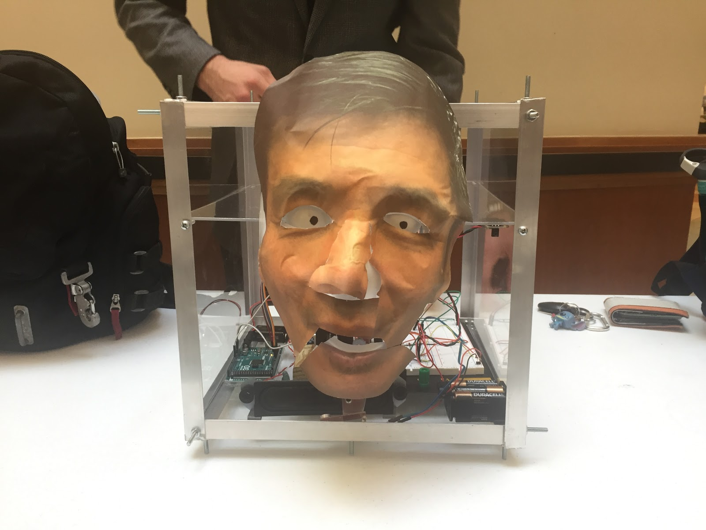

Zachary Taylor

Dept. of Mechanical Engineering

San Antonio, TX, USA 78249

xuu348@my.utsa.edu

Conrad Bowden

Dept. of Mechanical Engineering

San Antonio, TX, USA 78249

bowden.cg@gmaill.com

Elizabeth Pillar

Dept. of Mechanical Engineering

San Antonio, TX, USA 78249

epillar3@gmail.com

Submitted as part of project for ME 4543 Mechatronics, Fall 2018

TABLE OF CONTENTS

|  |  |
| --- | --- |
| Abstract | 1 |
|
| Literature Review | 1 |
| Brainstorming (Initial Planning) | 2 |
| Supporting Structure | 3 |
| Joints and Motors | 3 |
| Sensors | 4 |
| Programming | 5 |
| Lesson learnt and suggestions | 5 |
| Personnel and Bill of Materials | 6 |

**ABSTRACT**

The purpose of this project is to design and construct an animatronic face that interacts with the user. The animatronics face was modeled after a professor from the Department of Mechanical Engineering. This project allowed students to combine the knowledge from the lectures, as well as the experience from the lab to build this animatronic face. The project lasted 4 weeks and that concluded with a presentation of the final project on November 30, 2018.

**Section 1: Literature review**

The animatronics face of the SSU-1 (Savannah State University-1), shown in reference [1], robot was designed to create human like motions for entertainment purposes. A Styrofoam head served as the frame and was hollowed out to fit actuators such as solenoids, servo motors, stepper motors and others.  This frame also served as a base to attach the mask. Springs were used in conjunction with DC motors to control the eyes. The eye’s functionality included up, down, left and right motion. The hardware utilized in the SSU-1 project included a PSOC (CY8C26443-24PI) microcontroller. The microcontroller was programmed in C language to control various different facial mechanisms.

        Another design that was researched, in regard to animatronic eyes, was an Adafruit design that was modified by Max Maxfield to give the eyes the full ability to rotate 180°.  The full design can be seen in reference [2].The purpose of Max building these eyes was to learn more about servos and for pure entertainment purposes. Max utilized an Arduino coupled with a Adafruit servo shield that was capable of controlling up to 16 servos and interfaces to the Arduino via I2C.  Maxwell created a frame for the servos out of balsa wood and attached two ping pong balls to wooden dowels. The dowels were then attached to the horns (the black pieces of plastic that convey the motion of the servos to other objects) with superglue. Also, Max utilized two potentiometers to determine the pulse widths required for each servo to look directly forward.  These pulse widths were then fed to the servos and an RGB LCD screen to determine the pulse width magnitude.

        Robert Fitzpatrick had an interesting design in his animatronics research project, in which his goal was to create an animatronic head capable of human motion that was programmed using a face-tracking software.  Robert opted to utilize a fiberglass bust instead of a polystyrene head due to the fiberglass bust having more character. Robert’s project encompassed a whole range of different motions; however the eyebrows were of main interest to our group.  The design of the eyebrows can be seen at reference [3]. Robert concluded that an eyebrow moves a total of 13 mm from the down (angry) to top (surprised) positions. The motion cam was the first thing that Robert designed to control the rotation of the eyebrow.  Both translation and rotation were utilized to allow the eyebrow to be controlled with one motor. The eyebrows were attached to a metal rod, which was then mounted into a lever, spring and servo system, all of which was attached to a metal plate to serve as a frame.

**Section 2: Brainstorming (Initial Planning)**

The animatronic will perform eye, eyebrow, and mouth movements. The eye will perform uniform vertical and horizontal movements once by the Infrared Emission (IE) sensor. The eyes will utilize one servo motor. The motor will be attached to a single rod (connection rod) and that rod will have attached to the eyes by two separate rods with joints. At the opposite end of the rods, ½ section of  ping pong balls will glued to the end to get the eye shape. It will allow for the eyes to move up and down when the connection rod translates up and down and will move left and right when the connection rod translate left and right.

The eyebrows will move utilizing one servo per eyebrow. The movement of the outermost portion of each eyebrow will rotated about the innermost portion of the eyebrow.  This motion will simulate emotions of happy, sad and confused. A combination of the motion sensor and the infrared sensor will serve a stimuli for the eyebrows.

The mouth will have a rotational movement about the bottom of the chin area.  This movement will be accomplished utilizing a servo motor with a push rod attached to the top of the mouth portion.  This rotation of the mouth will cause the top of the mouth portion to rotate away from the top “head” portion of the animatronic, which will simulate a talking motion.

The Motion sensor to start-up interaction. The sensor will be placed towards the bottom of the structure, near the chin of the face. It will sense motion up to 2 ft away and will initialize Wake up Statement and then Wake up motion code. This will be synchronized by delays and will be tweaked by trial-and-error.  After the statement, the animatronic will utilize the IE sensor to perform up to different 5 sequences. Of the 5 sequences, 2 of the sequences will contain Statement 1 and Statement 2 below.

A picture of Dr. Feng will be printed and glued to the  MDF board face that is cut to the rough shape of the face.  The face will then be attached to the structure by a mixture of bolts, nuts and wood glue. The mouth of the face will be cut in half to allow for movement. The eyes from the picture will be cut from the picture and glued onto the cut portion of the ping pong ball.

Below is the soundtrack list.

Wake up Statement: “Hello, my name is Zhi-Gang Feng. Interact with the Infrared Sensor to see what I can do.” (Initiated with motion sensor)

Statement 1: “It’s kind of stuffy in here. Sometimes, I wish I was more than a head.” (Initiated with IE Sensor)

Statement 2: “I’m sure if I had a body, I would do something noble… Like teaching.” (Initiated with IE Sensor)

This will be the script recorded during the meeting with Dr. Feng.

The chassis of the animatronic device will be constructed of wood and half-rods similar to the type used on RC cars. A wood frame will hold the servo motors in place along with any other static parts. Moving parts will be attached using the half-rods, bolts and nuts.

After recording the required statements and filtering the sound, it will be uploaded using IC2 to a micro SD card, through a SD card module. Then, each statement will be activated through its respective stimuli.

To power the Arduino we will use a 9V battery and the servo motors will run off of a 12 volt battery. The sensors will be powered through the 5V power output on the Arduino and the SD module will run off of the 3.3 volt power output on the Arduino.

**Section 3: Supporting structure**

The supporting structure is plexiglass box with aluminum edges. The plexiglass allows for clear visual of the joint and motors attached to the head. The box was divided into two sections. The bottom section housed most of the wiring and the motor for the mouth. It also supports the bottom part of the mask.

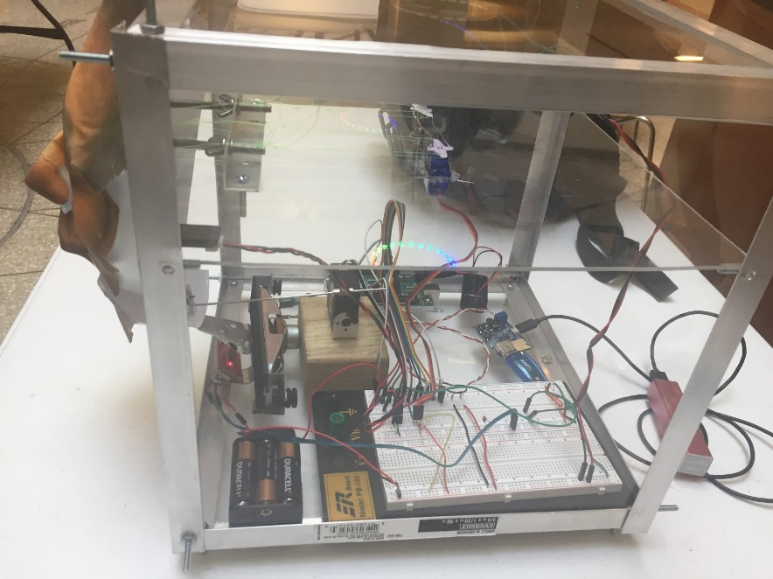

Figure 1. Bottom Section of Structure

The top section housed the servo connected to the eye joints and supported the top section of the mask. The division between the top and bottom section are divided by plexiglass which allows for clear visual of the inner working of animatronic.

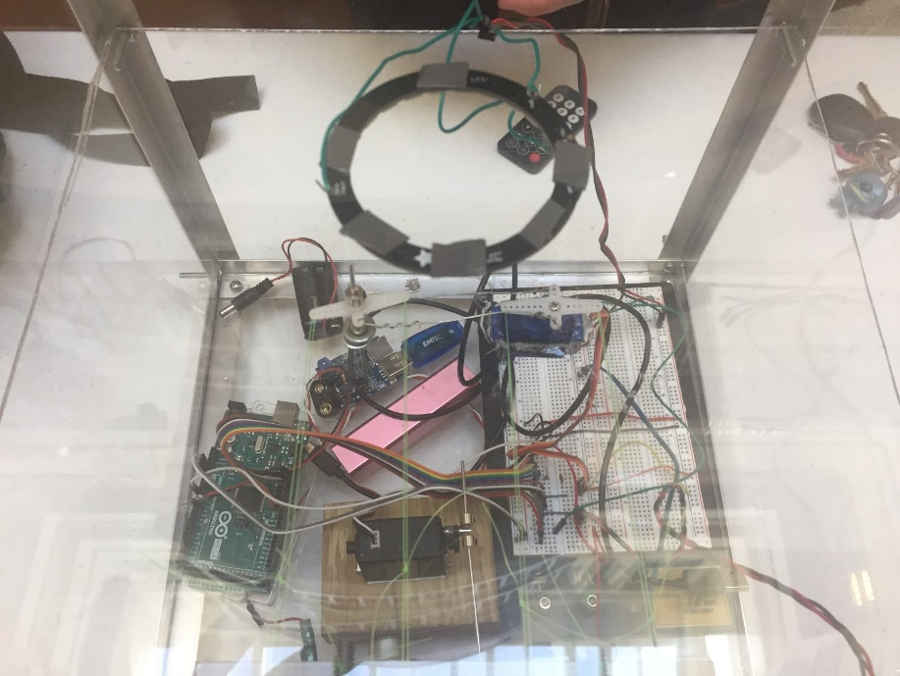

Figure 2. Top Section of Structure

The face was constructed using a plastic mask with a photo of Dr. Feng glued onto its surface. From the photo, the eyes were cut and placed onto the ping pong ball section in order for the eyes of the animatronic to visibly move. The bottom part of the mask was cut to allow for mouth movement. The final version of the face is shown below.

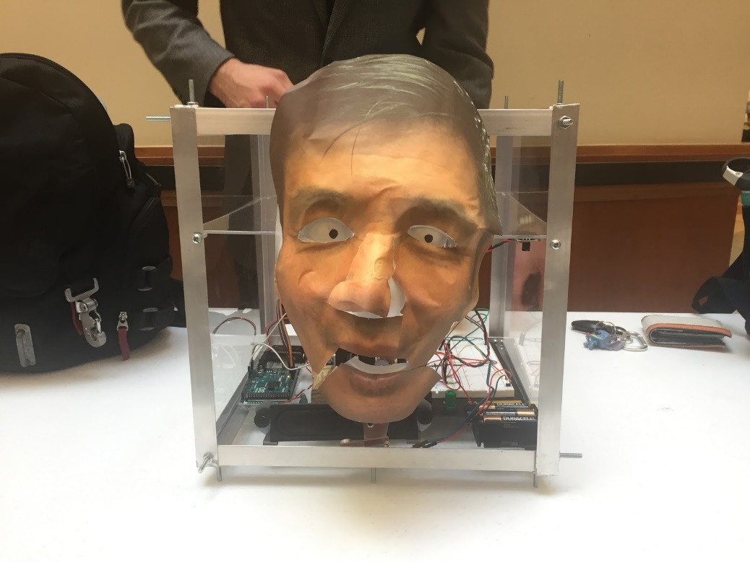

Figure 3. Face of Animatronic

**Section 4: Joints and motors**

The joint for the eyes and the mouth create the desired movement in the animatronic. The mouth joint was created by using door hinge. The section of the hinge was bent 180 degrees opposite of the initial bend as depicted below.

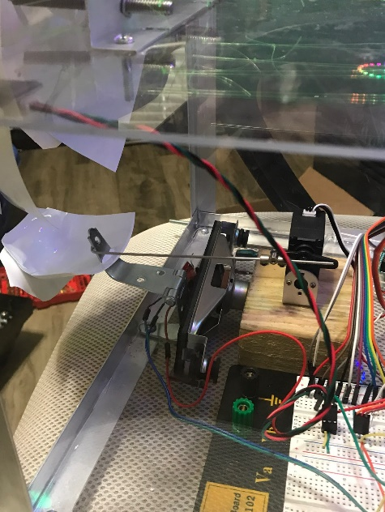

Figure 4. Mouth Joint

The hinge is connect to the servo motor by a slender metal rod. This allowed for vertical movement of the bottom part of the mask by pushing the hinge forward and backward. A large servo motor was chosen to complete this movement because the hinge was slightly heavier and working against gravity. The motor only moved slightly, but the motor still needed to support the hinge.

The joint for the eyes was created by using two carriage bolts, two halves of a ping pong, and are held in place and moved by fishing wire. The ping pong halves were placed over the carriage bolts that are attached to the chassis. The fishing wire is attached to the ping pong halves to stay in place and also to move the eyes. The setup is shown below.

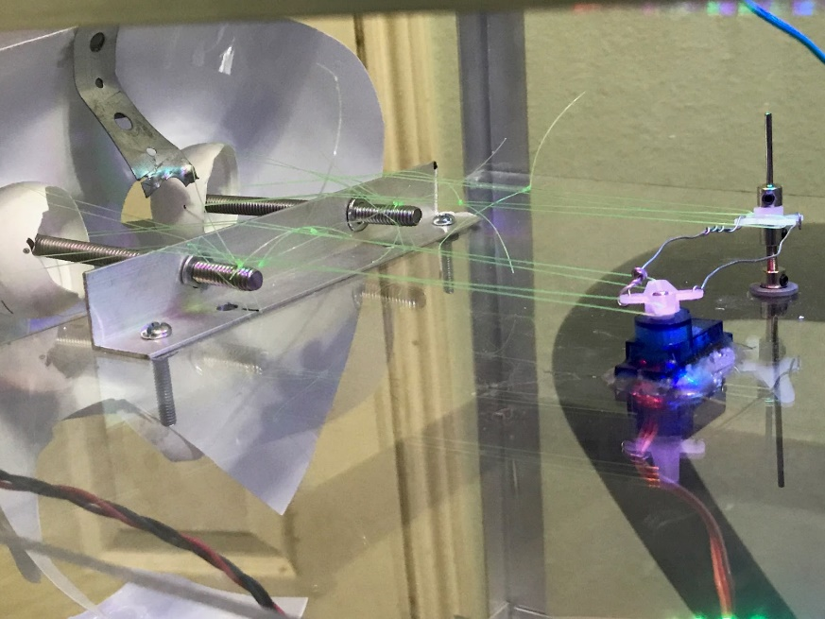

Figure 5. Eye Joint Set Up

This connections allows the eyes, which are represented by the ping pong ball halves, to move left and right. This is done by attaching the two sets fishing wire connected to the sides of the ping pong ball halves and one set connecting it to the base of the carriage to stabilize it. The servo motor moves the attached propeller left and right to create the motion. The fishing wire connected to the left eye replicates the movement while another propeller attached to the other propeller mimics the movement. This in turn causes the right eye to move like the left eye. A small servo motor was chosen to complete this movement because the ping pong are lightweight so a great amount of force or torque was not needed/

**Section 5: Sensors**

The two sensors chosen were audio sensor and an IE sensor. The audio sensor allowed us to sync the recordings with the mouth movement by adjusting the sensor to cancel out background noise and then reacting to the loudest sound in its range. The loudest thing in its range was the speaker placed right in front of it. A picture of the setup is shown below.

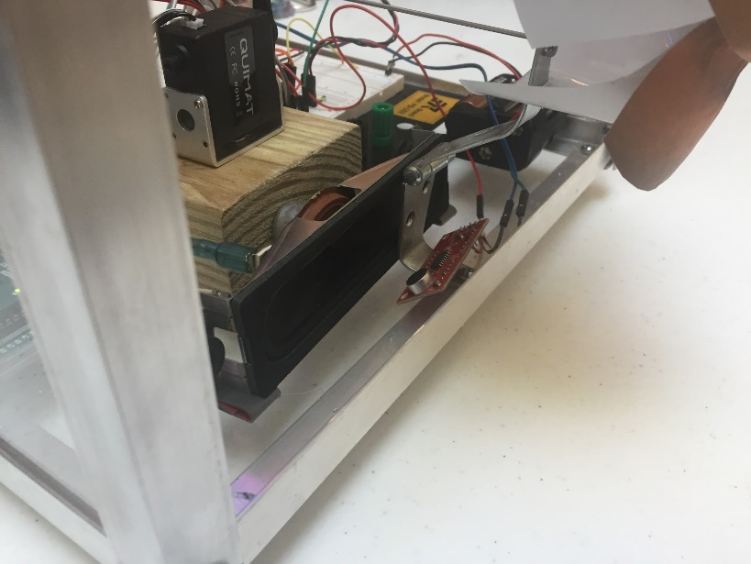

Figure 6. Audio Sensor Set-Up

The audio would either be the recording of Dr. Feng or it would play music. The sensor would then tell the larger servo motor forward or backward depending on the intensity of the sound. This would cause the mouth to move in sync with the audio. The IE Sensor allowed to switch across 3 main preset codes that would cause the eyes to move, the mouth to move, or the light show to go off. This allowed for more controlled motions by use of a remote and was initially use to test the movement of the eye and mouth joints. This made it easier to have multiple movements without the codes for the different movements overlapping and causing an error. The sensor would receive signals from the remote which correspond to a preset code and in turn, the code would instruct one of the devices to complete its code. The first present would cause the small servo motor to move back and forth rotation to cause the eyes to look around. The second preset would move the large servo motor forward and backward to cause the mouth to open and close. The third preset would cause the music in the MP3 shield to start playing. The bonus preset would cause a light show using a row of LED lights. The sensor is shown below.

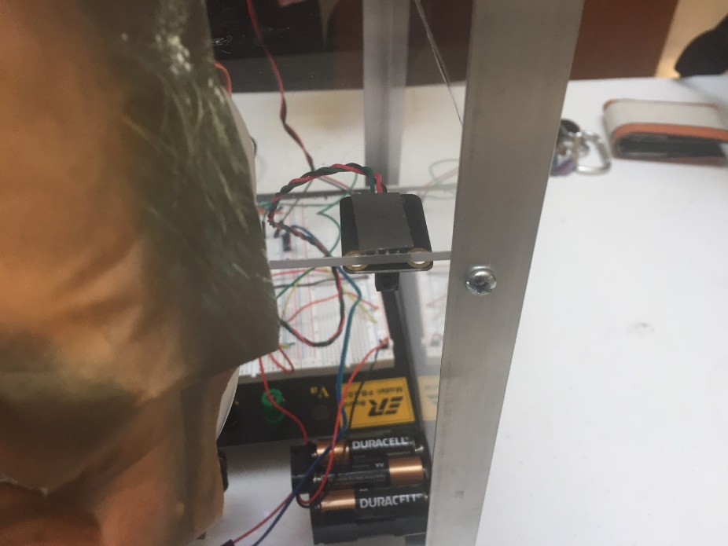

Figure 7. IE Sensor Setup

**Section 6: Programming for interaction**

The logic of the interaction was to show allow for controlled mouth movement. Emphasis was put on the mouth movement when using the audio sensor. The audio sensor was coded to react to the loudest noise as well detect the current ambient noise and negate it. This was done by initially taking a recorded value of the ambient noise, subtract that value from current values, and react to the largest sound in the room. The values from the sound sensor are read as analog values and upload onto the large servo motor as a PWM value.

The IE sensor was heavy on coding due to the use of preset codes. The IE Sensor was coded to receive signals from a remote, it is inputted as an analog signal, and then processed. Depending on the signal received it, the one of the motor or lights will run through the coded sequence. This setup allowed for testing and allowed for easy control of the animatronic.

Below is the a link to the video on YouTube to see Animatronic Dr. Feng in action.

https://youtu.be/Jlvd4bKogwQ

**Section 7: Lessons learnt and suggestions**

1. Presentation is important. When the project was first introduced, the President Romo animatronic was a jumbled mess of cables. The creator of the animatronic tried to explain what was happening, the class could not tell what he was talking about because the animatronic did not provide good visuals.
   1. Have a larger working space allows for easier setup of the animatronic. The extra space utilize during the construction of Animatronic Dr. Feng allowed ease of assembly and quick problem solving if something was not working. It also made it easier to explain what was going on in the animatronic during the presentation.
   2. Organize the cables. The cables with a visually clear line to the ports allow for easy presentation and quick problem solving.
2. There were times where parts would break once inside the chassis of the animatronic. This could be problematic depending on which part this was. Maintenance could take several minutes and may not solve the problem.
   1. Allow parts of the structures where key components are attached to be removable. For instance, the wire connection between the left eye servo motor and the right eye propeller broke. At first, the team tried to fix the component within the chassis, but it was difficult to do. The chassis upper level was removable so it allowed that section of the structure to be removed and maintenance to be done on the eye joint. If this was not done, it would have been a botched maintenance job.
   2. Create a checklist to be able to indicate which component(s) need maintenance. This will be beneficial when trying to indicate which part is broken without taking apart the entire structure to figure out the section you need to fix.
3. Paying attention to details could save you time in the long run.
   1. The MP3 shield used in the creation of this device only used wav format. The recording was made in MP4 format. This is a key detail to have and it could have set the team back if it were not caught beforehand. The conversion was easily made using on online audio convertor.
   2. The syncing of the audio was far more difficult than most teams expected. There multiple approaches to how this could be approached. The best found from this team was using an audio sensor. This saved time when it came to figuring out the timing of the audio and overall time spent in coding.

**Section 8: Personnel and bill of materials**

**(a) Personnel**

|  |  |  |
| --- | --- | --- |
| Task | Main Personnel | Secondary personnel |
| Chassis Design and Assembly | Zachary Taylor | Conrad Bowden |
| Programming | Zachary Taylor | Elizabeth Pillar |
| Project Management | Conrad Bowden | Elizabeth Pillar |
| Mask/Recordings | Elizabeth Pillar | Conrad Bowden |
| Final Assembly | Zachary Taylor | Conrad Bowden |
|  |  |  |

**(b) Bill of materials**

|  |  |  |  |  |  |
| --- | --- | --- | --- | --- | --- |
| No. | Description | Website/comment | Qty. | Unit $ | Total $ |
| 1 | Arduino MEGA 2560 | Provided | 1 |  |  |
| 2 | Micro Servo Motor | Amazon | 1 | 11.78 | 11.78 |
| 3 | Clear Acrylic Sheet | Home Depot (Chassis) | 1 | 28.98 | 28.98 |
| 4 | Aluminum Siding | Home Depot (Chassis) | 3 | 9.96 | 28.88 |
| 5 | ClearWeld Pro | Home Depot (Chassis) | 1 | 15.97 | 15.97 |
| 6 | 3” Hinge | Home Depot (Chassis) | 1 | 3.27 | 3.27 |
| 7 | 1.5” Narrow Hinge | Home Depot (Chassis) | 1 | 2.27 | 2.27 |
| 8 | Mach Screw | Home Depot (Chassis) | 1 | 5.80 | 5.80 |
| 9 | Washers | Home Depot (Chassis) | 1 | 1.18 | 1.18 |
| 10 | Machine Screw Nut | Home Depot (Chassis) | 1 | 3.92 | 3.92 |
| 11 | Rechargeable Batteries | Amazon | 1 | 23.99 | 23.99 |
| 12 | Battery Clip | Amazon | 1 | 5.99 | 5.99 |
| 13 | HiLetgo MP3 Audio Module | Amazon | 1 | 4.99 | 4.99 |
| 14 | SparkFun Sound Detector | Amazon | 1 | 11.95 | 11.95 |
| 15 | Infrared Module for Arduino | Amazon | 1 | 8.89 | 8.89 |

The total price for this project excluding the Arduino MEGA was $166.39.

**References:**

[1]Yousuf, Asad, et al. “Animatronics and Emotional Face Displays of Robots.” *The International Journal of Modern Engineering,* vol. 7, no. 1, Nov. 2006, pp.1-14.,

[www.researchgate.net/publication/228712974_Animatronics_and_Emotional_Face_Displays_of_Robots](http://www.researchgate.net/publication/228712974_Animatronics_and_Emotional_Face_Displays_of_Robots)

[2] Max’s Cool Beans. “Building a Pair of Animatronic Robot Eyes.” Oct. 27, 2014.,

[www.eetimes.com/author.asp?section_id=216&doc_id=1324402](http://www.eetimes.com/author.asp?section_id=216&doc_id=1324402)

[3] Robert Fitzpatrick. “Designing and Constructing and Animatronic Head Capable of Human Motion Programmed using Face-Tracking Software.” *A Graduate Capstone Project Report Submitted to the Faculty of the WORCESTER POLYTECHNIC INSTITUTE, May 1 2010*

<https://web.wpi.edu/Pubs/ETD/Available/etd-050112-072212/unrestricted/Fitzpatrick.pdf>