# **4. RESULTS**

This chapter displays and explains the results obtained from applying the Stand Allocation Heuristic to the training data. Due to the commercial sensitivity of the flight data, the detailed numerical result tables have not been displayed.

## 4.1 Stand Allocation Gantt Chart

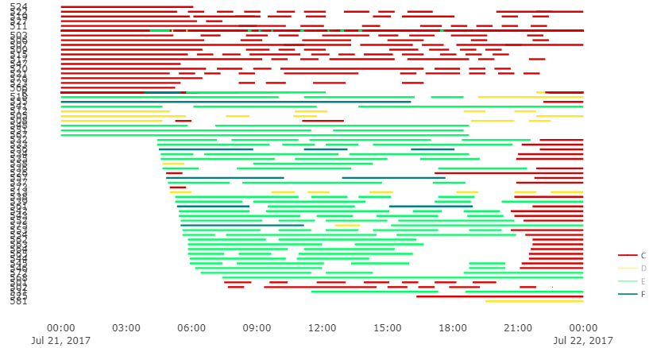

*Figure 4.1(i): The Stand Allocation Gantt chart for all the flights on 21st July 2017*

The Stand Allocations Schedule for 21st July 2017

Figure 4.1(i), above, shows the Gantt chart for all the scheduled flights for the whole day of 21st July. This was generated through Python and was colour coded based on the fleet type. C-code flights were red, D-code flights were yellow, E-code flights were green and the F-codes were blue.

The stand allocation heuristic used a partitioning concept to choose the feasible stands for the different flights. The impact of this could be seen from the Gantt chart had blocks of colour at different time periods.

The through the Gantt chart it was also seen that the number of E-code and C-code flights are significantly higher than others.

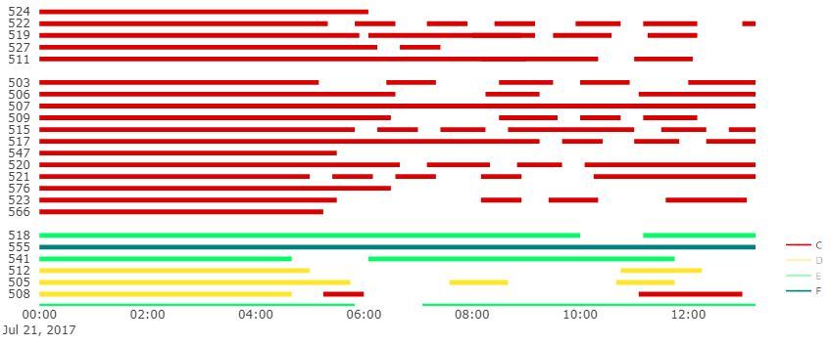

Stands

The Stand Allocations Schedule for 21st July 2017

*Figure 4.1(ii): Section of C-code & D-code flight Stand Allocation Gantt chart (12 am to 12 pm on 21st July 2017)*

Stands

The Stand Allocations Schedule for 21st July 2017

*Figure 4.1(iii): Section of E-code & F-code flight Stand Allocation Gantt chart (4 am to 4 pm on 21st July 2017)*

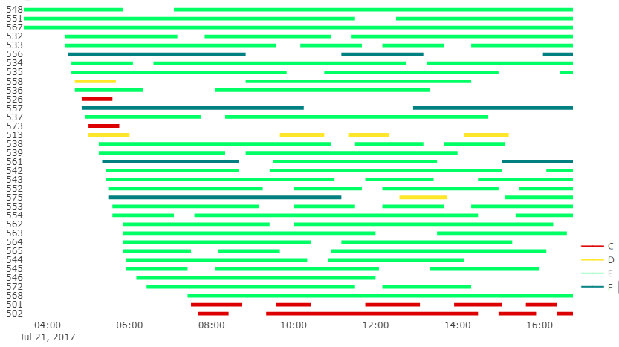

The Gantt chart had several empty, "unallocated", spaces. A closer look at these is shown in figures 4.1(ii) and 4.1(iii). The C and D-code flights showed to be allocated without any overlaps, but these stands were only able to hold small aircraft. And the empty spaces from figure 4.1(iii) were at remote stands where all flights types were treated as remote (e.g. stands 573 and 526).

Table 4.1(A) is a table of the summary of the flight data for 21st July. The number of flights referred to the journeys from origin to destination that occurred, and the number of stand operations was the turnarounds after the splitting process. The total number of passengers was the sum of all the passenger enplaning and deplaning, from all arrival and departure flights.

The number of stand operations for C-code flights was the highest at **363** of the 500 operations**,** followed by E-code flights at **99.** D and F-code flights had the least stand operations, at **27** and **11**, respectively.

## 4.2 Breakdown of Allocations for each Fleet type

The restrictions on the compatibility of remote and pier-served stands depended on the fleet type as well as the origin/destination. Therefore, the results were presented for each fleet type separately.

The number of flights and passengers that were not allocated to a stand were analysed.

According to Table 4.1(A), there were a total of 375 **arrival/departure stand operations** and the results from the flights that arrived and departed on the same day showed that **205** of those operations were not allocated. All the aircraft fleets had failed allocations but the majority of them were of C-code aircraft – this was expected since more than half of the occurred flights were from C-code aircraft. In the 205 failed allocations, there were **40,565 passengers.**

For the flights that were parked overnight before a departure or after an arrival, the results showed that only **33** of the 125 **overnight parking operations** were not allocated to stands. 30 of these were for C-code aircraft and, in the case of E and F-code flights, all overnight parking operations were allocated. The overnight parking operations did not have any passengers – no people are being served overnight. These results – for both arrival/departure and overnight parking operations have been summarised in Table 4.2(A).

The flight results showed that the **rate of allocation** of the heuristic was **52.4%.** The results also indicated that **61% of passengers**, passing through Terminal 5 in a day, were in flights served by a Terminal 5 stand.



There was a total of **63,538** passengers in the flights that were allocated to Terminal 5 stands. The C-code stands served a total of **27,976** passengers; D-code stands served **4198** passengers; E-code stands served **18,276** passengers and the F-code stands served **13,088** passengers.

The pier-served C-code stands were restricted by 4 conditions: Domestic Arrivals, Domestic Departures, International flights and CTA Arrivals. Any flights that were allocated to these stands that didn’t adhere to the conditions were remote (e.g. if an international arrival was serviced by a domestic arrival stand – it was remote). This resulted in **20,705 pier-served passengers** and **7271 remote passengers** at the C-code stands. A breakdown of these numbers at each set of stands are shown in Figure 4.2(i). Only overnight parking operations were allocated to the remote C-code stands.

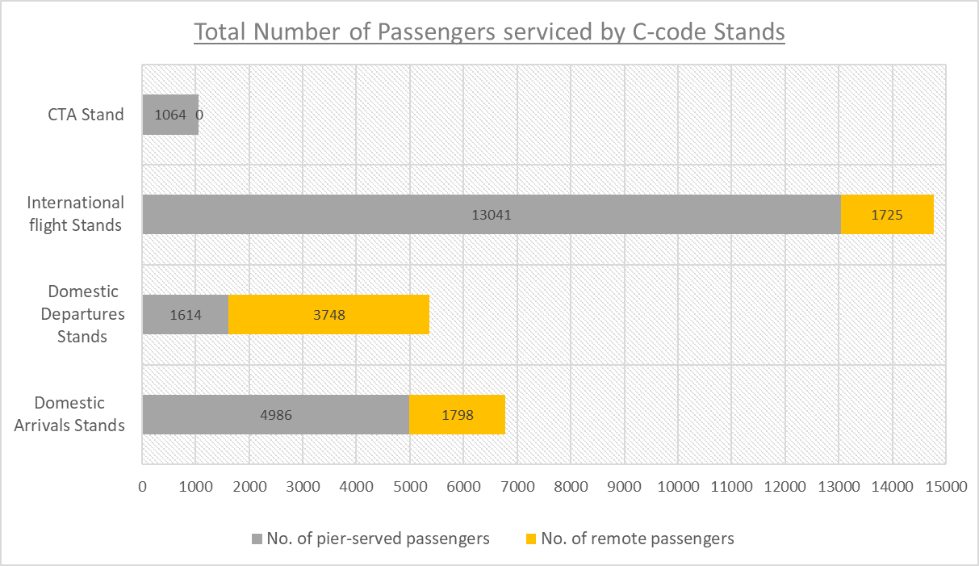

*Figure 4.2(i): A breakdown of no. of passengers serviced by each set of C-code stands*

The pier-served D-code stands were restricted between international and domestic flights. The results showed that **all** the passengers were **pier-served.** These results have been displayed on the bar chart in Figure 4.2(ii). All the remote D-code stands were only allocated with overnight parking.

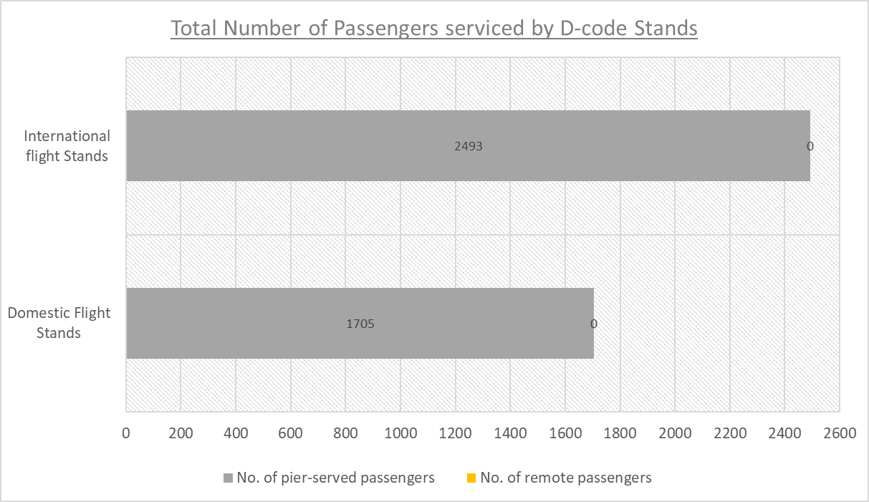

*Figure 4.2(ii): A breakdown of no. of passengers serviced by each set of D-code stands*

For the E-code and F-code stands, all the pier-served stands were ones that accepted international flights. The number of **pier-served passengers** at the E-code stands was **15,273** and at F-code stands was **11,350**. The number of **remote passengers** at the E-code stands was **3003** and at F-code stands was **1738**. This included the passengers of flights allocated to the remote E and F-code stands and of any domestic flights allocated to the pier-served stands. These results have been summarised in Figure 4.2(iii).

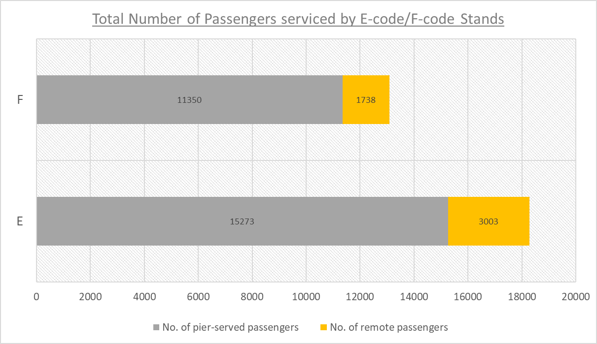

*Figure 4.2(iii): A breakdown of no. of passengers serviced by E-code and F-code stands*

The stand allocation produced resulted in a **Pier-Service Level** (the proportion of pier-served passengers) **of 81.1%.**