#1

db.collection.find({},

{

"user_id": 1,

"firstName": 1,

"lastname": 1,

"_id": 0

})

#2

db.collection.find({

"firstName": "Grace"

},

{

"email": 1,

"password": 1,

"_id": 0

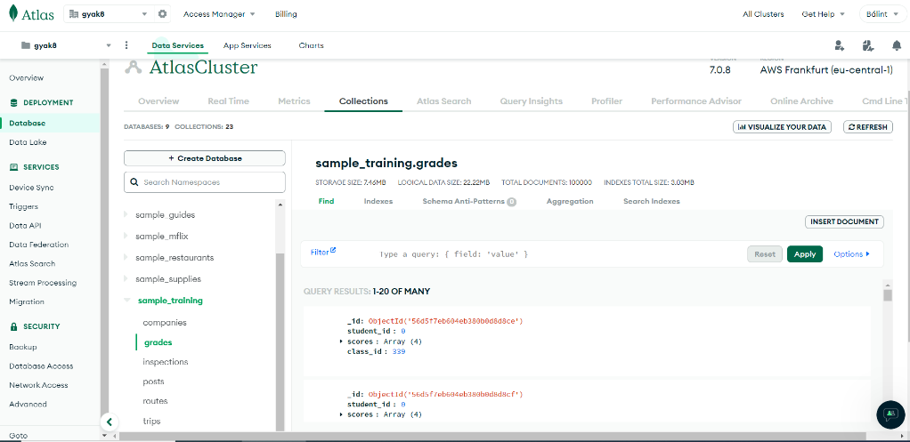})

#3

#4

{"class_id": 339, "student_id": {$lt: 100}}