**Tableau ESG Data Visualization Project Report**

Project Title: ESG Data Visualization Using Tableau

Project Overview:

This project involved analyzing and visualizing ESG (Environmental, Social, and Governance) metrics using Tableau Public. The data used for this project consisted of six CSV files containing various country-level indicators over time.

Data Sources:

* ESGData.csv
* ESGCountry.csv
* ESGCountry-Series.csv
* ESGFootNote.csv
* ESGSeries.csv- ESGSeries-Time.csv

Key Steps Performed:

1. Imported all six CSV datasets into Tableau Public.
2. Used 'ESGData.csv' as the primary data source for visualizations.
3. Explored and identified key fields: Country Name, Country Code, Indicator Name, and year-wisevalues (19602022).
4. Filtered and visualized specific indicators such as CO2 Emissions (metric tons per capita) and

Access to electricity (% of population).

1. Created bar charts showing indicator trends per country for selected years.
2. Applied filters (Indicator Name, Year) and used Measure Names and Measure Values for flexibleplotting.
3. Generated country-wise comparison charts for a single year (e.g., 1960) using selected ESGindicators.

Final Visualization:

The final chart displayed in the worksheet shows country-wise CO2 emissions for the year 1960.

Filters were applied to isolate the indicator and specific years for clarity.

Graph: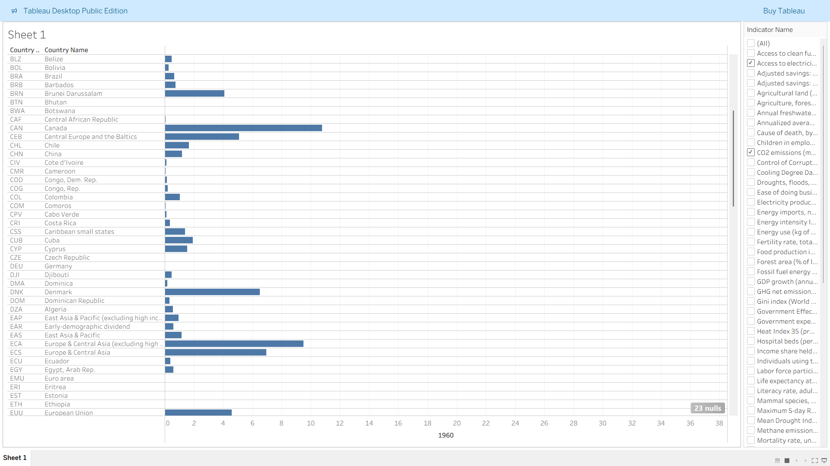

Outcome:

This project demonstrates the capability to work with multi-source datasets in Tableau, clean and join data, and produce interactive visualizations that reveal insights into ESG metrics across the globe.

Tools Used:

* Tableau Public Desktop 2025.2
* CSV files as input datasets

Internship Contribution:

The work completed here reflects the core learning outcomes of the internship. The project involved handling real-world data, transforming it into usable visual insights, and communicating results effectively through visual storytelling.

Submitted by: Paban Basumatary