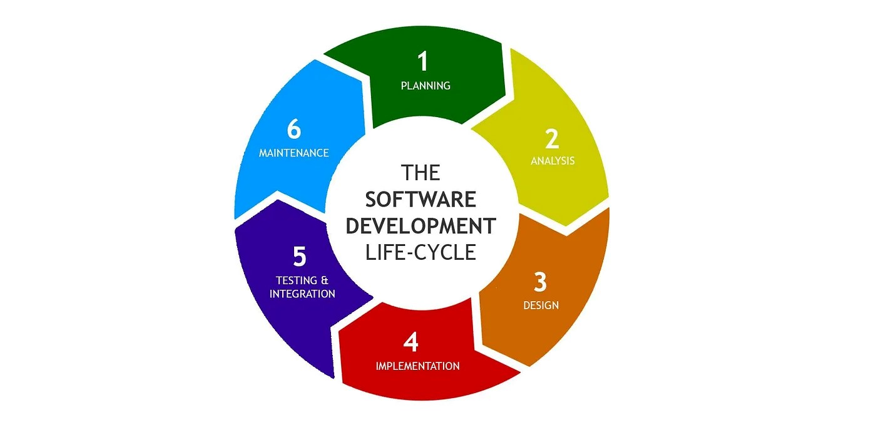

The **Software Development Life Cycle (SDLC)** is a structured approach to software development that outlines different phases to ensure high-quality software delivery. Here's an overview of the primary phases in the SDLC:

**1. Planning:**

Objective: Define the project scope, goals, objectives, and constraints.

Activities: Feasibility study, resource allocation, project scheduling, cost estimation.

* Checking if the project is possible and worth doing.
* Figuring out what resources (like time, money, and people) are needed.
* Making a schedule of when tasks should be completed.
* Identifying potential risks and planning how to manage them.

Output: Project plan, feasibility report.

**2.** **Analysis and Requirements Gathering:**

Objective: Gather detailed requirements from stakeholders and analyse them.

Activities: Interviews, questionnaires, document analysis, risk analysis.

Output: Software Requirements Specification (SRS) document.

**3. Design:**

Objective: Define the architecture and design of the system.

Activities: High-level design (HLD) for system architecture, low-level design (LLD) for detailed design of components.

* Creating a high-level design that shows the overall system architecture.
* Developing detailed designs for each component of the software.

Output: Design documents, system architecture diagrams, database design that guide the developers on how to build the software.

**4. Implementation (or Coding):**

Objective: Convert design into executable software.

Activities: Writing code based on design documents, unit testing, integration testing.

Output: Source code, unit test cases.

**5. Testing:**

Objective: Identify and fix defects in the software.

Activities: Functional testing, system testing, user acceptance testing (UAT).

* Testing the software in various ways to find and fix bugs.
* Testing if different parts of the software work well together.
* Ensuring the software meets user needs through User Acceptance Testing (UAT)

Output: Test plans, test cases, defect reports, test results.

**6. Deployment:**

Objective: Make the software available for use.

Activities: Deployment planning, software installation, user training, documentation.

Output: Deployed software, deployment guides, user manuals.

**7. Maintenance:**

Objective: Ensure the software continues to function correctly and efficiently.

Activities: Bug fixing, performance tuning, software updates, enhancements.

Output: Updated software, maintenance reports.