**CI-CD DevSecOps project with Jenkins | Python webapp**

[Steps:-](https://mrcloudbook.hashnode.dev/ci-cd-devsecops-project-with-jenkins-python-webapp#heading-steps)

[References](https://mrcloudbook.hashnode.dev/ci-cd-devsecops-project-with-jenkins-python-webapp#heading-references)

[Now, let's get started and dig deeper into each of these steps:-](https://mrcloudbook.hashnode.dev/ci-cd-devsecops-project-with-jenkins-python-webapp#heading-now-lets-get-started-and-dig-deeper-into-each-of-these-steps)

[Step 1 — Launch an AWS T2 Large Instance.](https://mrcloudbook.hashnode.dev/ci-cd-devsecops-project-with-jenkins-python-webapp#heading-step-1-launch-an-aws-t2-large-instance)

[Step 2 — Install Jenkins, Docker and Trivy](https://mrcloudbook.hashnode.dev/ci-cd-devsecops-project-with-jenkins-python-webapp#heading-step-2-install-jenkins-docker-and-trivy)

[2A — To Install Jenkins](https://mrcloudbook.hashnode.dev/ci-cd-devsecops-project-with-jenkins-python-webapp#heading-2a-to-install-jenkins)

[2B — Install Docker](https://mrcloudbook.hashnode.dev/ci-cd-devsecops-project-with-jenkins-python-webapp#heading-2b-install-docker)

[2C — Install Trivy](https://mrcloudbook.hashnode.dev/ci-cd-devsecops-project-with-jenkins-python-webapp#heading-2c-install-trivy)

[Step 3 — Install Plugins like JDK, Sonarqube Scanner, OWASP Dependency Check, Docker.](https://mrcloudbook.hashnode.dev/ci-cd-devsecops-project-with-jenkins-python-webapp#heading-step-3-install-plugins-like-jdk-sonarqube-scanner-owasp-dependency-check-docker)

[3A — Install Plugin](https://mrcloudbook.hashnode.dev/ci-cd-devsecops-project-with-jenkins-python-webapp#heading-3a-install-plugin)

[3B — Configure Java and Maven in Global Tool Configuration](https://mrcloudbook.hashnode.dev/ci-cd-devsecops-project-with-jenkins-python-webapp#heading-3b-configure-java-and-maven-in-global-tool-configuration)

[3C — Create a Job](https://mrcloudbook.hashnode.dev/ci-cd-devsecops-project-with-jenkins-python-webapp#heading-3c-create-a-job)

[Step 4 — Install OWASP Dependency Check Plugins](https://mrcloudbook.hashnode.dev/ci-cd-devsecops-project-with-jenkins-python-webapp#heading-step-4-install-owasp-dependency-check-plugins)

[Step 5 — Configure Sonar Server in Manage Jenkins](https://mrcloudbook.hashnode.dev/ci-cd-devsecops-project-with-jenkins-python-webapp#heading-step-5-configure-sonar-server-in-manage-jenkins)

[Step 6 — we have to install make package](https://mrcloudbook.hashnode.dev/ci-cd-devsecops-project-with-jenkins-python-webapp#heading-step-6-we-have-to-install-make-package)

[Step 7 — Docker Image Build and Push](https://mrcloudbook.hashnode.dev/ci-cd-devsecops-project-with-jenkins-python-webapp#heading-step-7-docker-image-build-and-push)

[Step 8 — Deploy the image using Docker](https://mrcloudbook.hashnode.dev/ci-cd-devsecops-project-with-jenkins-python-webapp#heading-step-8-deploy-the-image-using-docker)

[Step 9 — Access the Real World Application](https://mrcloudbook.hashnode.dev/ci-cd-devsecops-project-with-jenkins-python-webapp#heading-step-9-access-the-real-world-application)

[Step 10 — Terminate the AWS EC2 Instance](https://mrcloudbook.hashnode.dev/ci-cd-devsecops-project-with-jenkins-python-webapp#heading-step-10-terminate-the-aws-ec2-instance)

we will be deploying a python based application. This is an everyday use case scenario used by several organizations. We will be using Jenkins as a CICD tool and deploying our application on a Docker Container. Hope this detailed blog is useful.

Github: https://github.com/pabbakalyan/Python-Webapp.git

**Steps:-**

Step 1 — Create an Ubuntu T2 Large Instance

Step 2 — Install Jenkins, Docker and Trivy. Create a Sonarqube Container using Docker.

Step 3 — Install Plugins like JDK, Sonarqube Scanner, OWASP Dependency Check,

Step 4 — Create a Pipeline Project in Jenkins using a Declarative Pipeline

Step 5 — Configure Sonar Server in Manage Jenkins

Step 6 — we have to install and make the package

Step 7 — Docker Image Build and Push

Step 8 — Deploy the image using Docker

Step 9 — Access the Real World Application

Step 10 — Terminate the AWS EC2 Instance

References

**Now, let's get started and dig deeper into each of these steps:-**

**Step 1 — Launch an AWS T2 Large Instance.**

Use the image as Ubuntu. You can create a new key pair or use an existing one. Enable HTTP and HTTPS settings in the Security Group.

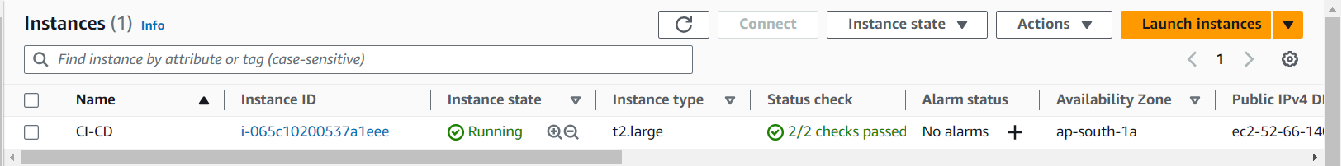

**Step 2 — Install Jenkins, Docker and Trivy**

**2A — To Install Jenkins**

Connect to your console, and enter these commands to Install Jenkins

sudo apt update -y

#sudo apt upgrade -y

wget -O - https://packages.adoptium.net/artifactory/api/gpg/key/public | tee /etc/apt/keyrings/adoptium.asc

echo "deb [signed-by=/etc/apt/keyrings/adoptium.asc] https://packages.adoptium.net/artifactory/deb $(awk -F= '/^VERSION_CODENAME/{print$2}' /etc/os-release) main" | tee /etc/apt/sources.list.d/adoptium.list

sudo apt update -y

sudo apt install temurin-17-jdk -y

/usr/bin/java --version

curl -fsSL https://pkg.jenkins.io/debian-stable/jenkins.io-2023.key | sudo tee \

/usr/share/keyrings/jenkins-keyring.asc > /dev/null

echo deb [signed-by=/usr/share/keyrings/jenkins-keyring.asc] \

https://pkg.jenkins.io/debian-stable binary/ | sudo tee \

/etc/apt/sources.list.d/jenkins.list > /dev/null

sudo apt-get update -y

sudo apt-get install jenkins -y

sudo systemctl start jenkins

sudo systemctl status Jenkins

Once Jenkins is installed, you will need to go to your AWS EC2 Security Group and open Inbound Port 8080, since Jenkins works on Port 8080.

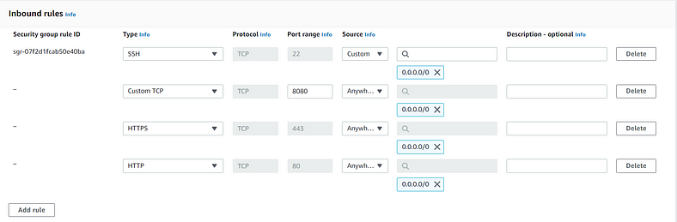

Now, grab your Public IP Address

<EC2 Public IP Address:8080>

sudo cat /var/lib/jenkins/secrets/initialAdminPassword

Unlock Jenkins using an administrative password and install the required plugins.

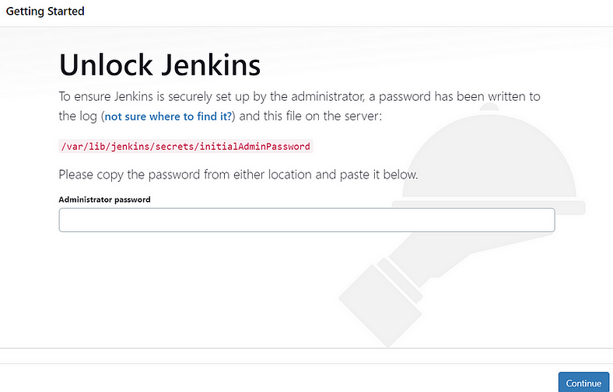

Jenkins will now get installed and install all the libraries

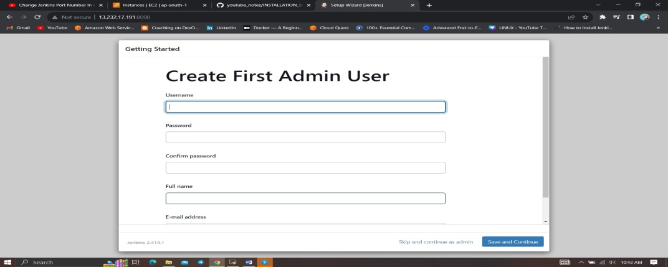

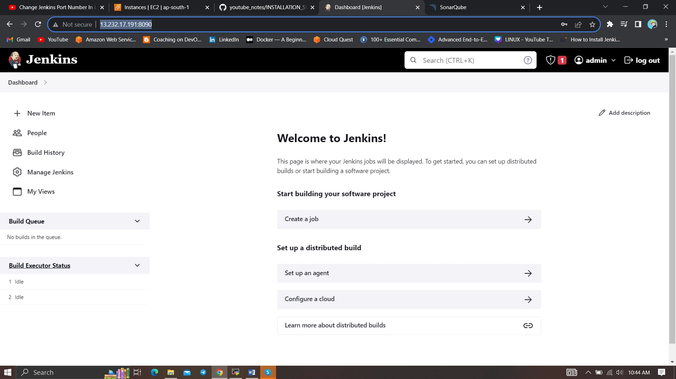

**2B — Install Docker**

**sudo apt-get update**

**sudo apt-get install docker.io -y**

**sudo usermod -aG docker $USER**

**sudo chmod 777 /var/run/docker.sock**

**sudo docker ps**

After the docker installation, we create a sonarqube container (Remember added 9000 port in the security group)

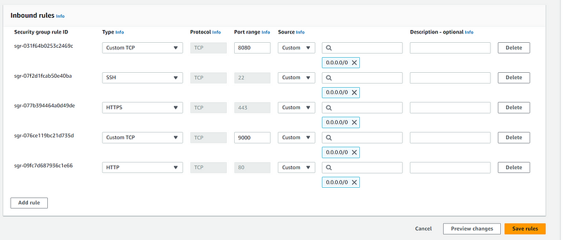

docker run -d --name sonar -p 9000:9000 sonarqube:lts-community

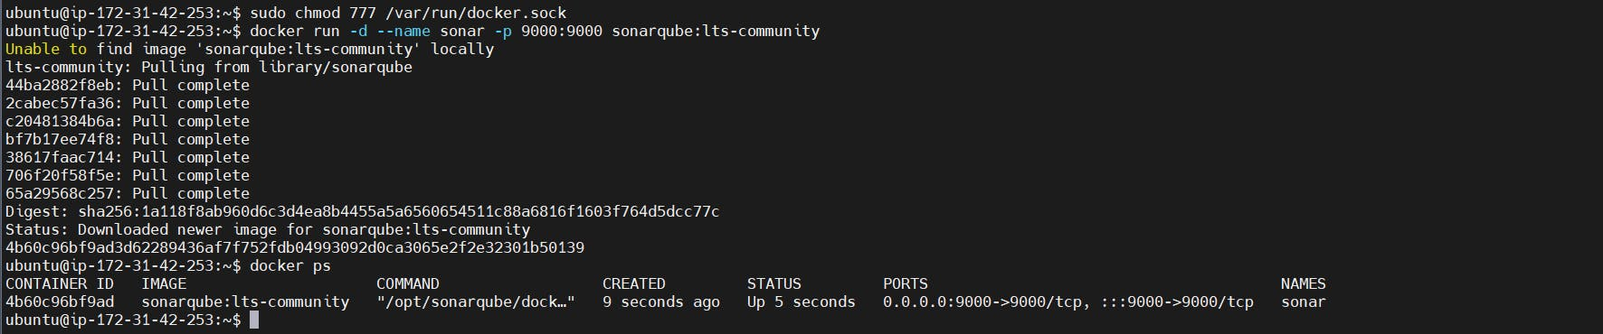

Now our sonarqube is up and running

Enter username and password, click on login and change password

Username =admin

Pass=admin

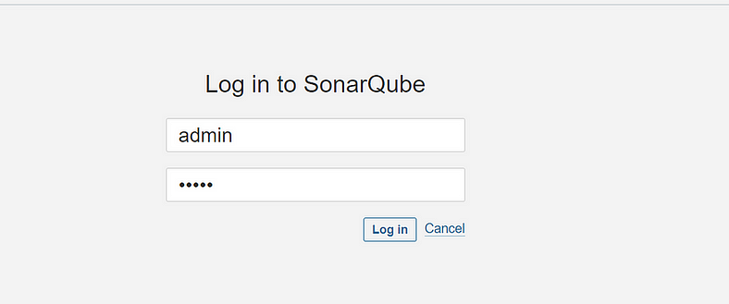

**2C — Install Trivy**

**sudo apt-get install wget apt-transport-https gnupg lsb-release -y**

**wget -qO - https://aquasecurity.github.io/trivy-repo/deb/public.key | gpg --dearmor | sudo tee /usr/share/keyrings/trivy.gpg > /dev/null**

**echo "deb [signed-by=/usr/share/keyrings/trivy.gpg] https://aquasecurity.github.io/trivy-repo/deb $(lsb_release -sc) main" | sudo tee -a /etc/apt/sources.list.d/trivy.list**

**sudo apt-get update**

**sudo apt-get install trivy –y**

Next, we will log in to Jenkins and start to configure our Pipeline in Jenkins

**Step 3 — Install Plugins like JDK, Sonarqube Scanner, OWASP Dependency Check, Docker.**

**3A — Install Plugin**

Goto Manage Jenkins →Plugins → Available Plugins →

Install below plugins

1 → Install OWASP ( (Install without restart)

2 → SonarQube Scanner (Install without restart)

3 → 1 → Eclipse Temurin Installer (Install without restart)

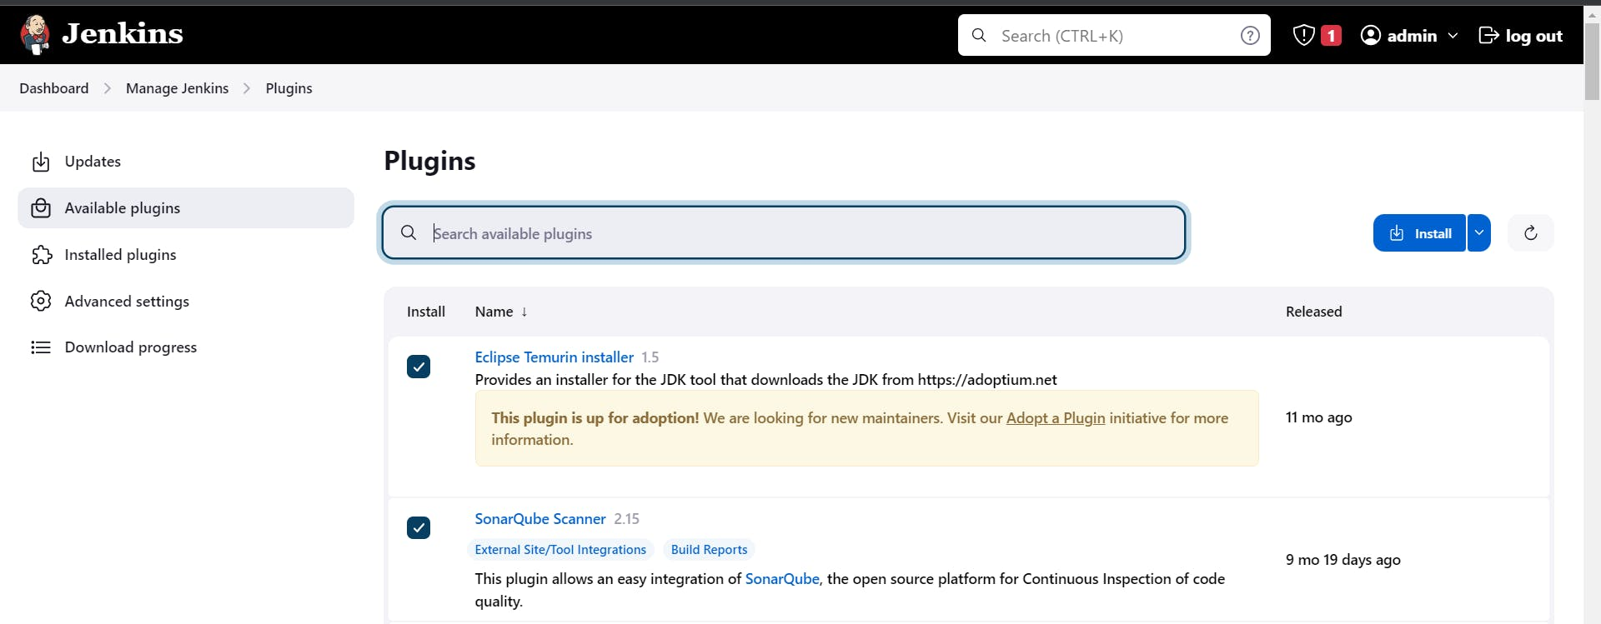

**3B — Configure Java and Maven in Global Tool Configuration**

Goto Manage Jenkins → Tools → Install JDK Click on Apply and Save

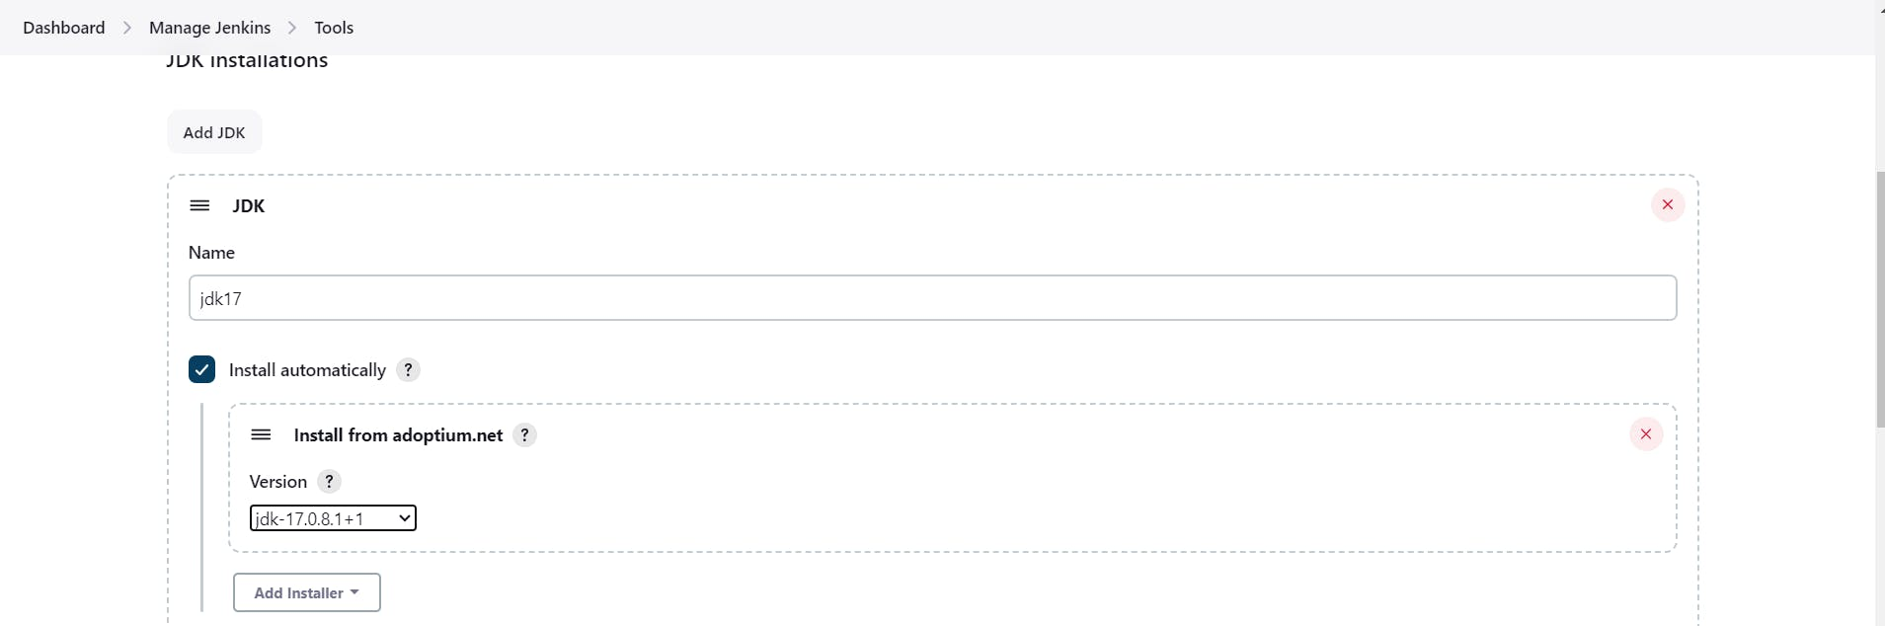

**3C — Create a Job**

Label it as Dotnet CI-CD, click on Pipeline and OK.

**Step 4 — Install OWASP Dependency Check Plugins**

GotoDashboard → Manage Jenkins → Plugins → OWASP Dependency-Check. Click on it and install it without restart.

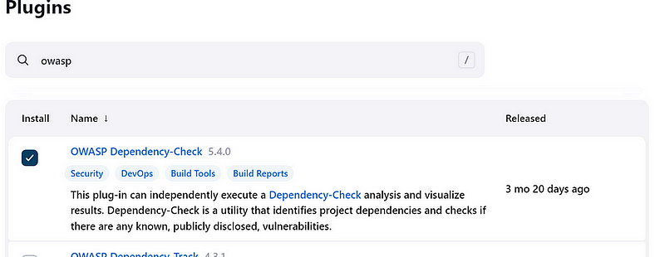

First, we configured the Plugin and next, we had to configure the Tool

Goto Dashboard → Manage Jenkins → Tools →

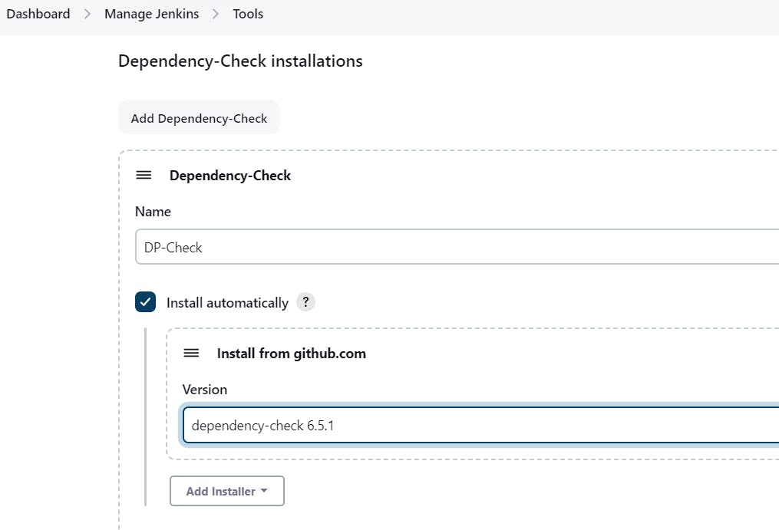

Click on Apply and Save here.

**Step 5 — Configure Sonar Server in Manage Jenkins**

Grab the Public IP Address of your EC2 Instance, Sonarqube works on Port 9000, sp <Public IP>:9000. Goto your Sonarqube Server. Click on Administration → Security → Users → Click on Tokens and Update Token → Give it a name → and click on Generate Token

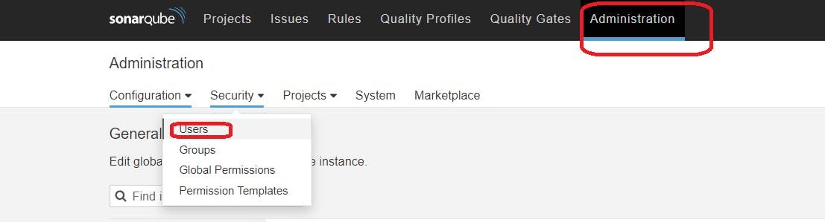

Click on Update Token

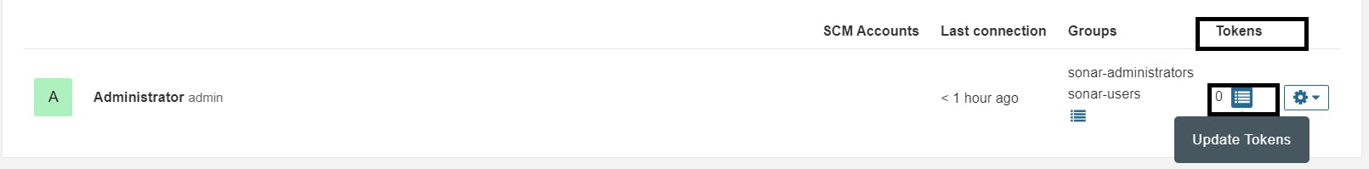

Create a token with a name and generate

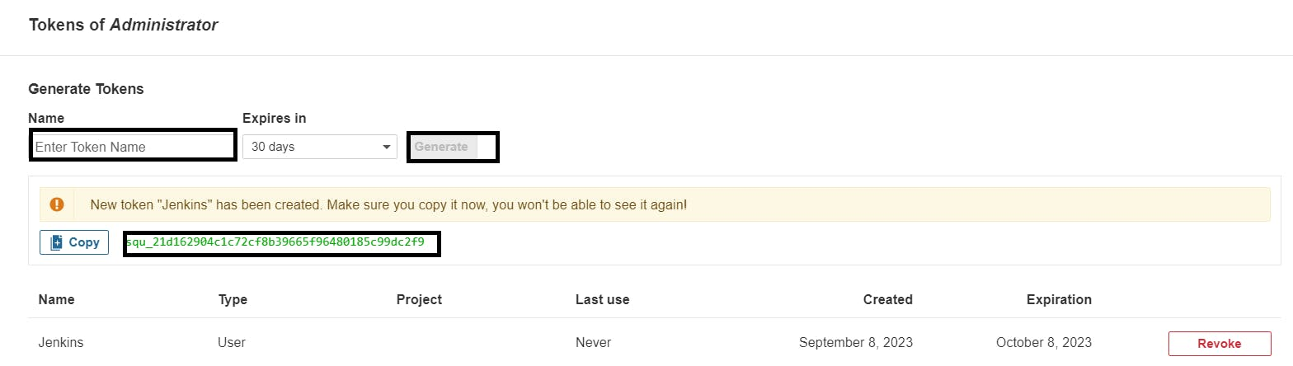

Copy this Token

Goto Dashboard → Manage Jenkins → Credentials → Add Secret Text. It should look like this

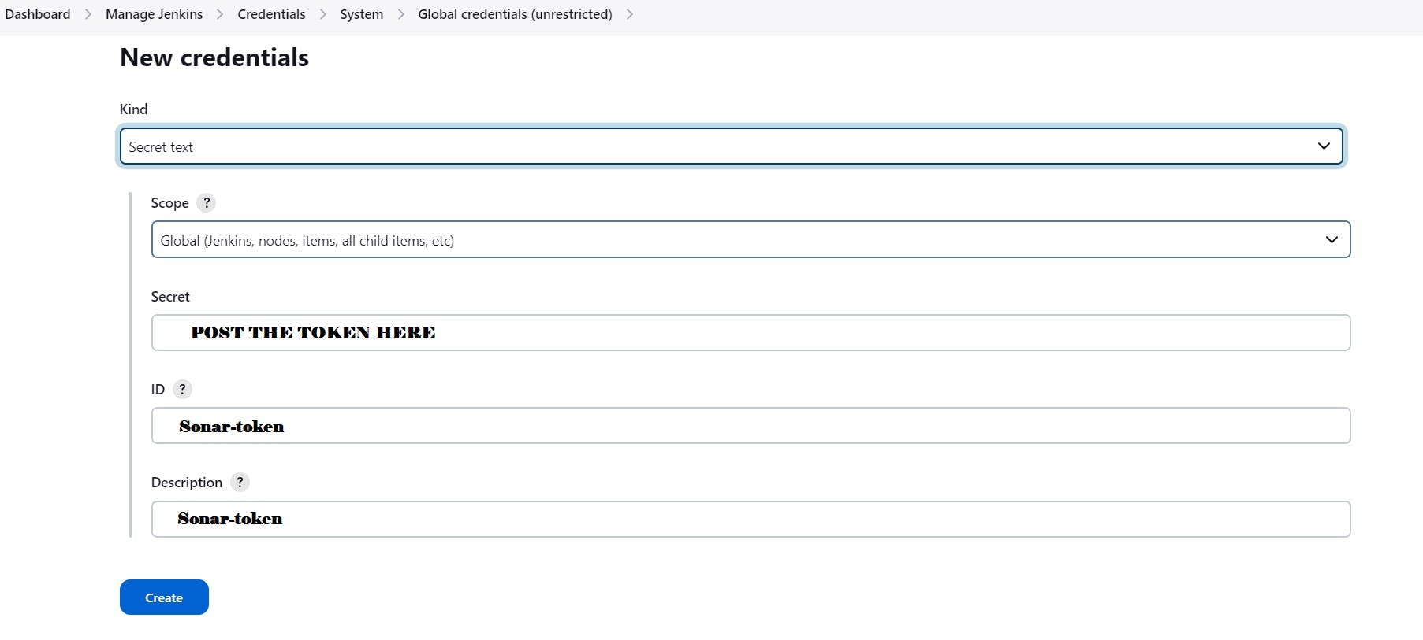

You will this page once you click on create

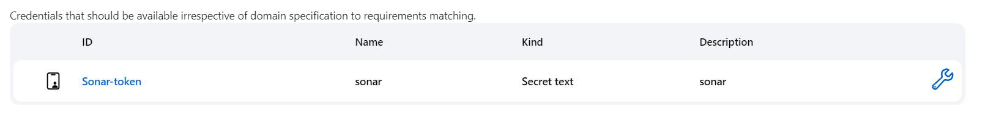

Now, go to Dashboard → Manage Jenkins → Configure System

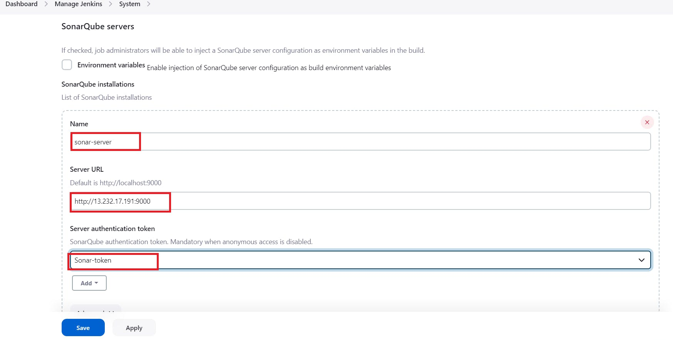

Click on Apply and Save

**The Configure System option** is used in Jenkins to configure different server

**Global Tool Configuration** is used to configure different tools that we install using Plugins

We will install a sonar scanner in the tools.

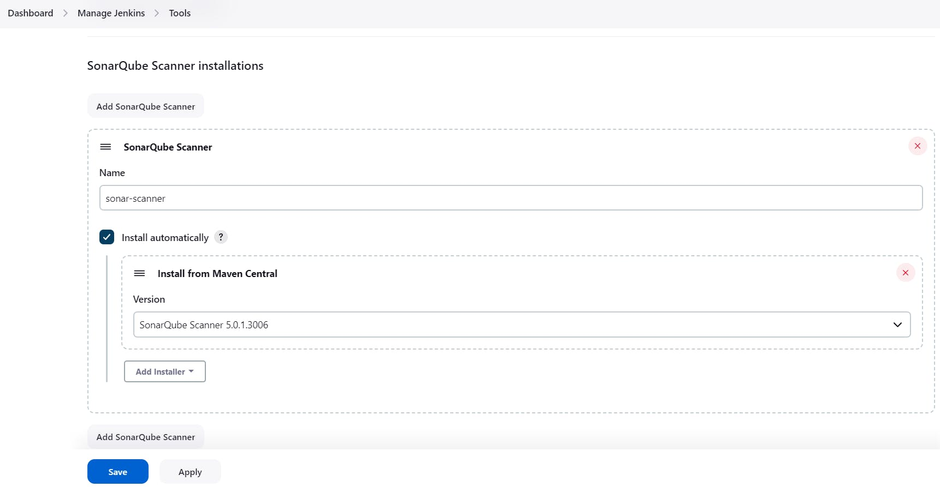

In the Sonarqube Dashboard add a quality gate also

Administration--> Configuration-->Webhooks

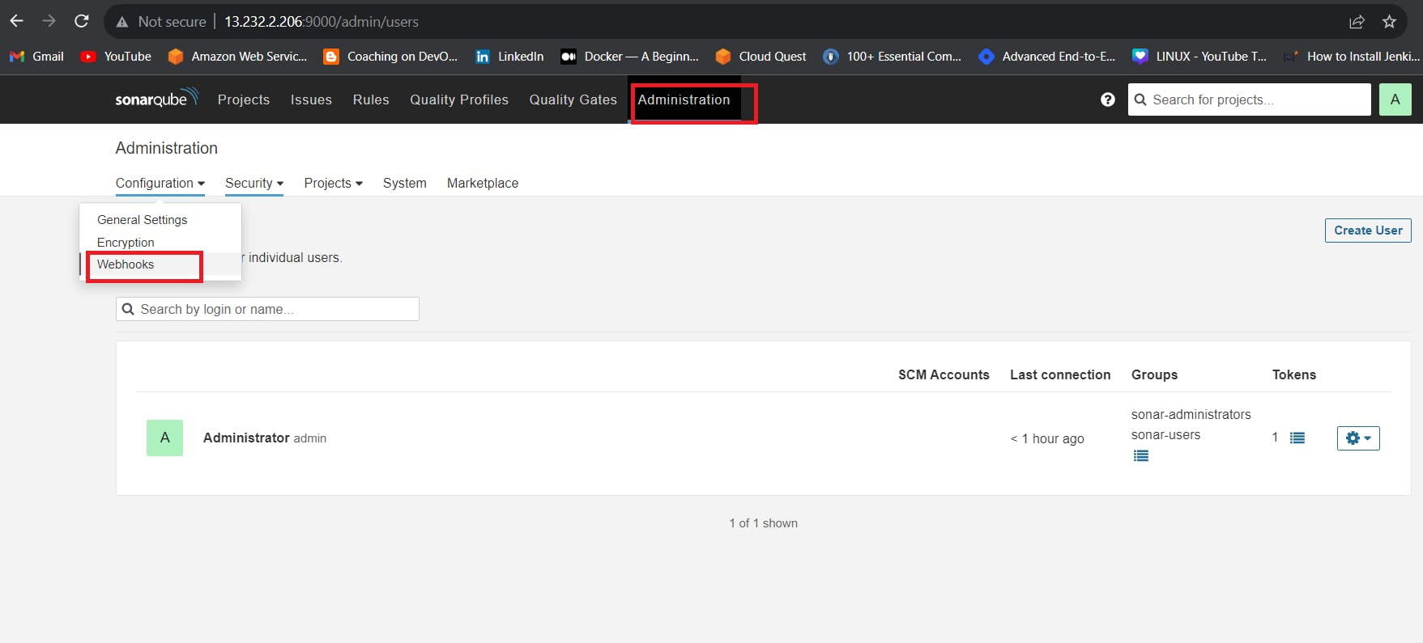

Click on Create

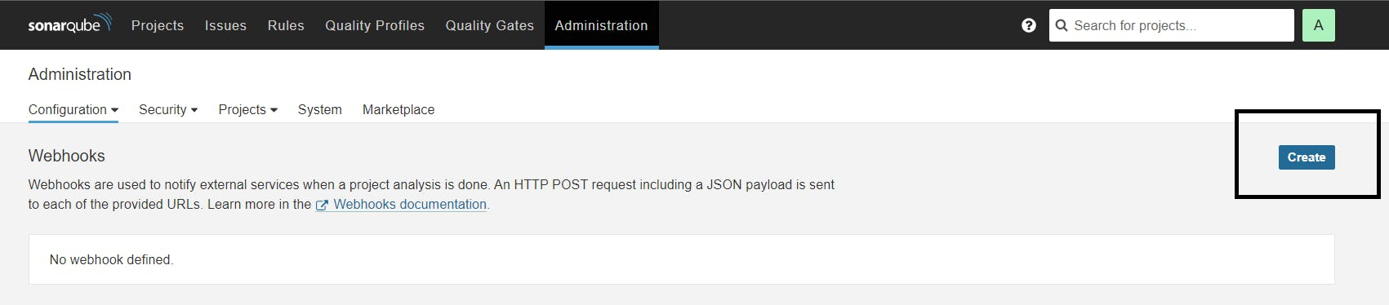

Add details

#in url section of quality gate

<http://jenkins-public-ip:8080>/sonarqube-webhook/

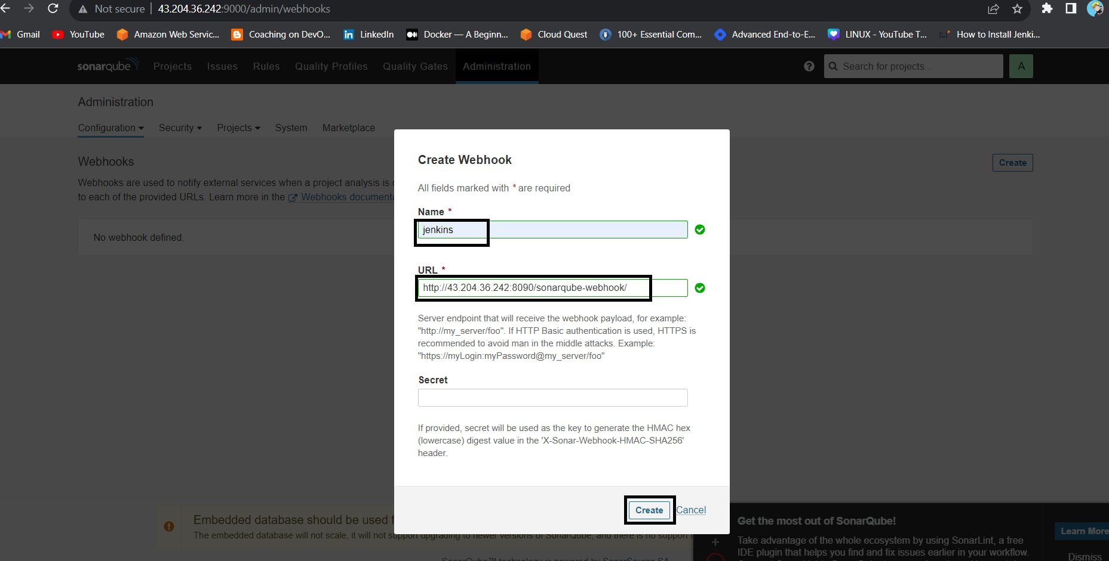

Let's go to our Pipeline and add the below code Pipeline Script.

pipeline{

agent any

tools{

jdk 'jdk17'

}

environment {

SCANNER_HOME=tool 'sonar-scanner'

}

stages {

stage('clean workspace'){

steps{

cleanWs()

}

}

stage('Checkout From Git'){

steps{

git branch: 'main', url: 'https://github.com/Aj7Ay/Python-System-Monitoring.git'

}

}

stage("Sonarqube Analysis "){

steps{

withSonarQubeEnv('sonar-server') {

sh ''' $SCANNER_HOME/bin/sonar-scanner -Dsonar.projectName=Python-Webapp \

-Dsonar.projectKey=Python-Webapp '''

}

}

}

stage("quality gate"){

steps {

script {

waitForQualityGate abortPipeline: false, credentialsId: 'Sonar-token'

}

}

}

stage("TRIVY File scan"){

steps{

sh "trivy fs . > trivy-fs_report.txt"

}

}

stage("OWASP Dependency Check"){

steps{

dependencyCheck additionalArguments: '--scan ./ --format XML ', odcInstallation: 'DP-Check'

dependencyCheckPublisher pattern: '**/dependency-check-report.xml'

}

}

}

}

Click on Build now, you will see the stage view like this

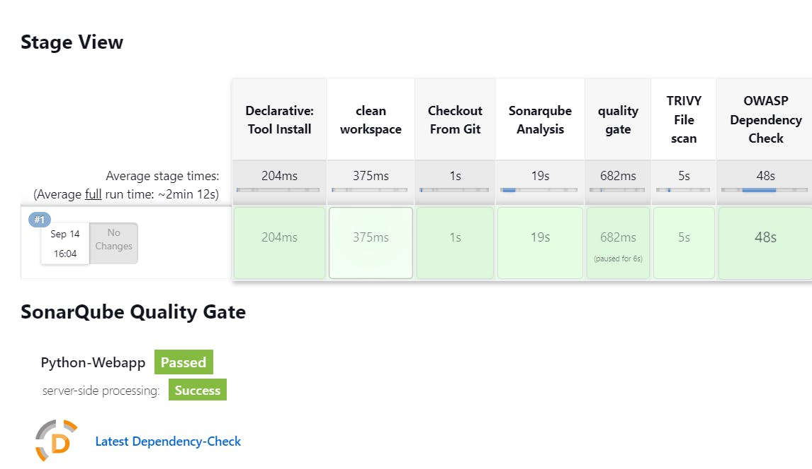

To see the report, you can go to Sonarqube Server and go to Projects.

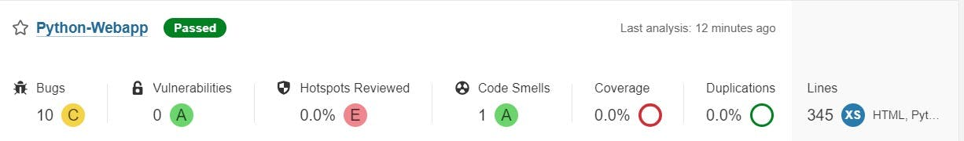

You can see the report has been generated and the status shows as passed. You can see that there are 522 lines. To see a detailed report, you can go to issues.

**Step 6 — we have to install make package**

sudo apt install make

# to check version install or not

make -v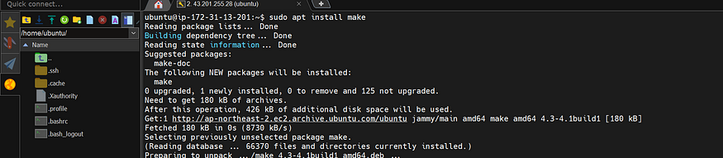

**Step 7 — Docker Image Build and Push**

We need to install the Docker tool in our system, Goto Dashboard → Manage Plugins → Available plugins → Search for Docker and install these plugins

Docker

Docker Commons

Docker Pipeline

Docker API

docker-build-step

and click on install without restart

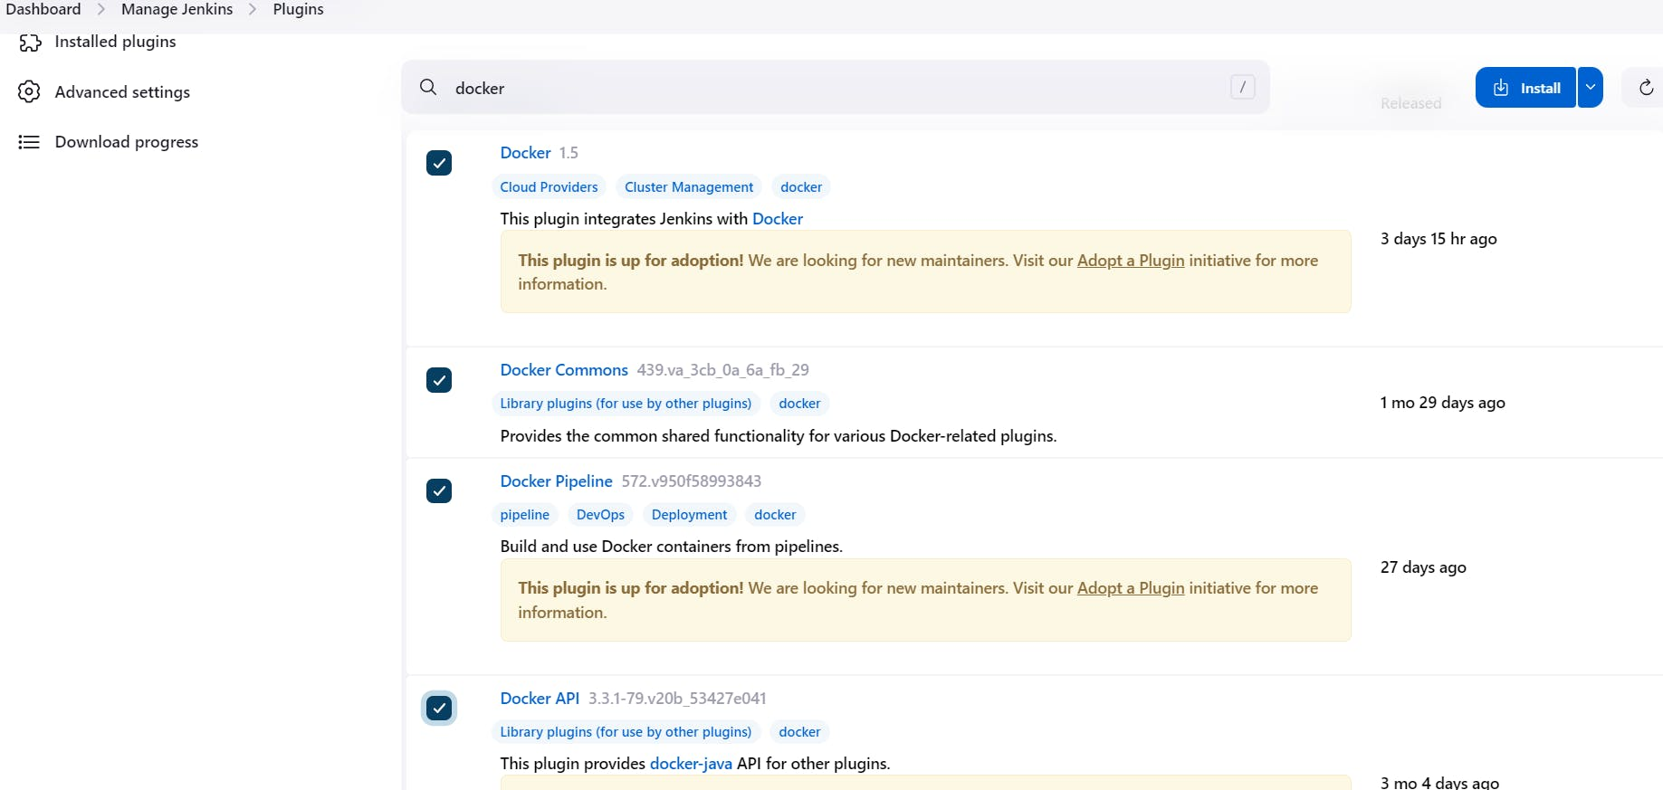

Now, goto Dashboard → Manage Jenkins → Tools →

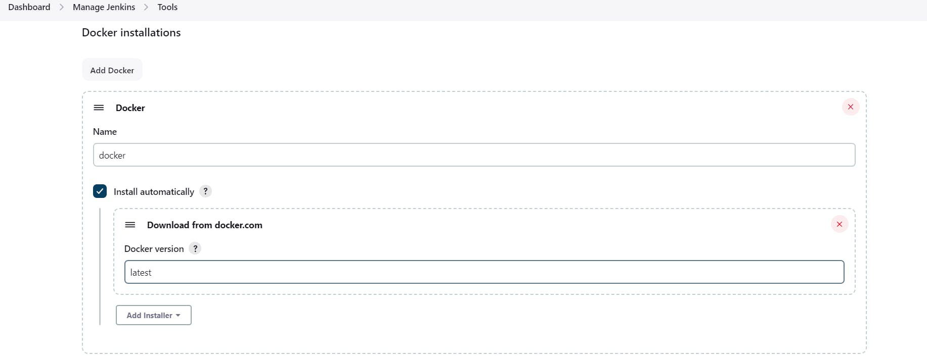

Add DockerHub Username and Password under Global Credentials

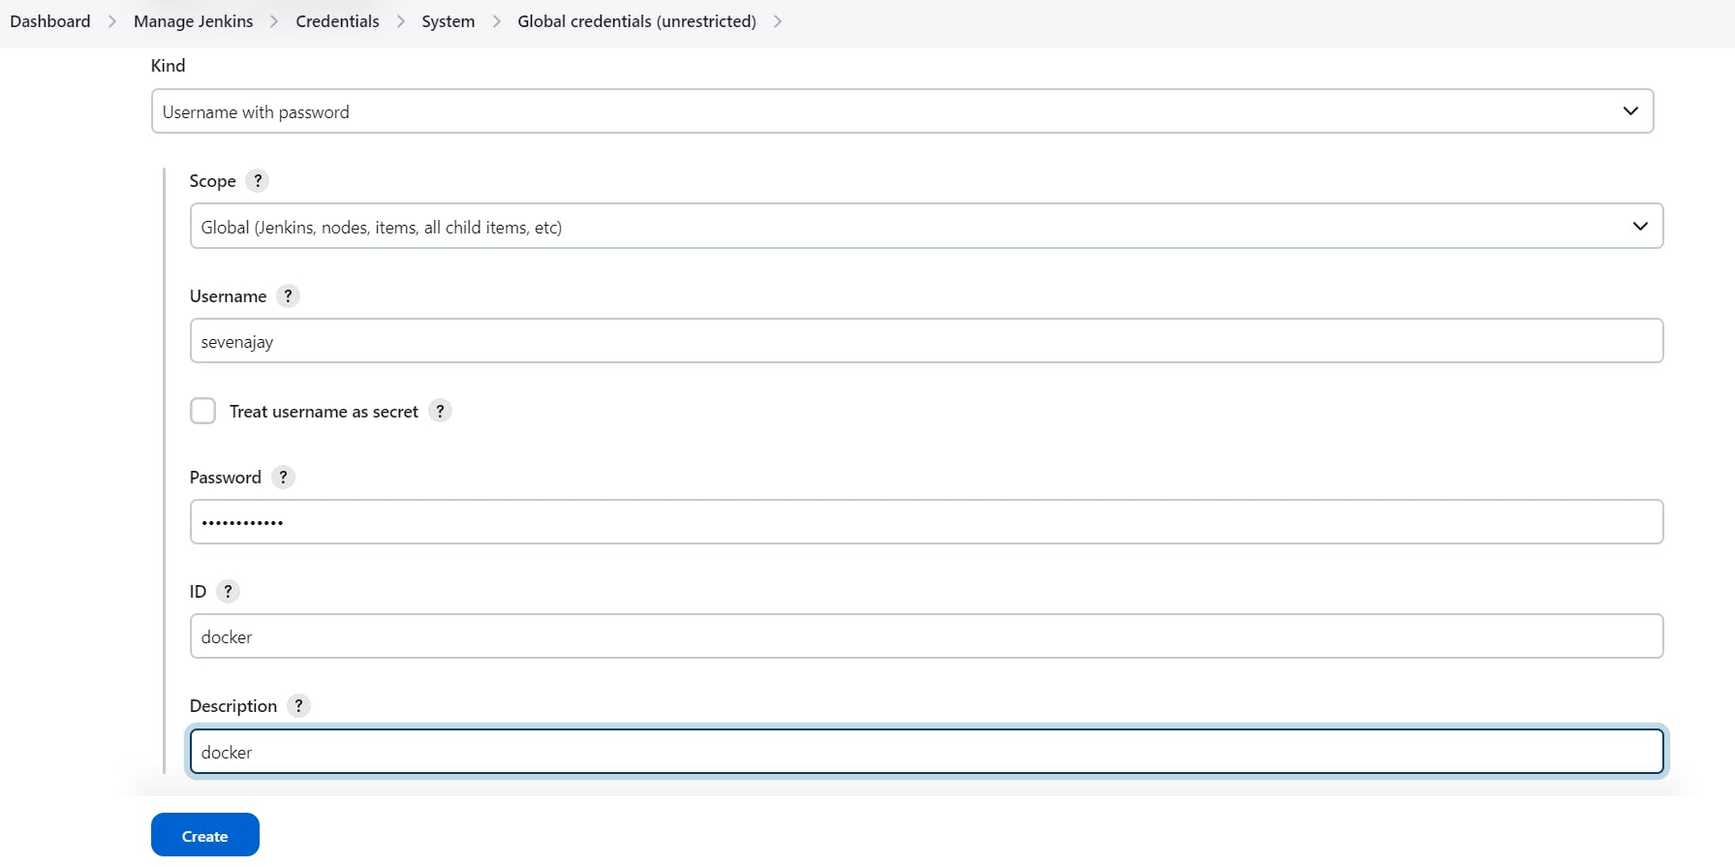

In the makefile, we already defined some conditions to build, tag and push images to dockerhub.

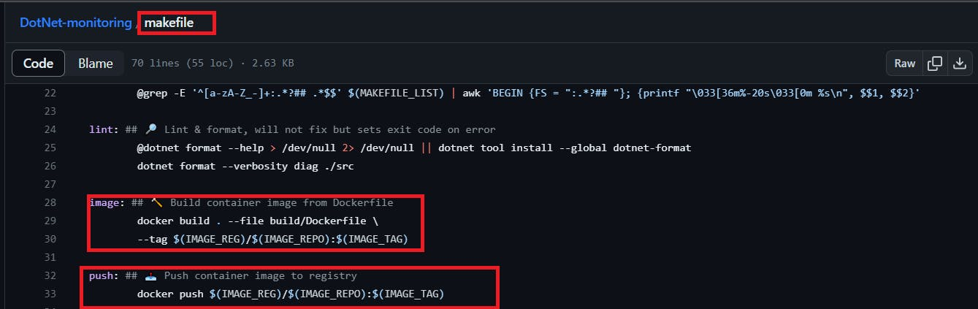

that's why we are using make image and make a push in the place of docker build -t and docker push

Add this stage to Pipeline Script

stage("Docker Build & tag"){

steps{

script{

withDockerRegistry(credentialsId: 'docker', toolName: 'docker'){

sh "make image"

}

}

}

}

stage("TRIVY"){

steps{

sh "trivy image sevenajay/python-system-monitoring:latest > trivy.txt"

}

}

stage("Docker Push"){

steps{

script{

withDockerRegistry(credentialsId: 'docker', toolName: 'docker'){

sh "make push"

}

}

}

}

When all stages in docker are successfully created then you will see the result You log in to Dockerhub, and you will see a new image is created

stage view

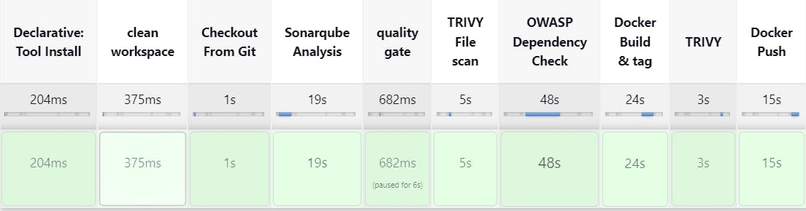

**Step 8 — Deploy the image using Docker**

Add this stage to your pipeline syntax

COPY

COPY

stage("Deploy to container"){

steps{

sh "docker run -d --name python1 -p 5000:5000 sevenajay/python-system-monitoring:latest"

}

}

You will see the Stage View like this,

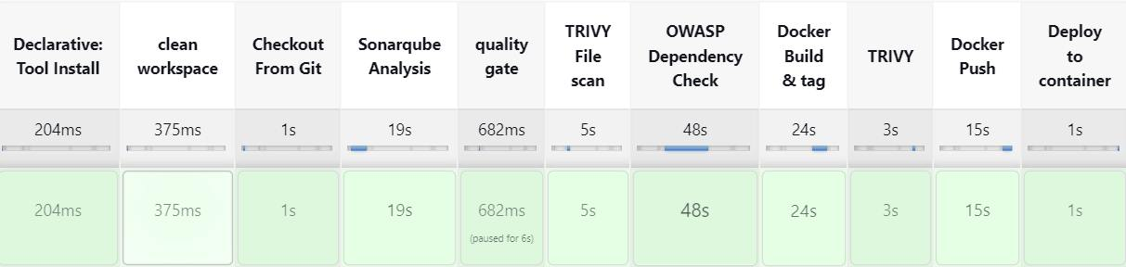

(Add port 5000 to Security Group)

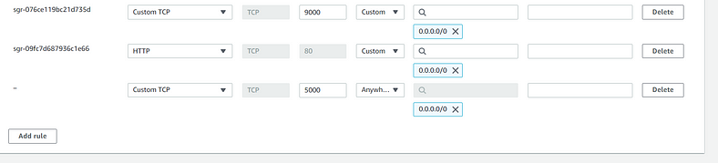

The final script looks like this,

pipeline{

agent any

tools{

jdk 'jdk17'

}

environment {

SCANNER_HOME=tool 'sonar-scanner'

}

stages {

stage('clean workspace'){

steps{

cleanWs()

}

}

stage('Checkout From Git'){

steps{

git branch: 'main', url: 'https://github.com/Aj7Ay/Python-System-Monitoring.git'

}

}

stage("Sonarqube Analysis "){

steps{

withSonarQubeEnv('sonar-server') {

sh ''' $SCANNER_HOME/bin/sonar-scanner -Dsonar.projectName=Python-Webapp \

-Dsonar.projectKey=Python-Webapp '''

}

}

}

stage("quality gate"){

steps {

script {

waitForQualityGate abortPipeline: false, credentialsId: 'Sonar-token'

}

}

}

stage("TRIVY File scan"){

steps{

sh "trivy fs . > trivy-fs_report.txt"

}

}

stage("OWASP Dependency Check"){

steps{

dependencyCheck additionalArguments: '--scan ./ --format XML ', odcInstallation: 'DP-Check'

dependencyCheckPublisher pattern: '**/dependency-check-report.xml'

}

}

stage("Docker Build & tag"){

steps{

script{

withDockerRegistry(credentialsId: 'docker', toolName: 'docker'){

sh "make image"

}

}

}

}

stage("TRIVY"){

steps{

sh "trivy image sevenajay/python-system-monitoring:latest > trivy.txt"

}

}

stage("Docker Push"){

steps{

script{

withDockerRegistry(credentialsId: 'docker', toolName: 'docker'){

sh "make push"

}

}

}

}

stage("Deploy to container"){

steps{

sh "docker run -d --name python1 -p 5000:5000 sevenajay/python-system-monitoring:latest"

}

}

}

}

And you can access your application on Port 5000. This is a Real World Application that has all Functional Tabs.

COPY

COPY

<public-ip of jenkins:5000>

**Step 9 — Access the Real World Application**

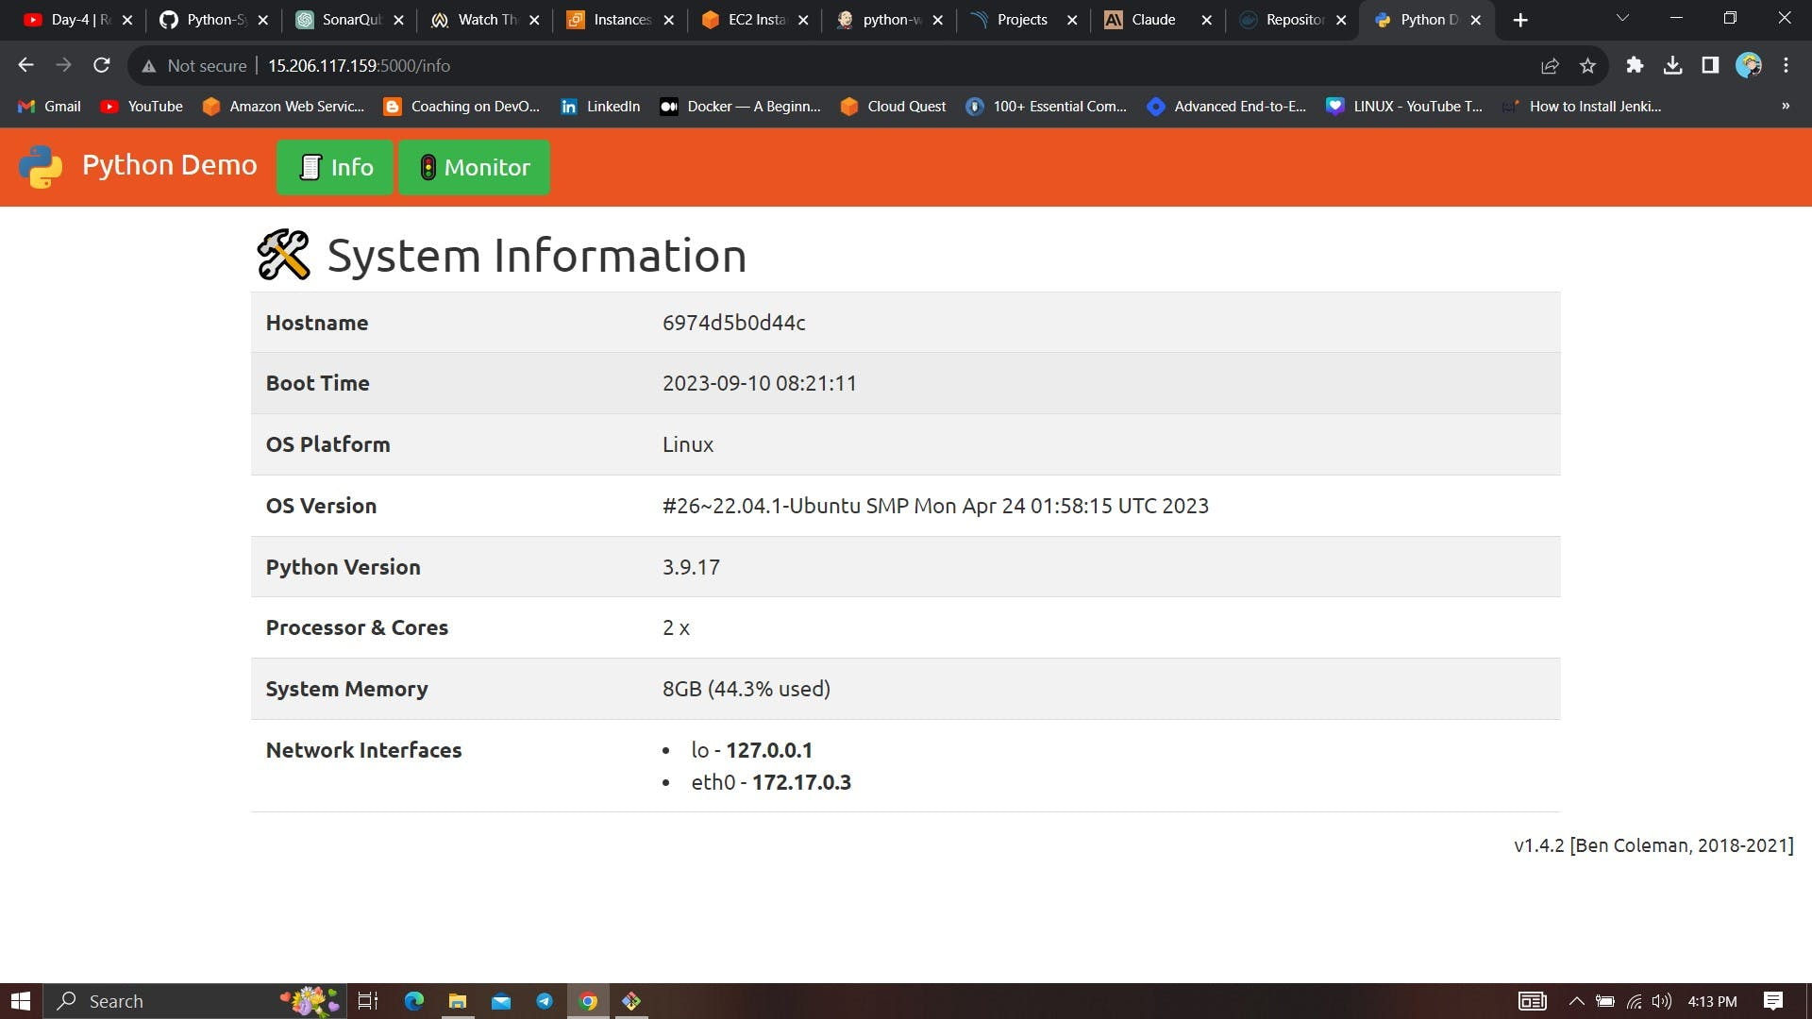

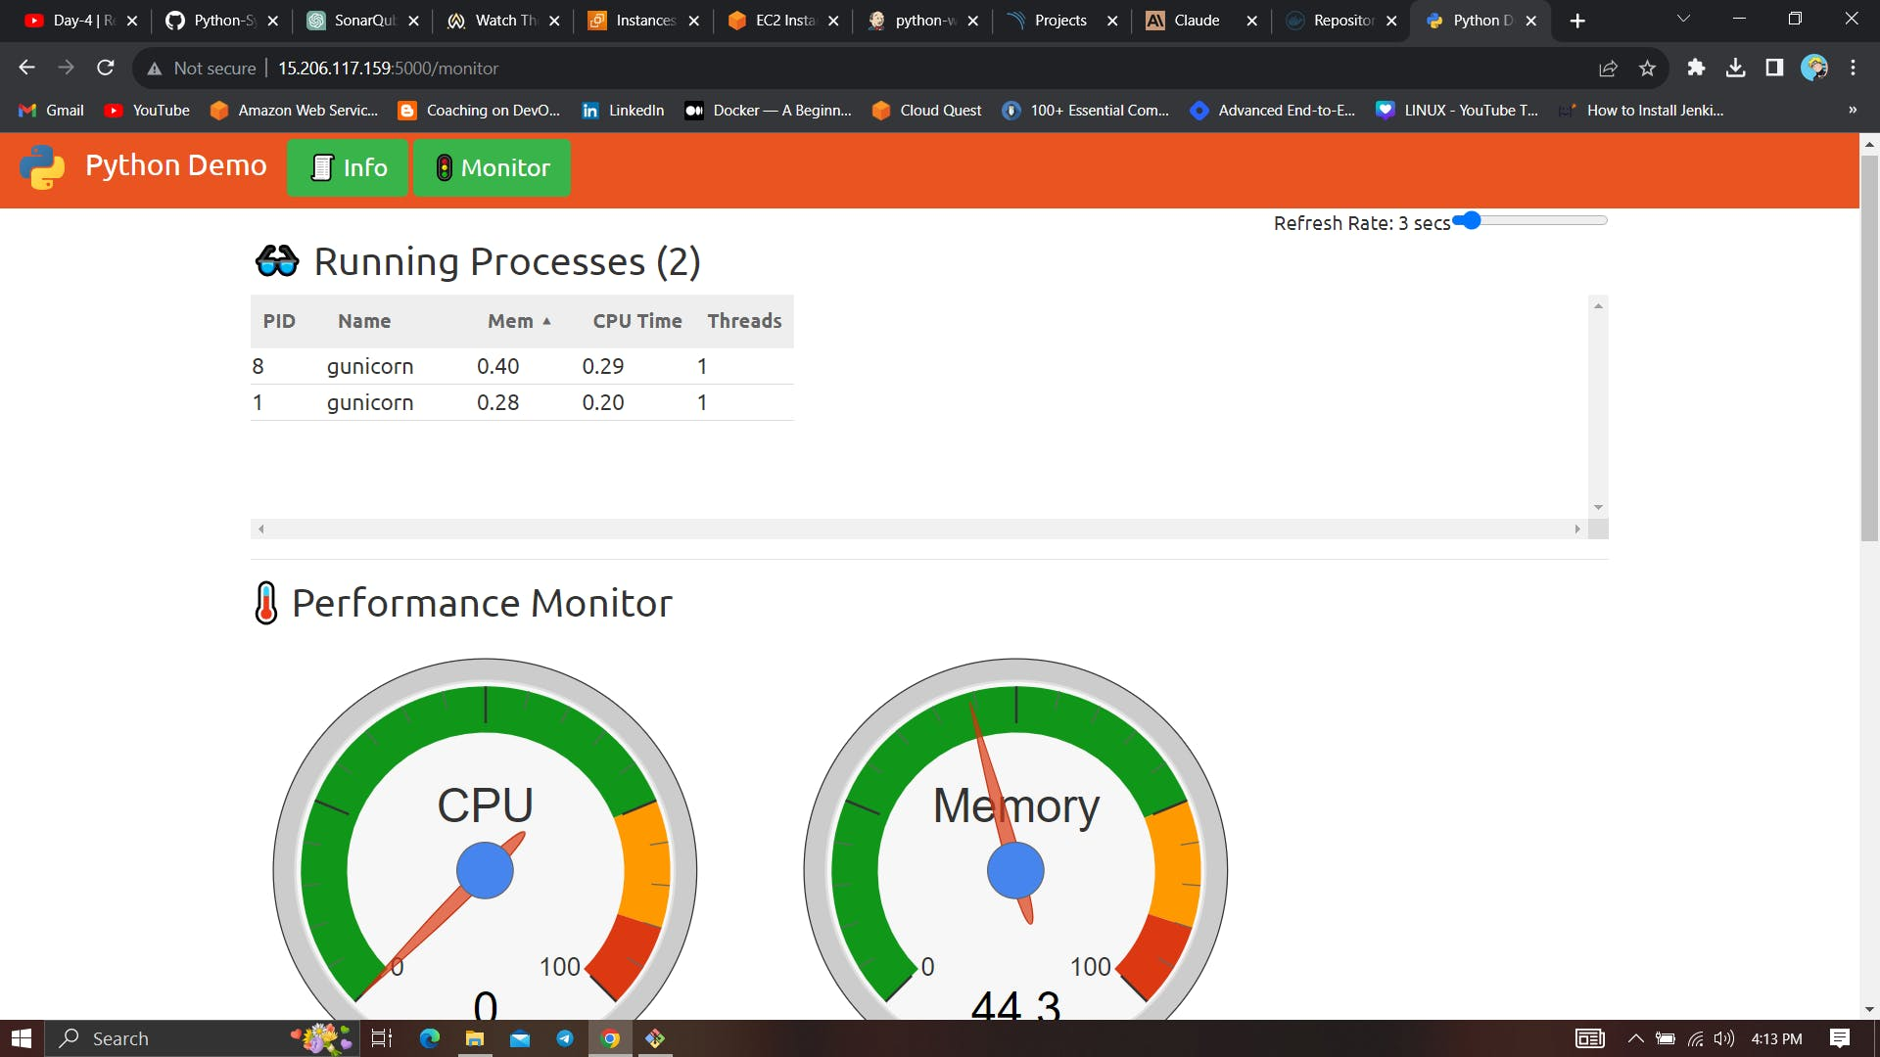

**Step 10 — Terminate the AWS EC2 Instance**

Lastly, do not forget to terminate the AWS EC2 Instance.