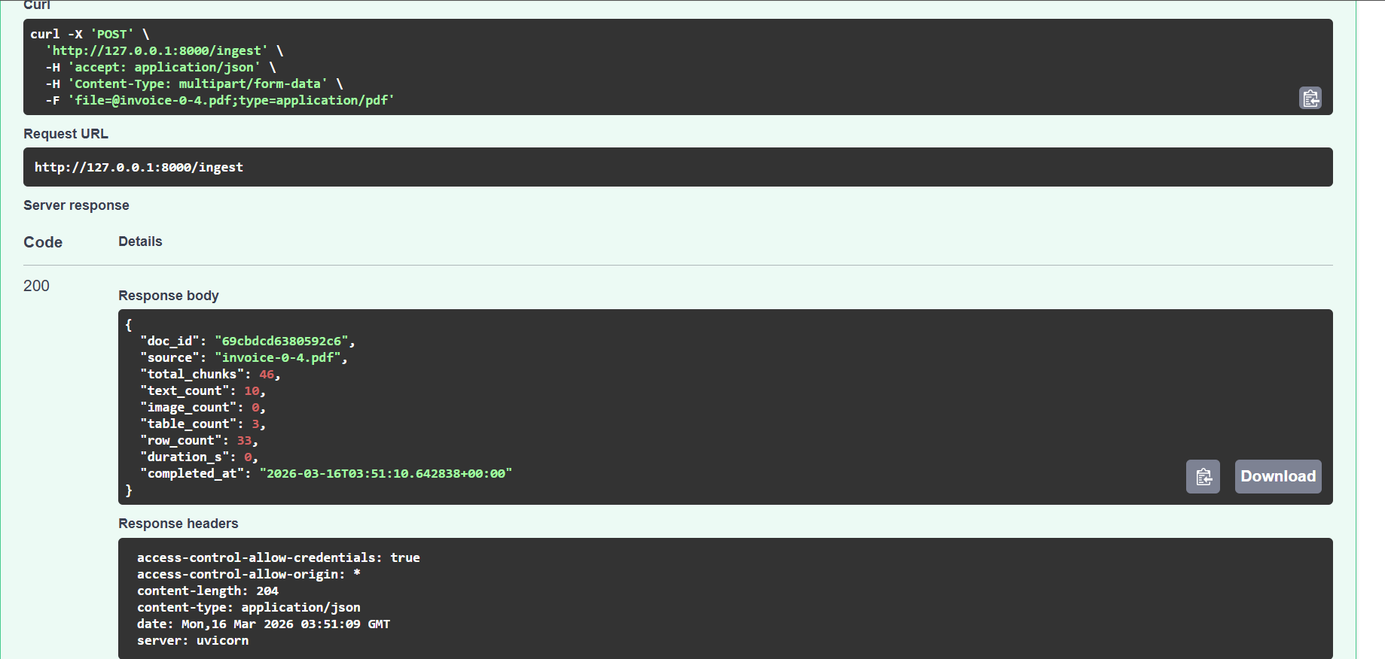
Tax Verification
If the subtotal of the invoice is 5964.50 and the sales tax rate applied is 10%, verify whether the sales tax value in the invoice is correct.
Answer:
Sales tax should be:
$$5964.50×0.10=596.45$$

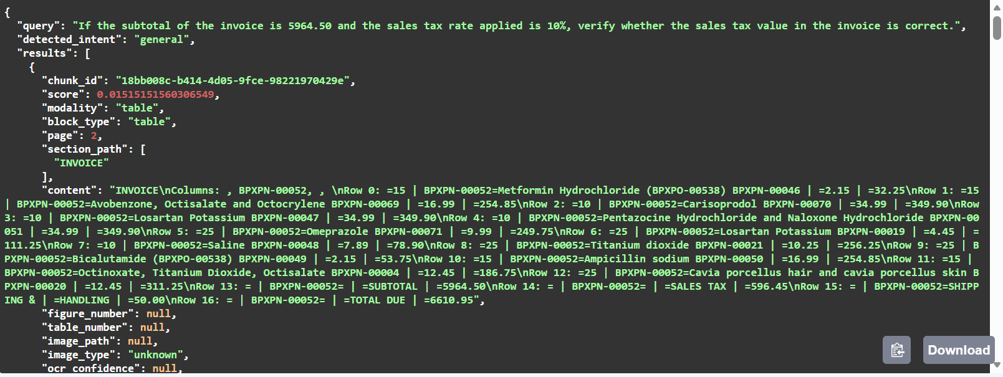
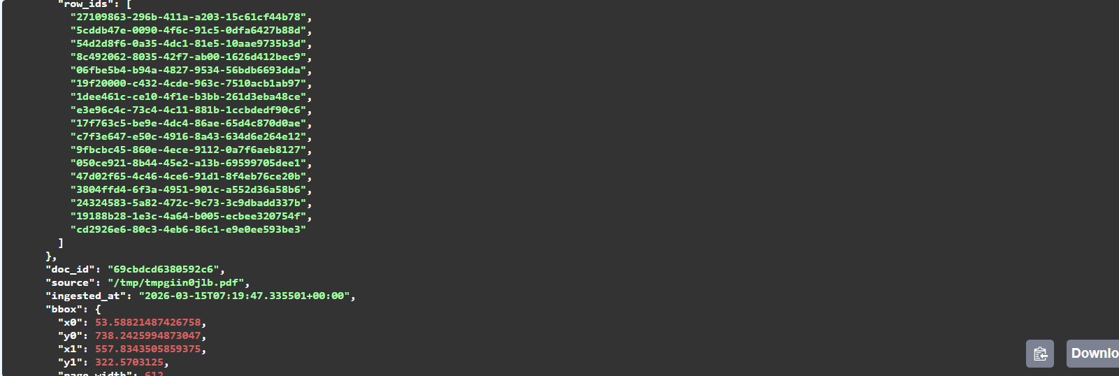
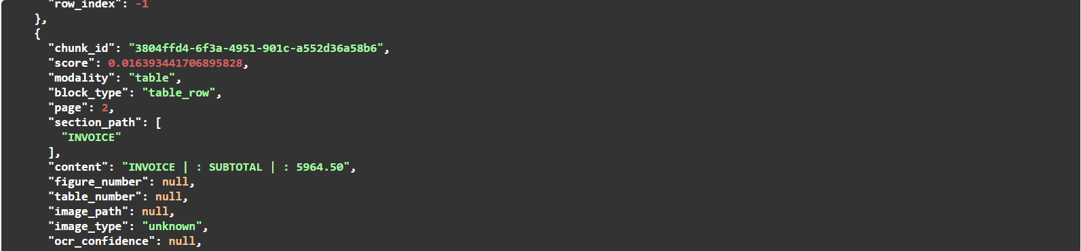

Question: Highest Cost Line Item
Q:
Which product contributes the highest total price in the invoice, and what is that total amount?
Answer:
The highest total item is:
Venlafaxine Hydrochloride
- Quantity: 25
- Unit Price: 16.00
Total:
$$25×16.00=400.00$$
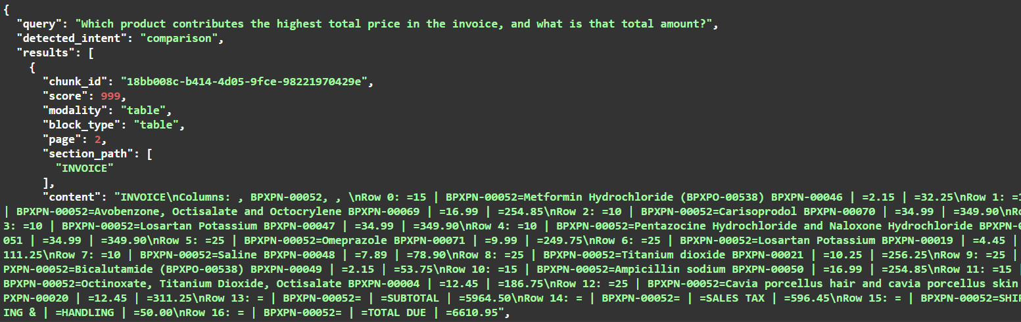
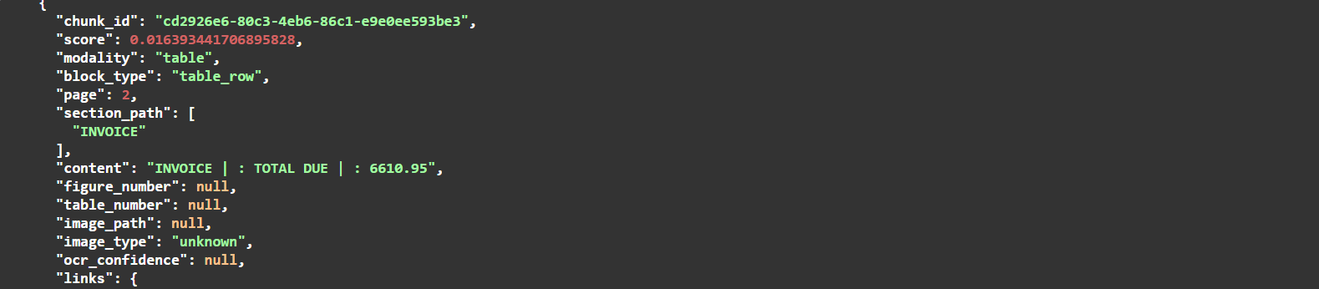
Combined cost reasoning
What is the combined total price of the following products?
- Risperidone
- Metoprolol succinate
- Acetaminophen

