QUESTIONS:
Image-based Question
The document contains images such as the R&D Lab, Company Group Photo, and Close-ups of Cartoon Weapons.
Actual Answer:
The Design and Prototyping stage led by Dr. Nefario and his team is responsible for creating prototypes and brainstorming new products.

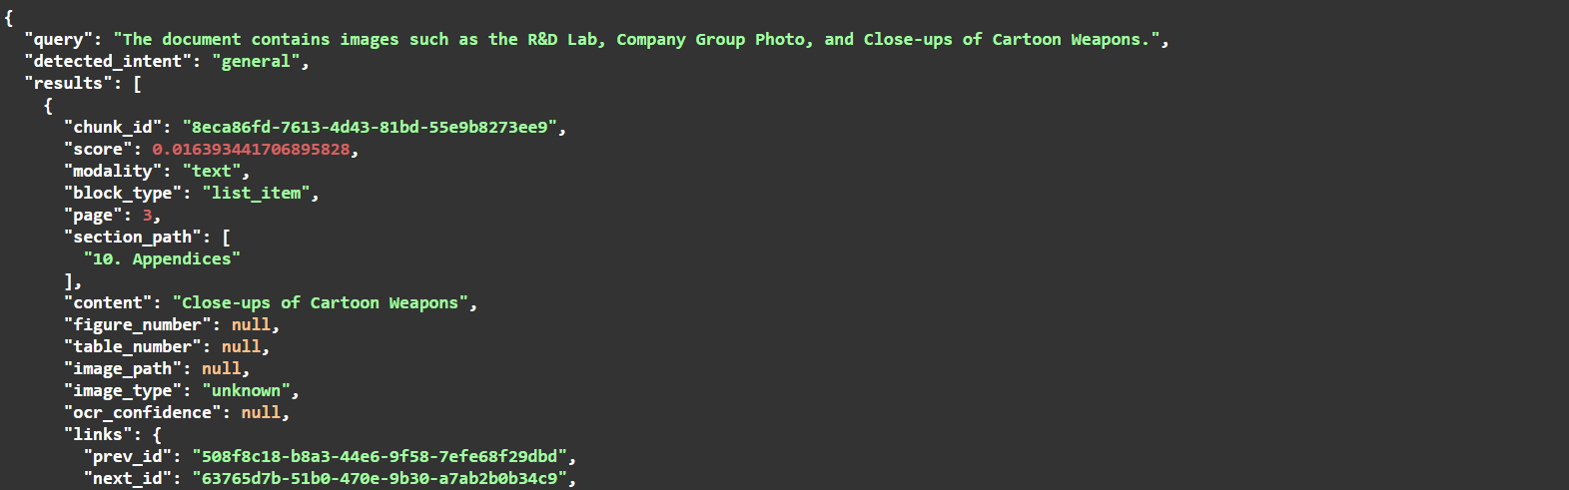



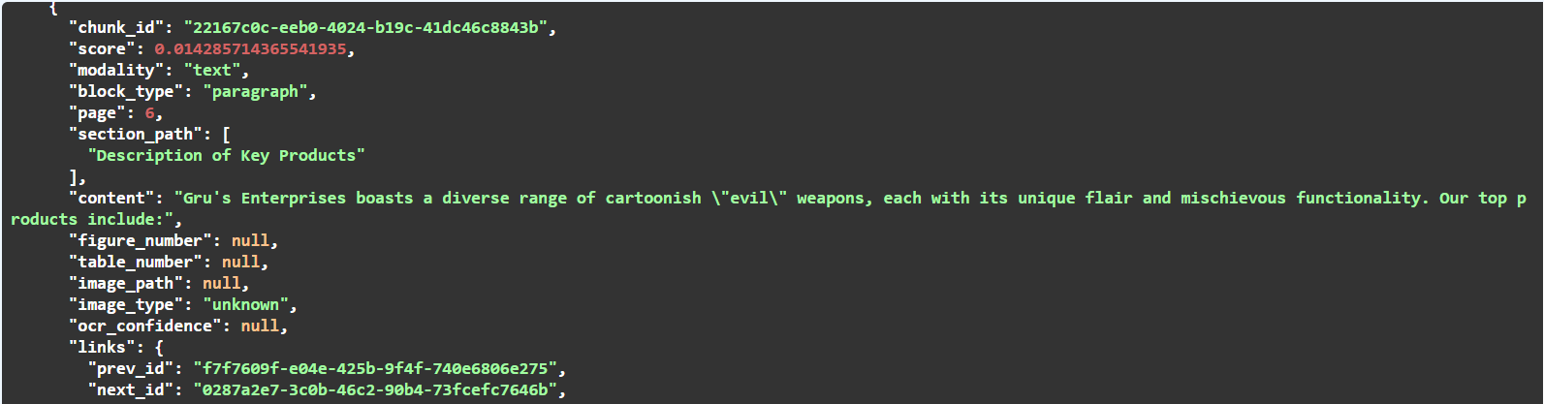
Image-based Question
According to the Best-selling Products Analysis table, which product has the highest gross margin, and what is its margin percentage?
Actual Answer:
The Freeze Ray has the highest gross margin of 70%.
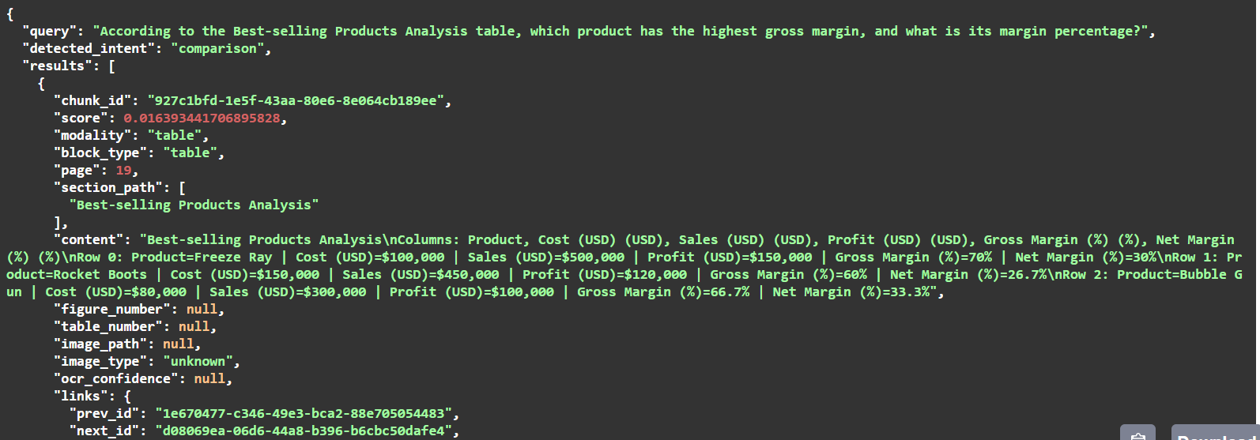
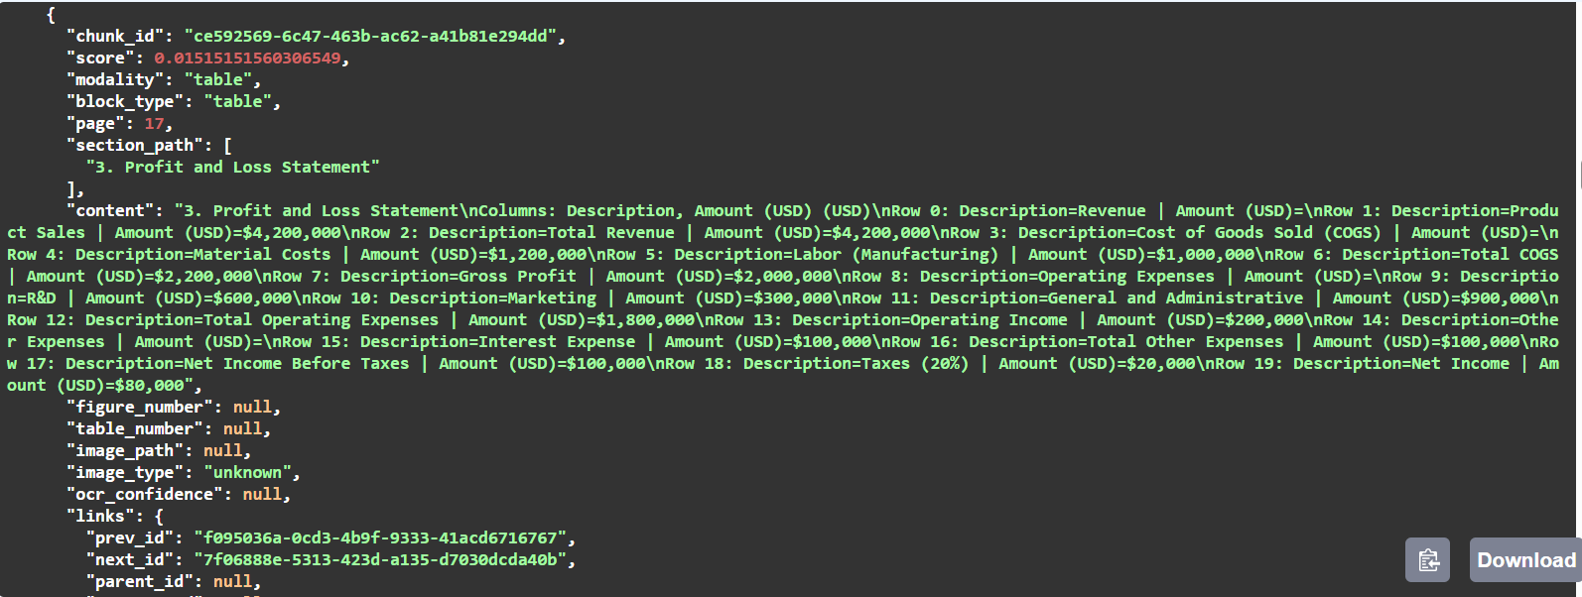
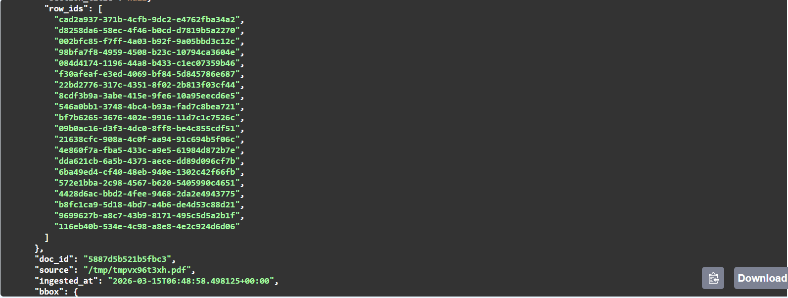
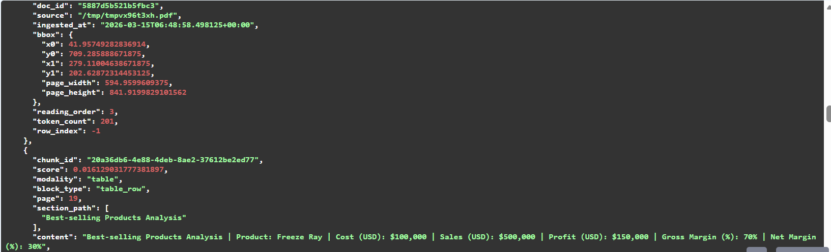
Financial Table Question
From the Balance Sheet table, what is the total value of assets, and which asset category contributes the most?
Answer:
- Total Assets: $2,500,000
- Largest Asset: Property, Plant, and Equipment ($1,200,000)

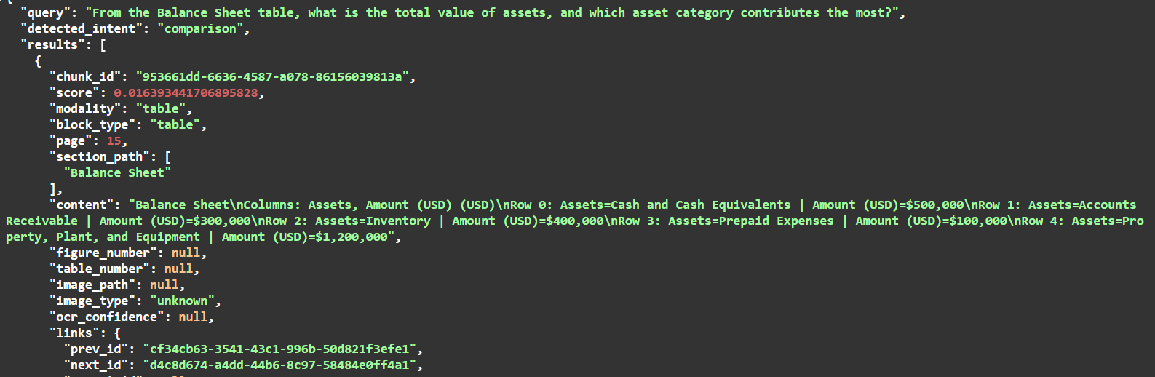
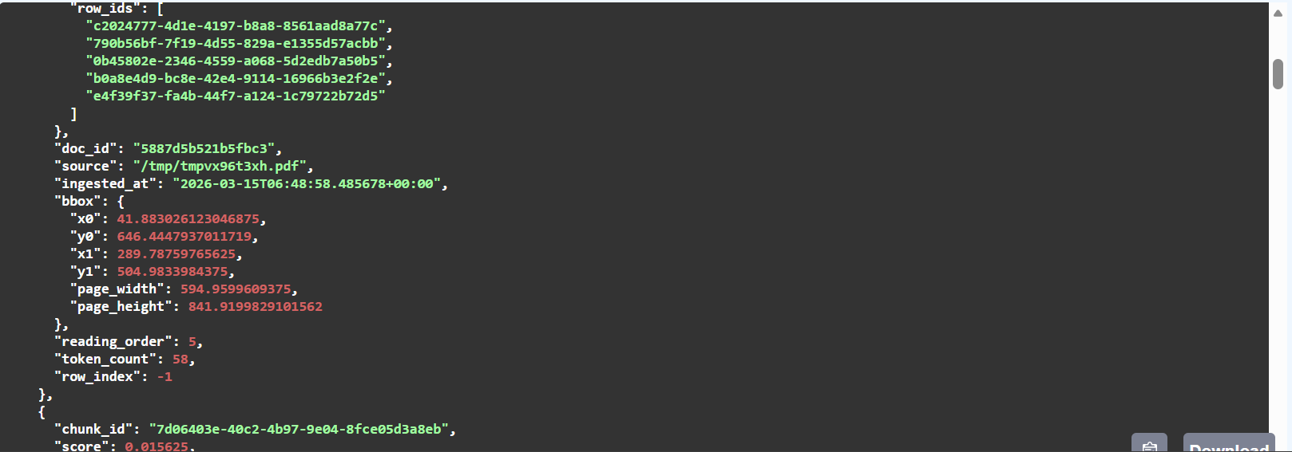
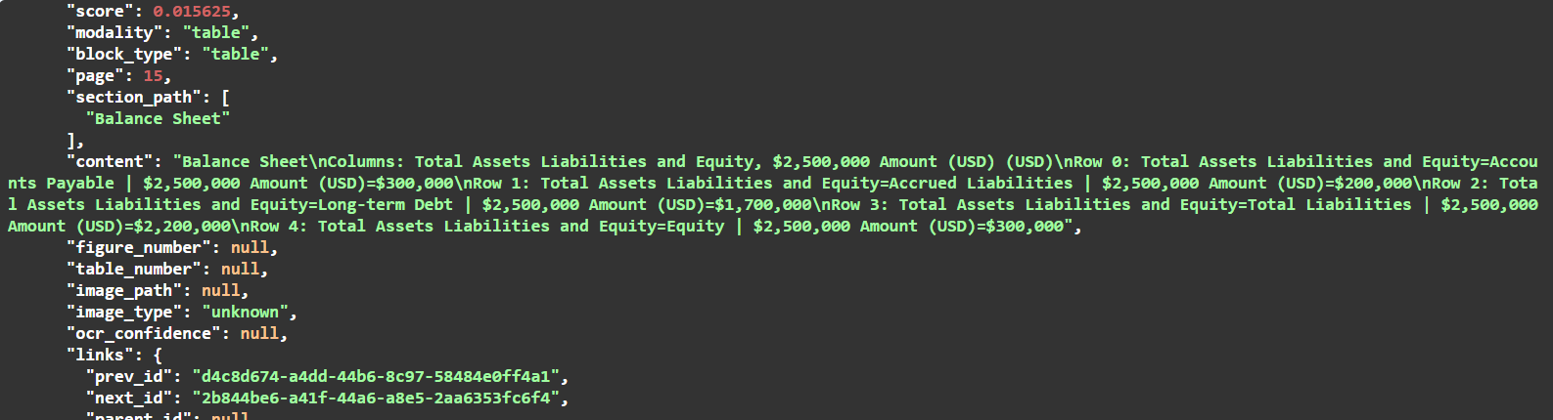



Text Understanding Question
What is the core business model of Gru's Enterprises described in the executive summary?
Answer:
Gru's Enterprises designs and manufactures cartoonish "evil" weapons, such as freeze rays and rocket boots, targeting a niche market interested in humorous fantasy gadgets.

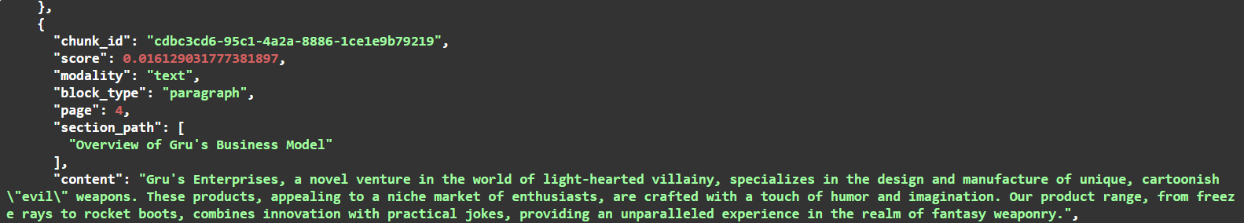

Cross-modal Question (Table + Text Reasoning)
Question:
Based on the Profit and Loss Statement, calculate the gross profit and explain which two major cost components contributed to the cost of goods sold.
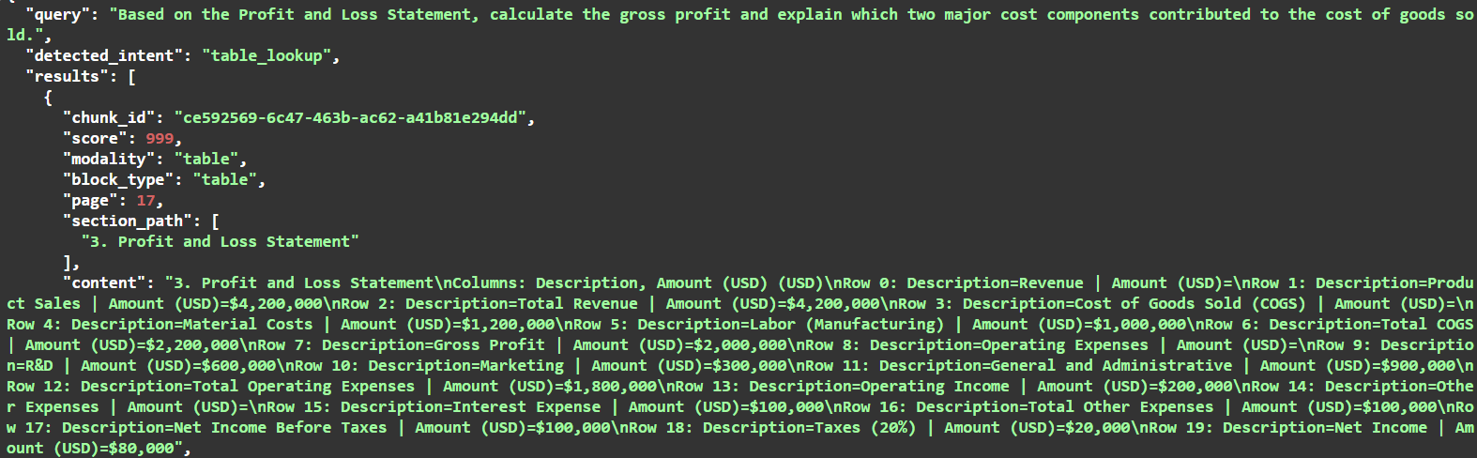

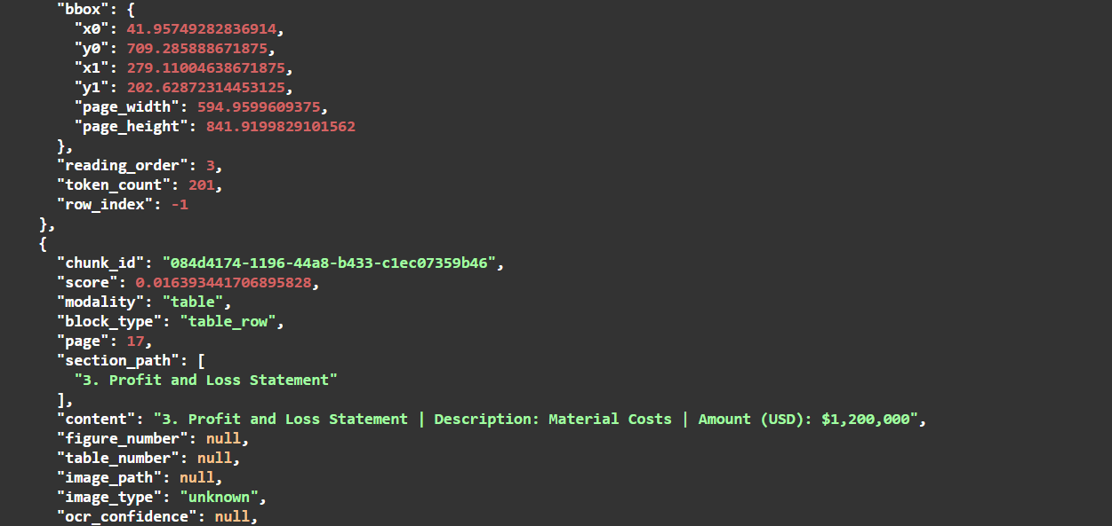
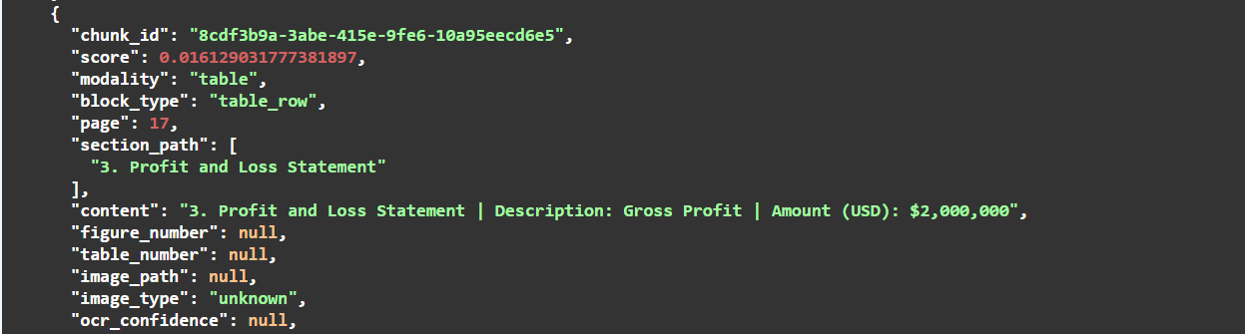

Chart/Table Interpretation
According to the Geographical Distribution of Product Use table, which region generates the highest revenue, and what does this indicate about the company's market presence?
Region: North America
Revenue: $1,000,000
Interpretation: The company has its strongest market presence in North America.

