**StarPlatinum**

**Created by**

Suchon Chatavaraha 6130577521

Pabhanuwat Pongsawad 6130308021

**2110215 Programming Methodology**

**Semester 1 Year 2019**

**Chulalongkorn University**

**Game : A 4 Christmas Present**

**Introduction:**

This game is inspired by Doodle Jump, but we recreated it in Christmas theme. It’s objective is to jump on obstacles and get as much scores as you can.

**Rules:**

The rule is easy just jump on obstacles and try not to fall.

**Example:**

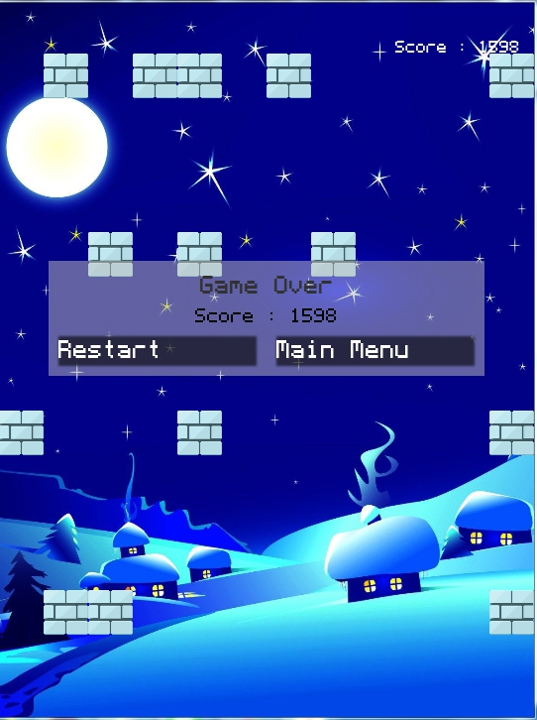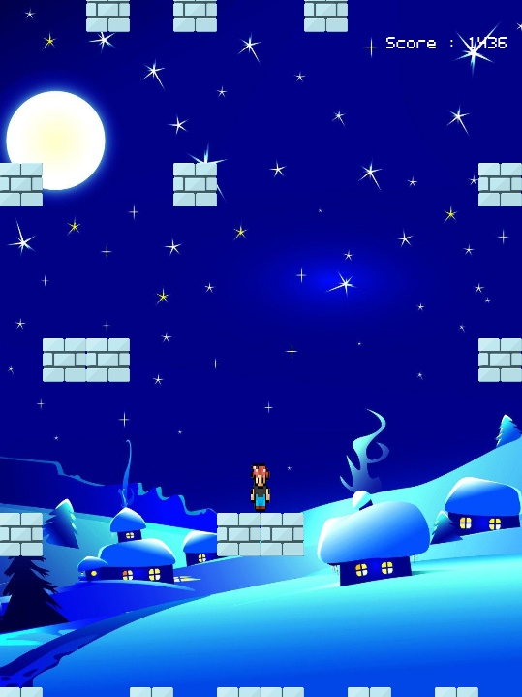

**Main Menu Scene:**





**Class Diagram:**

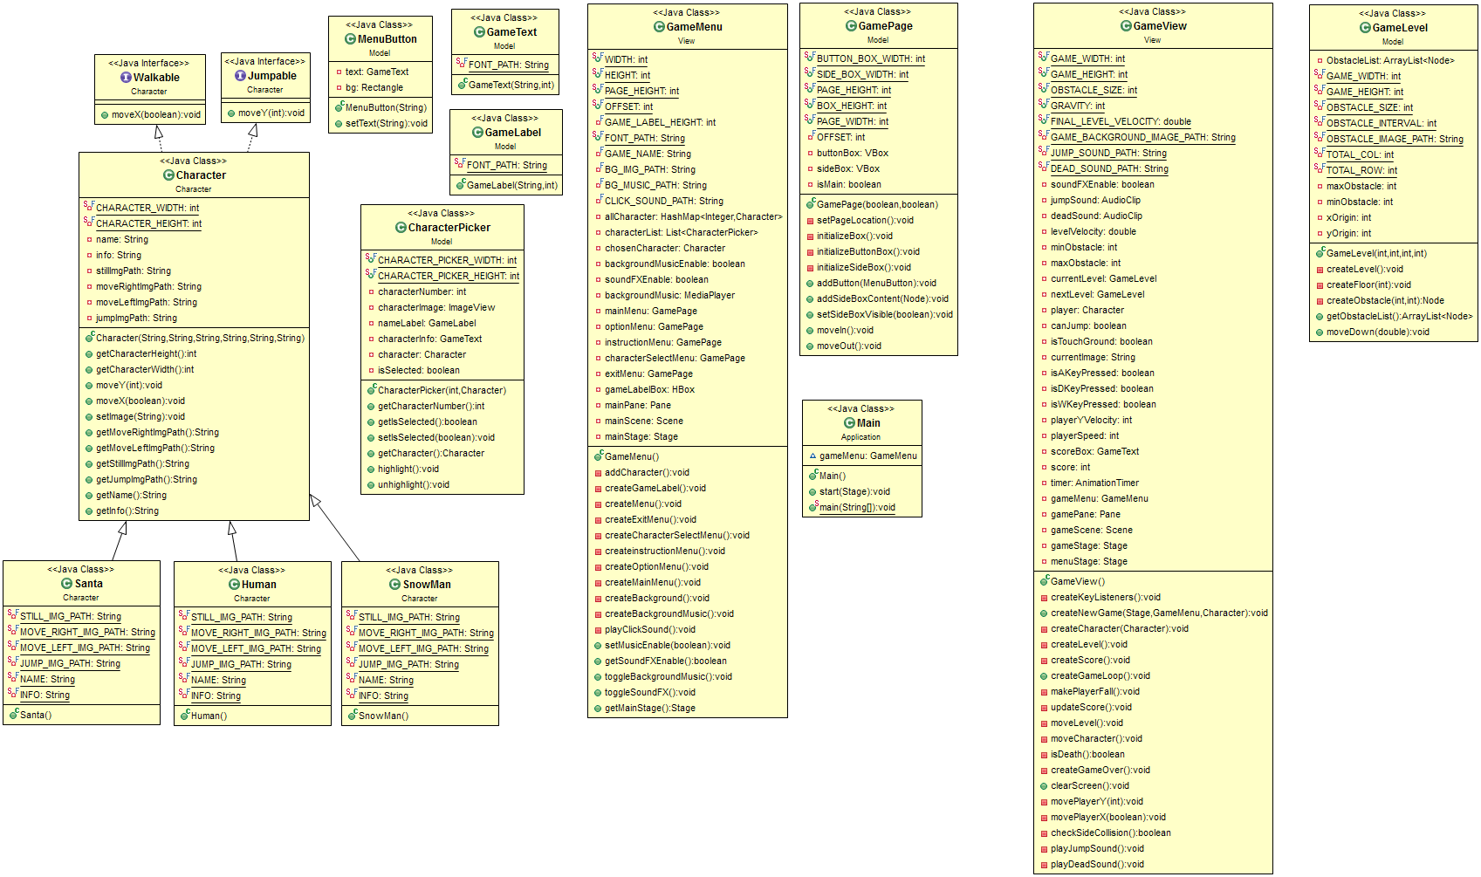

**\* Noted that Access Modifier Notations can be listed belo**

**+ (public)**

**# (protected)**

**- (private)**

**BOLD** for final variable

*ITALIA* for static variable

1. **Package Application**

1.1 Class Main

* extends Application

1.1.1 Fields

|  |  |
| --- | --- |
| * GameMenu gameMenu | * Contain Game Menu |

1.1.2 Methods

|  |  |
| --- | --- |
| * void start(Stage primaryStage) | * Initialize gameMenu * Get main stage from GameMenu * Set resizable to false |
| * void *main*(String[] args) | * Launch application |

1. **Package Character**

2.1 Interface Jumpable

|  |  |
| --- | --- |
| * void moveY(int y) | * Make player move on Y Axis |

2.2 Interface Walkable

|  |  |
| --- | --- |
| * void moveX(boolean movingRight) | * Make player move on X Axis |

2.3 Class Character

* extends ImageView
* implements Jumpable, Walkable

2.3.1 Fields

|  |  |
| --- | --- |
| * int ***CHARACTER_WIDTH*** | * Contains width for character |
| * int ***CHARACTER_HEIGHT*** | * Contains height for character |
| * String name | * Contains name for character |
| * String info | * Description for character |
| * String stillImgPath | * Path to image of character staying still |
| * String moveRightImgPath | * Path to image of character moving right |
| * String moveLeftImgPath | * Path to image of character moving right |
| * String jumpImgPath | * Path to image of character jumping |

2.3.2 Constructor

|  |  |
| --- | --- |
| * Character(String name, String stillImgPath,String moveRightImgPath,String moveLeftImgPath, String jumpImgPath,String info) | * Set height with CHARACTER_HEIGHT * Set width with CHARACTER_WIDTH * Initialize all fields |

2.3.3 Methods

|  |  |
| --- | --- |
| * void setImage(String path) | * Set image to specified path |
| * void moveX(boolean movingRight) | * Move player in X Axis |
| * void moveY(int y) | * Move player in Y Axis |
| * Getters for every fields | * returns fields |

2.4 Class Santa

* extends Character

2.4.1 Fields

|  |  |
| --- | --- |
| * String ***STILL_IMG_PATH*** | * Path to character staying still image |
| * String ***MOVE_IMG_PATH*** | * Path to character moving image |
| * String ***JUMP_IMG_PATH*** | * Path to character jumping image |
| * String ***NAME*** | * Contains name |
| * String ***INFO*** | * Description |

2.4.2 Contructor

|  |  |
| --- | --- |
| * Santa() | * Call parent’s constructor |

2.5 Class Human

* extends Character

2.5.1 Fields

|  |  |
| --- | --- |
| * String ***STILL_IMG_PATH*** | * Path to character staying still image |
| * String ***MOVE_IMG_PATH*** | * Path to character moving image |
| * String ***JUMP_IMG_PATH*** | * Path to character jumping image |
| * String ***NAME*** | * Contains name |
| * String ***INFO*** | * Description |

2.5.2 Constructor

|  |  |
| --- | --- |
| * Human() | * Call parent’s constructor |

2.6 Class SnowMan

* extends Character

2.6.1 Fields

|  |  |
| --- | --- |
| * String ***STILL_IMG_PATH*** | * Path to character staying still image |
| * String ***MOVE_RIGHT_IMG_PATH*** | * Path to character moving right image |
| * String ***MOVE_LEFT_IMG_PATH*** | * Path to character left image |
| * String ***JUMP_IMG_PATH*** | * Path to character jumping image |
| * String ***NAME*** | * Contains name |
| * String ***INFO*** | * Description |

2.6.2 Constructor

|  |  |
| --- | --- |
| * SnowMan() | * Call parent’s constructor |

1. **Package Model**

3.1 Class CharacterPicker

* extends VBox

3.1.1 Fields

|  |  |
| --- | --- |
| * int ***CHARACTER_PICKER_WIDTH*** | * Width of character picker box |
| * int ***CHARACTER_PICKER_HEIGHT*** | * Height of character picker box |
| * int characterNumber | * Number of character |
| * ImageView characterImage | * Image of character |
| * GameLabel nameLabel | * Name of character |
| * GameText characterInfo | * Character’s description |
| * Character character | * Character object |
| * boolean isSelected | * True if character is selected else False |

3.1.2 Constuctor

|  |  |
| --- | --- |
| * CharacterPicker(int num, Character character) | * Set background color to Dark Grey * Set alignment to center * Set spacing 20 * Set size with WIDTH and HEGIHT * Initialize nameLabel with character’s name, 28 font size and 56 height * Initialize characterImage with proper width and 168 height * Initialize characterInfo with character’s info and 16 font size * Add nameLabel, characterImage and characterInfo to VBox |

3.1.3 Methods

|  |  |
| --- | --- |
| * int getCharacterNumber() | * returns characterNumber |
| * boolean getIsSelected() | * returns isSelected |
| * void setIsSelected(boolean isSelected) | * Set isSelected to given value |
| * Character getCharacter() | * returns character |
| * void highlight() | * Set border’s color to LightYellow |
| * void unhighlight() | * Set border’s color to Black |

3.2 Class GameLabel

* extends Label

3.2.1 Fields

|  |  |
| --- | --- |
| * String ***FONT_PATH*** | * Path to specified font |

3.2.2 Constructor

|  |  |
| --- | --- |
| * GameLabel(String text, int size) | * Initialize label with given text, font type and font size |

3.3 Class GameLevel

* extends Pane

3.3.1 Fields

|  |  |
| --- | --- |
| * ArrayList<Node> ObstacleList | * Contains all obstacles on the screen |
| * int ***GAME_WIDTH*** | * Width of the screen |
| * int ***GAME_HEIGHT*** | * Height of the screen |
| * int ***OBSTACLE_SIZE*** | * Size of obstacles |
| * int ***OBSTACLE_INTERVAL*** | * Space between each row of obstacles |
| * String ***OBSTACLE_IMAGE_PATH*** | * Obstacle’s image path |
| * int ***TOTAL_COL*** | * Total column of the screen |
| * int ***TOTAL_ROW*** | * Total row of the screen |
| * int maxObstacle | * Maximum obstacles in a row |
| * int minObstacle | * Minimum obstacles in a row |
| * int xOrigin | * X coordinate of top left screen |
| * int yOrigin | * Y coordinate of top left screen |

3.3.2 Constructor

|  |  |
| --- | --- |
| * GameLevel(int x, int y, int min, int max) | * Initialize every field * Set (x, y) with (xOrigin, yOrigin) * Set size with GAME_HEIGHT and GAME_WIDTH * call createLevel() |

3.3.3 Methods

|  |  |
| --- | --- |
| * void createLevel() | * Create obstacles every 4 row by calling these methods * Call method createObstacle() * Call method createFloor() |
| * void createObstacle(int col, int row) | * Create obstacle at given column and row of the screen |
| * void createFloor(int row) | * Create obstacles for every column in a given row |
| * ArrayList<Node> getObstacleList() | * returns obstacleList |
| * void moveDown(double y) | * Move screen down for amount of “y” |

3.4 Class GamePage

* extends HBox

3.4.1 Fields

|  |  |
| --- | --- |
| * int ***BUTTON_BOX_WIDTH*** | * Width of the box of buttons |
| * int ***SIDE_BOX_WIDTH*** | * Width of side box |
| * int ***PAGE_HEIGHT*** | * Height of the Pane |
| * int ***BOX_HEIGHT*** | * Height of the box |
| * int ***PAGE_WIDTH*** | * Width of the Pane |
| * int **OFFSET** | * Offset |
| * VBox buttonBox | * Pane of buttons |
| * VBox sideBox | * Pane of sideBox |
| * boolean isMain | * True if the page if Main Menu False otherwise |

3.4.2 Constuctor

|  |  |
| --- | --- |
| * public GamePage(boolean isMain,boolean sideBoxVisible) | * Set (25, 25, 75, 25) padding * Set 25 spacing * Set size with PAGE_WIDTH and PAGE_HEIGHT * Set alignment to Top Center * Set visibility with given value * Initialize field with given value * Call initializeBox() * Call setPageLocation() |

3.4.3 Methods

|  |  |
| --- | --- |
| * void setPageLocation() | * Set page’s location to proper position |
| * void initializeBox() | * Call initializeButtonBox() * Call initializeSideBox() |
| * void initializeButtonBox() | * Initialize buttonBox with 10 spacing and set proper size * Set alignment to Top Right |
| * void initializeSideBox() | * Initialize sideBox with VBox, 10 spacing, 15 padding, set alignment to Top Center. set proper size and set background to Grey |
| * void addButton(MenuButton button) | * add button to buttonBox |
| * void addSideBoxContent(Node node) | * add node to sideBox |
| * setSideBoxVisible(boolean set) | * Set sideBox’s visibility to given value |
| * void moveIn() | * Perform moving in effect |
| * void moveOut() | * Perform moving out effect |

3.5 Class GameText

* extends Text

3.5.1 Fields

|  |  |
| --- | --- |
| * String ***FONT_PATH*** | * Font’s path |

3.5.2 Constructor

|  |  |
| --- | --- |
| * GameText(String text,int size) | * Initialize text with given text and size by calling parent’s constructor |

3.5 Class MenuButton

* extends StackPane

3.5.1 Fields

|  |  |
| --- | --- |
| * GameText text | * Contains text which will be put in a button |
| * Rectangle bg | * Background |

3.5.2 Constructor

|  |  |
| --- | --- |
| * MenuButton(String name) | * Build a text with given name * Initialize and set color of bg to Black * Set alignment to Center Left * Setup mouse event * Setup effect and sound * Add bg and text to the Pane |

3.5.3 Methods

|  |  |
| --- | --- |
| * void setText(String text) | * Set text with given text |

1. **Packag View**

4.1 Class GameMenu

4.1.1 Fields

|  |  |
| --- | --- |
| * int ***WIDTH*** | * Menu’s width |
| * int ***HEIGHT*** | * Menu’s height |
| * int ***PAGE_HEIGHT*** | * Page’s height |
| * int ***OFFSET*** | * Offset |
| * int **GAME_LABEL_HEIGHT** | * Game label’s height |
| * String ***FONT_PATH*** | * Font’s path |
| * String **GAME_NAME** | * Name of the game |
| * String **BG_IMG_PATH** | * Path to background’s image |
| * String **BG_MUSIC_PATH** | * Path to background music |
| * String **CLICK_SOUND_PATH** | * Path to click audio |
| * HashMap<Integer, Character> allCharacter | * Map of character’s number and character |
| * List<CharacterPicker> characterList | * Contains boxes of each character to be picked |
| * Character chosenCharacter | * Contains chosen character |
| * boolean backgroundMusicEnable | * Boolean for enabling background music |
| * boolean soundFXEnable | * Boolean for enabling sound FX |
| * MediaPlayer backgroundMusic | * Object of background music |
| * GamePage mainMenu | * Main menu |
| * GamePage optionMenu | * Option menu |
| * GamePage instructionMenu | * Instruction menu |
| * GamePage characterSelectMenu | * Character selection menu |
| * GamePage exitMenu | * Exit menu |
| * HBox gameLabelBox | * HBox for game’s title |
| * Pane mainPane | * Main pane |
| * Scene mainScene; | * Main scene |
| * Stage mainStage | * Main stage |

4.1.2 Constructor

|  |  |
| --- | --- |
| * GameMenu() | * Initialize mainPage, mainScene and mainStage * Calls addCharacter() * Calls createBackground() * Calls createBackgroundMusic() * Calls createMenu() * Calls createGameLabel() |

4.1.3 Methods

|  |  |
| --- | --- |
| * void addCharacter() | * Add 3 characters to allCharacter’s map |
| * void createGameLabel() | * Create game label and add to mainPane |
| * void createMenu() | * Create all menus * Calls createMainMenu() * Calls createCharacterSelectMenu() * Calls createOptionMenu() * Calls createHighScoreMenu() * Calls createExitMenu() |
| * void createExitMenu() | * Initialize exitMenu * Setup sounds and events * Add to mainPane |
| * void createCharacterSelectMenu() | * Initialize characterSelectMenu * Setup sounds and events * Add to mainPane |
| * void createinstructionMenu() | * Initialize instructionMenu * Setup sounds and events * Add to mainPane |
| * void createOptionMenu() | * Create option menu * Contains music muting button * Contains FX muting button |
| * void createMainMenu() | * Create main menu * Contains startButton * Contains optionButton * Contains instructionButton * Contains exitButton * Setup sound and events for each button * Add to mainPane |
| *For every object of menu set proper location, style and size | |
| * void createBackground() | * Create background with specified path * Add to mainPane |
| * void createBackgroundMusic() | * Create background music with specified path |
| * void playClickSound() | * Play clickick sound if soundFXEnable is true |
| * boolean getSoundFXEnable() | * Get value of soundFXEnable |
| * void toggleBackgroundMusic() | * Toggle background music |
| * void toggleSoundFX() | * Toggle sound FX |
| * Stage getMainStage() | * returns mainStage |
| * void setMusicEnable(boolean val) | * Set value of backgroundMusic according to val |

4.2 Class GameView

4.2.1 Fields

|  |  |
| --- | --- |
| * int ***GAME_WIDTH*** | * Game screen’s width |
| * int ***GAME_HEIGHT*** | * Game screen’s height |
| * int ***OBSTACLE_SIZE*** | * Obstacle’s size |
| * int ***GRAVITY*** | * Gravity |
| * String ***FONT_PATH*** | * Font’s path |
| * double ***FINAL_LEVEL_VELOCITY*** | * Max level speed |
| * String ***GAME_BACKGROUND_IMAGE_PATH*** | * Path to background music |
| * String ***JUMP_SOUND_PATH*** | * Path to jumping sound |
| * String ***DEAD_SOUND_PATH*** | * Path to dead sound |
| * double levelVelocity | * Current level speed |
| * int minObstacle | * Minimum obstacles in a row |
| * int maxObstacle | * Maximun obstacles in a row |
| * GameLevel currentLevel | * Current level (current screen) |
| * GameLevel nextLevel | * Next level (next screen) |
| * GameMenu gameMenu | * Game menu |
| * Pane gamePane | * Game’s pane |
| * Scene gameScene | * Game’s scene |
| * Stage gameStage | * Game’ stage |
| * Stage menuStage | * Menu’s stage |
| * boolean soundFXEnable | * Boolean value of sound FX enabling |
| * AudioClip jumpSound | * Jumping sound |
| * AudioClip deadSound | * Dead sound |
| * Character player | * Contains current player |
| * boolean canJump | * True if player is able to jump |
| * boolean isTouchGround | * True if player is on the ground |
| * String currentImage | * Current player image |
| * boolean isAKeyPressed | * True if key A is being pressed False otherwise |
| * boolean isWKeyPressed | * True if key W is being pressed False otherwise |
| * boolean isDKeyPressed | * True if key D is being pressed False otherwise |
| * int playerYVelocity | * Velocity of player in Y Axis |
| * int playerSpeed |  |
| * GameText scoreBox | * Box showing score on the screen |
| * int score | * Current score |
| * AnimationTimer timer | * Timer for looping the game |

4.2.2 Constructor

|  |  |
| --- | --- |
| * GameView() | * Initialize gamePane, set background and size * Initialize gameScene * Initialize gameStage, set size and resizable to false * Calls createKeyListeners() |

4.2.3 Methods

|  |  |
| --- | --- |
| * void createNewGame(Stage menuStage, GameMenu gameMenu, Character character) | * Create a new game * Calls createCharacter() * Calls createLevel() * Calls createScore() * Calls createGameLoop() * Show gameStage |
| * void createScore() | * Score = 0 * Initialize scoreBox * Add scoreBox to gamePane |
| * void updateScore() | * Increment score point * Increase levelVelocity every 1000 points * Decrease maximum obstacle by 1 every 3000 points by nevery less than minimum obstacle |
| * void createCharacter(Character character) | * Create player * Add the gamePane |
| * void createLevel() | * Initialize currentLevel and nextLevel * Add currentLevel and nextLevel to gamePane |
| * void createGameLoop() | * Game loop * Initialize timer * Calls makePlayerFall() * Calls moveCharacter() * Calls moveLevel() * Calls updateScore() * If the player is dead, stop the timer and calls createGameOver() |
| * boolean isDeath() | * return True if the player is dead False otherwise |
| * void createGameOver() | * Create game over windows showing score, restart button and back to menu button |
| * void clearScreen() | * Clear the screen |
| * void makePlayerFall() | * Make player falls by increase player’s Y velocity by GRAVITY |
| * void moveLevel() | * Make obstacles down and random new ones |
| * void moveCharacter() | * Move and change character animation according to key pressed |
| * void movePlayerY(int x) | * Move player in Y Axis for amount of “x” and also detect collisions in Y Axis |
| * void movePlayerX(boolean moveRight) | * Move player in X Axis for amount of playerSpeed |
| * boolean checkSideCollision() | * Check collisions in X Axis |
| * void createKeyListeners() | * Setup key event for gameScene |
| * void playJumpSound() | * Play jumping sound |
| * void playDeadSound() | * Play dead sound |