#Abhishek Prajapati

#CS336 HW 1

#Query 1 - Bars which sell Michelob Amber Bock or Budweiser

select bar

from BarBeerDrinker.sells

where beer = 'Michelob Amber Bock' OR beer = ‘Budweiser';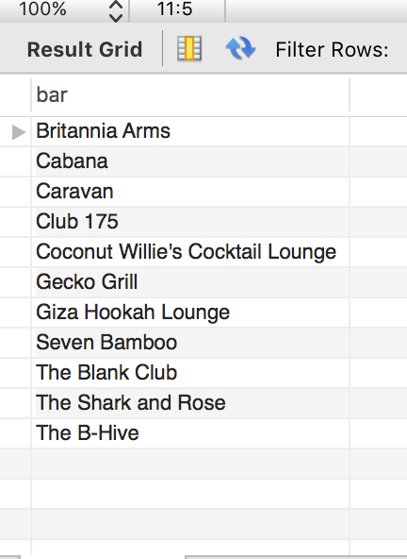

#Query 2 - Drinkers who like some beers other than Budweiser (they do not have to like Budweiser)

select distinct drinker

from BarBeerDrinker.likes

where beer <> ‘Budwiser’;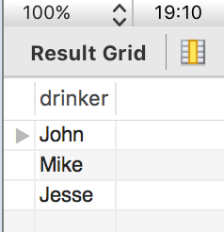

#Query 3 - Beers other than Hefeweizen which are served by Gecko Grill bar

select beer

from BarBeerDrinker.sells

where bar = 'Gecko Grill' AND beer <> ‘Hefeweizen';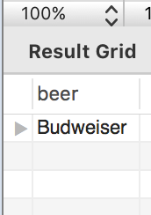

#Query 4 - Bars who serve some beers which John likes

select distinct bar

from BarBeerDrinker.sells S

join (select beer from BarBeerDrinker.likes where drinker = 'john')J

on S.beer = J.beer;

#select distinct bar from BarBeerDrinker.sells, BarBeerDrinker.likes where ( likes.drinker = 'John' AND sells.beer = likes.beer);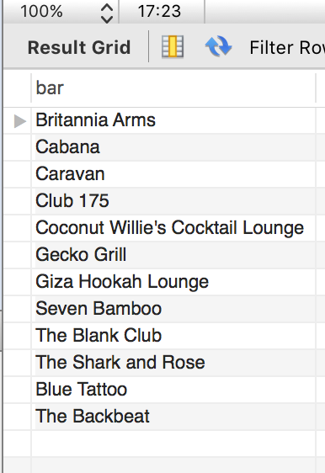

#Query 5 - Drinkers who frequent bars which serve Original Premium Lager Dog

select distinct

drinker

from

BarBeerDrinker.frequents S

join

(select bar from BarBeerDrinker.sells where beer = 'Original Premium Lager Dog')J

on

S.bar = J.bar;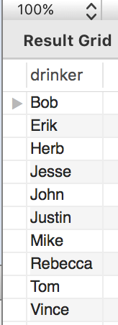

#Query 6 - Bars which are frequented by John or Rebecca but not by both of them

select

f.bar

from

BarBeerDrinker.frequents f

where

(drinker = 'John' OR drinker = 'Rebecca')

AND NOT EXISTS

(select f1.bar

from BarBeerDrinker.frequents f1, BarBeerDrinker.frequents f2

where

(f1.drinker = 'john' AND f2.drinker = 'Rebecca') AND f.bar = f1.bar AND f.bar = f2.bar);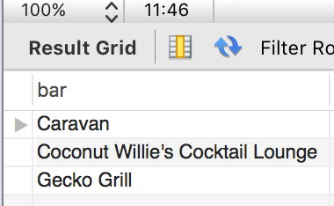

#Query 7 - Drinkers who frequent at least three bars

select distinct

drinker

from

BarBeerDrinker.frequents d

where exists

(select distinct bar from BarBeerDrinker.frequents where drinker = d.drinker

HAVING COUNT(distinct bar ) >= 3);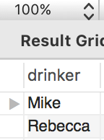

#Query 8 - Drinkers who frequent bars which sell some beer they like

select distinct f1.drinker

from BarBeerDrinker.frequents f1, BarBeerDrinker.likes l1, BarBeerDrinker.sells s1

where (f1.drinker = l1.drinker) and f1.bar = s1.bar and l1.beer = s1.beer;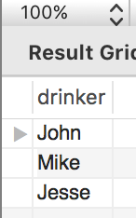

#Query 9 - Beers which are served by bars which John frequents

select distinct

beer

from

BarBeerDrinker.sells S

join

(select bar from BarBeerDrinker.frequents where drinker = 'John')J

on

S.bar = J.bar;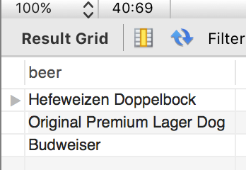

#Query 10 - Bars which serve some beers which John or Rebecca like and which are cheaper than $5

select distinct

bar

from

BarBeerDrinker.sells S

join

( select beer from BarBeerDrinker.likes where (drinker = 'john' OR drinker = 'Rebecca'))J

on

S.beer = J.beer

where price < 5;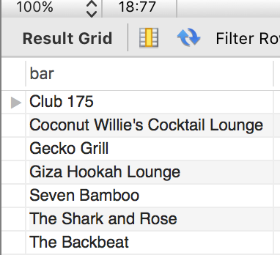

#Query 11 - Bars which serve some beers which Mike likes or which John likes

select distinct

bar

from

BarBeerDrinker.sells S

join

( select beer from BarBeerDrinker.likes where (drinker = 'john' OR drinker = 'Mike'))J

on

S.beer = J.beer;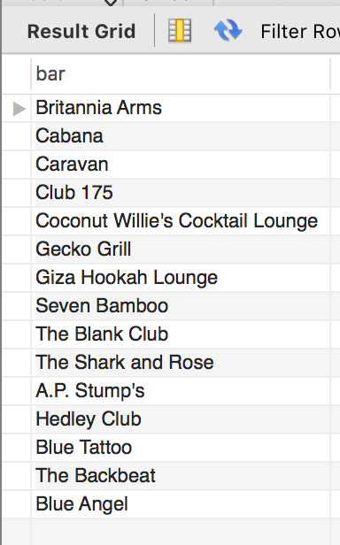

#Query 12 - Drinkers who like both Hefeweizen and Killian's

select

drinker

from

BarBeerDrinker.likes

where

beer = 'Hefeweizen' AND beer = (‘Killian''s');

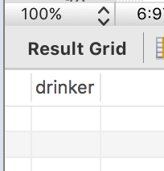

#Query 13 - List all bars, beers they sell and beer prices in euros

SELECT * FROM BarBeerDrinker.sells ;

select sells.bar, sells.beer, sells.price * 0.89 AS price_EUR FROM BarBeerDrinker.sells ;

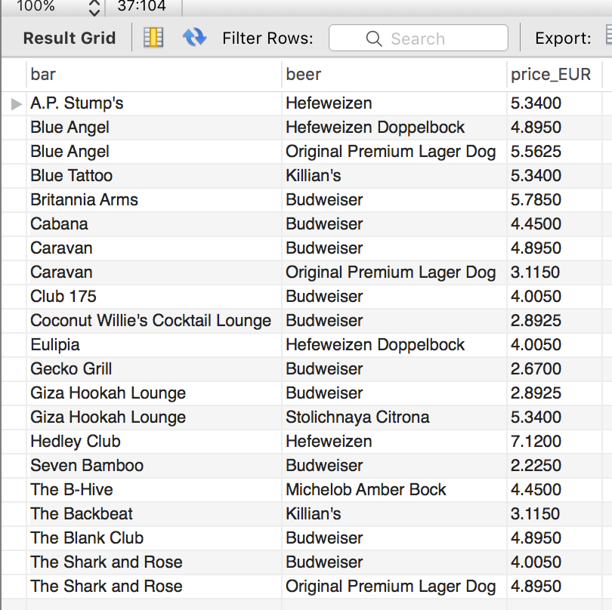

#Query 14 - Bars with names containing "The"

select

bars.name

from

BarBeerDrinker.bars

where

bars.name LIKE ‘%The%';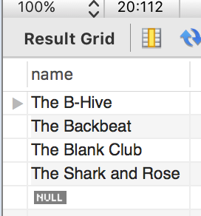

#Query 15 - Drinkers who like Killian's and who also frequent Gecko Grill

select f1.drinker from BarBeerDrinker.frequents f1, BarBeerDrinker.likes l1

where f1.drinker = l1.drinker and l1.beer = 'Killian''s' and f1.bar = 'Gecko Grill';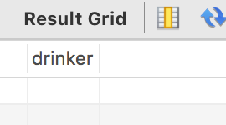

Abhishek Prajapati

HW 2

#1)Drinkers who like only Bud

select drinker

from BarBeerDrinker2.likes

where drinker not in(select drinker from BarBeerDrinker2.likes where not beer = ‘Bud');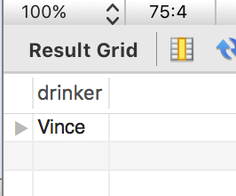

#2)Beers which every drinker who frequents Cabana likes

select distinct beer

from BarBeerDrinker2.likes B

join (select drinker from BarBeerDrinker2.frequents where bar = 'Cabana')D

on B.drinker = D.drinker;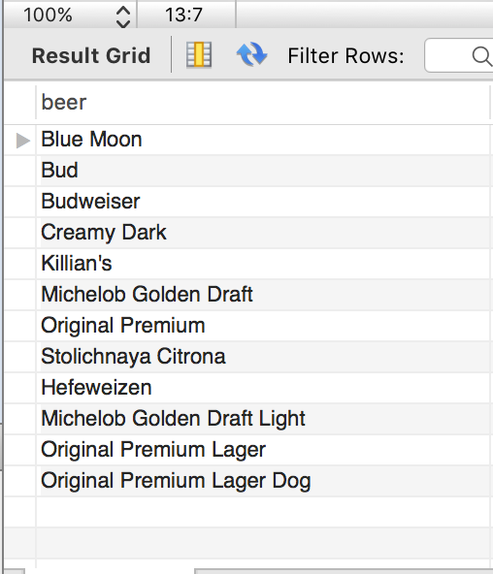

#3) Bars which serve only beer(s) which Joe likes

select s.bar

from sells s ,sells s2

where s.beer=(select distinct l.beer from likes l,sells s where l.drinker ='Joe' and l.beer = s.beer) and s.bar=s2.bar

group by s2.bar having count(s2.bar)=1;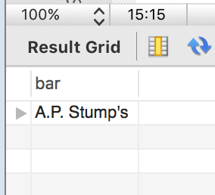

#4) Bars which every drinker frequents

select b.name from bars b where not exists

(select d.name from drinkers d where not exists

(select f.bar from frequents f where f.drinker = d.name and f.bar = b.name));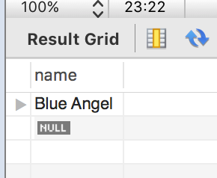

#5)Drinkers who frequent exactly one bar of bar(s) which Joe frequents

select d.drinker

from (select f2.drinker from frequents f1, frequents f2 where f1.drinker='Joe' and f1.bar=f2.bar)d group by d.drinker

having count(*) =1;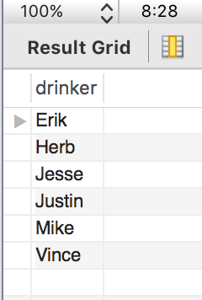

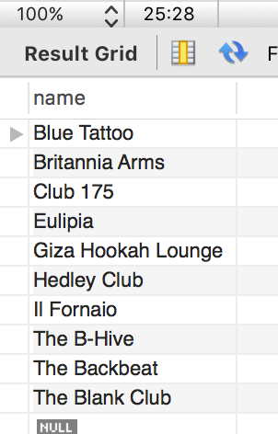

#6) Bars which no drinker frequents

select bars.name

from bars

where bars.name

Not in

(select distinct B.bar from BarBeerDrinker2.frequents B

join (select drinker from BarBeerDrinker2.frequents) D

on NOT B.drinker = D.drinker);