**Aditya Raj**

**11905310**

**Roll No : 09**

CA-3 Epam DevOps

1 )create and configure a vpc, subnet, route table, etc. with terraform,Ec2 instance and a load balancer with terraform.

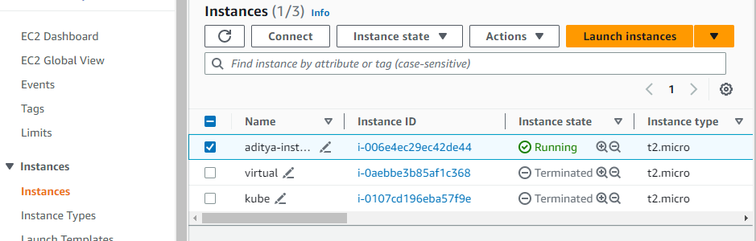

2) How to configure your Ec2 instances with Ansible?

Ans :- ---

- name: Create EC2 instance

hosts: localhost

connection: local

gather_facts: no

tasks:

- name: Create EC2 instance

ec2:

key_name: id_rsa

instance_type: t2.micro

image: ami-02396cdd13e9a1257

region: ap-south-1

security_group: default

wait: true

count: 1

instance_tags:

Name: aditya

register: ec2