CSC 554: Human-Computer Interaction

# Course Project Report

# Compiled by: Pratik Abhyankar (paabhyan)

Table of Contents

1. Introduction 2

2. Background 2

3. Approach and Methods Used 2

4. Heuristic Evaluation of Existing Product 2

5. Contextual Design 2

5.1. Interviews and Observations 2

5.2. Interpretations 2

5.3. Affinity Diagrams 2

5.4. Visioning and Ideation 2

6. Survey and Analysis 2

7. Competitive Analysis 2

8. Task Analysis 2

9. Prototyping 2

10. Internationalization 2

11. Heuristic Evaluation on Proposed Model 2

12. Conclusion 2

# Introduction

In this project we studied the Computer Science (CSC) Department’s website, of North Carolina State University (NCSU), by utilizing the fundamental principles of Human-Computer Interaction. On applying various methods such as heuristic evaluation, affinity diagramming and task analysis etc. we have proposed a new design of the website which aims to provide better user experience and improved look & feel.

We started off by examining the existing product (CSC website) for its design pros & cons with the help of heuristic evaluation and contextual design. We gathered data from the website users by interviewing them and conducting surveys. We also performed competitive analysis and task analysis. Finally we came up with a wireframe prototype for the new design which we prove to be more user friendly by re-evaluating it with a second heuristic analysis.

**NOTE:** Going forward, we refer to the NCSU’s CSC Website as “CSC website” or as “product” for simplicity.

# Background

The CSC website under study, as stated above, can be visited at <https://www.csc.ncsu.edu/>.

We chose to conduct our project on the CSC website primarily because we are also one of its users, being the current Computer Science students at NCSU. We also had access to the vast and diverse consumers of that website which helped us in getting measurably useful feedback from surveys and interviews for our study.

The project was initiated by conducting heuristic analysis by each of the team members individually. Together as a team, later, we conducted several interviews with different types of users like future students, current student, faculty and parents of the students etc. All interviews were 1-on-1 basis, strictly confidential and anonymous to maintain integrity of data generated from their user stories. Similarly, the survey conducted was also anonymous, which can be viewed online at: <https://ncsu.qualtrics.com/jfe/form/SV_86x2Cer7OUs3Jid>

In the last stage, we compiled all the information and analyzed it to propose a new design of the website, of which the methods and processes used are described in the following sections of this report.

# Methods Applied – How and Why

# Heuristic Evaluation of Existing Product

# Contextual Design

## Interviews and Observations

## Interpretations

## Affinity Diagrams

## Visioning and Ideation

# Survey and Analysis

To gather quantifiable data from the users regarding the website’s usability and experience, we asked them to fill out an online survey hosted on NCSU Qualtrics, [here](https://ncsu.qualtrics.com/jfe/form/SV_86x2Cer7OUs3Jid). The survey presented a wide variety of 35 questions ranging from rhetorical (yes/no) type, likert scale type, and free text type as well.

Questions were asked to understand if enough visual cues and relevant images/icons were added for the user, and if yes, were they relevant to the information they were trying to seek. We also measured the frequency of users to visit the website and if they were successfully able to get information with minimal efforts. Furthermore, questions also tested to see if users found adequate and quality content on the website as well as how fast did they find it.

We received a total of 72 responses over the course of 1 week. Based on all these, we then analyzed the data to seek and resolve the major pain points of users. We made sure that these points are addressed well into our new proposed model for making the website more user friendly. For the detailed report on survey analysis please see the Appendix section. Following are a few example responses from the survey:

**Question**: Could you find the information you were looking for?

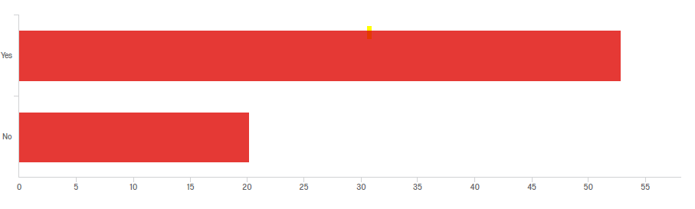

**Question**: Please rate how easily you were able to find the information you were looking for.

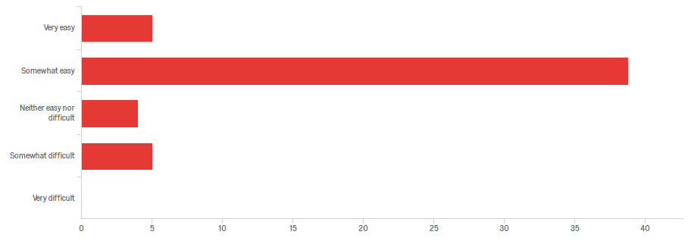

**Question**: Please rate the CSC website on each of the following –

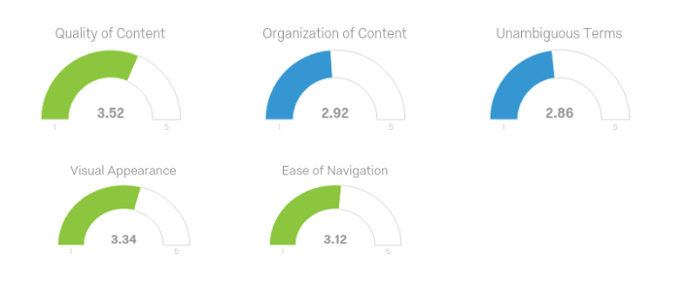

**Question**: How well does the CSC website serve your requirements in each of the following?

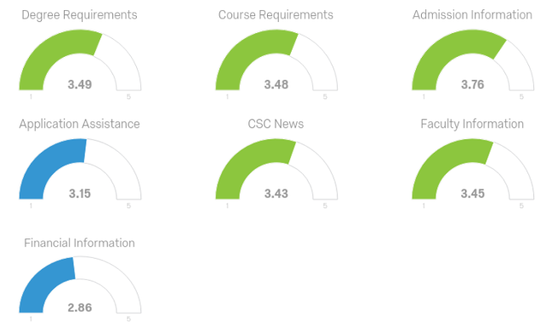

Apart from rating based statistics, we had some very good responses in the free text based questions too. They can be viewed in the Appendix section of this report.

What we understood in the analysis was that most users had difficulty finding the Financial Information about courses and needed more assistance in filling out applications. There appeared to be ambiguous terms on webpages and organization of content was not satisfactorily good. We saw a window of improvement here, and worked on that in our new model to address these issues.

# Competitive Analysis

In order to perform a competitive analysis of the CSC website, we chose to study 6 other CSC websites of different state universities similar to NCSU in terms of courses and ranking from different US locations. The following chart concisely summarizes the information we sought out. We primarily assessed how many pages were navigated (Y-Axis) to find a particular type of information (X-Axis i.e. Parameter) on each of these competitor websites as compared to NCSU’s CSC website:

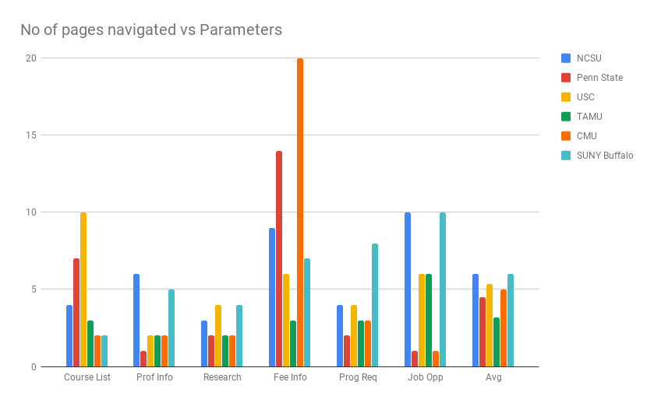

As observed, NCSU’s CSC website compares well with other websites, when it comes to finding information about Courses, Research and Program Requirements. However, information about Job Opportunities after education, Fee Structure, and Faculty takes number pages to be navigated before the user can access it. From the survey we had inferred that financial information is something current and future students seek out more often, and it is not easily available to them as compared to other universities which proved by this chart. Our new proposed model fixed these issues by bettering the navigation and menus.

# Task Analysis

# Prototyping

# Internationalization

Finally, we noticed that the CSC website is only supported in English language and lacked support for international languages like Spanish, Chinese, Hindi, Japanese etc. So we decided to add this feature as well, in our proposed new model of the website. Furthermore, multi-lingual screen readers could also be used to provide support to visually disabled people browsing the website.

# Heuristic Evaluation on Proposed Model

# Conclusion