World Yoshukai Karate Kobudo Organization
Black Belt Study Guide

- Master Funakoshi came from Okinawa to pioneer Karate in Japan. He changed the term “Chinese Hand “ to “Empty Hand” in 1937.
- Grandmaster Yamamoto founded Yoshukai Karate in 1963 in Kitakyushu City, Japan.
- Dr. Chitose, Founder of Chito-Ryu Karate, was Kaicho’s instructor.
- Master Yuki Koda brought Yoshukai to the U.S.A. in 1969.
- Shihan Toyama and Shihan Culbreth founded the WYKKO in 2000.
- Recognize the following Japanese symbols and know what they mean.
- Rikki Hitatsu (Make efforts and you will achieve.)
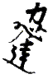

- Yoshukai (Strive for Excellence)
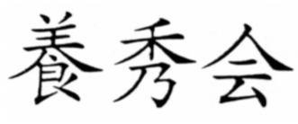

- Michi (The way or path)
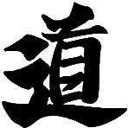

- Nin (Patience)
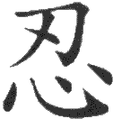

- Karate (Open Hand)
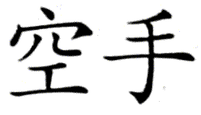

- The Yoshukai patch originates from the Yata No Kagami. This symbol is formed from “The National Mirror of Japan,” which represents truth, goodness, and beauty.
- Be able to name five styles of Karate (Yoshukai, Chito-Ryu, Shotokan, Goju-Ryu, and Isshin-Ryu) and five styles of martial arts (Karate, Sumo, Jujitsu, Judo, and Aikido).
- Be able to write “The Five Precepts for Learners” (“Shugyosha Gokun”) in Japanese.
  - Hitostu Reigi o omonzubeshi
  - Hitostu Taido o imashimubeshi
  - Hitostu Gengo o tsutsushimubeshi
  - Hitostu Iki o sakan ni subeshi
  - Hitostu Seiketsu o mune to subeshi
- Be able to match Japanese and English karate related terminology.
- Be able to identify blocks, stances, kicks, and strikes when given visual examples.
- Know the origins of the weapons used in karate.
- Nunchucka- Okinawan tool used to thresh rice.
- Sai – Derived from a pitchfork; used for defense against the bo or sword.
- Bo – Used to balance heavy loads across the shoulders.
- Tonfa – Tool used to grind wheat, rice, and beans to powder.
- Kama – Sickle tool used to cut stalks of grain.
- Katana – “Samurai sword” A sharp blade of about a yard in length used by warriors in battle.
Be able to complete a few short answer questions.
Write a paragraph outlining your goals as a Yoshukai Black Belt.

