**Module 2.1: Core Azure Services**

* How does Azure works?
  1. It uses Virtualization which separates the tight coupling between computer Hardware and OS
  2. It uses an abstraction layer called Hypervisor which emulates all the functions of computer and CPU
  3. Hypervisor can run multiple VMs at the same time and optimize the capacity
  4. Azure takes this VMs and repeats on a massive scale in Microsoft data centers
  5. Each DC has many racks built with servers and each server includes a Hypervisor
  6. On server in each rack runs a special software called Fabric Controller
  7. Each Fabric Controller is connected to another software known as Orchestrator
  8. Orchestrator manages everything that happens in Azure
  9. Users makes request to orchestrator using WEB API using various tools like CLI, Azure Portal etc.
  10. A network switch provides connectivity to all of these
* Services offered by Azure
  1. Computer

1. Virtual Machines(VMs):- Windows or Linux virtual machines (VMs)
2. Virtual Machine Scale Sets:- High Availability Auto Scaling for Windows or Linux VMs
3. Kubernetes Service(AKS):- Cluster of VMs that run containerized services
4. Service Fabric:- Develop microservices and orchestrate containers
5. Batch:- Cloud-scale job scheduling and compute management
6. Container Instances:- Run containerized apps on Azure without provisioning VMs
7. Functions:- Event-driven, serverless compute service
8. App Services:- Create powerful cloud apps for web and mobile
9. SQL Servers on VMs:- Host enterprise SQL Server apps in the cloud
10. Azure Cloud Service:- Highly-available, infinitely-scalable cloud applications and APIs
11. Web Apps:- Quickly create and deploy mission critical web apps at scale
12. Mobile Apps:- Build and host the backend for any mobile app
13. Cycle Cloud:- HPC and big compute clusters of any scale
14. Cloud Simple:- Run your VMware workloads natively on Azure
15. Dedicated Host
16. Virtual Desktop
    1. Networking
       1. Virtual Network(VPN):- Connects VMs to incoming Virtual Private Network (VPN)
       2. Load Balancer:- Balances inbound and outbound connections to applications endpoints
       3. Application Gateway:- Optimize delivery from application server farms while increasing application security with a web application firewall
       4. VPN Gateway:- Accesses Azure Virtual Networks through VPN gateways using internet
       5. DNS:- Provides ultra-fast DNS responses and ultra-high domain availability
       6. CDN:- Delivers high-bandwidth content to customers globally
       7. DDoS Protection:- Protect your Azure applications from the impacts of DDoS attacks
       8. Traffic Manager:- Distributes network traffic across Azure regions worldwide
       9. ExpressRoute:- Private network connectivity to access Azure from you network
       10. Network Watcher:- Monitors and diagnoses network issues using scenario-based analysis
       11. Azure Firewall:- High-security, high-availability firewall with unlimited scalability
       12. Virtual WAN:- Unified WAN connecting local and remote sites
       13. Front Door Service:- Microservice-based web applications  delivery point for global
       14. Bastion:- Fully managed RDP and SSH access to your virtual machines
    2. Storage
       1. Disk storage:- Storage for your virtual machines
       2. Blob storage:- Storage for your unstructured very large data, video files or bitmaps
       3. Archive storage:- low-cost storage for rarely accessed data
       4. Files Storage:- File shares that you can access and manage like a file server
       5. Avere vFXT for Azure:- high-performance, file-based workloads in the cloud
       6. Queue storage:- Storaeg for queuing & message-based communication b/n apps
       7. Data Box:- Data transfer to Azure and edge compute
       8. Azure NetApp Files:- File shares for enterprise workloads, including open-source/Linux
       9. Table storage:- NoSQL store that hosts unstructured data independent of any schema
    3. Security
       1. Security Center:- Security management and advanced threat protection for workloads
       2. Key Vault:- Cryptographic keys and secrets used by cloud apps and services
       3. DDoS Protection:- Protect your Azure resources from denial of service threats
       4. Azure Information Protection:- secure email, documents and sensitive data that you share outside your company
       5. Application Gateway:- Protect your applications from common web vulnerabilities and exploits with a built-in web application firewall
    4. Identity(IAM)
       1. Active Directory:- Identity and access management for cloud
       2. Active Directory B2C:- Customer identities and access in the cloud
       3. Active Directory Domain Services:- Join virtual machines in Azure to a domain without deploying domain controllers
    5. Mobile
       1. App Service:- Back-end services, authentication, offline data sync and integrations
       2. Notification Hubs:- Push notifications to any mobile platform from any back end
       3. Visual Studio App Centre:- Automatically build, test, distribute, deploy and mobile apps
       4. Xamarin:- Build apps with native performance and UI using existing skills
       5. Azure Maps:- Geospatial services maps, search, routing and traffic capabilities
       6. API Management:- Publish APIs , manage access, gain insights, fine-tune performance
    6. Database
       1. Cosmos DB:- NoSQL Database
       2. SQL Database
       3. MySQL
       4. PostgreSQL
       5. SQL Server on VMs
       6. Data Warehouse
       7. Database Migration Service
       8. Redis
       9. Table Storage: - Semi-structured datasets using a NoSQL key-value store.
       10. Data Explorer
       11. MariaDB
    7. Web
       1. App Service
       2. Notification Hubs
       3. API Management
       4. Azure Search
       5. SignalR Service:- Real-time functionality to your web app
       6. CDN
       7. Media Services :- Encode, store and stream video and audio , broadcast OTT video
       8. Maps
       9. DNS
       10. Application Gateway
    8. IoT
       1. IoT Central
       2. IoT Hub
       3. IoT Edge
       4. IoT Solutions Accelerator
       5. Digital Twins
       6. Time Series Insights
       7. Azure Sphere :- Build and connect highly secure MCU-powered devices
    9. Big Data
       1. SQL Data Warehouse
       2. HDInsight:-  Hadoop clusters in the cloud
       3. Databricks:- Apache Spark–based analytics service
    10. AI & ML
        1. Bot Service
        2. Vision
        3. Speech
        4. Knowledge mappings
        5. NLP
        6. ML
    11. DevOps
        1. DevOps
        2. Boards
        3. Artifacts
        4. DevTest Labs
        5. Pipelines
        6. Repos
        7. Monitor
    12. Analytics
        1. Data Lakes
        2. Event Hubs
        3. Data Catalog
        4. Power BI
        5. Stream Analytics
    13. Azure Stack
    14. Blockchain
    15. Containers
        1. Kubernetes Services(AKS)
        2. Open Shift
    16. Developer Tools
    17. Integration
        1. Event Grid
        2. Logic Apps
        3. Service Bus
    18. Media
    19. Migration
        1. Data Box
        2. Site Recovery
        3. Cost Management
        4. Azure Migrate
        5. DB Migration Service
    20. Management & Governance
        1. Backup
        2. Advisor
        3. Monitor
        4. Automation
        5. Service Health
        6. Resource Manager
        7. Lighthouse
        8. Policy
        9. Could Shell
        10. Network Watcher
        11. Traffic Manager
        12. Scheduler
    21. Mixed Realty
    22. Intune

# Module 2.2: Azure architecture and service guarantees

* Geographies
  1. An Azure geography is a discrete market typically containing two or more regions defined by geopolitical boundaries or country borders that preserve data residency and compliance boundaries
  2. Geographies are fault-tolerant to withstand complete region failure
  3. Geographies ensure that data residency, sovereignty, compliance, and resiliency requirements
  4. 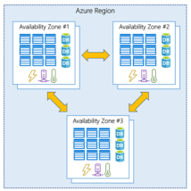Geographies are broken up into the following areas:
     1. Americas
     2. Europe
     3. Asia Pacific
     4. Middle East and Africa
* Region
  1. A **region** is a geographical area on the planet containing multiple datacenters that are nearby and networked together with a low-latency network.
  2. Each region belongs to a single geography and has min of 3 availability zones
  3. Some services or virtual machine features are only available in certain regions, such as specific virtual machine sizes or storage types
  4. There are also some global Azure services that do not require you to select a particular region, such as Microsoft Azure Active Directory, Microsoft Azure Traffic Manager, and Azure DNS
  5. Azure has specialized for compliance or legal purposes. These include:
     1. *US DoD Central*, *US Gov Virginia*, *US Gov Iowa* and more
     2. *China East*, *China North* and more
* Region Pair
  1. Each Azure region is always paired with another region within the same geography at least 300 miles away.
  2. This approach allows for the replication of resources across geography that helps reduce the likelihood of interruptions due to events such as natural disasters, civil unrest, power outages, or physical network outages affecting both regions at once.
* Availability Zones
  1. Availability Zones are physically separate datacenters within an Azure region.
  2. Not every region has support for Availability Zones
  3. Each Availability Zone is made up of one or more datacenters equipped with independent power, cooling, and networking. It is set up to be an isolation boundary
  4. Availability Zones fall into two categories:
     1. **Zonal services** – you pin the resource to a specific zone
     2. **Zone-redundant services** – platform replicates automatically across zones

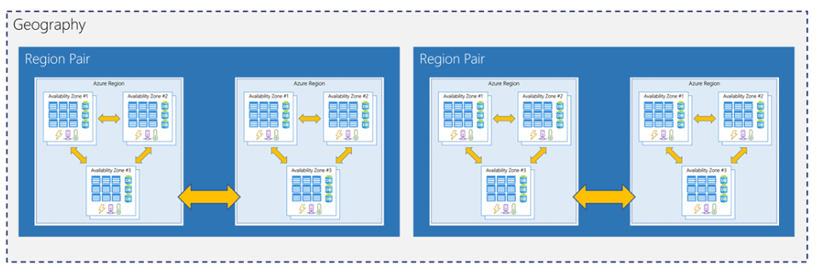

* Service Level Agreements (SLA)
  1. There are SLAs for individual Azure products and services
  2. Azure does not provide SLAs for most services under the Free or Shared tiers
  3. SAL range from 99.9 percent ("three nines") to 99.999 percent ("five nines")

| **SLA %** | **Downtime per week** | **Service Credits %** | **Service Credits%** |
| --- | --- | --- | --- |
| 99 | 1.68 hours | < 95 | 100 |
| 99.9 | 10.1 minutes | < 99 | 25 |
| 99.95 | 5 minutes | < 99.9 | 10 |
| 99.99 | 1.01 minutes |  |  |
| 99.999 | 6 seconds |  |  |

* Composite SAL
  1. When combining SLAs across different service offerings, the resultant SLA is called a *Composite SLA*.
  2. The resulting composite SLA can provide higher or lower uptime values, depending on your application architecture.
  3. Calculating SAL
     1. 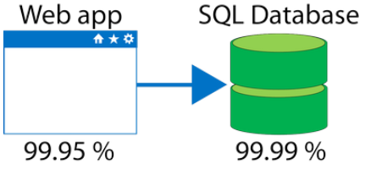 99.95 percent × 99.99 percent = 99.94 percent
     2. 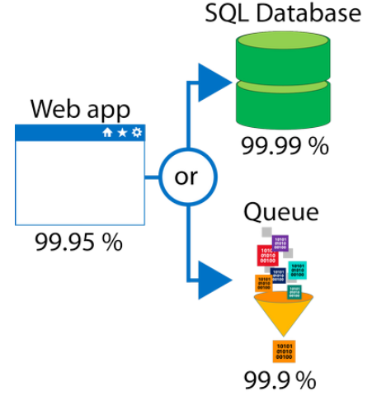 99.95 percent × 99.99999 percent = ~99.95 percent
* Application SAL
  1. Creating your own SAL by using and calculating SAL provided by Azure
* Resiliency
  1. *Resiliency* is the ability of a system to recover from failures and continue to function

# Module 2.3: Azure Account & Subscription

# An *Azure account* is tied to a specific identity and holds information like

# An *Azure subscription* is a logical container used to provision resources in Microsoft Azure

* 1. 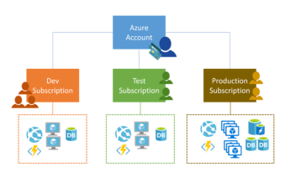Free
  2. Pay-As-You-Go
  3. Enterprise Agreement
  4. Student

# You can create multiple subscriptions under a single Azure account

# One billing is generated for every Azure Subscription on a monthly basis

# Access control and billing occurs at subscription level

# A tenant is a dedicated, isolated instance of the Azure Active Directory service

# Support and Help

# Microsoft provides 4 paid Azure support plan

# Developer

# Standard

# Professional Direct

# Premier

# Support optional outside Azure

# Azure Knowledge center

# MSDN Forums

# Stack Overflow

# Server Faults

# Azure feedback Forum

# Twitter

# Module 2.3: Manage services with the Azure portal

# Commonly used day to day tools

# Azure Portal

# Azure Power shell

# Azure CLI

# Azure Cloud Shell

# Azure Mobile App

# Azure Dashboard

# We can edit by using JSON file

# Share Dashboard

# Azure Preview

# Module 2.4: Azure Compute Options

# Azure Compute

# Azure compute is an on-demand computing service for running cloud-based applications

# There are four common techniques for performing compute in Azure:

* + 1. Virtual machines
       - Is a software emulator of physical computer (Iaas)
       - It includes Virtual Processor , OS , Memory , Storage & Networking
       - VM image is a template used to create a VM that already include an OS and often other software, like development tools or web hosting environments
       - Excellent choice when moving from a physical server to the cloud ("lift and shift")
       - Availability sets
         1. An **availability set** is a logical grouping of two or more VMs that help keep your application available during planned or unplanned maintenance.
         2. **Update domains** are a logical part of each data center and are implemented with software and logic.
         3. A **fault domain** is essentially a rack of servers physical separated across different power, cooling, and network hardware
         4. There's no cost for an availability set
       - Virtual Machine Scale Sets
         1. Azure Virtual Machine Scale Sets let you create and manage a group of identical, load balanced VMs
         2. Scale sets allow you to centrally manage, configure, and update a large number of VMs
         3. The number of VM instances can automatically increase or decrease in response to demand or a defined schedule
       - Azure Batch
         1. Azure Batch enables large-scale job scheduling and compute management with the ability to scale to tens, hundreds, or thousands of VMs
    2. Containers
       - Modified runtime environment built on top of a host OS for running multiple instances of an application on a single host machine
       - Containers are often used to create solutions using a microservice architecture
       - The container orchestrator can start, stop, and scale out application instances as needed
       - Containers run on to of host OS but they don’t include OS for sunning apps
       - Containers bundle the libraries & components needed to run the application and use the existing host OS running the container
       - Azure Container Instances (ACI)
         1. Is a PaaS docker container services provided by Azure
       - Azure Kubernetes Service (AKS)
         1. Is an orchestration service for containers with distributed architectures with multiple containers
         2. The task of automating, managing, and interacting with a large number of containers is known as orchestration
    3. Azure App Service
       - PaaS service offered by Azure to host web application, background jobs, mobile backends, and RESTful APIs without managing infrastructure
       - Enables automated deployments from GitHub, Azure DevOps
       - With Azure App Service, you can host below App types
         1. Web Apps
         2. API Apps
         3. Web Jobs

WebJobs are often used to run background tasks as part of your application logic

They can be scheduled, or run by a trigger

WebJobs allows you to run a program (.exe, Java, PHP, Python, or Node.js) or script (.cmd, .bat, PowerShell, or Bash)

* + - * 1. Mobile Apps

Backend for Mobile Apps

* + 1. Serverless computing
       - Serverless computing is a cloud-hosted execution environment that runs your code but completely abstracts the underlying hosting environment
       - Abstraction of Servers, Event driven scale , Micro billing are some of the benefits
       - **Azure Functions**, which can execute code in almost any modern language.
         1. Stateless functions
         2. Durable Functions(State full)
       - **Azure Logic Apps**, which are designed in a web-based designer and can execute logic triggered by Azure services without writing any code
       - It executes Work Flow rather than code as in case of functions

# Module 2.4: Azure Data Storage Options

# Benefit of Azure Data Store

# Automated backup and recovery

# Replication across the globe

# Support for data analytics

# Encryption capabilities

# Multiple data types

# Data storage in virtual disk up to 32TB

# Storage tires

# Types of Data

# Structured Data: relational data

# Semi-Structured Data: no-relation NoSQL data

# Unstructured Data: BLOB data

# Storage options provided by Azure

# Azure SQL Database

# Relational Database as service (DaaS)

# Azure Migrate Database service (*Microsoft Data Migration Assistant*) can be used to migrate onprem to cloud

# Azure Cosmos DB

# Globally distributed schema-less database service

# Distributed

# Azure Blob Storage

# Un Structured data similar to files on disk

# Azure Blob storage lets you stream large video or audio files directly to the use

# Blob storage is also used to store data for backup, disaster recovery, and archiving

# It has the ability to store up to 8 TB of data for virtual machines

# Azure Data Lake Storage

# Data Lake is a large repository that stores both structured and unstructured data

# Data Lake allows you to perform analytics on your data usage and prepare reports

# Azure Files

# Azure Files offers fully managed file shares in the cloud that are accessible via the industry standard Server Message Block (SMB) protocol to share files anywhere in the world

# Any number of Azure virtual machines or roles can mount and access the file storage share simultaneously

# Azure Queue

# Azure Queue storage is a service for storing large numbers of messages that can be accessed from anywhere in the world

# Queue storage provides asynchronous message queueing for communication between application components, whether they are running in the cloud, on the desktop, on-premises, or on mobile devices

# Disk Storage

# Disk storage provides disks for virtual machines, applications, and other services to access and use as they need, similar to how they would in on-premises scenarios

# Storage ties

# Azure offers three storage tiers for blob object storage:

# Hot storage tier: optimized for storing data that is accessed frequently.

# Cool storage tier: optimized for data that are infrequently accessed and stored for at least 30 days.

# Archive storage tier: for data that are rarely accessed and stored for at least 180 days with flexible latency requirements.

# Encryption & Replication

# Azure Storage Service Encryption (SSE)

# Client-Side Encryption

# Module 2.4: Azure Network Options

* Loosely coupled architecture
  1. N-Tire architecture pattern can be used
  2. A higher tier can access services from a lower tier. A lower tier should never access a higher tier.
  3. Three-tier refers to an n-tier application that has three tiers
* What is an Azure region
  1. A region is one or more Azure data centers within a specific geographic location
* What is Virtual Network
  1. A virtual network is a logically grouped & isolated network / systems on Azure
  2. A virtual network is scoped to a single region
  3. Multiple virtual networks from different regions can be connected together using **virtual network peering**
  4. Virtual networks can be segmented into one or more **subnets**
  5. Users can directly interact to a Public IP and not to a Private IP
  6. A VPN gateway can provide a secure connection between an Azure Virtual Network and an on-premises location over the internet
* What is Network Security Group
  1. A network security group, or NSG, allows or denies inbound network traffic to your Azure resources
* Azure Load Balancer
  1. A load balancer distributes traffic evenly among each system in a pool
  2. The load balancer becomes the entry point to the user
  3. A load balancer can help you achieve both high availability and resiliency.
  4. Availability refers to how long your service is up and running without interruption
  5. High availability refers to a service that's up and running for a long period of time
  6. Resiliency refers to a system's ability to stay operational during abnormal conditions
     + Natural disasters
     + System maintenance
     + Spikes in traffic to your site
     + Malicious attacks
* Azure Application Gate way
  1. Application Gateway is a load balancer designed for web applications for all your HTTP traffic
  2. It is known as application layer (OSI layer 7) load balancing since it understands the structure of the HTTP message
  3. Benefits of Application Gate way
     + **Cookie affinity** to keep a user session on the same backend server
     + **SSL termination** Application Gateway can manage your SSL certificates
     + **Web application firewall** supports a sophisticated firewall (WAF)
     + **URL rule-based routes**
     + **Rewrite HTTP headers**
* What is a CDN
  1. A content delivery network (CDN) is a distributed network of servers that can efficiently deliver web content to users
  2. It minimizes latency , supports cache  at strategically placed physical nodes across the world and provide better performance
* What is DNS
  1. DNS, or Domain Name System, is a way to map user-friendly names to their IP addresses
* Azure Traffic Manager
  1. Azure Traffic Manager uses the DNS server that's closest to the user to direct user traffic to a globally distributed endpoint
  2. Traffic Manager monitors the health of your endpoints
  3. Traffic Manager finds an unresponsive endpoint, it directs traffic to the next closest endpoint that is responsive.
  4. **Latency** refers to the time it takes for data to travel over the network. Latency is typically measured in milliseconds.
  5. **Bandwidth** refers to the amount of data that can fit on the connection. Latency refers to the time it takes for that data to reach its destination
  6. One way to reduce latency is to provide exact copies of your service in more than one region **scale out** to different region