Arduino-Based Environmental
Monitoring System

Placement Project Technical Report
Author: | Emmanuel Phiri
University: | University of the West of England (UWE Bristol)
Degree: | Electrical and Electronics Engineering
Placement Company: | SC Groupe Global
Academic Year: | 2026-2027
Date: | April 2026

Table of Contents

- Executive Summary
- Introduction
- System Requirements and Objectives
- Hardware Design and Component Selection
- Circuit Design and PCB Layout
- Firmware Development
- Enclosure Design and 3D Printing
- System Testing and Results
- Challenges and Solutions
- Conclusion and Future Work
- References

Executive Summary

This report presents the design, development, and implementation of an Arduino-based environmental monitoring system, completed as part of the placement project at SC Groupe Global. The system monitors real-time environmental conditions including temperature, humidity, and ambient light levels, providing intelligent alerts to help users maintain ideal living or working conditions.
The project encompasses the full engineering development lifecycle: from initial requirements gathering and component selection through to firmware development, printed circuit board (PCB) design using KiCad, mechanical enclosure design in SolidWorks, and 3D printing. The final system integrates a DS3231 real-time clock, DHT11 temperature and humidity sensor, LDR light sensor, 20x4 I2C LCD display, active buzzer alert system, and two user input buttons, all housed within a custom-designed 3D-printed enclosure.
The system successfully monitors all environmental parameters, displays real-time data across multiple LCD screens, and alerts the user via buzzer when conditions fall outside defined thresholds. The project demonstrates competence in embedded systems programming, analogue circuit design, PCB design, and mechanical enclosure design.

Introduction

Environmental monitoring has become increasingly important in both domestic and industrial settings. Maintaining optimal temperature, humidity, and lighting conditions contributes significantly to occupant comfort, energy efficiency, and health. Traditional monitoring solutions can be costly and complex; this project aims to demonstrate that a cost-effective, embedded systems approach can achieve comparable functionality.
The placement project at SC Groupe Global provided an opportunity to apply theoretical knowledge gained during the Electrical and Electronics Engineering degree programme at UWE Bristol to a real-world engineering problem. The brief required the design and implementation of a standalone embedded monitoring device capable of sensing multiple environmental parameters, displaying results clearly to the user, and providing actionable feedback when conditions deviate from acceptable ranges.
This report documents the complete engineering process, including hardware selection rationale, circuit design, firmware architecture, PCB layout considerations, and mechanical enclosure design. It also reflects on challenges encountered during development and the solutions implemented.

System Requirements and Objectives

Functional Requirements
ID | Requirement | Priority
FR1 | Measure ambient temperature in degrees Celsius | High
FR2 | Measure relative humidity as a percentage | High
FR3 | Measure ambient light level via LDR | High
FR4 | Display real-time clock (hours, minutes, seconds) | High
FR5 | Display all sensor readings on LCD | High
FR6 | Alert user via buzzer when thresholds are exceeded | High
FR7 | Allow user to silence buzzer via button | Medium
FR8 | Allow user to toggle between display screens | Medium
FR9 | Provide contextual advice (e.g. open window, turn off light) | Medium

Non-Functional Requirements
The system must operate reliably from a 9V battery supply, consume minimal power during idle operation, and fit within a compact enclosure suitable for wall mounting. The firmware must be maintainable, well-commented, and structured for ease of future modification. The PCB must conform to standard manufacturing tolerances and the enclosure must be 3D printable using PLA material.

System Thresholds
Parameter | Min Threshold | Max Threshold | Action if Exceeded
Temperature | 16 degrees C | 25 degrees C | Alert: turn on/off heating
Humidity | — | 60% | Alert: open a window
Light (daytime 6am-10pm) | 600 (ADC) | — | Alert: turn on lights
Light (night-time 10pm-6am) | — | 700 (ADC) | Alert: turn off lights

Hardware Design and Component Selection

The hardware architecture centres on the Arduino Uno R3 microcontroller, selected for its ease of programming, broad community support, and sufficient I/O for the required peripherals. The following table summarises all components used in the final design.
Component | Model | Interface | Purpose
Microcontroller | Arduino Uno R3 | — | Main processing unit
Display | LCD 20x4 + PCF8574 I2C ba | ckpackI2C (A4/A5) | Display data and alerts
Temp/Humidity Sensor | DHT11 | Digital (Pin 7) | Measures temperature and humidity
Light Sensor | LDR + 100k resistor | Analogue (A0) | Measure ambient light level
Real-Time Clock | DS3231 | I2C (A4/A5) | Accurate timekeeping
Buzzer | Active buzzer | Digital (Pin 4) | Audible alert system
Button 1 | Tactile push button | Digital (Pin 5) | Silence buzzer
Button 2 | Tactile push button | Digital (Pin 6) | Toggle LCD screen
Power Supply | 9V battery pack | Barrel jack | Standalone power

Sensor Selection Rationale
The DHT11 was selected as the temperature and humidity sensor due to its simple single-wire digital interface, low cost, and sufficient accuracy for environmental monitoring applications (plus or minus 2 degrees C, plus or minus 5% RH). The sensor is powered at 5V and interfaced via a digital pin with the DHT11 library by Dhruba Saha, which provides reliable reading functions.
The DS3231 real-time clock module was chosen over the initially trialled DS1302 due to superior accuracy, integrated temperature-compensated crystal oscillator, and I2C interface which shares the existing I2C bus with the LCD, minimising pin usage on the Arduino.
The LDR is configured in a voltage divider arrangement with a 100k resistor, providing an analogue voltage proportional to ambient light intensity. This voltage is read by the Arduino 10-bit ADC on pin A0, yielding values from 0 to 1023. Measured values ranged from 53 in complete darkness to 1014 with a torch applied directly.

Pin Allocation
Arduino Pin | Connected To | Type
A0 | LDR voltage divider midpoint | Analogue Input

A4 (SDA) | LCD I2C SDA + DS3231 SDA | I2C Data
A5 (SCL) | LCD I2C SCL + DS3231 SCL | I2C Clock
Pin 4 | Active buzzer (+) | Digital Output
Pin 5 | Silence button | Digital Input
Pin 6 | Toggle button | Digital Input
Pin 7 | DHT11 data | Digital Input
5V | LCD, DS3231, DHT11, Buttons | Power
GND | All component grounds | Ground
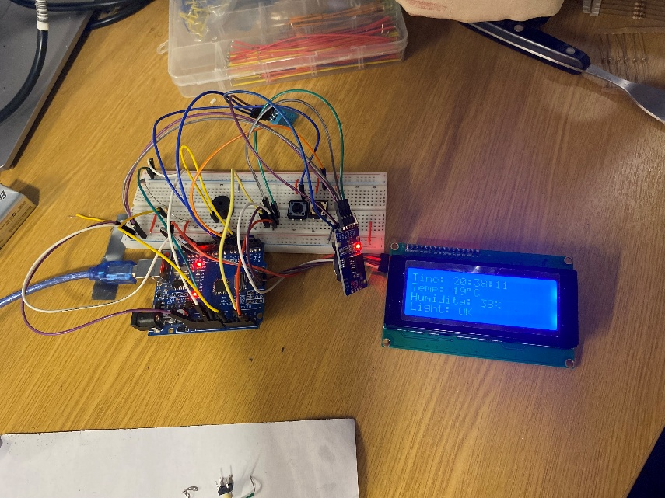
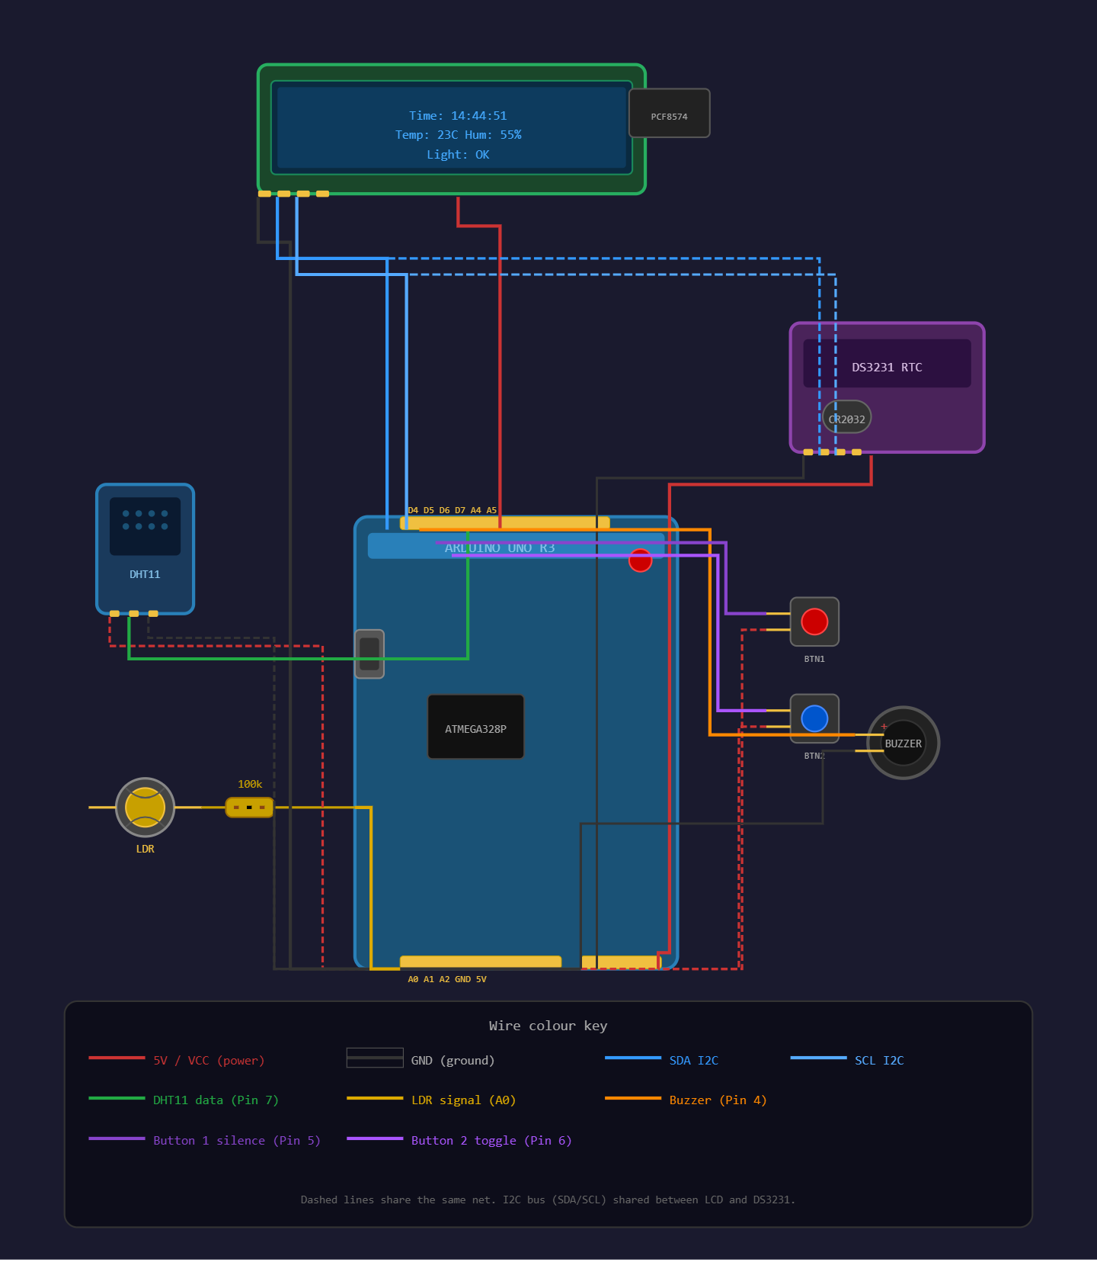

Circuit Design and PCB Layout

Schematic Design
The circuit schematic was designed using KiCad 9.0. The schematic captures all electrical connections between the Arduino Uno R3, LCD with PCF8574 I2C backpack, DS3231 RTC, DHT11 sensor, LDR voltage divider, active buzzer, and two tactile push buttons. The I2C bus
(SDA/SCL) is shared between the LCD module (address 0x27) and the DS3231 RTC (address 0x68), demonstrating multi-device I2C communication where each device responds only to its unique address.
The LDR is wired in a pull-down voltage divider configuration: one leg connects to the 5V supply, the other to analogue pin A0 and to the 100k resistor which is grounded. As light intensity increases, the LDR resistance decreases, raising the voltage at A0 and increasing the ADC reading. Both push buttons connect between the Arduino digital pin and 5V supply, configured as INPUT in firmware, so pressing pulls the pin HIGH.

PCB Layout
Following schematic completion and electrical rules check (ERC) verification, the design was transferred to the KiCad PCB editor. Component footprints were assigned from the KiCad standard libraries, with the LCD 20x4 footprint sourced from SnapEDA. The PCB measures approximately 170mm x 130mm, accommodating all components within a two-layer layout.
The LCD module is positioned at the top of the board for visibility, with the Arduino Uno centrally located as the primary hub. Smaller components including the DHT11, DS3231, buzzer, and buttons are arranged around the Arduino to minimise trace lengths. Traces are routed on the front copper (F.Cu) and back copper (B.Cu) layers. The board outline is defined on the Edge.Cuts layer.

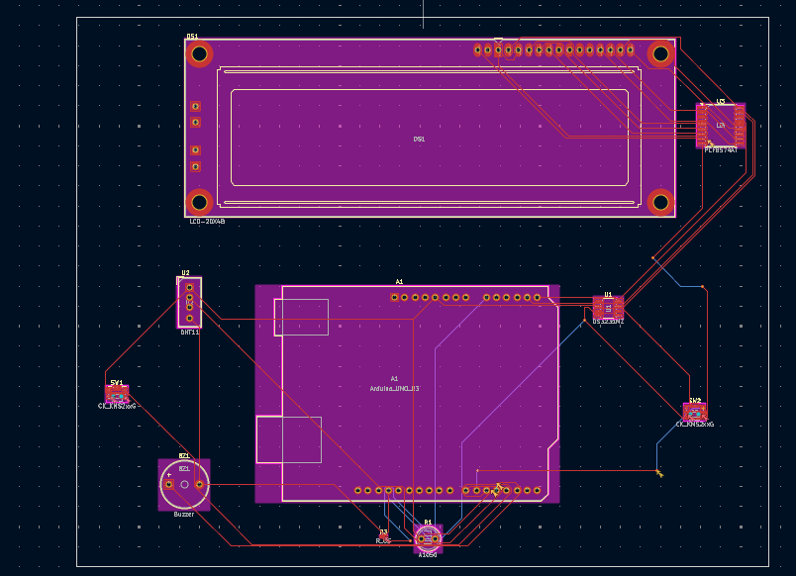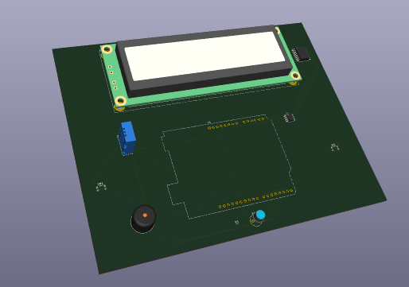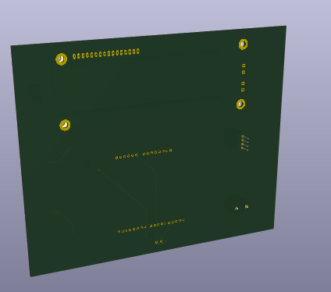

Firmware Development

Software Architecture
The firmware was developed using the Arduino IDE (C++) and structured around a main loop with non-blocking timing using millis(). This approach avoids delay() in the main loop, ensuring responsive button handling and smooth LCD updates. The firmware is organised into logical sections: clock management, sensor reading, threshold evaluation, button handling, buzzer control, LCD display management, and Serial Monitor debug output.

Display Logic
The 20x4 LCD provides four lines of 20 characters. Two display screens cycle automatically every 5 seconds or on press of the toggle button. Screen 0 shows time, temperature, humidity, and light status. Screen 1 shows a conditions summary with advisory messages. When any alert is triggered, the display immediately jumps to Screen 1 to inform the user.

Threshold and Alert Logic
The core alert evaluation code is shown below:
bool tooDark = (hours >= 6 && hours < 22 && lightval < 600); bool tooBright = ((hours
>= 22 || hours < 6) && lightval > 700); bool tooHot = (temp > 25); bool tooCold =
(temp < 16); bool tooHumid = (humidity > 60); bool alertNeeded = tooDark || tooBright
|| tooHot || tooCold || tooHumid; if (alertNeeded && !buzzerSilenced) { digitalWrite(buzzerPin, HIGH); } else { digitalWrite(buzzerPin, LOW); }

Libraries Used
Library | Author | Purpose
Wire.h | Arduino | I2C communication
LiquidCrystal_I2C.h | Frank de Brabander | I2C LCD control
DHT11.h | Dhruba Saha | DHT11 sensor reading
RTClib.h | Adafruit | DS3231 RTC interface

Enclosure Design and 3D Printing

Design Concept
The enclosure was designed in SolidWorks as a flat, wall-mountable form factor inspired by domestic devices such as thermostats and smoke detectors. This design was chosen to ensure the LCD is clearly visible and the device is unobtrusive when mounted in a room. The enclosure was modelled as a solid rectangular block and hollowed using the Shell feature with a 3mm wall thickness.

Cutouts and Features
Feature | Location | Purpose
LCD window | Front face, upper centre | LCD visibility
Button hole 1 | Front face, left of LCD | Silence button access
Button hole 2 | Front face, right of LCD | Toggle button access
DHT11 aperture | Side face | Sensor ventilation and access
LDR aperture | Side face | Ambient light sensing
Battery connector hole | Bottom face | 9V power input

3D Printing Specifications
The enclosure is designed for 3D printing using PLA (Polylactic Acid), selected for its ease of printing, dimensional accuracy, and suitability for indoor applications. Recommended print settings are 0.2mm layer height, 20% infill, with no support structures required. The 3mm wall thickness ensures structural integrity without excessive print time or material usage.

System Testing and Results

Component-Level Testing
Each component was individually tested before system integration using dedicated test sketches with Serial Monitor output. This modular approach allowed faults to be isolated efficiently.
Component | Test Method | Result
LCD | Hello World sketch via I2C | Pass-after I2C integration
DHT11 | Serial output of temp/humidity readings | Pass - 23 degrees C, 55% RH typical
LDR | Serial output of ADC value | Pass-53(DARK) 1014(torch on)
DS3231 RTC | Serial output of time | Pass- accurate time reading
Buzzer | digitalWrite HIGH/LOW test | Pass - audible alert confirmed
Button 1 (silence) | digitalRead with Serial output | Pass - debounced correctly
Button 2 (toggle) | digitalRead with Serial output | Pass - debounced correctly

System Integration Testing
Following successful component-level testing, the full firmware was integrated and tested as a complete system. The Serial Monitor was used alongside the LCD to verify consistency between displayed values and raw sensor readings. Alert conditions were manually triggered by covering the LDR, applying heat to the DHT11, and breathing on the humidity sensor. All threshold conditions triggered the buzzer and caused the LCD to jump immediately to the conditions summary screen. The silence button reliably suppressed the buzzer, and the toggle button correctly cycled between screens. The DS3231 maintained accurate time independent of Arduino resets.

Challenges and Solutions

LCD Not Displaying Text
The LCD showed a backlit screen with black blocks but no text. After extensive debugging, the root cause was identified as the wrong library being used. Switching from the standard LiquidCrystal library to LiquidCrystal_I2C by Frank de Brabander, and verifying the I2C address as 0x27, resolved the issue immediately.

DHT11 Sensor Damage
Two DHT11 sensors were damaged during development due to incorrect pin orientation. The third sensor was connected following careful verification of the module pin labelling (VCC left, DATA centre, GND right when facing the mesh side). Correct library selection (DHT11 by Dhruba Saha rather than the Adafruit DHT library) also proved critical for reliable readings.

DS1302 RTC Failure
The initially specified DS1302 RTC module proved faulty, consistently reading 0:0:0 regardless of wiring configuration or pin assignment. The module was replaced with the DS3231, which offered superior accuracy and a simpler I2C interface compatible with the existing bus, resolving the issue entirely.

Button Debouncing
Initial button testing showed rapid bouncing between HIGH and LOW states on press, causing multiple unintended triggers. This was resolved by implementing a state-change detection pattern tracking the previous button state, combined with a 50ms debounce delay, to detect only rising edges.

KiCad LCD Footprint
The LCD 20x4B footprint was not available in the standard KiCad libraries. The footprint was sourced from SnapEDA and manually imported into the KiCad footprint library manager, allowing the PCB layout to proceed with an accurate physical component representation.

Conclusion and Future Work

Conclusion
The Arduino-based environmental monitoring system has been successfully designed, developed, and tested. The system meets all functional requirements: it accurately monitors temperature, humidity, and light levels; displays real-time data and actionable advice on a 20x4 LCD; and alerts the user via buzzer when any parameter exceeds its defined threshold.
The project provided valuable hands-on experience across multiple engineering disciplines including embedded firmware development in C++, analogue and digital circuit design, PCB layout using KiCad, and mechanical enclosure design in SolidWorks. The iterative debugging process developed problem-solving skills and reinforced the importance of systematic, component-level testing before system integration.

Future Work
Several enhancements are identified for future development iterations:
- Bluetooth connectivity (HC-05/HC-06) to enable data logging to a smartphone application
- Integration with smart home automation platforms such as Home Assistant via MQTT
- Addition of a CO2 or air quality sensor for more comprehensive environmental monitoring
- Implementation of actuator outputs (relay to control heating or ventilation systems)
- Low-power sleep mode to significantly extend battery life
- Wi-Fi connectivity via ESP8266 or ESP32 upgrade for remote web dashboard monitoring

References
- Arduino. (2024). Arduino Uno R3 Documentation. https://docs.arduino.cc/hardware/uno-rev3
- Saha, D. (2023). DHT11 Arduino Library. https://github.com/dhrubasaha08/DHT11
- Adafruit Industries. (2024). RTClib Library Documentation. https://github.com/adafruit/RTClib
- de Brabander, F. (2023). LiquidCrystal_I2C Library.
https://github.com/fdebrabander/Arduino-LiquidCrystal-I2C-library
- KiCad EDA. (2024). KiCad 9.0 Documentation. https://docs.kicad.org
- SnapEDA. (2024). LCD-20X4B Component Symbol and Footprint. https://www.snapeda.com
- Dassault Systemes. (2024). SolidWorks 3D CAD Documentation. https://www.solidworks.com
- Maxim Integrated. (2015). DS3231 Extremely Accurate RTC Datasheet.
https://datasheets.maximintegrated.com/en/ds/DS3231.pdf
- Aosong Electronics. (2010). DHT11 Humidity and Temperature Sensor Datasheet.

