Pablo albaladejo
Investment Manager
Detailed Design document
Pablo Albaladejo Mestre
22/07/2014

[This document describes de software architecture, data object design, interfaces and also includes an user guide]

Index
Index 2
Introduction 3
System configuration 3
Application Configuration 4
Setup 6
Prerequisites 6
Installation 6
Class Diagram 7
Global 7
Services 8
Domain 10
Design Patterns 12
Design and implementation strategy 13
Limitations of the system 14
Potential problems 14
Next Steps 14

Introduction

This site provides a financial service in order to help you in your investments.
All the forecasts are calculated based on the Capital Asset Pricing Model (CAPM)
Risk Free (rf) value is consider according to the 1-year US Treasury bond interest rate.

Future versions will include the capability of selecting others Risk Free rates (as 10-year note)
The Market Return E(rm) considered is the S&P 500 Trailing Twelve Months (TTM).

The software selects the TOP 30 companies of the NASDAQ market, according to its Market Capitalization. For each one, a CAPM analysis is done considering a specific beta based on each asset.

The software selects 6 of those companies to perform some investments forecast: the 3 ones more risky (a bigger CAPM, i.e. a bigger beta value) but with greater future earning (or loosing) capability, versus the 3 more stable companies (a lower CAPM, i.e. a lower beta value) with a more conservative prediction but bigger interest than the US Bond (according with the current market return value).

For each one of the selected companies, an investment simulation is perform considering investments of $1,000.00 , $10,000.00 and $100,000.00 considering time intervals of 5 days, 1 month and one year.

The CAPM analysis is not performed for those companies with no available beta value (and as consequence, there are not candidates to be included at the forecast selection).

The report will be refreshing automatically every minute. It is also possible to subscribe to the mailing list, and receive a daily e-mail including the report.

It is also published a JSON interface in order to other devices/systems access automatically to the reports.

System configuration

IDE Environment

- Grails v2.4.2 (https://grails.org/)
- NetBeans v7.4 (https://netbeans.org/)
- Java JDK v1.7.0_17 (http://www.oracle.com/)
- MySQL v5.0.51b (http://www.mysql.com/)
- Apache Tomcat v7.0.54 (http://tomcat.apache.org/)

Grails Plugging

- Quartz v1.0.1 (http://grails.org/plugin/quartz)
- Mail v1.0.6 (http://grails.org/plugin/mail)
- Spring Mobile v0.5.1 (http://grails.org/plugin/spring-mobile)

Libraries used at the development:

- jaxb-ri v2.2.7 (https://jaxb.java.net/)
- gson (http://google-gson.googlecode.com/svn/trunk/gson/docs/javadocs/index.html)
- javax.xml (http://docs.oracle.com/javase/7/docs/api/javax/xml/parsers/package-summary.html)

Data source APIs

- US Treasury XML service
  - http://data.treasury.gov/feed.svc/DailyTreasuryYieldCurveRateData?$filter=month(NEW_DATE) eq 7 and year(NEW_DATE) eq 2014

- Google Finance
  - https://www.google.com/finance?start=0&num=30&q=[%28exchange+%3D%3D+%22NASDAQ%22%29+%26+%28beta+%3E%3D+-3.19%29+%26+%28beta+%3C%3D+5.36%29]&restype=company&noIL=1&sortas=MarketCapstart=0&num=30&q=[%28exchange+%3D%3D+%22NASDAQ%22%29+%26+%28beta+%3E%3D+-3.19%29+%26+%28beta+%3C%3D+5.36%29]&restype=company&noIL=1&sortas=MarketCap

Application Configuration

The project includes a Conf.groovy configuration file where to include specific configurable parameters. I have customized the following ones:

Mail configuration server

//----------------- MAIL
grails {
mail {
host = "smtp.gmail.com"
port = 465
username = " investment.manager.mailing@gmail.com"
password = "investmentpassword"
props = ["mail.smtp.auth":"true",
"mail.smtp.socketFactory.port":"465",
"mail.smtp.socketFactory.class":"javax.net.ssl.SSLSocketFactory",
"mail.smtp.socketFactory.fallback":"false"]
}
}

//grails.mail.overrideAddress="pablofdi@gmail.com"

JSON output format

//---------------JSON
grails.converters.json.default.deep=true
grails.converters.json.pretty.print=true

GUI options. The relevant ones:

//----------------- USER OPTIONS
grails.data.emails = "10"
grails.data.assets.seconds = "60" //SECONDS TO REFRESH THE REPORT
grails.data.assets.items = "30"//TOP COMPANIES
grails.data.forecast.items = "3"//NUM OF COMPANIES CONSIDERED FOR SIMULATION
grails.data.forecast.principals = ["1000","10000","100000"] //$ AMOUTS SIMULATED
grails.data.forecast.days = ["5","30","360"]//INVESTMENTS DURATION

APIs server address

//Google Finance
grails.data.source.google.finance.server = "https://www.google.com/finance?"
grails.data.source.google.finance.market = "SPY"

//Daily Treasury
grails.data.source.treasury.dailytreasury.server = "http://data.treasury.gov/feed.svc/DailyTreasuryYieldCurveRateData?"

The application supports proxy server:

//PROXY
grails.data.source.proxy.enable = false
grails.data.source.proxy.server = "proxy.host.es"
grails.data.source.proxy.port = "8080"
grails.data.source.proxy.user = "user"
grails.data.source.proxy.password = "password"
grails.data.source.proxy.protocol = ["http", "https"]

Setup

Prerequisites
- Tomcat 7 server
- MySQL 5 server

Installation
- Create a DB at MySQL sever named “investment_manager”.
- Make sure that the user “admin” (pass ”admin”) exits and it have privileges to update the DB.
- At the MySQL server, execute the sql script “investment_manager.sql”
- Deploy the “InvestmentManager-0.1.war” at the tomcat server

Class Diagram
Below the main class diagrams are represented:

Global

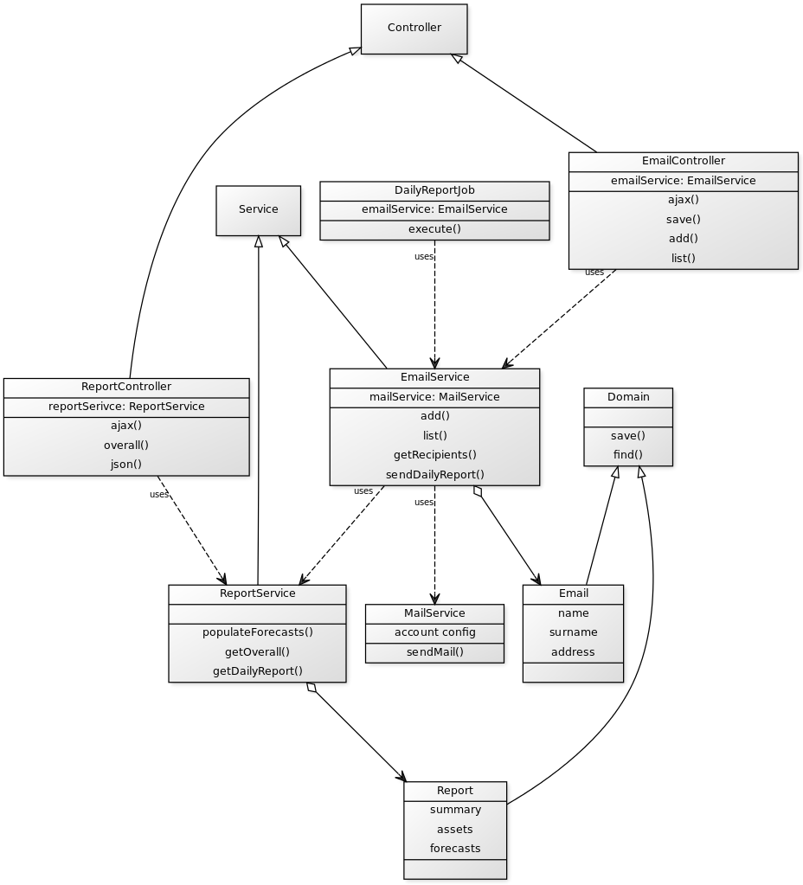

Services
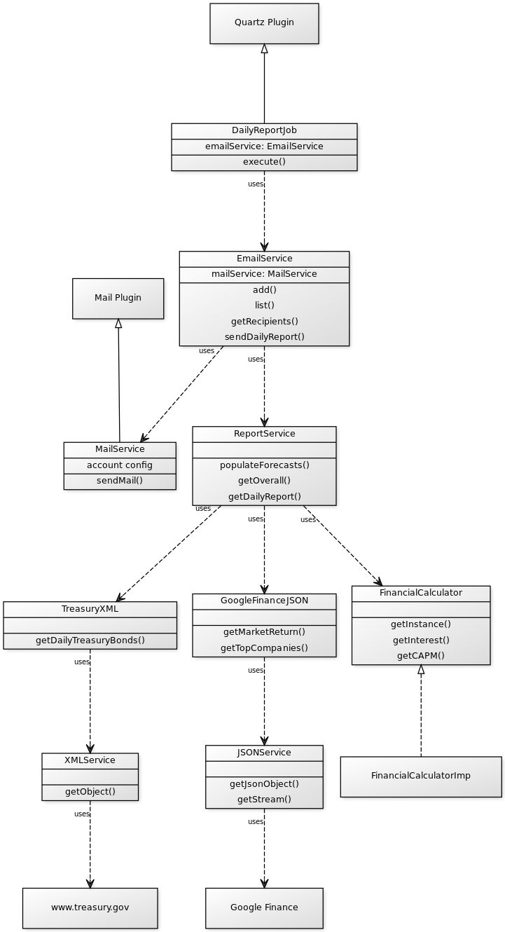
Basically, the application service layer is divided regarding two services: Email and Report Service.

The Report Service is where all the mathematical operations for calculating the forecast take place. It uses the TreasuryXML to access the US Treasury DB, updated daily. For the financial data, the application access via GoogleFinanceJSON to the Google Finance API. Both data providers have been designed as external resources with the aim to be reused in other related developments.
For the mathematical operations, a specific Financial Calculator has been implemented to segregate the pure mathematical environment from the specific business logic.

The data produced by the Report Service is requested from the ReportController to be displayed at the view, but it is also required at the Email Service when the scheduled mailing task is triggered. For implementing these programmed events, the Quartz plug-in is invoked.
Once configured as a cron task, the Quartz plug-in handles the DailyReportJob as a new batch worker. Using the Mail plug-in, this object is in charge of sending the email to the mailing list. A Gmail account is required as sp output server.

Domain
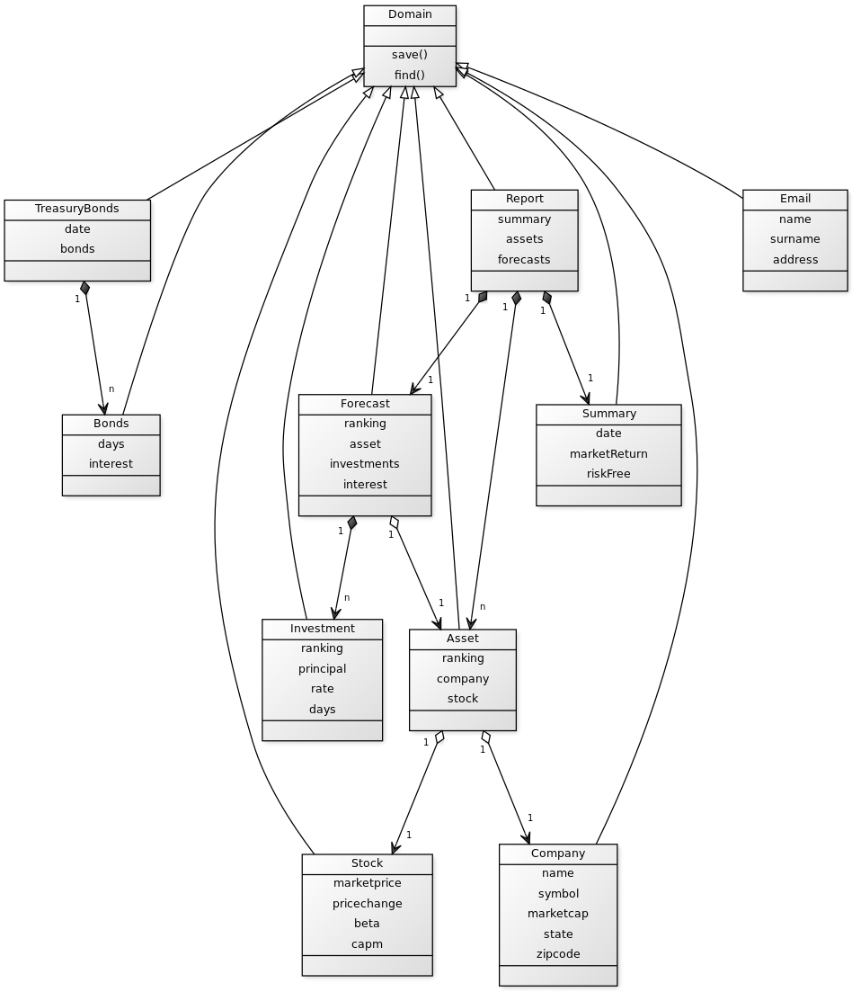

The main Domain classes are Report, Bound and Email.

At this stage of the development, Email class represents the users and only stores the required information to send the daily report. It has been allowed not unique email address in order to be able to test the mailing function. Otherwise, it becomes so complicated testing real situations with multiple recipients.

The Treasury objects represents the transfer pattern to have an efficiently information management from the DAO layer to the business logic, where it is required to consider different risk rates.
But the most representative model is the Report, which include all the relevant information of the system. The report is composed by a summary, a list of assets (by default, the Top 30 market cap) and a list of investments considering six of the 30 assets.

Each asset represents a Company (which includes all the static info, such the address, the symbol and so) and the company’s Stock (which includes all the variable information, such the market price, or the beta value).

The forecast object represent the predicted behavior of inverting at asset considering different parameters (i.e. time and money), each one of them is represented by an investment object.

Design Patterns

Grails implements the Model-View-Controller patterns, so all the implementation is according this pattern.

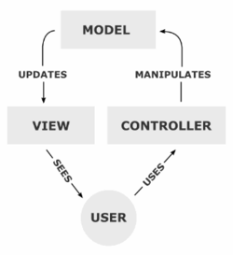

The information is sent to the user thought the views (gsp files), and the system receives the user interaction by the actions (mapped at the urls). These actions are processed by the specialized controllers and delegates into the Service layer the Domain data processing. The Service layer contains all the business logic and uses some extra functions implemented as external java code. The Service layer delegates the data save/storage into the Integration layer, which is handled by GORM (Hibernate).
There is no much to decide regarding application architecture using Grails. The programmer responsibility is just to keep these good decisions/practices with the new code.

I have decided to extract some code from the application core, due to reusability reason. This is the case of the financial calculator. Since it is a modular and independent component, it can be easily reused at any other Java development.
I have chosen a Singleton pattern implemented through an Abstract factory. The Singleton patter guarantees that only one object is used by the application, and the abstract factory approach provides an interface which provides the capability to change the implementation of the CAPM even dynamically if required.

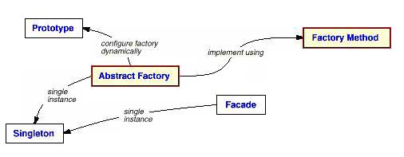

Design and implementation strategy

Design strategy has been driven by the Domain Model.
Since it is a very simple application from the point of view of data type, but there is an important amount of mathematical operations, a good approach is to define in a first phase the Domain Objects and keep the data and the mathematical operations as simply as possible. This way to go also provides the capability to test all the business logic at very early implementation phase, since all the data required for the operations is already available.

The technical development has been faced as an incremental integration. Each integration produces an usable version including new features based on the one already tested at the previous phase. This procedure guarantee the correctness of the implementation

Limitations of the system
The main issue discovered during the technical research is that no free API provides beta values for all the companies: Google has some blank values and Yahoo does not provide this value at the interface. However, it is displayed at the web version. A workaround cloud be to access the web HTML code, but it is out of the license terms and could be an instable pitfall.
For this reason, some of the Top 30 displayed companies provides a “N/A” value at the beta field. As consequence, the CAPM formula is incomplete and another “N/A” is displayed.
According with this situation, related companies are removed from the list to be candidate to perform the investment forecasts, and next company is consider, even if it have a lower Market Cap ranking.

Potential problems
Google currently has deprecated the Financial API, but it still working. However it means that the service could be suddenly interrupted.
On the other hand, it has been detected that the Treasury XML service is unstable and sometimes provides a 400 server error. It has been surround including a default value for the bond, but when considering different timed bonds could be consider as risk for the business logic.

Next Steps
Since the application provides a JSON API including the overall report, it is quite simple to scale the architecture to include distribute usages such Android/iOS native applications.
Including user profiles will provide the capability to each user to configure a particular report, with different parameters, assets mailing options.
Because of the business logic and the domain object is ready, considering different bonds rates will result a more useful tool for traders.

