**Actividad 3.1 - Practicando los Lenguajes Regulares**

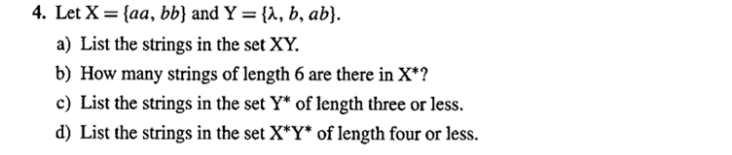

1. xy = {aa, aa, aab, aaab, bb, bb, bbb, bbab, , b, ab}
2. 8 strings

x*= {aaaaaa, aaaabb, aabbaa, aabbbb, bbaaaa, bbaabb, bbbbaa, bbbbbb}

1. y*= {, b, ab, , bb, b, b, bb, bb, bb,ab, ab, bab, abb, bbb, }
2. x*= {aa, bb, aaaa, bbbb, aabb, bbaa}

y*= {, b, ab, , bb, b, b, bb, bb, bb,ab, ab, bab, abb, bbb, ,, bbbb, abab, bbb, bb, bb, b, bb,b, b,bbab,babb, abbb, ab, ab, ab, bbb, bbb, bb,bbb,bb,bb,b }

x*y* = { aa, aa, aab, baa, aa, aa }