
Software Engineering Department
Braude College of Engineering
Capstone Project Phase B
Mutation Network Tool
PROJECT CODE:
25-2-D-27
By:
Lee Potashnik, ID: 318158565
leep0313@gmail.com
Pablo Dobrzynski, ID: 327248720
pablo161198@gmail.com

Advisor:
Dr. Zakharia Frenkel

GitHub

Table of Contents
Abstract 3
1 Introduction 3
2 Biological Background 5
2.1 Immune Response 5
2.2 B-Cells & B-Cell Receptors (BCRs) 5
2.3 Amino Acids 5
2.4 Genetic Code 5
2.5 K-mer or Fragment 5
2.6 PROSTAlign 6
3 Solution description 7
3.1 Activity Diagram 7
3.2 Package Diagram 8
4 Development Process and Challenges 10
4.1 Development Process Overview 10
4.2 Tools and Technologies Used 10
5 Challenges and Solutions 11
6 Verification plan 12
6.1 Testing Process Overview 12
6.2 Testing Methods and Tools 12
6.3 Testing Results and Acceptance Criteria 13
7 Conclusions and Reflections 14
7.1 Project Goals and Outcomes 14
7.2 Design Decisions and Considerations 15
7.3 Lessons Learned 16
8 References 17
9 User Guide 19
10 Maintenance Guide 25

Abstract
This project introduces a novel computational and visual tool for analyzing antibody populations by constructing and comparing triplet-based similarity networks. Rather than aligning entire protein sequences, our approach focuses on amino acid triplets-short, recurring sub-sequences that capture fine-grained biological variation. We begin by building a comprehensive reference network of all possible triplets, where each node represents a unique triplet and edges denote minimal mutational differences. Experimental antibody datasets are then loaded, and real-world triplets are mapped onto this reference network, allowing us to measure their structural and statistical properties. From these networks, we extract “signature profiles” that characterize each antibody population’s connectivity landscape. A dedicated similarity-scoring algorithm supports quantitative comparison between profiles, revealing biologically meaningful differences across conditions such as age, vaccination, or disease. The system includes an intuitive GUI for visual exploration, enabling researchers to interactively inspect connectivity patterns and codon-level mappings. By combining theoretical mutational models with real biological data, the tool offers a unique perspective on immune diversity and opens new possibilities for both immunological research and personalized medical applications.

Introduction
Understanding proteins and their functional dynamics is a fundamental goal in modern biology. Proteins are composed of sequences of amino acids, and their function, structure, and interactions are tightly related to the order and combination of these amino acids. Within the vast space of possible sequences, researchers are particularly interested in identifying biologically meaningful patterns-such as triplets (sequences of three amino acids) or nonamers (sequences of nine)- and analyzing how these motifs relate to structural and functional properties of the protein. However, one of the biggest challenges in protein research is the lack of intuitive and expressive ways to represent and compare these patterns.
Annotation of proteins, which refers to the process of identifying and labeling important regions within protein sequences, remains a labor-intensive and often ambiguous task. While bioinformatics tools can detect conserved domains or known active sites, they struggle to represent the closeness between similar sequences, the likelihood of successful substitutions, or the effects of mutations. Researchers often rely on sequence alignments, motif searches, or statistical summaries-methods that are limited in their ability to show the full complexity of the relationships between short amino acid segments and their roles within longer sequences. This creates a significant gap in the analytical workflow, particularly when it comes to studying proteins such as antibodies, where certain regions are highly variable while others are conserved.
Developed in collaboration with Uri Hershberg, a biology professor from the University of Haifa, the system will provide both analytical depth and visual clarity. It will allow researchers to explore sequence variability through signature graphs, compare immune responses under different physiological conditions, and visualize structural similarities in a way that reflects both statistical and biological relevance.
Ultimately, this project aspires to bridge the gap between biological intuition and computational analysis. By translating amino acid sequence data into graph-based models, we aim to empower researchers with a new way of thinking about proteins-not just as linear sequences of characters, but as rich, interconnected systems that reflect relationships between sequence segments. This representation supports a more intuitive understanding of how sequence elements relate to one another and how variations may influence overall protein behavior. The system is designed to serve as a supportive tool in research workflows, offering a visual and analytical perspective that complements existing annotation methods and enhances biological insight.

Biological Background

Immune Response
The immune response is the body's coordinated reaction to invading pathogens such as viruses, bacteria, fungi, and parasites. The immune system consists of two major components that work together to ensure host protection: the innate immune system, which provides a rapid, non-specific first line of defense, and the adaptive immune system, which generates antigen-specific responses and immunological memory[1].
The innate immune response includes physical barriers (e.g., skin, mucous membranes), phagocytic cells (such as macrophages and neutrophils), and signaling molecules like cytokines and chemokines. The adaptive immune response involves the activation of lymphocytes-B cells, which produce antibodies, and T cells, which help regulate and destroy infected cells. These systems interact to mount effective defenses and tailor responses to specific pathogens.

B-Cells & B-Cell Receptors (BCRs)
B cells are a type of lymphocyte central to the adaptive immune system.B cells express B cell receptors (BCRs) on their surfaces, which are essentially membrane-bound antibodies[1]. Each BCR is specific to a unique antigen, allowing the B cell to recognize and bind foreign pathogens precisely. Upon antigen binding and receiving additional activation signals, B cells proliferate and differentiate into plasma cells, which secrete large amounts of soluble antibodies, or memory B cells, which persist in the body to enable a faster and stronger response upon future exposure to the same antigen.

Amino Acids
Serine is one of the 20 standard amino acids encoded by the genetic code. It is specified by six different codons, making it one of the most redundantly encoded amino acids [15]. This high level of redundancy suggests that serine played an important role in the early evolution of the genetic code.

Genetic Code
The genetic code is the system by which the sequence of nucleotide bases (A, T, C, G) in DNA is translated into the amino acid sequence of proteins [11]. It works through codons-three-letter combinations of DNA or RNA bases-each of which specifies a single amino acid or a stop signal during protein synthesis [2]. This code is nearly universal across all living organisms and is fundamental to how genetic information is expressed [11].

K-mer or Fragment
In bioinformatics, a k-mer refers to a subsequence of length k extracted from a longer biological sequence, such as DNA, RNA, or protein sequences. K-mer–based approaches are widely utilized in repertoire analysis because they provide a standardized framework for comparing sequences across individuals, which is particularly valuable given the high variability of full-length immune receptor sequences [6].
When applied to protein sequences, k-mers typically consist of contiguous amino acid fragments. Research indicates that fragments comprising approximately 20 amino acids are effective for capturing structural and functional domains within proteins [17]. This fragment length balances the need for sufficient specificity with computational efficiency, facilitating tasks such as protein classification and functional annotation [9].
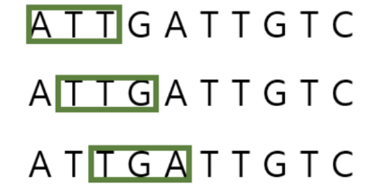

PROSTAlign
Another noteworthy approach for aligning remote protein sequences relies on the use of deep learning-derived contextual embeddings rather than traditional sequence similarity alone. A recent method, called PROSTAlign, leverages embeddings from pretrained protein language models (such as ESM-1b) to capture complex sequence relationships that extend beyond direct amino acid similarity. This method combines these embeddings with a dynamic programming algorithm and an innovative 400×400 substitution matrix that accounts for correlated amino acid pair substitutions, enabling more accurate alignments of highly divergent sequences.
In contrast to classical alignment tools, PROSTAlign introduces a contextual correlation map, which models long-range dependencies between amino acid positions using information learned from large-scale protein databases. These maps enhance the ability to align structurally and functionally similar regions, even when there is low sequence identity. The method has shown superior performance when aligning proteins with intrinsically disordered regions or significant conformational differences, outperforming traditional structure-based alignment tools in these challenging cases.
By integrating statistical learning and embedding-based representations, PROSTAlign marks a shift from purely sequence-based alignment to representation-based alignment, offering a more expressive and biologically relevant framework for analyzing protein families such as antibodies.

Solution description

Activity Diagram
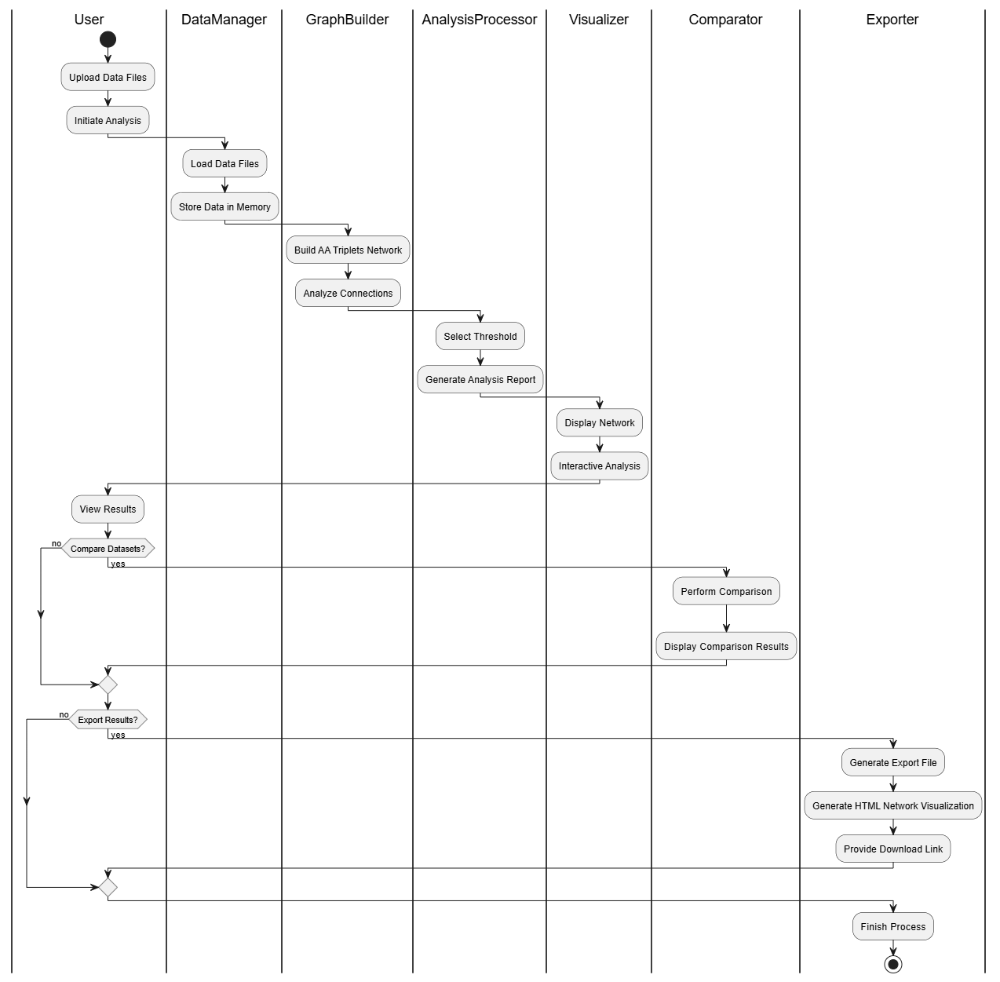
The following diagram illustrates the dynamic flow of the application, from the initial data ingestion to the final export of results. The process is divided into functional "swimlanes" to clearly define the responsibilities of each system component.
Data Ingestion and Mapping
The workflow begins when the user uploads raw sequence files. The DataManager loads these records into memory, which are then passed to the GraphBuilder. Unlike a general similarity graph, this module is specifically engineered to Build an Amino Acid Triplets Network, mapping DNA sequences into their respective amino acid triplets while maintaining strict links to the original data source.
Analysis and Refinement
Once the network structure is built, the AnalysisProcessor introduces a critical research step: Select Threshold. This allows the researcher to filter out background noise or rare mutations, ensuring that the resulting Analysis Report focuses on statistically significant biological signatures. The Visualizer then renders this refined data into an interactive 3D environment for manual inspection.
Comparative Evaluation and Export
After viewing the primary results, the user has the option to Compare Datasets. This comparative flow bypasses individual profile selection and proceeds directly to the Comparator, which calculates divergence scores between two populations (e.g., infected vs. healthy). Finally, the Exporter provides the user with comprehensive outputs, including raw data reports and the HTML Network Visualization, a standalone interactive file designed for collaborative research.

3.2 Package Diagram
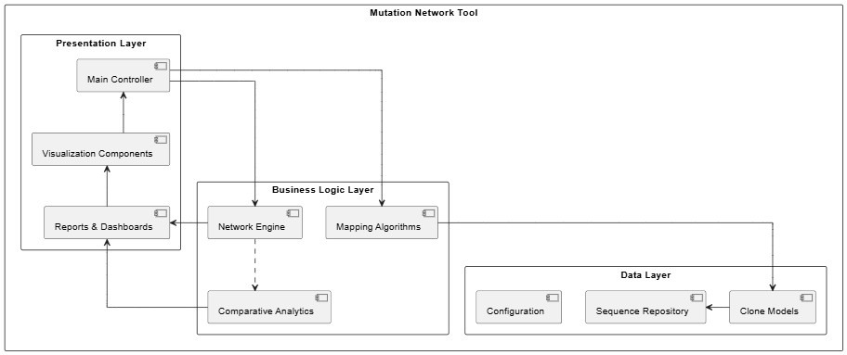
The diagram illustrates the structural organization of the application, which is divided into three primary layers, Presentation, Business, and Data - supported by specialized modules for visualization and configuration.
The Presentation Layer
This layer manages the user interface and the interactive experience of the researcher. It consists of three main components:
- Main Controller: The central desktop interface (GUI) that handles user inputs, such as file uploads and analysis triggers.
- Visualization Components: Powered by interactive rendering engines, this component generates the 3D mutational landscapes and graphical network views.
- Reports & Dashboards: Displays quantitative results, including network topology metrics and comparative statistical signatures.
This layer communicates downward with the Business Layer to request data processing and algorithmic analysis.
The Business Logic Layer
Responsible for the core scientific transformations and computational logic, this layer includes:
- Mapping Algorithms: Handles the translation of raw DNA sequences into amino acid triplets while maintaining strict data integrity.
- Network Engine: Manages the construction of the mutational graph, defining nodes and edges based on single-residue difference rules.
- Comparative Analytics: An optional module that performs cross-dataset evaluations to compute distance scores and population divergence between different antibody groups.
The Data Layer
This layer manages the internal data structures and information persistence. It includes:
- Sequence Repository: Manages the ingestion and temporary storage of large-scale genomic datasets.
- Clone Models: Defines the data structures used to represent biological clones, ensuring that metadata and original provenance are preserved.
- Configuration: Stores environment settings and parameter thresholds used for filtering noise and defining network connectivity.
Together, these layers provide a modular and robust foundation, bridging the gap between raw biological data and high-level research insights.

Development Process and Challenges

Development Process Overview
The development of the Mutation Network Tool followed a structured, research-oriented engineering process, bridging molecular biology with iterative software prototyping. The workflow was designed to transform complex biological questions into a reproducible computational framework, ensuring the final product serves as a reliable platform for scientific discovery.
The process was divided into several key strategic phases:
- Requirements Modelling and Scientific Scoping: This initial stage involved translating biological research goals into technical specifications. Continuous collaboration with a biology faculty member was essential to define mutation mechanisms and sequence constraints, ensuring the system’s analytical goals aligned with real-world laboratory needs.
- Architectural Design and Environment Setup: We established a modular development environment optimized for bioinformatics. The focus was on selecting a method that supports large-scale data manipulation and network modelling, providing a foundation for rapid prototyping and transparent data transformations.
- Iterative Pipeline Implementation: The core analytical engine was developed in stages: extracting amino acid triplets (k-mers), performing mutational mapping, and normalizing the data for comparative analysis. This stage focused on maintaining data provenance-preserving the link between raw DNA and the resulting network nodes.
- Visualization and UX Engineering: We focused on creating an interactive interface to make complex 3D mutation landscapes intuitive for researchers. This phase emphasized interactive exploration: researchers can iteratively adjust network filtering thresholds and immediately regenerate visualizations to better inspect connectivity clusters and derived metrics.
- Validation and Scientific Verification: The system underwent rigorous testing, including unit tests and biological sanity checks. Iterative refinements were applied to ensure numerical stability and to verify that the software effectively filters research noise while preserving meaningful biological signals.

Tools and Technologies Used
During the development of the Mutation Network Tool, we utilized a carefully selected set of technologies that supported our goals of intensive data processing, scientific reproducibility, and the visual accessibility of complex biological information.
For the core analytical pipeline, we chose Python due to its extensive ecosystem of scientific libraries. We integrated Pandas and NumPy to manage the substantial antibody sequence datasets; these tools enabled the efficient mapping of raw DNA into amino acid triplets while strictly preserving data provenance. This ensures that every extracted triplet remains linked to its original sequence index and metadata throughout the entire transformation process, providing researchers with full auditability of their results.
To construct and analyse the mutational landscape, we utilized the NetworkX library, which provided the mathematical framework for defining nodes and edges and computing "signature profiles" such as cluster counts and dispersion metrics. For visual exploration, we incorporated Plotly to generate interactive 3D networks. This choice allows biologists to manually inspect mutational "hotspots" and export interactive findings as standalone HTML artifacts for seamless collaboration.
The system’s accessibility was supported by CustomTkinter, enabling high-performance analysis on the researcher’s local hardware, and PyInstaller, which packaged the application into a standalone executable for easy laboratory deployment.

Challenges and Solutions
Throughout the development of the Mutation Network Tool, we addressed several technical hurdles to ensure scientific accuracy and performance.
Data Mapping and Integrity
- Challenge: Extracting thousands of sequences into triplets while ensuring every record remains linked to its original raw data.
- Solution: We engineered a pipeline that filters data by sample and processes it through a custom mapping algorithm. By using a dedicated CloneID class, the system permanently links each triplet to its parent clone and metadata, providing full auditability from the network back to the raw DNA.
Managing Network Complexity
- Challenge: Representing a vast mutational landscape of 9261 (21 amino acids in power of 3- which are triplets) potential triplets and hundreds of thousands of connections.
- Solution: We built a reference network where nodes represent unique triplets and edges denote single-residue mutations. By populating this model with our CloneID data, the system tracks frequencies and origins across the protein space, creating a quantitative database of mutational activity.
High-Dimensional Visualization
- Challenge: Visualizing an immense, interconnected network in a way that is intuitive for researchers.
- Solution: We implemented a 3D Spatial Framework where each axis corresponds to a position within the triplet. This projects mutational pathways as physical clusters, allowing biologists to visually identify "hotspots" and convergent immune responses that are invisible in linear sequence views.

Verification plan

Testing Process Overview
To ensure the Mutation Network Tool produces scientifically accurate and reproducible results, we implemented a structured verification process throughout the development lifecycle. Testing was conducted in parallel with implementation, combining automated software checks with expert biological validation.
A central pillar of our verification was the iterative review process with our Supervisor and the Biology Professor. These sessions ensured that every algorithmic transformation-from DNA parsing to network inference-aligned with biological logic and provided genuine research value. Each module was first tested individually (unit-level) before being integrated into the full analytical pipeline to verify data consistency and mapping accuracy.

Testing Methods and Tools
We utilized the following methods and tools to validate the system’s performance and scientific integrity:
- Expert Manual Review: Regular consultations with domain experts were used to inspect interactive visualizations and network profiles. This ensured that the inferred mutational "hotspots" and connectivity patterns matched established biological expectations.
- Automated Functional Testing: We used Pytest to execute unit and integration tests. This included verifying the deterministic mapping of DNA sequences into amino acid triplets and ensuring that normalization rules preserved vital biological signals.
- Scalability and Stress Testing: We performed "Parameter Sweeps" to ensure the network generation remained stable and performant when processing millions of sequence records.
- UI and Distribution Validation: The desktop interface and web-based Plotly exports were tested on multiple environments to guarantee responsiveness and ensure that the standalone executable functioned correctly for end-users.

Testing Results and Acceptance Criteria
To ensure the system's reliability and scientific value, our verification focused on producing accurate, reproducible, and biologically meaningful results. The process prioritized the integrity of the analytical pipeline- the initial mapping of sequences to the final 3D visualization-ensuring that every output provides genuine insight for researchers. A central part of this effort was the iterative review with our project supervisor and the Biology Professor, aligning our technical implementation with real-world research requirements.
Test ID | Module | Tested Function | Expected Result | Actual Result | Pass/Fail
1 | Data Ingestion | Upload raw DNA sequence file (csv) | System successfully parses records and extracts metadata | Files parsed correctly; metadata stored in memory | Pass
2 | Biological Mapping | Convert DNA sequences into amino acid triplets | Triplets are correctly mapped based on codon rules | 100% accuracy in DNA-to-triplet conversion | Pass
3 | Data Integrity | Maintain link between triplet and original sequence (Provenance) | Every triplet node contains a reference to its source CloneID | Provenance records are complete and auditable | Pass
4 | Network Inference | Generate similarity network based on single-residue difference | Edges are created between triplets differing by one amino acid | Network topology reflects mutational proximity | Pass
5 | Signal Distillation | Apply frequency thresholding (Noise reduction) | Rare/stochastic triplets are filtered based on relative probability | Background noise reduced- core signatures remained stable | Pass
6 | 3D Visualization | Render interactive triplet connectivity graph | Nodes are projected in a 3D space with clear mutational edges | Responsive 3D model generated with interactive tooltips | Pass
7 | Comparative Analysis | Compare two antibody group profiles (e.g., Infected vs. Healthy) | System calculates a Distance Score between two networks | Difference score accurately reflects population divergence | Pass
8 | Performance | Process large-scale dataset (e.g., 1 million records) | System completes processing without memory overflow or crashes | Efficient handling of high-volume sequence data | Pass
9 | Expert Review | Visual and scientific validation by Biology Professor | Inferred clusters and pathways match biological intuition | Expert confirmed the potential findings of our outputs | Pass

Conclusions and Reflections

Project Goals and Outcomes
Commissioned by a biology professor to support specialized research, this project delivers a robust bioinformatics tool that transforms massive, raw DNA datasets into actionable protein mutation networks. By streamlining the transition from sequence data to amino acid triplets, the platform bridges the gap between data accumulation and biological discovery. Through advanced 3D visualization and automated quantitative analysis, the system empowers biologists to bypass manual processing and focus on high-level hypothesis generation and the extraction of insights from complex immune dynamics.
Data Integrity and Contextual Biological Mapping:
We implemented a codon-aware triplet extraction pipeline that slides across nucleotide sequences, translates each 9-nt window into an amino-acid triplet using the standard genetic code, and preserves per-clone positional indices (and region labels) to keep results biologically interpretable.
- Research Utility: Beyond mere extraction, the system preserves the "provenance" of each triplet, including its precise sequence index, sample identity, and original codon mapping.
- Biological Insight: This allows researchers to identify structural preferences and "hotspots" of antibody activity, providing a granular view of where the most significant immune developments occur within a sequence.
Visual Exploration of the Mutational Landscape:
The information is presented through an interactive 3D network where each node represents a unique amino acid triplet, and edges signify single-point mutations.
- Research Utility: This visualization offers "visual evidence" of network topology that was previously inaccessible
- Biological Insight: Researchers can immediately identify dense clusters-indicating convergent immune responses-versus sparse regions. The visual representation of counters and transitions enables experts to infer the probability of specific antibody emergence and the overall nature of the immune response to a given pathogen
Signal Distillation through Dynamic Thresholding:
To manage the inherent noise in large-scale biological data, we implemented a dynamic thresholding mechanism based on the relative probability of each triplet's occurrence.
- Research Utility: These tools enable the researcher to filter out "stochastic noise"-rare or accidental triplets- focus on the broadly impactful responses.
- Biological Insight: By refining the data, the system allows for the identification of core "immune signatures," helping characterize the primary antibodies involved in a disease response while minimizing rare variants that may obscure cross-sectional patterns.
Comparative Analysis of Immune Repertoires:
The platform facilitates direct quantitative and visual comparison between distinct datasets, such as different viral variants or patient cohorts.
- Research Utility: Identifying high similarity between networks representing different conditions can indicate shared immune pathways.
- Biological Insight: Such insights can lead researchers to conclude that the immune system "attacks" different strains in a similar manner, potentially informing the development of broad-spectrum therapeutic strategies or universal vaccine candidates.

Design Decisions and Considerations
Throughout the development process, design decisions were driven by a balance between the specific biological requirements of the research faculty and algorithmic efficiency. Key considerations include:
- Language Selection (Python): We chose Python as the primary development language due to its robust ecosystem for large-scale data analysis. This choice ensures that the pipeline can efficiently process and simplify massive genomic sequence datasets while maintaining the flexibility required for complex biological computations.
- Hybrid Architecture (Local GUI & Web-based Visualization): To handle the substantial data load, the core processing tool was developed as a local application. This allows for high-performance data ingestion on the researcher’s hardware, while the 3D network visualizations are offloaded to a web-based interface. This hybrid approach optimizes system resources and ensures a responsive user experience during exploration.

Lessons Learned
We followed a structured development plan to bridge the gap between biological needs and computational logic. However, the process highlighted two key areas for improvement:
- Processing Scalability: Handling datasets with thousands of records demonstrated that even more aggressive memory optimization and parallel processing are essential to maintain performance during large-scale network construction.
- Expert-Centered Balance: Collaborating with a biology professor emphasized the challenge of balancing high-level network visualizations with granular access to raw sequence data, a trade-off that requires constant iterative refinement.
Despite these points, the project provided invaluable experience in developing research-grade bioinformatics tools tailored for real-world scientific inquiry.

References
[1] Chaplin, D. D. (2010). Overview of the immune response. Journal of Allergy and Clinical Immunology, 125(2).
[2] Encyclopaedia Britannica. "Genetic Code," Encyclopaedia Britannica.
[3] Frappier, V., Lagarde, N., Lamoureux, P., & Najmanovich, R. (2023). New alignment method for remote protein sequences by the direct use of pairwise sequence correlations and substitutions.
[4] Frenkel, Z. M., Frenkel, Z. M., Trifonov, E. N., & Snir, S.. Structural relatedness via flow networks in protein sequence space.
[5] Frenkel, Z. M., & Trifonov, E. N.. Walking Through the Protein Sequence Space: Towards New Generation of the Homology Modeling.
[6] Greiff, V., Miho, E., Menzel, U., & Reddy, S. T. (2020). Mining adaptive immune receptor repertoires for biological and clinical information. Current Opinion in Systems Biology, 24, 109–119.
[7] Janeway, C. A., Travers, P., Walport, M., & Shlomchik, M. J. Janeway's Immunobiology (9th Edition), Garland Science.
[8] Kovaltsuk, A., et al. (2018). Structural diversity of B-cell receptor repertoires. Frontiers in Immunology, 9, 2278.
[9] Lemaitre, C., et al. (2022). Flexible protein database based on amino acid k-mers. Nucleic Acids Research, 50(12), e69.
[10] McHeyzer-Williams, M. G., & McHeyzer-Williams, L. J. (2005). Antigen-specific memory B cell development. Nature Reviews Immunology, 5(4), 331–342.
[11] National Human Genome Research Institute. "Genetic Code," Genetics Glossary.
[12] Pal, R., Mukherjee, S., & Saha, S. (2023). Use of 2D FFT and DTW in Protein Sequence Comparison. Journal of Computational Biology.
[13] Roitt, I., & Delves, P. Roitt's Essential Immunology (13th Edition), Wiley.
[14] Schatz, D. G., & Ji, Y. (2011). Recombination centres and the orchestration of V(D)J recombination. Nature Reviews Immunology, 11(4), 251–263.
[15] Schwartz, G. W., Shauli, T., Linial, M., & Hershberg, U. (2019). Serine Substitutions are Linked to Codon Usage and Differ for Variable and Conserved Protein Regions. Scientific Reports, 9, 17238.
[16] Sircar, A., Kim, E. T., & Gray, J. J. (2007). CDRs in Antibody Structures. Nature Reviews Immunology.
[17] Zhang, Z., et al. (2022). An accurate alignment-free protein sequence comparator based on amino acid k-mer frequency. Scientific Reports, 12, 15266.

User Guide
Main Screen
The entry screen serves as the starting point for the research process, where the user uploads genomic datasets to initiate the mutational analysis. This interface allows researchers to transform raw sequence data into structured biological models by applying critical pre-processing filters.
- Dataset Upload: Researchers upload antibody DNA data, typically categorized by specific conditions such as COVID-19 patient samples.
- Metadata Preview: Once a dataset is uploaded, the system automatically parses the file to display a summary of the genomic data, including Experiment IDs, Sample Sources, and Total Clone counts. This provides immediate context regarding the scale and biological origin of the data.
- Node Frequency Threshold:
  - Function: This slider controls the minimum appearance count required for an amino acid triplet to be included as a node in the network.
  - Biological Meaning: High-throughput sequencing often captures "background noise" from sequencing errors or rare, non-functional mutations. By raising this threshold, the researcher effectively removes these stochastic outliers.
  - Result: The resulting network focuses exclusively on dominant antibody populations, which represent the functional core of the immune response.
- Edge Probability Threshold:
  - Function: This filter determines the strength of the mutational connection between two triplets.
  - Biological Meaning: In an evolving immune system, some mutational paths are far more probable than others. This threshold removes unlikely "leap" mutations, "cleaning" the graph to reveal the most plausible evolutionary lineages.
  - Result: The researcher can visualize the most likely pathways of antibody development and identify specific mutational "hotspots" that drive the immune system's adaptation.
- Compare Areas: This feature allows researchers to compare different regions within the dataset by selecting specific triplet indices. It is essential for identifying how mutational patterns differ across various segments of the antibody sequence.
- Add Another Dataset: This feature enables the loading of additional cohorts for later comparative analysis, allowing for the discovery of divergent signatures between different biological groups.
- Analyze Button: Pressing the Analyze button triggers the mapping and normalization algorithms. This builds the 3D mutation network and navigates the researcher to the visualization screen to begin exploring the biological findings.

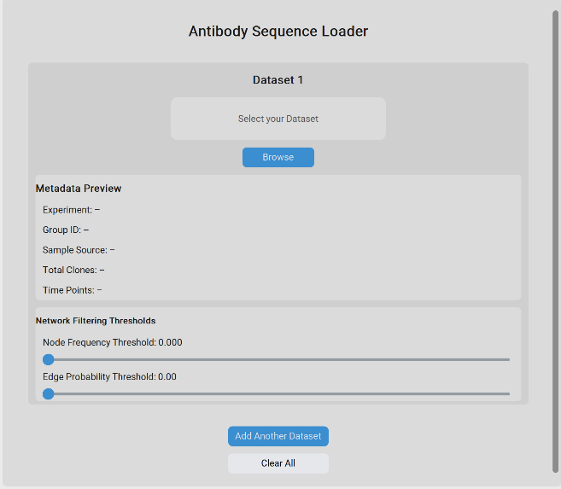
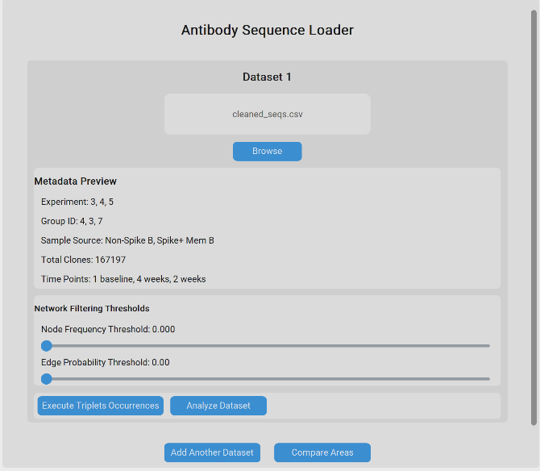

Comparison Results Screen (Optional If Compare Chosen)
This view provides a statistical summary of the relationship between two networks, offering objective metrics to support biological observations.
- Region vs. Region Comparison: This allows the researcher to compare different indices (segments) within the same dataset to determine if certain areas of the antibody sequence are more mutationaly active or structurally complex than others.
- Dataset vs. Dataset Comparison: This is used to contrast different biological groups, such as comparing the antibody evolution of a COVID-19 patient against a healthy control group.
- Node Count (Size Analysis): The report displays the total number of nodes for both selections (e.g., Region 1 vs. Region 2). This provides an immediate sense of the "mutational diversity" within each group, a higher node count often suggests a more diverse and evolving immune response.
- Network Distance Score: This is the primary statistical output of the comparison. It quantifies the topological divergence between the two networks on a scale where a higher score indicates greater structural differences.
  - Low Distance: Suggests that the two groups share similar mutational pathways and evolutionary signatures.
  - High Distance: Indicates significant divergence, potentially highlighting unique immune adaptations or specific antibody signatures exclusive to one group.
- Biological Inference: By analyzing these results, researchers can pinpoint specific evolutionary shifts and validate whether a particular treatment or infection has fundamentally altered the topology of the mutation network.

Visualization Screen
Following the analysis, the system renders an interactive 3D environment that represents the antibody mutational space. This view allows researchers to visually inspect the structural properties of the immune response.
- Spatial Mapping: Each node in the 3D space represents a unique amino acid triplet. The network uses a 3D coordinate system where each axis corresponds to a specific residue position within the triplet, allowing for a clear spatial representation of mutational proximity.
- Mutational Edges: Edges are drawn between nodes that differ by exactly one amino acid. These lines represent a single point mutation, enabling the researcher to trace evolutionary pathways through the network.
- Biological Significance of Color (Red Nodes): Nodes highlighted in red represent "Stop Codons" (indicated by the * symbol in the mapping). Biologically, these are critical points as they signal the termination of protein synthesis. Observing where these occur in the network helps researchers identify truncated antibody sequences that may be non-functional.

Dynamic Filtering (Noise vs. Signal): The difference in node density between visualizations is a direct result of the Threshold settings applied on the Main Screen.
- High-Density View: Displays the complete mutational landscape, including rare variants.
- Filtered View: By increasing the threshold, the system hides lower-frequency nodes, revealing the "skeleton" of the most dominant and statistically significant antibody clusters.

Interactive Tools (Zoom & Tooltips): The interface supports dynamic interaction, such as Zoom In for granular inspection of specific clusters. Hovering over a node activates a Tooltip, providing immediate biological data including the specific triplet sequence (e.g., *HE), its raw count in the dataset, and its normalized frequency.

Data Export Output
The system allows researchers to export the processed datasets, providing a granular view of the biological transformations. This exported data links the raw genetic input to the structured amino acid triplets used for network construction.
- Triplet Mapping & Indexing: For every uploaded dataset, the tool generates a comprehensive map identifying each Amino Acid Triplet and its specific Index (position) within the original DNA sequence.
- Biological Provenance (Clone ID): Every triplet is explicitly linked to its Clone ID, ensuring full auditability. This allows researchers to trace a specific mutational signature back to the exact sample or patient source it originated from.
- Research Applications & Insights
This raw export provides several critical capabilities for downstream biological analysis:
- Frequency Filtering: Researchers can use this data to perform independent statistical counts, identifying which specific triplets appear most frequently across different samples. High-frequency triplets often point to convergent immune responses or "public" antibody motifs.
- Positional Analysis: By filtering the Index column, scientists can isolate specific regions of the antibody sequence (such as the CDR3) to study mutational density in high-variability areas versus conserved regions.
- Cross-Sample Correlation: By analyzing the Clone ID distribution, the researcher can conclude if certain mutational pathways are unique to a single individual or shared across the entire cohort (e.g., specific COVID-19 patient groups).
- Custom Data Integration: The exported format is designed for easy ingestion into other bioinformatics pipelines, allowing for specialized longitudinal studies or integration with protein folding simulators.

Maintenance Guide
The goal of this document is to ensure the long-term viability of the Mutation Network Tool. It provides the necessary instructions for setting up the environment, understanding the core logic, and implementing future updates or improvements.
Environment Setup & Installation
    - To maintain or update the system, the developer must set up a local Python environment.
Installation Steps
- Clone the Repository:
- Create a Virtual Environment:
- Install Dedicated Dependencies: The system relies on specific libraries for latge data analysis and visualization.
pip install -r requirements.txt
Running the Application
The application can be executed in two ways:
- From Source: Run python main_window.py to launch the GUI via the interpreter.
- From Executable: If a build has been generated for main_window.py using PyInstaller, run the MutationTool.exe located in the /dist folder.
System Architecture Overview
The tool is built using a Three-Tier Architecture, ensuring that biological data processing is decoupled from the user interface.
- Presentation Layer (/ui): Built with CustomTkinter. It manages user inputs (sliders, file uploads) and handles the asynchronous execution of heavy tasks to prevent UI freezing.
- Business Logic Layer (/src & /scripts): Contains the "brain" of the tool. It handles the mapping of sequences to triplets and the graph theory logic.
- Data Layer (/src): Manages the ingestion of CSV files and maintains data integrity through Pandas DataFrames.

Core Algorithms & Data Processing
1. Data Ingestion & Extraction
- Module: src/load_clones.py, src/build_triplet_df.py
- Logic: The system parses raw DNA, assigns a unique CloneID, and translates sequences into amino acid triplets using a lookup table in codon_mapper.py.
- Location: Data remains in memory as a DataFrame to allow for high-speed filtering and positional indexing.
2. Threshold & Noise Reduction
- Module: src/networks.py, ui/main_window.py
- Logic: Before building the network, the system applies Frequency and Probability filters.
- Significance: This reduces sequencing errors and stochastic noise, focusing the network on dominant antibody signatures.
3. Network Construction & Comparison
- Module: src/networks.py, scripts/network_comparison.py
- Graph Logic: Uses NetworkX to create nodes (triplets) and edges (mutations).
- Comparison Math: Calculates a weighted Distance Score to quantify the divergence between two datasets or regions.
$$D\left(A,B\right)=\frac{\sum{w_{i}}w_{j}d_{ij}}{\sum{w_{i}}w_{j}}$$
Where w is clone abundance and d is mutational distance.

Extending the System (Future Improvements)
The modular design allows for easy expansion. Below are examples of how to add features:
- Example 1: Adding a New Biological Metric
To add a metric like "Conservation Score":
- Logic: Create a new function in src/metrics.py that calculates the score per triplet.
- Integration: Update build_triplet_df.py to include this score as a new column in the primary DataFrame.
- UI: Add a checkbox in ui/main_window.py to allow the user to toggle this metric.
- Example 2: Supporting New File Formats
To support .fasta or .json sequence files:
- Parser: Add a new loading function in src/load_clones.py.
- Normalization: Ensure the output matches the standard internal format (CloneID, Sequence, Count).
- Example 3: Enhancing Visualization
To add a 2D Heatmap alongside the 3D view:
- Script: Create scripts/plot_heatmap.py using Plotly.
- Export: Use the existing export logic to save the heatmap as a Standalone HTML file, ensuring researchers can share it easily.

