
Capstone Project Phase A
Mutation Network Tool
PROJECT CODE:
25-2-D-27
Supervisor:
Dr. Zakharia Frenkel

Authors:
Lee Potashnik, ID: 318158565
leep0313@gmail.com
Pablo Dobrzynski, ID: 327248720
pablo161198@gmail.com
GitHub

Abstract 3
1. Introduction 3
2. Literature review 4
2.1. Immune response 4
2.2 B-Cells & B-Cell Receptors (BCRs) 5
2.3 V(D)J Recombination 5
2.4 Clones, Clonal Selection 5
2.5 Immunoglobulins 6
2.6 Somatic Hypermutation 6
2.7. Framework Region (FWR) & Complementarity-Determining Regions (CDRs) 6
2.8. Genetic Code 6
2.9 Serine 6
2.10 Amino Acids 7
2.11 K-mer or Fragment 7
2.12 PROSTAlign [3] 7
2.13 2D-FFT and DTW-Based Protein Sequence Comparison [12] 8
3. Expected Achievements 8
4. Engineering Process 9
4.1 Process 9
4.2 Product 11
4.2.1 GUI 11
Triplet Similarity Network 12
4.2.2 Activity Diagram 15
4.2.3 Project Class & Data: 17
5. Verification plan: 18
6. References 19

Abstract
This project introduces a novel computational and visual tool for analyzing antibody populations by constructing and comparing triplet-based similarity networks. Rather than aligning entire protein sequences, our approach focuses on amino acid triplets—short, recurring sub-sequences that capture fine-grained biological variation. We begin by building a comprehensive reference network of all possible triplets, where each node represents a unique triplet and edges denote minimal mutational differences. Experimental antibody datasets are then loaded, and real-world triplets are mapped onto this reference network, allowing us to measure their structural and statistical properties. From these networks, we extract “signature profiles” that characterize each antibody population’s connectivity landscape. A dedicated similarity-scoring algorithm supports quantitative comparison between profiles, revealing biologically meaningful differences across conditions such as age, vaccination, or disease. The system includes an intuitive GUI for visual exploration, enabling researchers to interactively inspect connectivity patterns and codon-level mappings. By combining theoretical mutational models with real biological data, the tool offers a unique perspective on immune diversity and opens new possibilities for both immunological research and personalized medical applications.

1. Introduction
Understanding proteins and their functional dynamics is a fundamental goal in modern biology. Proteins are composed of sequences of amino acids, and their function, structure, and interactions are tightly related to the order and combination of these amino acids. Within the vast space of possible sequences, researchers are particularly interested in identifying biologically meaningful patterns-such as triplets (sequences of three amino acids) or nonamers (sequences of nine)- and analyzing how these motifs relate to structural and functional properties of the protein. However, one of the biggest challenges in protein research is the lack of intuitive and expressive ways to represent and compare these patterns.
Annotation of proteins, which refers to the process of identifying and labeling important regions within protein sequences, remains a labor-intensive and often ambiguous task. While bioinformatics tools can detect conserved domains or known active sites, they struggle to represent the closeness between similar sequences, the likelihood of successful substitutions, or the effects of mutations. Researchers often rely on sequence alignments, motif searches, or statistical summaries-methods that are limited in their ability to show the full complexity of the relationships between short amino acid segments and their roles within longer sequences. This creates a significant gap in the analytical workflow, particularly when it comes to studying proteins such as antibodies, where certain regions are highly variable while others are conserved.
Connectivity strength between antibody populations is then estimated using network-theoretic techniques such as clustering, maximal flow, or models based on electrical networks. These allow us to detect subtle but meaningful relationships between sequences that would otherwise remain hidden in alignment-based frameworks. In our project, we aim to extend these PCN construction methods and develop customized analysis tools suitable for relatively small but diverse sets of antibody sequences.
Developed in collaboration with Uri Hershberg, a biology professor from the University of Haifa, the system will provide both analytical depth and visual clarity. It will allow researchers to explore sequence variability through signature graphs, compare immune responses under different physiological conditions, and visualize structural similarities in a way that reflects both statistical and biological relevance.
Ultimately, this project aspires to bridge the gap between biological intuition and computational analysis. By translating amino acid sequence data into graph-based models, we aim to empower researchers with a new way of thinking about proteins-not just as linear sequences of characters, but as rich, interconnected systems that reflect relationships between sequence segments. This representation supports a more intuitive understanding of how sequence elements relate to one another and how variations may influence overall protein behavior. The system is designed to serve as a supportive tool in research workflows, offering a visual and analytical perspective that complements existing annotation methods and enhances biological insight.

2. Literature review

2.1. Immune response
The immune response is the body's coordinated reaction to invading pathogens such as viruses, bacteria, fungi, and parasites. The immune system consists of two major components that work together to ensure host protection: the innate immune system, which provides a rapid, non-specific first line of defense, and the adaptive immune system, which generates antigen-specific responses and immunological memory[1].
The innate immune response includes physical barriers (e.g., skin, mucous membranes), phagocytic cells (such as macrophages and neutrophils), and signaling molecules like cytokines and chemokines. The adaptive immune response involves the activation of lymphocytes-B cells, which produce antibodies, and T cells, which help regulate and destroy infected cells. These systems interact to mount effective defenses and tailor responses to specific pathogens.

2.2 B-Cells & B-Cell Receptors (BCRs)
B cells are a type of lymphocyte central to the adaptive immune system.B cells express B cell receptors (BCRs) on their surfaces, which are essentially membrane-bound antibodies[1]. Each BCR is specific to a unique antigen, allowing the B cell to recognize and bind foreign pathogens precisely. Upon antigen binding and receiving additional activation signals, B cells proliferate and differentiate into plasma cells, which secrete large amounts of soluble antibodies, or memory B cells, which persist in the body to enable a faster and stronger response upon future exposure to the same antigen.

2.3 V(D)J Recombination
V(D)J recombination is a somatic genetic rearrangement process that occurs exclusively in developing lymphocytes during early B and T cell maturation. This mechanism [14] assembles variable (V), diversity (D), and joining (J) gene segments to generate the diverse repertoire of antigen receptors found in immunoglobulins (in B cells) and T cell receptors (in T cells).
The process is initiated by the recombination-activating gene products RAG1 and RAG2, which introduce double-stranded DNA breaks at recombination signal sequences (RSSs) flanking the gene segments. These breaks are then resolved and the segments joined by the non-homologous end joining (NHEJ) DNA repair pathway. This recombination results in unique antigen-binding sites, enabling the immune system to recognize a vast array of pathogens and altered self cells, making it a defining feature of the adaptive immune response.

2.4 Clones, Clonal Selection
Clone: A clone refers to a population of genetically identical lymphocytes that originate from a single progenitor cell. Each cell in the clone expresses the same antigen-specific receptor and retains the same functional characteristics.
Clonal selection is a foundational principle of adaptive immunity. Individual B cells express unique antigen-specific receptors (BCRs) generated through somatic recombination[10]. When an antigen binds to a BCR with high affinity, that B cell is activated, undergoes clonal expansion, and differentiates into either plasma cells, which produce antibodies, or memory B cells, which contribute to long-term immunity. This selection and expansion process ensures that only lymphocytes specific to the encountered antigen are amplified.

2.5 Immunoglobulins
Immunoglobulins, also known as antibodies, are Y-shaped glycoproteins produced by plasma cells that play a central role in the adaptive immune[7]. They bind specifically to antigens such as viruses or bacteria, neutralizing them or tagging them for elimination [13]. Each immunoglobulin molecule consists of two heavy and two light chains, with variable regions that determine antigen specificity and constant regions responsible for activating immune mechanisms [7]. There are several classes of immunoglobulins—IgG, IgA, IgM, IgE, and IgD—each with distinct functions and distributions, which help tailor immune responses to different types of pathogens [13].

2.6 Somatic Hypermutation
Somatic hypermutation is a process that occurs in activated B cells, where small changes (mutations) are made to the genes that code for antibodies [7]. These mutations help the B cells produce antibodies that bind more strongly to antigens, improving the body’s ability to fight infections [13].

2.7. Framework Region (FWR) & Complementarity-Determining Regions (CDRs)
Antibodies contain variable regions made up of framework regions (FWRs) and complementarity-determining regions (CDRs). FWRs are relatively conserved segments that form the structural scaffold of the antibody, helping maintain the proper shape and orientation of the antigen-binding site [8]. In contrast, CDRs are highly variable regions that directly bind to specific antigens and determine the antibody’s binding specificity [16]. Each variable domain contains three CDRs supported by four FWRs, and this combination is essential for generating the vast diversity of antibodies the immune system can produce [8].

2.8. Genetic Code
The genetic code is the system by which the sequence of nucleotide bases (A, T, C, G) in DNA is translated into the amino acid sequence of proteins [11]. It works through codons-three-letter combinations of DNA or RNA bases-each of which specifies a single amino acid or a stop signal during protein synthesis [2]. This code is nearly universal across all living organisms and is fundamental to how genetic information is expressed [11].

2.9 Serine
Serine is one of the 20 standard amino acids encoded by the genetic code. It is specified by six different codons, making it one of the most redundantly encoded amino acids [10]. This high level of redundancy suggests that serine played an important role in the early evolution of the genetic code.

2.10 Amino Acids
Serine is one of the 20 standard amino acids encoded by the genetic code. It is specified by six different codons, making it one of the most redundantly encoded amino acids [15]. This high level of redundancy suggests that serine played an important role in the early evolution of the genetic code.

2.11 K-mer or Fragment
In bioinformatics, a k-mer refers to a subsequence of length k extracted from a longer biological sequence, such as DNA, RNA, or protein sequences. K-mer–based approaches are widely utilized in repertoire analysis because they provide a standardized framework for comparing sequences across individuals, which is particularly valuable given the high variability of full-length immune receptor sequences [6].
When applied to protein sequences, k-mers typically consist of contiguous amino acid fragments. Research indicates that fragments comprising approximately 20 amino acids are effective for capturing structural and functional domains within proteins [17]. This fragment length balances the need for sufficient specificity with computational efficiency, facilitating tasks such as protein classification and functional annotation [9].
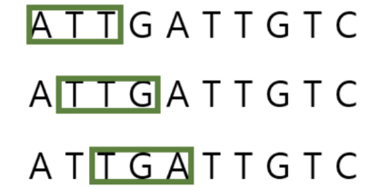

2.12 PROSTAlign [3]
Another noteworthy approach for aligning remote protein sequences relies on the use of deep learning-derived contextual embeddings rather than traditional sequence similarity alone. A recent method, called PROSTAlign, leverages embeddings from pretrained protein language models (such as ESM-1b) to capture complex sequence relationships that extend beyond direct amino acid similarity. This method combines these embeddings with a dynamic programming algorithm and an innovative 400×400 substitution matrix that accounts for correlated amino acid pair substitutions, enabling more accurate alignments of highly divergent sequences.
In contrast to classical alignment tools, PROSTAlign introduces a contextual correlation map, which models long-range dependencies between amino acid positions using information learned from large-scale protein databases. These maps enhance the ability to align structurally and functionally similar regions, even when there is low sequence identity. The method has shown superior performance when aligning proteins with intrinsically disordered regions or significant conformational differences, outperforming traditional structure-based alignment tools in these challenging cases.
By integrating statistical learning and embedding-based representations, PROSTAlign marks a shift from purely sequence-based alignment to representation-based alignment, offering a more expressive and biologically relevant framework for analyzing protein families such as antibodies.

2.13 2D-FFT and DTW-Based Protein Sequence Comparison [12]
An innovative approach for protein sequence comparison was proposed by Bera et al., combining Two-Dimensional Fast Fourier Transform (2D-FFT) with Dynamic Time Warping (DTW) to improve the alignment of sequences, particularly those with low similarity or unequal lengths. In this method, protein sequences are first converted into numerical representations based on their physicochemical properties, enabling the application of 2D-FFT to extract meaningful frequency-domain features. These features capture periodicity and global structure, which are often missed by traditional alignment techniques.
Once transformed, DTW is employed to flexibly align the frequency-based representations, allowing the model to handle variations in local sequence structure and timing. This combination allows for the detection of subtle similarities that may not be apparent through direct character-level comparisons. The method is particularly useful for analyzing structurally diverse or disordered proteins, offering a complementary perspective to conventional alignment methods.
By integrating signal processing and temporal alignment, this hybrid technique provides a powerful framework for identifying biologically relevant relationships between protein sequences, even under challenging conditions.

3. Expected Achievements
In this project, we propose to adopt a similarity network approach for the analysis of antibody populations, focusing on relatively small and related sets of protein sequences within the adaptive immune system. The core of the work involves developing a novel algorithm for defining edges in a triplet-based similarity graph, exploring modifications to previously established rules for global sequence similarity networks.
The computational tool we will develop will process antibody sequence datasets, extract recurring amino acid triplets, and build connectivity graphs that reflect structural and statistical properties unique to each population. These networks will then be analyzed to produce distinct “signature profiles” that encapsulate the identity of each antibody population.
The implemented system will support comparison between these profiles using a similarity-scoring mechanism, enabling the identification of meaningful differences between immune responses under varying biological conditions (e.g., age, disease, vaccination). The tool will also feature a visual interface for interactive exploration of antibody network structures and their comparative properties.
This tool will be evaluated according to three main criteria:
- Profiling Capability – The ability to generate unique and informative profiles for different antibody populations, validated using benchmark datasets.
- Comparison Accuracy – The effectiveness of the similarity-scoring algorithm in detecting biologically relevant differences.
- Usability and Insight – The clarity, interactivity, and scientific value of the user interface, assessed through expert feedback from immunologists and data scientists.
By achieving these goals, the project aims to deliver a functional and innovative system for characterizing antibody repertoires, offering new insights into immune diversity and supporting both scientific research and potential clinical applications.
What sets this tool apart is its unique integration of a triplet-based similarity algorithm, a densely connected mutational reference network, and an interactive visual interface designed to reveal complex patterns in an intuitive manner. Unlike conventional approaches that focus solely on full-sequence comparisons, this system enables fine-grained analysis of recurring sub-sequences and their structural context, uncovering hidden patterns and higher-order connectivity within antibody populations. This innovation holds promise for advancing our fundamental understanding of immune responses and paving the way for personalized applications in immunological research and healthcare.

4. Engineering Process

4.1 Process
In this project, we will develop an algorithmic and visual system for analyzing antibody populations, based on constructing similarity networks between short amino acid segments (triplets) extracted from protein sequences.
At the heart of our method lies a novel approach that shifts the focus from full-sequence comparisons to localized analysis of amino acid triplets- short yet information-rich segments capable of revealing subtle biological patterns. We construct a comprehensive mutational network that encodes all possible triplets and their structural proximity based on single amino acid differences. Real-world antibody data is then mapped onto this reference framework, enabling quantitative and topological analysis of how triplet usage and connectivity vary across populations or regions. The result is a rich network of associations—a kind of “map” that illustrates how triplets are interlinked within a given antibody population, offering a new lens for exploring immune diversity and response.
The data used to generate these networks will be derived from the experimental dataset presented in the study "Distinct antibody and memory B cell responses in SARS-CoV-2." This dataset includes sequencing information of antibodies and memory B cells, capturing clonal expansions, somatic hypermutation, and isotype switching across different physiological conditions, such as age, immune status, disease progression, and vaccination status. As part of the system, graphical tools will be developed to visualize these networks interactively, enabling researchers to compare them and detect meaningful differences between biological conditions-such as age, immune status, disease, or vaccination.
To achieve this, the process will be divided into the following key stages:
1. General Network Construction
We begin by constructing a general triplet similarity network of all 9,261 possible amino acid triplets (21³ combinations). Each node represents a unique triplet, and edges connect triplets that differ by a single amino acid. Since each triplet has 3 positions and 20 alternatives per position, each node have 60 edges. This network defines the mutational landscape and serves as a reference for mapping real antibody data in later stages.
2. Data Loading
The process begins with importing files containing groups of antibody sequences. Each file represents a specific population-such as individuals affected by a disease, healthy individuals, or participants following vaccination. Each sequence within the file is a string of letters, with each letter representing a nucleotide, while three nucleotides represent an amino acid-the building blocks of proteins. After loading the files, the system also retains metadata for each sequence, such as the experiment of origin, the group it belongs to, and the biological source of the sample.
3. Triplet Extraction
Each protein sequence is analyzed to extract all amino acid triplets-i.e., segments of nine consecutive nucleotides (three amino acids). Triplets are short enough to appear across sequences but long enough to carry meaningful biological information. During this step, the system compiles a list of all unique triplets per group, along with their position, frequency, and associated sequences.
These extracted triplets are then used to populate the general triplet network: each triplet is mapped to its corresponding node, its frequency is recorded, and dataset metadata (such as group ID, sequence origin, etc.) is stored. This process transforms the general graph into a biologically grounded representation specific to the loaded dataset.
4. Profile Construction
From the mutation network, signature profiles are extracted-mathematical summaries of the network’s topology. These profiles may include metrics such as average node connectivity, tightly connected subgraphs, dispersion levels, and more. Each profile characterizes the general structure of the corresponding antibody group, providing a compact yet informative fingerprint that allows comparison across populations.
5. Profile Comparison
The system then compares the signature profiles of different groups using a similarity-scoring algorithm. This algorithm computes a numerical similarity score between the networks, enabling the evaluation of how close or distant two groups are from one another. In turn, this helps identify biologically meaningful relationships-for example, similarities between groups of individuals of the same age, health background, or treatment history.
6. Visual Representation
By modeling and visualizing sub-sequence connectivity through network-based representations, the system offers a novel and powerful analytical tool for biological research. It enables researchers to discover hidden patterns that traditional sequence-alignment techniques might overlook, ultimately contributing to a deeper understanding of diversity, selection, and variation in the human immune system.

4.2 Product

4.2.1 GUI
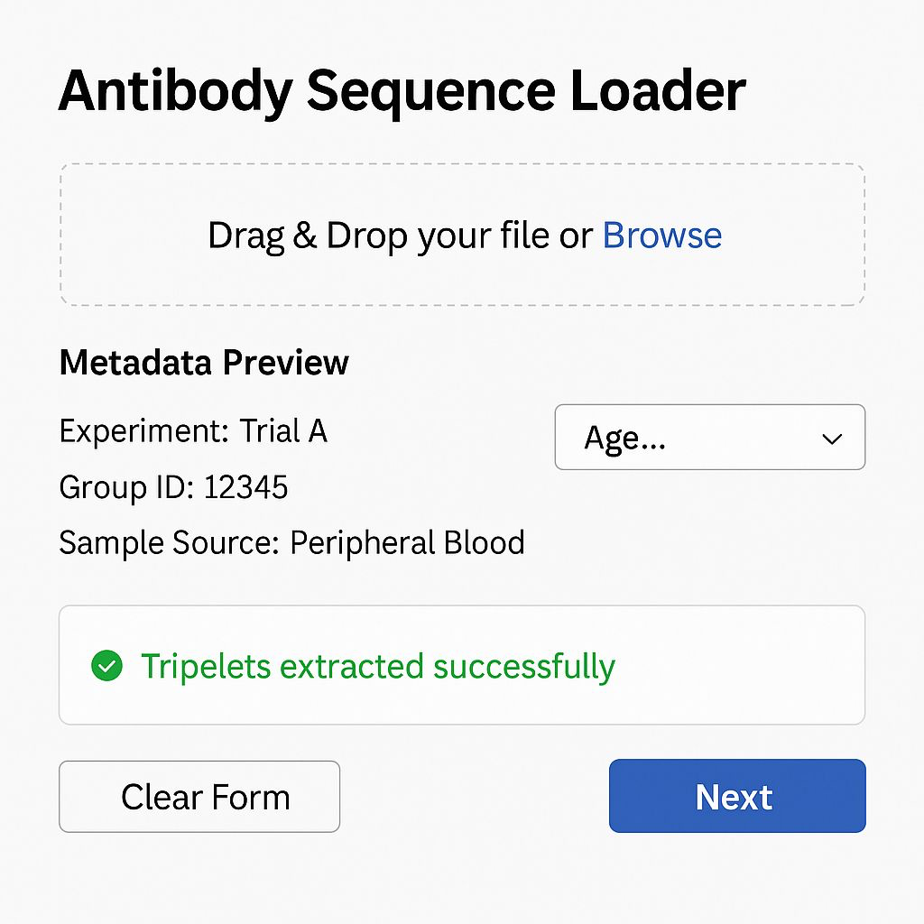
Antibody Sequence Loader
This interface enables users to upload antibody sequence files and preview essential metadata such as experiment name, group ID, and sample source. Users can classify the dataset using a dropdown menu and receive real-time confirmation of successful triplet extraction. Navigation options include clearing the form or proceeding to the next analysis step.
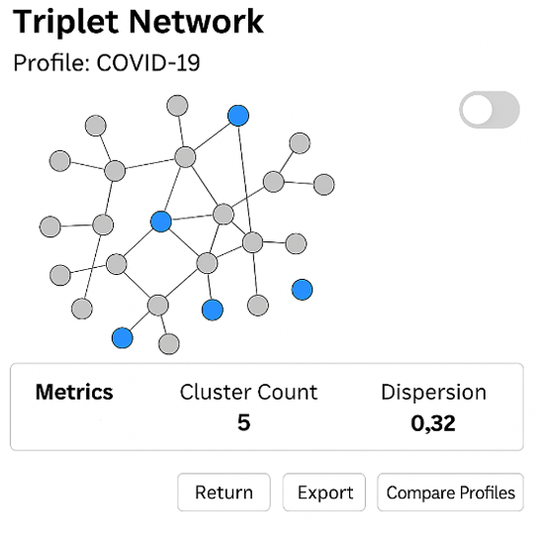

Triplet Similarity Network
This screen presents a graphical representation of the relationships between amino acid triplets extracted from antibody sequences. The user selects predefined similarity rules such as co-occurrence, one-residue difference, or known substitutions to construct a network. Each node represents a unique triplet, and edges indicate similarity based on the selected criteria.
The resulting network is summarized by two key metrics:
- Cluster Count – the number of densely connected triplet groups.
- Dispersion – the spread of connectivity across the network.
“Off” indicates that we are currently viewing the graph representing amino acids.
“On” indicates that we are viewing the nucleotide graph instead
Users can generate graphs, compare profiles, export results, or return to previous steps to refine input.

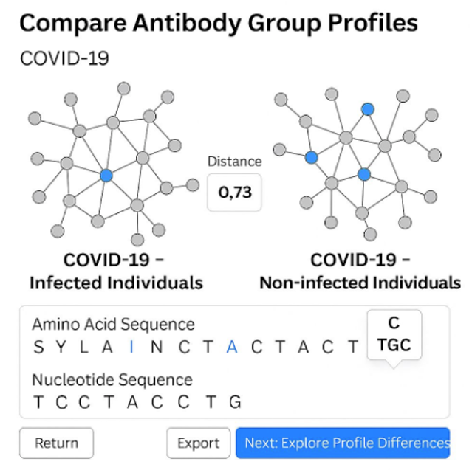Compare Antibody Group Profiles
This screen enables visual comparison between two antibody similarity networks derived from distinct groups-in this case, individuals infected with COVID-19 versus those who remained uninfected. Each graph represents the structural connectivity of amino acid triplets within a group. The Distance Score quantifies the overall difference between the two profiles.
Below the graphs, aligned amino acid and nucleotide sequences allow for interactive inspection. Clicking on an amino acid reveals the corresponding codon, providing a molecular-level link between protein structure and genetic origin.
Navigation options include returning to the previous step, exporting the current view, or proceeding to explore detailed differences between the profiles.

4.2.2 Activity Diagram
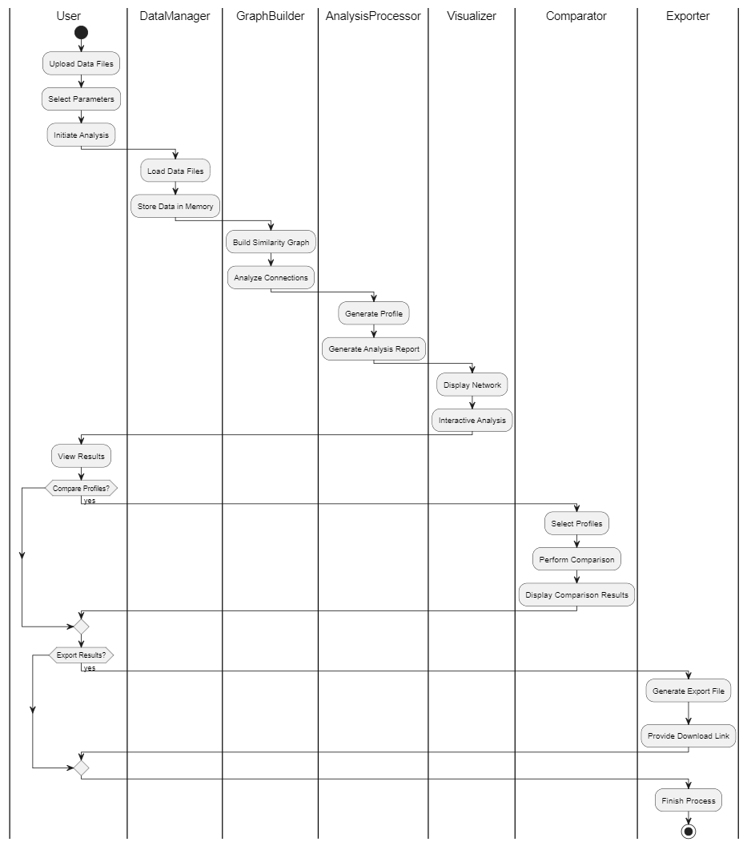
Activity Diagram Explanation – Antibody Population Analysis System
The activity diagram illustrates the workflow of the Antibody Population Analysis System, highlighting the interactions between the User, DataManager, GraphBuilder, AnalysisProcessor, Visualizer, Comparator, and Exporter within the system.
Key Elements and Flow:
Start Point:
The process begins when the user interacts with the application by uploading data files, selecting analysis parameters, and initiating the analysis process.
Data Management:
The user uploads data files containing biological information, which are processed and loaded into the system through the DataManager. The data is stored in memory for fast and efficient access during analysis.
The data files represent biological sequences that will be analyzed, DataManager handles loading and structuring the data for the next stages.
Graph Construction:
The GraphBuilder constructs a Similarity Graph that represents the relationships between amino acid triplets found in the sequences.
Nodes represent unique triplets of amino acids.
Edges represent the similarity or frequency of appearance in the sequences.
Connections are analyzed to understand structural and biological significance.
Profile Generation and Analysis:
The AnalysisProcessor generates structured profiles based on the similarity graph.
- These profiles contain statistical summaries and connectivity insights.
- An analysis report is created, capturing key findings from the data.
Visualization and User Interaction:
The analysis results are displayed to the user through the Visualizer.
- An interactive graph is presented, allowing exploration of nodes and connections.
- The user can click on elements to view deeper insights and relationships.
Task Execution:
After viewing the results, the user can choose to compare profiles or export results.
- If the user opts to compare profiles, the Comparator is activated.
- Selected profiles are analyzed side by side, and the differences are displayed visually.
Decision Points:
Compare Profiles?
If yes, the user selects profiles for comparison, the Comparator will compute similarities and differences and displays the results.
Export Results?
If yes, the Exporter module generates an export file containing the analysis results, then a download link is provided for the user to save the file locally.
Components and Their Responsibilities:
- User: Initiates the analysis, views results, compares profiles, and triggers export.
- DataManager: Loads and stores biological data in memory.
- GraphBuilder: Constructs the similarity graph for analysis.
- AnalysisProcessor: Generates profiles and analysis reports.
- Visualizer: Displays interactive visual representations of the results.
- Comparator: Compares multiple profiles side by side.
- Exporter: Generates downloadable files for external use.
End Points:
The process ends when the user finishes analyzing, comparing, or exporting the results. All data is properly managed, and the system is ready for the next analysis cycle.

4.2.3 Project Class & Data:
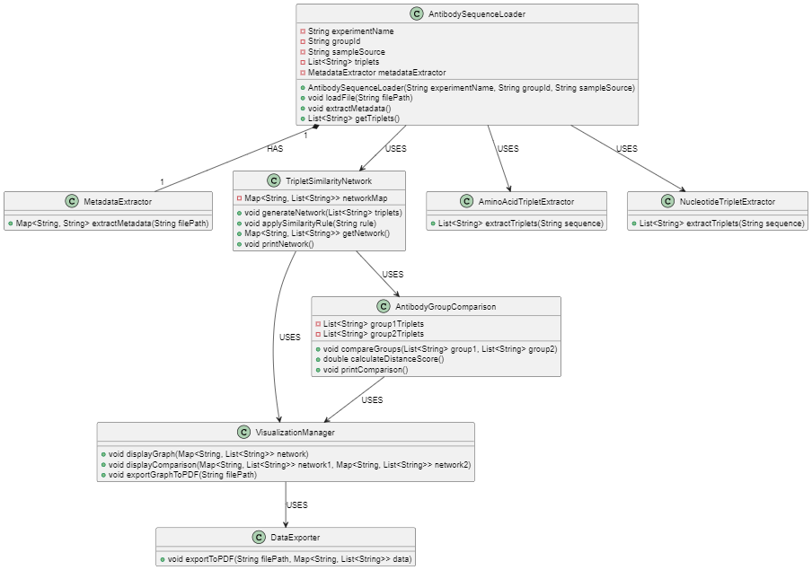

5. Verification plan:
# | Description | Test Steps | Expected Result
1 | Load Antibody Sequence File with disconnected status | Click "Fetch" and status is "Disconnected" | "Fetch" button is disabled, or an alert appears indicating that a connection to the database is required.
2 | Connect to the server | Click "Connect" and wait for the connection to succeed | Status changes to "Connected", and the list of databases loads successfully.
3 | Disconnect from the server | Click "Disconnect" | Status changes back to "Disconnected".
4 | Fetch metadata without database or sequence type selected | Click "Fetch" and Wait for the response | "Fetch" button is disabled or an alert appears indicating that at least one database and sequence type must be selected.
5 | Attach sequence file without uploading any file | Click "Attach" | "Attach" button is disabled or an alert appears indicating that the file must be uploaded.
6 | Advance to the next step after fetching | Click "Connect" and Click "Fetch" or "Attach" and click "Next" | The next window opens successfully.
7 | Convert extracted triplets | Click "Convert Sequences" | "Export Triplet Network" button is enabled, and a success message appears.
8 | Visualize triplet network | Click "Visualize" | The visualization window appears with the network graph.
9 | Compare two antibody group profiles | Click "Compare Profiles" | The comparison screen displays two networks side by side with the calculated distance.
10 | Export triplet network successfully | Click "Export to PDF" | The PDF file is saved with all the triplet data and relationships.
11 | Triplet Extraction on Large Data Set | Upload a .csv file with 1 million triplets and click "Extract Triplets" | The system successfully extracts all triplets without crashing and completes within a reasonable time.
12 | Switching from Amino Acid View to Nucleotide | Generate a network with triplets and click "Off" (switch to nucleotide view) | The graph updates smoothly to show nucleotide relationships instead of amino acids.
13 | Applying Multiple Rules Simultaneously | Generate the network and apply "Co-occurrence" and "One-residue Difference" simultaneously | The system handles both rules correctly, adding the right connections without performance loss.
14 | Comparing Two Complex Networks | Generate two separate networks with 500,000 triplets each and click "Compare Profiles" | The comparison completes successfully, and the Distance Score is calculated and displayed.
15 | Network Visualization with Overlapping Clusters | Generate a network with overlapping clusters and click "Visualize" | The visualization displays overlapping clusters with clear distinction and no overlap in rendering.
16 | Distance Calculation with Empty Networks | Attempt to compare two networks when both are empty | The system displays an error indicating that the comparison cannot be performed on empty networks.
17 | PDF Export Without Data | Click "Export to PDF" when no triplet data exists | The system displays a warning indicating that there is no data to export.
18 | Incomplete Metadata Information | Upload a valid .csv file without metadata fields like Experiment Name or Group ID | The system displays an error indicating that mandatory metadata is missing.
19 | Load Unsupported File Format | Upload a non-supported file format like .pdf or .docx | The system displays an error message and prevents processing of the file.

6. References
[1] Chaplin, D. D. (2010). Overview of the immune response. Journal of Allergy and Clinical Immunology, 125(2).
[2] Encyclopaedia Britannica. "Genetic Code," Encyclopaedia Britannica.
[3] Frappier, V., Lagarde, N., Lamoureux, P., & Najmanovich, R. (2023). New alignment method for remote protein sequences by the direct use of pairwise sequence correlations and substitutions.
[4] Frenkel, Z. M., Frenkel, Z. M., Trifonov, E. N., & Snir, S.. Structural relatedness via flow networks in protein sequence space.
[5] Frenkel, Z. M., & Trifonov, E. N.. Walking Through the Protein Sequence Space: Towards New Generation of the Homology Modeling.
[6] Greiff, V., Miho, E., Menzel, U., & Reddy, S. T. (2020). Mining adaptive immune receptor repertoires for biological and clinical information. Current Opinion in Systems Biology, 24, 109–119.
[7] Janeway, C. A., Travers, P., Walport, M., & Shlomchik, M. J. Janeway's Immunobiology (9th Edition), Garland Science.
[8] Kovaltsuk, A., et al. (2018). Structural diversity of B-cell receptor repertoires. Frontiers in Immunology, 9, 2278.
[9] Lemaitre, C., et al. (2022). Flexible protein database based on amino acid k-mers. Nucleic Acids Research, 50(12), e69.
[10] McHeyzer-Williams, M. G., & McHeyzer-Williams, L. J. (2005). Antigen-specific memory B cell development. Nature Reviews Immunology, 5(4), 331–342.
[11] National Human Genome Research Institute. "Genetic Code," Genetics Glossary.
[12] Pal, R., Mukherjee, S., & Saha, S. (2023). Use of 2D FFT and DTW in Protein Sequence Comparison. Journal of Computational Biology.
[13] Roitt, I., & Delves, P. Roitt's Essential Immunology (13th Edition), Wiley.
[14] Schatz, D. G., & Ji, Y. (2011). Recombination centres and the orchestration of V(D)J recombination. Nature Reviews Immunology, 11(4), 251–263.
[15] Schwartz, G. W., Shauli, T., Linial, M., & Hershberg, U. (2019). Serine Substitutions are Linked to Codon Usage and Differ for Variable and Conserved Protein Regions. Scientific Reports, 9, 17238.
[16] Sircar, A., Kim, E. T., & Gray, J. J. (2007). CDRs in Antibody Structures. Nature Reviews Immunology.
[17] Zhang, Z., et al. (2022). An accurate alignment-free protein sequence comparator based on amino acid k-mer frequency. Scientific Reports, 12, 15266.

