Core Unit 3.1 Packet 2: Global trends in consumption
Syllabus: ‘Measuring Trends in resource consumption: individual, national, and global ecological footprints’

What is resource consumption and how is it measured?

It generally refers to the use of non- renewable resources such as fossil fuels (coal, oil and gas) and minerals, which are finite and take millions of years to form, so once they are used they are gone (at current rates only about 139 years of coal, 54 of oil and 49 of gas are left).
It may also include renewable resources such as water, soil and biomass, which can be replaced naturally, but only if we use them no faster than they regenerate.

The rate of consumption of resources can have implications for future generations.
Most water supplies and biomass that produces food are renewable-if managed properly. Ex: hunting and fishing quotas need to be used to keep certain populations in balance. (Boar population in Belgium- extension of the hunting season)

Mismanagement example: cod Industry in Newfoundland, Canada
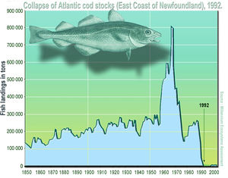

Other examples of mismanagement of resources: Water resources like aquifers and inland lakes can be mismanaged.
Example: Aral Sea

What do we mean by ecological footprint? (One measure of consumption)
A crude measurement of the area of land and water required to provide a society, group or individual with all their resource needs and to assimilate (absorb) all of their waste. It is measured in global hectares (gha; 1 gha = 10,000 m², about 2.5 acres) and tracks the use of cropland, grazing land, fishing grounds, built-up land, forest areas and carbon (the forest needed to absorb CO₂ emissions).
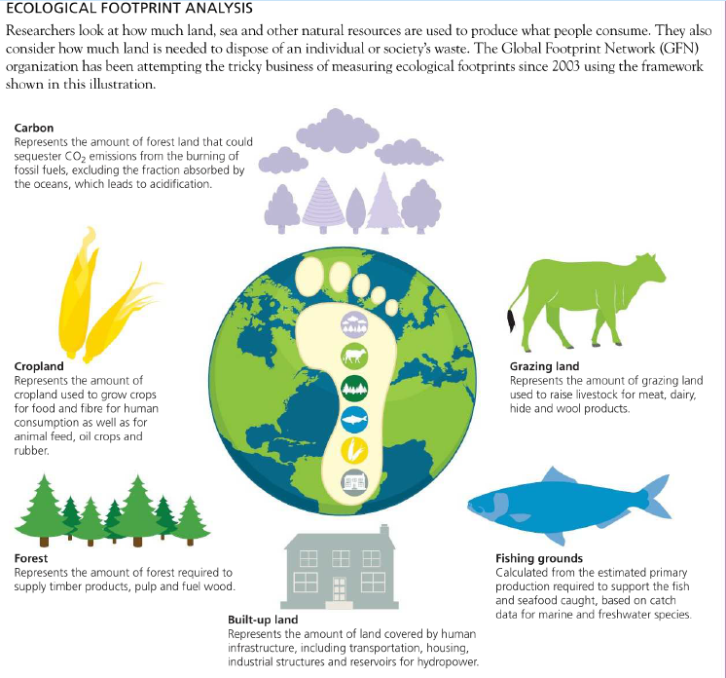
What about biocapacity?
A city or state’s national biocapacity is the ability of ecosystems to provide natural resources and absorb the waste produced by humans. (especially if left unharvested).

The Ecological footprint can be measured at the individual, national, and global scale.

Individual scale : What is your ecological footprint…? www.footprintcalculator.org.
How many planets do we need if everybody lives like you? About 3.3 planets
When is your personal Overshoot Day? About 21 April (day 111 of the year)
Comments on your personal consumption below. Think about areas (categories) where you could make changes and other areas where you are dependent on the decisions of your parents. My footprint is well above 1 planet, so if everyone lived like me we would be in overshoot, and I am also above the global average of about 1.7 planets (2.6 gha per person). Most of it is probably carbon: heating our home, transport and flights, and the food we eat (meat and dairy). Things I can change myself: eat less red meat, take shorter showers, switch off devices, buy fewer new clothes and gadgets (or second-hand), and walk, cycle or use public transport instead of being driven. Things that depend on my parents: how our house is heated and insulated, whether our electricity is renewable, whether we own a car and how much it is used, how often we fly on holiday, and what food is bought and cooked at home. I can still influence these decisions by suggesting changes and asking questions.
STOP HERE
National scale: Investigate three contrasting countries. https://data.footprintnetwork.org/?_ga=2.193038057.55054856.1641805699-870652287.1641490634#/
Country | Ecological footprint | Reasons for this footprint

Exam-style questions-
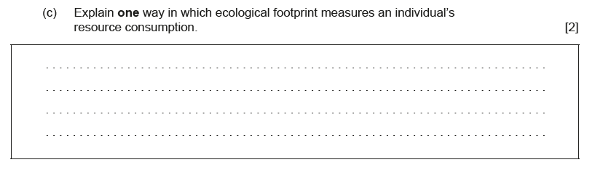
Take the The Overshoot quiz!

Note at least one thing you learned from taking this quiz:

