Core Unit 3.1 Packet 2: Global trends in consumption
Syllabus: ‘Measuring Trends in resource consumption: individual, national, and global ecological footprints’

What is resource consumption and how is it measured?

It generally refers to the use of non- renewable resources e.g. fossil fuels (coal, oil, gas) + minerals; finite, take millions of years to form; reserves left (2020): coal 139 yrs, oil 54, gas 49.
It may also include renewable resources such as water, soil and biomass, replaced naturally, IF used no faster than they regenerate.

The rate of consumption of resources can have implications for future generations.
Most water supplies and biomass that produces food are renewable-if managed properly. Ex: hunting and fishing quotas need to be used to keep certain populations in balance. (Boar population in Belgium- extension of the hunting season)

Mismanagement example: cod Industry in Newfoundland, Canada
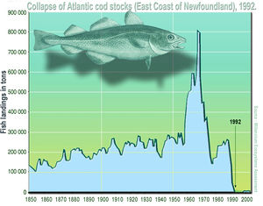

Other examples of mismanagement of resources: Water resources like aquifers and inland lakes can be mismanaged.
Example: Aral Sea

What do we mean by ecological footprint? (One measure of consumption)
Crude measurement of the area of land and water required to provide a society, group or individual with all their resource needs and to assimilate (absorb) all of their waste. Measured in global hectares (gha): 1 gha = 10,000 m² (2.5 acres). Tracks use of: cropland, grazing land, fishing grounds, built-up land, forest areas, carbon (CO₂ absorption).
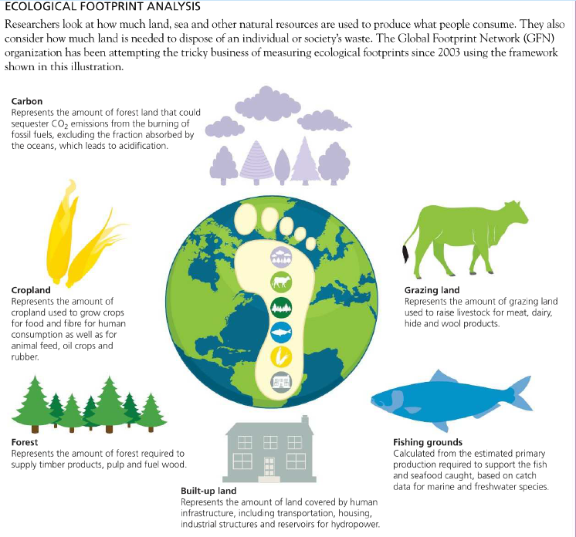
What about biocapacity?
A city or state’s national biocapacity is the ability of ecosystems to provide natural resources and absorb the waste produced by humans. (especially if left unharvested).

The Ecological footprint can be measured at the individual, national, and global scale.

Individual scale : What is your ecological footprint…? www.footprintcalculator.org.
How many planets do we need if everybody lives like you? ~3.3 planets
When is your personal Overshoot Day? ~21 April (day 111)
Comments on your personal consumption below. Think about areas (categories) where you could make changes and other areas where you are dependent on the decisions of your parents.
Result: ~3.3 planets = overshoot (global avg ~1.7 planets, 2.6 gha/person)
Biggest part probably carbon: heating, transport/flights, meat + dairy
CAN CHANGE (me):
• less red meat
• shorter showers, switch off devices
• buy less new / second-hand clothes + gadgets
• walk, cycle, public transport
DEPENDS ON PARENTS:
• home heating + insulation
• renewable electricity or not
• car ownership + use
• flights / holidays
• food bought + cooked at home
→ can still influence: ask, suggest
STOP HERE
National scale: Investigate three contrasting countries. https://data.footprintnetwork.org/?_ga=2.193038057.55054856.1641805699-870652287.1641490634#/
Country | Ecological footprint | Reasons for this footprint

Exam-style questions-
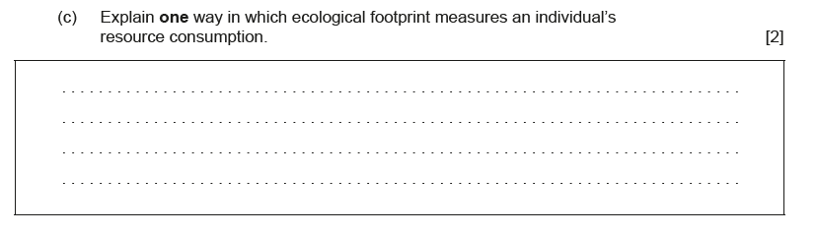
Take the The Overshoot quiz!

Note at least one thing you learned from taking this quiz:

