Smart Cricket Bat

Gavin Dahl, Jiakai Hu, Pablo Barron, Nolapat Pipitvitayakul

**Functional System Requirements**

REVISION – Draft

23 February 2022

Functional System Requirements

for

Smart Cricket Bat

Prepared by:

_____________________________

Author Date

Approved by:

_____________________________

Project Leader Date

_____________________________

John Lusher, P.E. Date

_____________________________

T/A Date

**Change Record**

| **Rev.** | **Date** | **Originator** | **Approvals** | **Description** |
| --- | --- | --- | --- | --- |
| **-** | 2/23/2022 | Gavin Dahl |  | Draft Release |
| 1 | 4/22/2022 | Gavin Dahl |  | Corrections |
| 2 | 11/18/2022 | Gavin Dahl |  | Second Revision |

**Table of Contents**

**List of Figures 4**

**1.** **Introduction 5**

1.1. Purpose and Scope 5

1.2. Responsibility and Change Authority 5

**2.** **Applicable and Reference Documents 6**

2.1. Applicable Documents 6

2.2. Reference Documents 6

2.3. Order of Precedence 7

**3.** **Requirements 8**

3.1. System Definition 8

3.2. Characteristics 9

3.2.1. Functional / Performance Requirements 9

3.2.2. Physical Characteristics 10

3.2.3. Electrical Characteristics 11

3.2.4. Environmental Requirements 13

3.2.5. Failure Propagation 14

**4.** **Support Requirements 15**

**Appendix A Acronyms and Abbreviations 16**

**List of Figures**

**Figure 1.** **The Smart Cricket Bat Conceptual Image** **5**

**Figure 2. Block Diagram of System 8**

# 

# Introduction

## Purpose and Scope

Our purpose is to help users improve their cricket skill through a training session using our system. The sensing unit will be attached to the end of the bat. This unit shall last for six hours of battery life after fully charged. The sensors will receive data and transfer them via bluetooth to an android phone app. The ML algorithm shall calculate the necessary data to the ones that need to be shown on the phone app like the hit location, swing angle and speed. The users shall be able to access these data through the phone app. The users will be able to know whether their hit was on the “sweet spot” or not as well as how efficient their swing was.

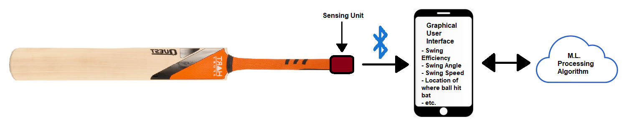

**Figure 1. The Smart Cricket Bat Conceptual Image**

## Responsibility and Change Authority

[Gavin Dahl](mailto:gavin.dahl@tamu.edu) has the responsibilities of making sure the team is sticking to the execution plan, completing milestones, and producing deliverables. He is also responsible for making the team confined to deadlines. The team's sponsor, Pranav Dhulipala, is the only one with the authority to make changes to our end goal requirements. If there is an unforeseen element that causes us to be unable to meet a requirement, Gavin and Pranav will discuss what will need to be done to change the requirement.

# Applicable and Reference Documents

## Applicable Documents

The following documents, of the exact issue and revision shown, form a part of this specification to the extent specified herein:

| **Document Number** | **Revision/Release Date** | **Document Title** |
| --- | --- | --- |
| IEEE 1780-2022 | 2022-02-09 | Standard for the Specification of Inertial Measurement Units |
| 10.1109/ICIAFS.2008.4783997 | 2009-02-13 | Design and Implementation of a Bluetooth based General Purpose Controlling Module |
| IEEE 802.15.1 | 2005-02-14 | Standard for Telecommunications and Information Exchange Between Systems |
| IEEE 802.15.4 | 2020-05-06 | Standard for Low-Rate Wireless Networks |

## Reference Documents

The following documents are reference documents utilized in the development of this specification. These documents do not form a part of this specification and are not controlled by their reference herein.

| **Link** | | **Document Title** |
| --- | --- | --- |
| <https://www.cricketequipmentusa.com/cricket-bats-specifications-recent-changes-to-the-law-52#:~:text=Length%20and%20width%20of%20the,than%2052%25%20of%20the%20bat> | | CRICKET BATS SPECIFICATIONS - RECENT CHANGES TO THE LAW |
| https://www.stancebeam.com/ | | Stance Beam |

## Order of Precedence

In the event of a conflict between the text of this specification and an applicable document cited herein, the text of this specification takes precedence without any exceptions.

All specifications, standards, exhibits, drawings or other documents that are invoked as “applicable” in this specification are incorporated as cited. All documents that are referred to within an applicable report are considered to be for guidance and information only, except ICDs that have their relevant documents considered to be incorporated as cited.

# Requirements

## System Definition

In cricket, ball placement on the bat is very crucial to maximize the points you receive. To better improve a player's ball placement, we will design a device that can be attached to any cricket bat and predict the location of the collision between the bat and the ball. Our device will be powered by a rechargeable lithium battery with a battery life of six hours. Data will then be gathered via a 3-axis accelerometer and gyroscope. A MCU will then send the data via bluetooth to an Android app to send to a server-based machine learning algorithm to predict the location of the collision. All results will then be displayed on the app.

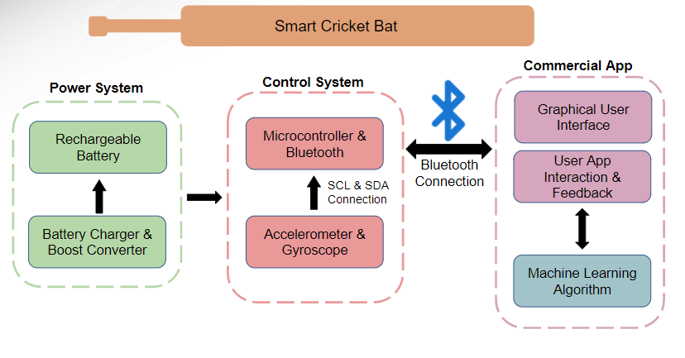

**Figure 2. Block Diagram of System**

The block diagram above shows the individual subsystems of our device. The subsystems include: Power System, Control System, and Commercial App. Our device will be powered by a lithium battery connected to a boost converter to deliver the necessary power requirement for the control system. We will design a separate docking station connected to the wall to recharge the battery. The control system encompasses a 3-axis accelerometer, a 3-axis gyroscope and a ATmega328p microprocessor. The angular momentum and rate of change data we measured with the gyroscope and accelerometer will then connect and be sent via bluetooth to the commercial app. The commercial app will then send the data to a machine learning algorithm via an internet connection to calculate collision location and efficiency. The results of our device will then be displayed on the easy to use app. Each output variable will have its own designated page to be viewed.

## Characteristics

### Functional / Performance Requirements

#### Calibration

Our device must be able to be calibrated to properly calculate results. The process of calibration will entail leaving the device at rest in an upright position, and pushing the calibration button on the corresponding mobile app.

*Rationale: The IMU sensor used in the device needs to be calibrated after start-up to deliver accurate and clean data to the machine learning algorithm. Calibrating our device before usage will result in a higher certainty percentage.*

* + - 1. **Collision Location Determination**

The main function of our device will be able to determine the location of the collision between the cricket bat and the ball based on the magnitude of the force felt by the bat and the torque produced by the ball on the bat, which is obtained from the data measured by the IMU sensor. The certainty must be at least 90%. This will require a machine learning (ML) algorithm.

*Rationale: Cricket players will use our device to improve their swing efficiency. The location of the collision will dictate how far and in which direction the ball will go. Depending on where the ball lands on the field is how many turns (points) a player can achieve. Therefore, knowing where the ball collides with the bat is crucial for the player to know.*

#### Efficiency Calculation

Our device will be able to calculate how efficient the user is swinging the bat based on gathered data from previous swings. Efficiency is determined by how close the collision was to the “sweet spot” of the bat. The sweet spot of a cricket bat is located on the thickest section of the bat and is different for each cricket bat.

*Rationale: Based on the efficiency the user will be able to tell how far off from the sweet spot their swing is.*

#### Bluetooth Range

Our device will be able to communicate with the app within a range of 50m.

*Rationale: The user should be able to do their practice swings with their phone clear from any danger of being hit while in the batting box.*

* + - 1. **Easy to Use App/GUI**

Our app will be easy navigable and easy to read the outputs

*Rationale: The user might not have programming or data analysis skills so having an app that anyone can use and read is crucial for our device to be successful in the cricket market.*

* + - 1. **Battery Life**

Our device will be powered by a lithium battery that must have a battery life of 2 hours and must be rechargeable.

*Rationale: Battery life and rechargeability were requirements set by the customer.*

### Physical Characteristics

#### Mass

The mass of the sensing unit that mounts to the handle of the cricket bat should be no more than 100g.

*Rationale: This is a requirement specified by our sponsor due to wanting our device to be as unobtrusive to the users swing as possible.*

#### Volume Envelope

The volume envelope of the smart cricket bat’s sensor unit shall be less than or equal to 40mm in height, 70mm in outer diameter.

*Rationale: This is a requirement specified by our sponsor due to wanting our device to be as unobtrusive to the users swing as possible.*

#### Mounting

The mounting device will attach to the bottom of the cricket bat’s handle and will have a locking mechanism with the sensor unit to give it a secure fit.

*Rationale: The vibrations that occur from the impact of a swing can be quite intense. The requirement is to have the device stay on the bat at all times during the user's use, through any kind of outside interference.*

### Electrical Characteristics

#### Inputs

1. The presence or absence of any combination of the input signals in accordance with ICD specifications applied in any sequence shall not damage the smart cricket bat, reduce its life expectancy, or cause any malfunction, either when the unit is powered or when it is not.
2. No sequence of command shall damage the smart cricket bat, reduce its life expectancy, or cause any malfunction.

*Rationale: By design, should limit the chance of damage or malfunction by user/technician error.*

##### Power Consumption

The maximum peak power of the system shall not exceed 300 mW.

*Rationale: This requirement is to ensure that enough power is being supplied to each of the components for at least 2 hours when the battery is fully charged.*

##### Input Voltage Level

The input voltage level for the MCU and the IMU shall be +5 V.

*Rationale: The microcontroller’s operating voltage is 5V and the IMU input voltage can be between 3.3V to 5V.*

##### External Commands

The smart cricket bat shall document all external commands in the appropriate ICD.

*Rationale: The ICD will capture all interface details from the low level electrical to the high-level packet format.*

#### Outputs

##### Data Output via App

Our app will be able to output data gathered from the accelerometer and gyroscope and the calculated results from the ML algorithm. The outputs will include: swing speed, swing angle, collision location, and efficiency. Each output will have its own page the user can navigate to via buttons on the home screen.

*Rationale: By having an app that can constantly be gathering and outputting data in an easy to read manner, it eliminates the need for the user to have tech. and data analysis skills. Without the app, users will have to download the data onto their computer to view their results.*

#### Connectors

The smart cricket bat will use a microUSB to charge the sensor unit, and will also be able to get the sensor data via a microUSB in the case of bluetooth not working.

*Rationale: Most efficient way to make the device is to make it rechargeable, so that it can be as small and light as possible.*

#### Wiring

The smart cricket bat will use a PCB to connect all the internal components (MCU, IMU, Li-Po Battery, Boost Convertor/Charger) of the sensor unit.

*Rationale: Normal wiring will most likely not be secure or robust enough for the amount of shock that the device will encounter.*

### Environmental Requirements

Our device will be adequate for indoor and outdoor use.

*Rationale: Although our device will not be used during a cricket match, a user might be holding their practice session indoors or outdoors.*

#### Pressure (Altitude)

Our device will be designed to operate in 1 atm pressure.

#### Temperature

Our device will be able to operate between temperature ranges of 0**°**C to 85**°**C.

*Rationale: Since our device can be used outdoors, temperatures during the summer in Texas are between 97℉* - *105℉*.

#### External Contamination

Our device will be housed in a casing to protect the components from any dirt or foreign objects.

*Rationale: Since our device can be used outdoors, it must be protected from any materials that can cause damage to the components.*

#### Rain

Our device will not be able to be used during the rain, but it should be waterproof enough to protect the components from the sweat of the user. The device will operate as intended within the humidity range of 0 to 80%, and should have the possibility of correct operation through 90 to 100%.

### Failure Propagation

The smart cricket bat shall not allow propagation of faults beyond the app's interface.

#### Failure Detection, Isolation, and Recovery (FDIR)

##### Communication Test

The Smart Cricket Bat System shall provide users a notification if the user is using the system out of range or the internet/bluetooth connection is unstable at this moment.

###### BIT Critical Fault Detection

The BIT shall be able to detect a critical fault in the smart cricket bat’s sensing unit, machine learning algorithm, or consumer app, 95 percent of the time.

*Rationale: This is to provide the best user experience we can, letting the user know that we know there is an error and the system is working to fix it.*

###### BIT False Alarms

The BIT shall have a false alarm rate of less than 5 percent.

*Rationale: Due to some of the possible erroneous uses of the cricket bat, it might interpret an action of the user as an error, when in reality it is not.*

###### BIT Log

The BIT shall save the results of each test to a log that shall be stored in the machine learning system for retrieval and will be used to improve common errors and overall quality of life of the user experience.

*Rationale: Our device is very user focused, so providing the best user experience is of high priority.*

##### Isolation and Recovery

The smart cricket bat should provide for fault isolation and recovery by enabling subsystems to be disabled based upon the result of the BIT.

*Rationale: If there are any errors, we want to turn the device off and let the user know to stop using it so they aren’t wasting energy on swings that will not be analyzed.*

# Support Requirements

The user will be provided with a user’s manual to know how to properly use the device. The user’s manual will encompass how to calibrate the device to be used in different sized cricket bats, the different functions of the app, ie. efficiency and swing speed, and how to charge the device. If any problems occur with the device, the user can send the device back to be fixed.

# Appendix A: Acronyms and Abbreviations

m Meter

mm Millimeter

mA Milliamp

mAh Milliamp-hour

mW Milliwatt

V Volt

MCU Microcontroller

IMU Inertial Measurement Unit (Accelerometer & Gyroscope)

PCB Printed Circuit Board

LiPo Lithium Polymer Battery

BLE Bluetooth Low Energy

GUI Graphical User Interface

BIT Built-in-test