Smart Cricket Bat

Gavin Dahl, Jiakai Hu, Pablo Barron, Nolapat Pipitvitayakul

**Interface Control Document**

REVISION – Draft

23 February 2022

Interface Control Document

for

Smart Cricket Bat

Prepared by:

_____________________________

Author Date

Approved by:

_____________________________

Project Leader Date

_____________________________

John Lusher II, P.E. Date

_____________________________

T/A Date

**Change Record**

| **Rev.** | **Date** | **Originator** | **Approvals** | **Description** |
| --- | --- | --- | --- | --- |
| - | 2/23/2022 | Gavin Dahl |  | Draft Release |
| 1 | 11/18/2022 | Gavin Dahl |  | First Revision |

**Table of Contents**

**List of Figures 4**

**1.** **Overview 4**

**2.** **References and Definitions** 5

2.1. References 5

2.2. Definitions 5

**3.** **Physical Interface 6**

3.1. Weight 6

3.2. Dimensions 6

3.2.1. Dimensions of Power System 6

3.2.2. Dimensions of Control System 6

3.3. Mounting Locations6

**4.** **Thermal Interface** **7**

**5.** **Electrical Interface 8**

5.1. Primary Input Power 8

5.2. Signal Interfaces 8

5.3. User Control Interface 8

**6. Communications / Device Interface Protocols 9**

6.1. Wireless Communications (Bluetooth & Internet ) 9

6.2. G.U.I. 9

6.3 Device Peripheral Interface 9

**List of Figures**

Figure 1: Mounting Locations on Bat 7

# Overview

In this ICD, the details for physical dimensions and weight will be provided in section 3. The sensing unit will be attached to the end of the bat, the details for attaching will also be provided. This unit does not have a cooling system. Temperature limits will be shown in section 4. This unit shall last for two hours of battery life after fully charged. The electrical details and thresholds for sensors and the whole system are listed in section 5. The details for communication between systems and the user control interface are provided in the last section.

# References and Definitions

## References

* Reference Device:
  + <https://www.stancebeam.com/>
* Standard for the Specification of IMU’s:
  + <https://standards.ieee.org/ieee/1780/5700/>
* Cricket Bat Standard:
  + <https://www.cricketequipmentusa.com/cricket-bats-specifications-recent-changes-to-the-law-52#:~:text=Length%20and%20width%20of%20the,than%2052%25%20of%20the%20bat>.

## Definitions

m Meter

mm Millimeter

mA Milliamp

mAh Milliamp-hour

mW Milliwatt

V Volt

MCU Microcontroller

IMU Inertial Measurement Unit (Accelerometer & Gyroscope)

LiPo Lithium Polymer Battery

BLE Bluetooth Low Energy

SCL Serial Clock Line

SDA Serial Data Line

# Physical Interface

## Weight

The goal is to keep the weight as low as possible, to not interfere with the players swing. The exact weight of the housing unit that will hold the components is still unknown, but ideally will be around 50 grams. The internal components of the device approximately add up to 40 grams. Weighing the device as a whole, including both the housing unit and the device internals, it will be less than 100 grams.

## Dimensions

The mounting device's interior restriction is limited by the internal components of the device, which will be around 30mm x 35mm x 30mm. The exact dimensions of the housing unit for the device is still unknown, but basing them off the known restrictions for internals of the device, it should be approximately 35mm x 40mm x 35mm, with the goal being to make it a cylindrical mounting device that will have a diameter of about 60mm and height of 35mm.

### Dimension of the power system

The power system itself, being composed of 1 Li-Po battery and 1 boost converter/recharging station, makes up approximately 33mm x 20mm x 14mm

### Dimension of the control system

The control system is made up of 1 Beetle BLE MCU and 1 6-axis IMU sensor (containing a 3-axis gyroscope and a 3-axis accelerometer), totaling up to approximately 30mm x 35mm x 8mm.

## Mounting Locations

The mounting location will be at the end of the cricket bat’s handle. It will use a kind of sleeve that is put over a little more handle and will securely lock together with the housing device for the control and power systems. If there are any complications with trying to mount the device in this location, the back up spot for mounting will be on the back of the bat at the other end of the handle.

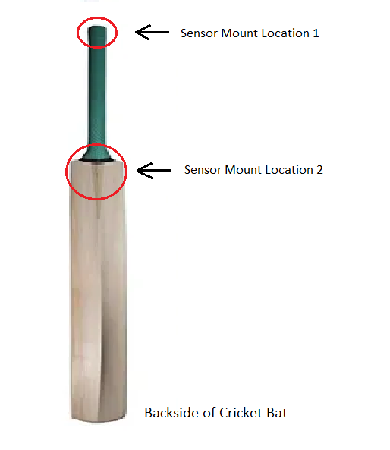

**Figure 1: Mounting Locations on Bat**

# Thermal Interface

Since our device will be small enough to be attached to the bottom of a cricket bat, there will not be a need for fans or heat sinks for cooling. The only thermal interface our device will require is having vents or perforations on the main housing of the MCU and IMU’s to allow airflow, as the MCU is the limiting factor and cannot run properly over 85°C (185°F). This will prevent overheating in case the user is using our device outdoors on a summer’s day.

# Electrical Interface

## Primary Input Power

Power will be supplied by a rechargeable 3.7V lithium ion polymer battery with 150 mAh capacity. The voltage will be regulated and the boost converter will convert the voltage to 5V, which is within the acceptable range of input voltage levels for the MCU and the sensors.

## Signal Interfaces

The signal interfaces are the input to the MCU from the IMU sensor containing a 3-axis gyroscope and a 3-axis accelerometer. The IMU sensor module uses SCL/SDA for communicating with the microcontroller.

## User Control Interface

The interface with the user will be an android app which will display the data collected by the IMU sensor as well as the data for the location of collision with the ball and the efficiency of the user’s swing predicted by a machine learning algorithm.

# Communications / Device Interface Protocols

## Wireless Communications (Bluetooth & Internet )

Our device will communicate with our app via bluetooth, which will have a connectivity range of about 50m. The app itself will also connect to our machine learning algorithm, that's stored in the cloud, via an internet connection.

## GUI

All user interactions with our device will be controlled by an android app. These interactions will include calibration of our device and data output. The user will be able to navigate through different pages of the app via designated buttons on the home screen. A screen show of the buttons on the dashboard is shown below.

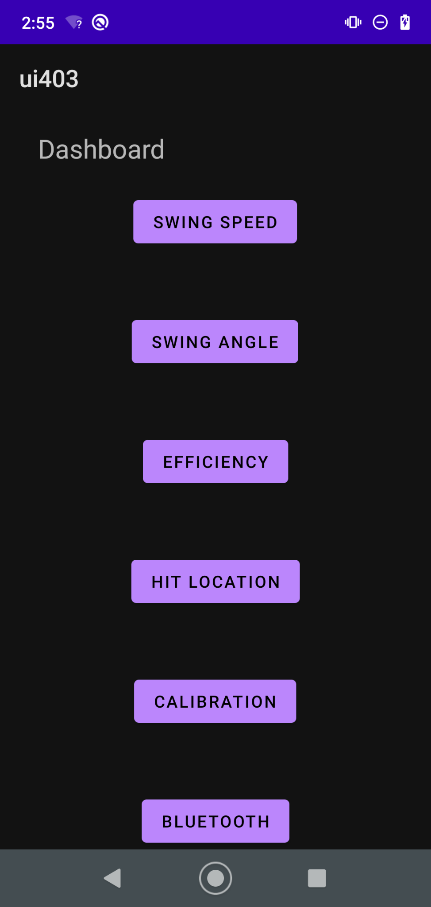

## Device Peripheral Interface

The MCU and IMU will communicate with each other via a SCL and SDA connection. This connection allows the SCL to be the synchronized clock signal between the MCU and IMU for data transfer over the IC2 bus, and SDA is the data line that holds the actual data.