Smart Cricket Bat

Gavin Dahl, Jiakai Hu, Pablo Barron, Nolapat Pipitvitayakul

**Concept of Operations**

REVISION – 1

23 February 2022

Concept of Operations

for

Smart Cricket Bat

Team <22>

Approved by:

_____________________________

Project Leader Date

_____________________________

Prof. Kalafatis Date

_____________________________

T/A Date

**Change Record**

| **Rev.** | **Date** | **Originator** | **Approvals** | **Description** |
| --- | --- | --- | --- | --- |
| - | 2/9/2022 | Pablo Barron |  | Draft Release |
| 1 | 2/23/2022 | Pablo Barron |  | First Revision |
| 2 | 11/17/2022 | Gavin Dahl |  | Second Revision |

**Table of Contents**

**Table of Contents** **3**

**List of Figures** **4**

**1.** **Executive Summary 6**

**2.** **Introduction 7**

2.1. Background 7

2.2. Overview 7

2.3. Referenced Documents and Standards 7

**3.** **Operating Concept 8**

3.1. Scope 8

3.2. Operational Description and Constraints 8

3.3. System Description 8

3.4. Modes of Operations 9

3.5. Users 9

3.6. Support 10

**4.** **Scenario(s) 11**

4.1. Indoor Cricket Batting Practice 11

4.2. Outdoor Cricket Batting Practice 11

**5.** **Analysis 11**

5.1. Summary of Proposed Improvements 11

5.2. Disadvantages and Limitations 11

5.3. Alternatives 11

5.4. Impact 12

**List of Figures**

# 

Fig. 1: Cricket Bat Region Subdivision Fig.2: StanceBeam Device

Charging Dock on the right. Main hardware

housing is in yellow. The mounting to attach to

the bat below the main hardware housing.

Figure above the main housing is to lock the

device in place

# 

Fig.3: Subsystem Block Diagram

# Executive Summary

While cricket has been around for much longer than its contemporary baseball, there is a stark difference in training equipment available for casual enjoyers, the smart cricket bat plans to fill that space. The smart cricket bat offers an easy at home alternative to coaching lessons in the form of an app and a device you put on your cricket bat of choice. The app will display measurements and calculations from the bat, such as the angle of the swing, the speed of the swing, the force the cricket ball exerts onto the bat, and the approximate position of where the ball hit the bat. The last of which is found via a machine learning algorithm that takes the other measurements and triangulates the impact location. This will help improve both accuracy and precision when swinging for the bats sweet spot.

# Introduction

Cricket is more of a niche sport than others, so it’s no surprise that the community overall is lacking in training and feedback equipment. Most of the training equipment they do have are primarily rudimentary items, such as ball rebounders, batting tees, etc. And recently, one start up, StanceBeam, that is trying to provide easier at home training is a little on the expensive side. The smart cricket bat will fill this gap by providing a device that will attach to the user’s cricket bat of choice and acquire various data points on each swing. This device will then connect to the player's phone via bluetooth, process the data acquired from the sensors on the bat, and give real time feedback to help the user.

## Background

In cricket, the goal is to score runs, this is accomplished through completing runs, hitting boundaries, losing wickets, and free runs. Half of these, completing runs and hitting boundaries, involve hitting the ball into a desired area of the field, to accomplish these feats easier the cricket bat is designed to have a “sweet spot” where the bat is thicker than everywhere else, thus having more force behind it. The goal is to have a consistent enough swing to hit the sweet spot as often as possible. StanceBeam is a start-up out of India that is trying to help the average player with this. Their product is a sensor that connects to an app and displays measurements from the bat such as swing angle, swing speed, power generated from swing, and overall swing efficiency. The app also has drills and real-time coaching from real coaches to help improve aspects of their play. In contrast, our app will display where the ball impacted the bat via a histogram, as well as displaying swing angle, swing speed, power generated from swing, and overall swing efficiency. So, while we can’t give drills or video analysis, we can help improve swing ball placement and overall consistency in hitting the sweet spot of the bat.

## Overview

The overall goal of the smart cricket bat is to deliver concise, analyzed data from the users swings to the app and give real-time feedback to the user to help improve their overall swing consistency and efficiency. This will be accomplished by a device that will mount to the end of the cricket bats handle and collect both speed and angle of the cricket bat during the user swing. It then sends that data to the smartphone app via bluetooth to process the data, through a machine learning algorithm, and output real time feedback to the user.

## Referenced Documents and Standards

* Reference Device:
  + <https://www.stancebeam.com/>
* Standard for the Specification of IMU’s:
  + <https://standards.ieee.org/ieee/1780/5700/>
* Cricket Bat Standard:
  + <https://www.cricketequipmentusa.com/cricket-bats-specifications-recent-changes-to-the-law-52#:~:text=Length%20and%20width%20of%20the,than%2052%25%20of%20the%20bat>.

# Operating Concept

## Scope

The main functionality of the smart cricket bat will be to calculate where on the bat the ball hits based on data gathered from a gyroscope and an accelerometer. Based on data collected from the gyroscope and accelerometer, the speed of the swing and angle of the swing will be calculated by an offline machine learning algorithm. The data gathered from the IMU sensors will be sent via bluetooth to an app. From the gathered data and ML algorithm results, the app will display to the user with a histogram of where on the bat the ball collided. From the data on the histogram, how efficient the user is hitting the ball will be calculated. The app will also show details of every swing ie. speed of the swing and swing angle.

## Operational Description and Constraints

Our device will be attached on the bottom of the handle of the bat. Once the device is attached, it will need to be calibrated to accurately measure collision location and efficiency. The calibration of the device will be the main constraint, since failure to properly calibrate the device will lead to false data being produced. The calibration step will be a simple button press while the bat is resting in an upright position. Once calibrated, the user will be able to practice for about six hours on full battery. During the user’s practice session or after the session, the user can check the app to view the data gathered for each swing. Once the battery is drained or the user’s practice session is finished, the user will need to recharge the device via a micro-USB cable. Another constraint for our device is size and weight. Our device must be small enough to attach to the bottom of the handle on the cricket bat and light enough to not affect the overall feel of the bat and performance of the user.

## System Description

* Power: The device will be powered by a lithium battery with a battery life of about six hours. The device will be rechargeable via a micro-USB cable.
* Sensors and Microcontroller: Our sensors(IMU) will encompass one 3-axis accelerometer and one 3-axis gyroscope. The device will gather the angular velocity and rate of change from the IMU and transfer data via bluetooth to be processed in a machine learning algorithm.
* App: The app will receive data from the MCU and send the data to an offline machine learning algorithm to calculate and predict the location of collision and the efficiency of the user’s swing. Once the region of collision and efficiency is determined, the app will display a histogram of the different collisions that occurred during the user’s training session. It will also display the swing speed, swing angle, and efficiency of the user.

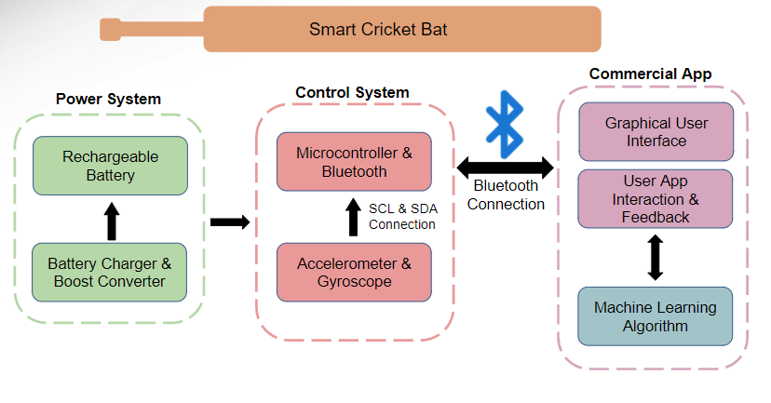

Fig. 2: Subsystem block diagram

## Modes of Operations

The device will have two modes of operation:

* Calibration Mode: Before the user can use the device, the device needs to be calibrated, doing so is as simple as pushing a button on the mobile application while the device is at rest in the upward position.
* Practice Mode: Once the device is calibrated, the user is now able to begin their training session. The device will have a six hour battery life. During the training session, the microprocessor will send data gathered from the IMU to the app to be sent to a server housing the machine learning algorithm to determine the location of collision and the efficiency of the user. The app will then display a histogram to show the collision location of each swing, the speed of the swing, swing angle, and user’s efficiency.

## Users

The main users will be cricket players trying to improve their swing. Their experience with cricket will range from grade-school level to professional players. The necessary skill level to operate our device is knowing how to use a phone app and read a histogram.

## Support

The user will be provided with a user’s manual to know how to properly use the device. The user’s manual will encompass how to calibrate the device to be used in different sized cricket bats, the different functions of the app, ie. efficiency and swing speed, and how to charge the device. If any problems occur with the device, the user can send the device back to be fixed.

# Scenario(s)

## Indoor Cricket Batting Practice

The first scenario for the smart cricket bat is the user uses the device to practice their swing in an indoor training environment. In this scenario, the only potential damage that the device will encounter is the energy transfer of the ball and the bat colliding and potential sweat from the user. Our device will have to be able to work efficiently under these conditions

## Outdoor Cricket Batting Practice

The second scenario is if the user wants to use the device to practice their swing in an outdoor training environment. In this scenario, many potential damages can occur. The device will need to not only withstand the conditions of the indoor scenario, but also take into account dirt, water, and extreme temperatures, for both cold and heat.

# Analysis

## Summary of Proposed Improvements

The device will offer a user-friendly app and system to allow them to increase the efficiency of their swing by seeing real time data and details on each swing. This device will be able to work on any size of cricket due to the required calibration mode prior to beginning a practice session.

## Disadvantages and Limitations

* There is a limitation to the size of the system because it should be small enough to fit on to the bottom of the cricket bat handle.
* Unable to record video for each swings and analyze the video
* The device cannot be too heavy to disrupt the feel of a natural cricket bat
* Every user hold the bat differently, which can cause inconsistencies in the data collection and calculations

## Alternatives

* The sensors could be attached to the back of the cricket bat instead of on the handle if size is an issue. Although we opposed from using this design due to a high risk of damaging our sensors due to the energy transfer from the collision of the ball and the cricket bat
* Additional sensors can be added to improve the accuracy of the results.

## Impact

* This project will help cricket players study and improve the user’s batting performance.
* If the device becomes as popular as cricket, it can cause an increase in the need for lithium batteries. This higher demand will then cause the mining of lithium and other raw metals to increase.
* Our device has the potential to reduce the need for cricket trainers.