Cognitive and Resting-State EEG Predictors of Intensive Multilingual Learning, and Change in Executive Function across Training: A Bayesian Multilevel Study

Pablo Bernabeu^{1,2}, Christina Athanasiadi², Stella L. Pischinger², Gabriella Silva³, My Ngoc Giang Hoang², Vincent DeLuca², Jason Rothman^{2,3,4}, Iva Ivanova⁵, Claudia Poch³, and Jorge González Alonso^{2,3}
¹Department of Education, University of Oxford
²Center for Language, Brain and Learning (C-LaBL), UiT The Arctic University of Norway
³Nebrija Research Center in Cognition (CINC), Nebrija University
⁴Department of Linguistics and English Language, Lancaster University
⁵Department of Psychology, University of Texas at El Paso

Author Note
Pablo Bernabeu https://orcid.org/0000-0003-1083-2460
Gabriella Silva https://orcid.org/0000-0002-5349-7036
Vincent DeLuca https://orcid.org/0000-0002-2275-209X
Jason Rothman https://orcid.org/0009-0003-3936-6384
Claudia Poch https://orcid.org/0000-0002-9357-4948
Jorge González Alonso https://orcid.org/0000-0001-5047-3226
The study design, tasks and session protocol were preregistered on the Open Science Framework (https://osf.io/tjr54). Data, code and materials are available at the locations given under Data and code availability. The electrophysiological and behavioural signatures of transfer in the same sample are reported in a companion manuscript submitted to the Journal of Neurolinguistics. Competing interests: The authors declare none. This work was supported by the Research Council of Norway (grant 326487-FORSKER21) and by the Comunidad de Madrid (grant 2020-T1/HUM-20037), both awarded to Jorge González Alonso. We thank Mona Kirkness Fossum for assistance with translating materials; Gaute Berglund, Anders Gabrielsen and Tekabe Legesse Feleke for assistance with session piloting; Teodóra Vékony for advice on the alternating serial reaction time task; Björn Lundquist for assistance with implementation in OpenSesame; and Antonio Fábregas, Natalia Mitrofanova, Yulia Rodina, Marit Westergaard, Merete Anderssen and Fatih Bayram for advice and assistance with the design and translation of materials and participant recruitment. Models were fitted on High-Performance Computing (HPC) clusters at Sigma2 (Norway) and the Advanced Research Computing facility of the University of Oxford. Generative AI statement: the authors used Claude Code (version 2.1, Anthropic), running primarily the Claude Opus and Claude Fable models and accessed through Anthropic’s Claude service (https://claude.com/claude-code) between July 2026 and September 2026, to support the research, the analyses and the writing. It drafted and revised text and code and checked the manuscript against its analysis artefacts. The authors reviewed all of its output and take responsibility for the content.
Author roles were classified using the Contributor Role Taxonomy (CRediT; https://credit.niso.org/) as follows:
Pablo Bernabeu: Conceptualization, Methodology, Software, Formal analysis, Data curation, Visualization, Writing – original draft, and Writing – review & editing. Christina Athanasiadi: Data curation, Project administration, and Writing – review & editing. Stella L. Pischinger: Data curation and Writing – review & editing. Gabriella Silva: Conceptualization, Methodology, Investigation, and Writing – review & editing. My Ngoc Giang Hoang: Data curation and Writing – review & editing. Vincent DeLuca: Conceptualization, Methodology, Supervision, and Writing – review & editing. Jason Rothman: Conceptualization, Funding acquisition, Resources, Supervision, and Writing – review & editing. Iva Ivanova: Conceptualization, Methodology, and Writing – review & editing. Claudia Poch: Methodology and Validation. Jorge González Alonso: Conceptualization, Methodology, Funding acquisition, Project administration, Supervision, and Writing – review & editing
Correspondence concerning this article should be addressed to Pablo Bernabeu, Department of Education, University of Oxford, 15 Norham Gardens, Oxford OX2 6PY, United Kingdom, Email: pcbernabeu@gmail.com; or Jorge González Alonso, Nebrija Research Center in Cognition (CINC), Nebrija University, Calle de Asura 90, 28043 Madrid, Spain, Email: jgonzalezal@nebrija.es.

Abstract
Keywords: second language acquisition, working memory, statistical learning, resting-state EEG, individual alpha frequency, Bayesian multilevel models, individual differences

Cognitive and Resting-State EEG Predictors of Intensive Multilingual Learning, and Change in Executive Function across Training: A Bayesian Multilevel Study
Adults differ markedly in the speed and the ultimate success with which they learn a new language, and explaining that variation is a central goal of the cognitive neuroscience of language. Three families of predictor recur in the literature. Working memory is the best-evidenced domain-general cognitive correlate of second-language outcomes, language-specific aptitude aside (S. Li, 2015), with a small-to-moderate positive meta-analytic association (Linck et al., 2014) that is stronger for executive and complex-span measures than for simple storage span and, for vocabulary learning, stronger for nonword repetition than for digit span (Kurokawa, 2026). Statistical or implicit learning, the ability to extract distributional regularities, relates positively but only weakly to language ability across 97 studies, with the size of the correlation depending on the task and the stimulus modality (Zhou et al., 2024), and nonadjacent statistical learning has predicted comprehension of particular native-language sentence types (Misyak & Christiansen, 2012). Two artificial-language training studies that tracked their predictors across five sessions found the contribution of statistical learning concentrated in the earliest exposure, after which explicit learning aptitude (Kenanidis et al., 2026) or cognitive control (Chen et al., 2022) carried more of the variance. Inhibitory control is the least settled. The bilingual-advantage literature finds no reliable executive-function benefit of bilingualism (Dick et al., 2019; Paap & Greenberg, 2013), and direct tests of inhibition against second-language outcomes have returned null associations, for phonological processing (Huensch, 2024), for classroom learning gains (Linck & Weiss, 2015) and for artificial-grammar learning, where a flanker index of inhibition predicted at no stage (Chen et al., 2022).
Alpha and theta dynamics in the resting electroencephalogram (EEG) index memory and cognitive performance (Klimesch, 1999). The individual alpha frequency is a stable, trait-like measure (Grandy, Werkle-Bergner, Chicherio, Schmiedek, et al., 2013) that has correlated positively with general cognitive ability (Grandy, Werkle-Bergner, Chicherio, Lövdén, et al., 2013), so a positive association with learning is the direction the cross-sectional literature would suggest. That association did not hold in a larger sample, where the frequency shared variance with processing speed alone (Ociepka et al., 2022), and the prior placed on it here is not directional (see Priors). Baseline oscillatory power has also predicted the rate of adult second-language learning directly, with faster learners distinguished mainly by higher-frequency (beta and low-gamma) rhythms (Prat et al., 2016, 2019). In the later of those studies, only the coherence measures survived correction for multiple comparisons, so the band-power precedent rests chiefly on the earlier one and on a 10-participant pilot in older adults, in which resting low-beta power predicted progress relative to the room left for improvement at baseline (Kliesch et al., 2021). We therefore enter five canonical bands (delta, theta, alpha, beta, gamma) and the individual alpha frequency as baseline predictors. That precedent implicates higher-frequency bands over right temporoparietal cortex, whereas our reduction is over posterior electrodes, so the bands enter without a directional prior (see Priors). Although intensive language learning can reshape the underlying neural architecture (P. Li et al., 2014; Mårtensson et al., 2012), the EEG here is measured only at baseline and used to predict subsequent learning.
Raw band power is, moreover, an ambiguous quantity. It conflates genuine oscillatory activity with the broadband aperiodic ($1/f$) background on which the peaks sit, and the two components carry different information (Donoghue et al., 2020). The aperiodic exponent has been proposed as a non-invasive proxy for cortical excitation–inhibition balance (Gao et al., 2017), varies systematically across individuals and with age (Voytek et al., 2015), and can drive associations that appear on the surface to belong to band power (Ouyang et al., 2020). Separating the two components therefore gives a test that can fail in either direction. An apparent band-power association should survive it, and an association carried by the aperiodic background should appear only once it is made. We run both.
A question cuts across all three families: whether an aptitude expresses itself in how fast learners improve or in the level they reach. Most individual-difference studies index learning by a per-learner slope estimated in a first stage, a design that treats an error-laden slope as an error-free quantity (see Learning outcome and model structure). We therefore model rate and level jointly at trial level and ask which of the two the predictors act on.
This study brings these strands together in a controlled, longitudinal artificial-language paradigm. Norwegian–English bilinguals learn one of two miniature languages across a series of laboratory sessions. At baseline, we measure working memory, inhibitory control, statistical learning and resting-state EEG, and across the training sessions we track the developing accuracy of grammaticality judgements. Designs that predict a controlled training outcome from a baseline neural recording remain uncommon, and the longitudinal precedents (Kliesch et al., 2021, 2022; Prat et al., 2016, 2019, 2020) indexed learning by a derived rate or gain score. The present study models the full trial-level trajectory jointly, separating the level reached from the rate of change and quantifying the reliability of each, and it asks the neural question of both the raw band powers and their aperiodic-adjusted decomposition, so that which characterisation of the resting spectrum the data prefer is itself an empirical question.
Two questions follow. Part A asks whether the baseline cognitive and neural measures predict the rate and attainment of learning. Part B asks whether executive function changes between the first and fifth sessions, and whether any change is confined to one index or broad across the battery. Part A bears on a question that recurs in the individual-differences literature (S. Li, 2015; Linck et al., 2014): whether success in adult grammar learning reflects a broad cognitive advantage or a single capacity. Because no language-specific aptitude test was administered, the contrast drawn here is between one domain-general capacity and several (see Limitations and future directions). A broad advantage should be evident across a battery of cognitive and neural measures assessed and modelled identically. A single capacity would leave one predictor associated with overall accuracy and its co-measured companions unrelated to it. Which memory or control ability predicts grammar learning has been found to depend on the stage of learning, in an artificial language (Morgan-Short et al., 2014), and on the learning condition and the difficulty of the rule, in second-language grammar (Rivera et al., 2023). The question is therefore put here to a battery assessed once at baseline and modelled across the whole trajectory, and the two accounts are separable to the extent that every predictor enters the same joint model under priors of comparable scale, subject to the reliability of each measure (see Limitations and future directions). Part B has a stake of its own. Whether cognitive capacities improve with demanding training is contested. Apparent gains often turn out to reflect retest artefacts and expectancy (Boot et al., 2013; Simons et al., 2016), and for language learning specifically an 11-week randomised trial in older adults found no gain in working memory, memory or intelligence over a relaxation control (Berggren et al., 2020). The three indices, administered together at both sessions, are used as internal controls on one another, because generic retest and expectancy effects act broadly across a battery.

Method

Participants
The participants are those of the companion study (Bernabeu et al., 2026), drawn from the longitudinal artificial-language project reported by González Alonso et al. (2025): Norwegian–English bilinguals (first language Norwegian, second language English) who learned one of two miniature languages. One participant was aged 16 at enrolment according to the language-history questionnaire, and all others were adults. Of the 65 enrolled, 64 contributed grammaticality-judgement trajectories (33 Mini-English, 31 Mini-Norwegian) and 63 a baseline cognitive battery. Of these, 62 had both measures and were therefore candidates for the joint predictor model, and 57 also had usable baseline resting-state EEG. Because the joint model requires complete data on every predictor, the fitted raw-band model comprises 56 of those participants. The difference is one participant with usable resting-state EEG and no baseline Stroop score, whom listwise deletion removes. The aperiodic variant described below comprises 50 participants, the subset for which the specparam re-parameterisation is defined. That decomposition returns no individual alpha frequency for a spectrum in which it fits no alpha peak, and listwise deletion then removes those participants too. This loss is therefore not independent of the alpha measures themselves. The Session-1-versus-5 pre/post models of executive function use all participants contributing data at either session (63 at Session 1 and 54 at Session 5 for digit span, 62 and 54 for Stroop interference, and 63 and 54 for statistical learning), with the session effect estimated within participants through the by-participant intercept. Participants tested only once inform the intercept but contribute no within-participant change. Figure 1 traces attendance and the resulting analysis samples across the six sessions.
Of the 64 participants with a Language History Questionnaire record [LHQ3; P. Li et al. (2020)], the mean age was 25.7 years ($SD=7.4$, range 16–54). Of that group, 40 were female, 21 male and 1 non-binary, and 2 did not disclose their gender. Most were right-handed (60 of 63 who reported handedness). English had been acquired early (age of first exposure $M=6.8$ years) and used for many years, with high self-rated proficiency ($M=0.82$ on a 0–1 scale). The project was registered with the Norwegian Agency for Shared Services in Education and Research (Sikt; project 2559611). All participants gave written informed consent. The authors assert that all procedures contributing to this work comply with the ethical standards of the relevant national and institutional committees on human experimentation and with the Helsinki Declaration of 1975, as revised in 2008.

Figure 1
Participant Flow
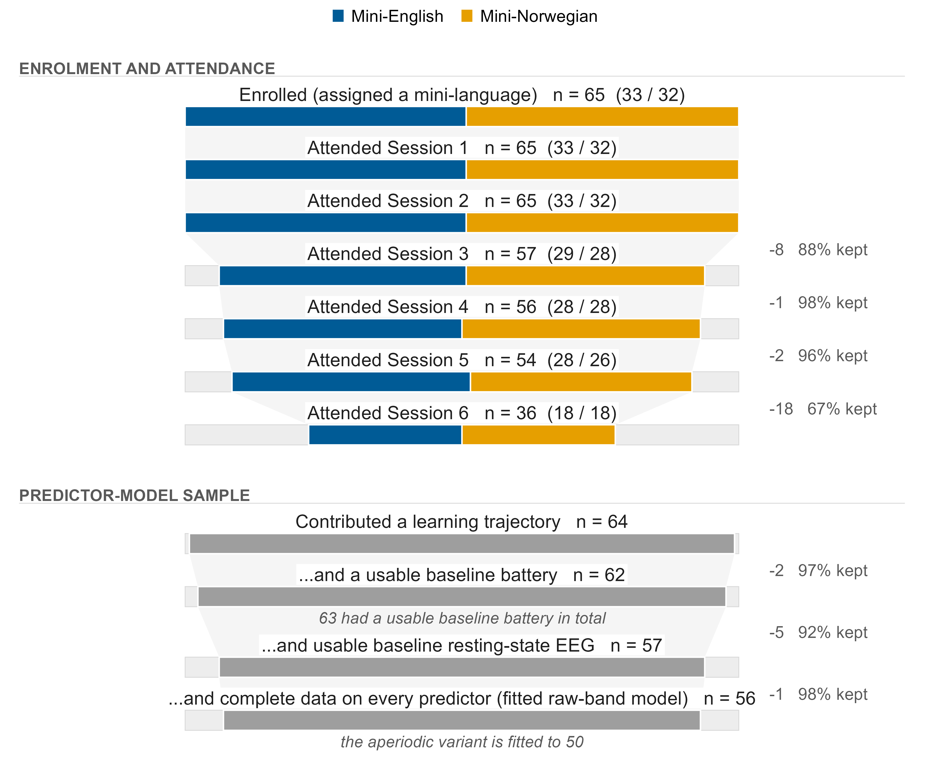
Note. Each stage spans the full enrolled cohort. The solid block is the participants still present and the faint block completing the bar is those no longer present, so cumulative attrition reads as filled against unfilled area. Tapering bands connect consecutive stages, each transition annotated with the number lost and the percentage retained. In the upper tier, the solid block is split by mini-language. The predictor-model stages are not recorded by language and are drawn in neutral grey. The upper tier tracks attendance across all six sessions, since this paper draws on all of them: the cognitive battery at Sessions 1 and 5, the resting-state recording at Session 2, and the learning trajectory across the four judgement sessions. The lower tier is the predictor-model sample proper, which is nested, and its final stage is the sample the raw-band model is fitted to, after listwise deletion on the full predictor set. Bands are drawn only within a tier, because the analysis samples pool across sessions and are not a subset of final-session attendance. The repository’s flow artefacts reproduce and cross-check every count shown.

Cognitive and neural indices
The cognitive battery was administered at Sessions 1 (baseline) and 5 (post) as browser-based tasks on the Gorilla experiment platform (Anwyl-Irvine et al., 2020), and records from individuals who completed the battery without enrolling were excluded at extraction, having no consent linkage to the participant key. Working memory was measured by digit span (forward and backward, list lengths 3–8 with four items each, 48 scored trials, the index being the number correct). Inhibitory control was measured by a four-colour Stroop task (Stroop, 1935) (100 test trials, 50 of them congruent, the index being the incongruent-minus-congruent mean reaction time, so that higher scores index poorer inhibitory control). Statistical learning was measured by an alternating serial reaction-time (ASRT) task (Howard & Howard, 1997), the alternating-sequence variant of the serial reaction-time paradigm (Nissen & Bullemer, 1987), of 25 blocks of 85 trials in which pattern and random trials alternate. The index is the low-minus-high-probability-triplet mean reaction-time difference, with higher scores indexing stronger learning. Reaction times were trimmed to 50–5000 ms and within-cell outliers beyond three standard deviations were removed, with both indices averaged over correct and incorrect responses alike. The Stroop index includes the practice block, which the export records in the same response zone as the test trials and which no filter removes at extraction. The trimming cells and the minimum trial counts are given in the online supplementary material (Section S1).
Resting-state EEG (rs-EEG) was recorded once, at Session 2, with a 32-channel Brain Products LiveAmp (500 Hz) in separate eyes-closed and eyes-open recordings of about five minutes each. Preprocessing in BrainVision Analyzer comprised visual inspection, re-referencing to the average of the mastoids, zero-phase Butterworth filtering (0.1–30 Hz, no notch) and ocular correction by independent component analysis. The full five minutes was retained for every participant in both conditions, and the acquisition and preprocessing details are given in the online supplementary material (Section S2). Power spectral density was estimated over eight occipito-parietal electrodes (O1, Oz, O2, P3, Pz, P4, P7, P8) by Welch’s method (Welch, 1967) and integrated over delta (1–4 Hz), theta (4–8 Hz), alpha (8–13 Hz), beta (13–30 Hz) and gamma (30–45 Hz). The individual alpha frequency (IAF) was the frequency of maximum power in the 7–13 Hz range (Klimesch, 1999), an argmax for which Corcoran et al. (2018) recommend a smoothed alternative, so the specparam IAF recovered in the aperiodic decomposition serves as the cross-check.
Because the one suggestive neural result rests on this measure, one failure mode of the argmax matters here. For a spectrum that merely decays across the search range it returns the lower bound, so a value at 7 Hz is not necessarily a peak. The argmax lies strictly inside the range for 57 of the 60 eyes-closed recordings, and the aperiodic decomposition described below fits a peak within that window in 54 of the 60. For the recordings in which the decomposition fits no such peak, the individual alpha frequency should be read as unresolved. Two of them are pinned at the 7 Hz floor with no fitted peak, and the others carry interior argmax values. In a refit of the gender-agreement model that excludes the two floor-pinned recordings, the individual-alpha-frequency association was $b=0.23$, 95% CrI $[−0.13,0.58]$, $p_{d}=89.4\%$.
The gamma band (30–45 Hz) lies entirely above the 30 Hz corner of the offline low-pass, so the retained power across that band has a median of 6.5% of what an unfiltered recording would have carried (interquartile range 6.3% to 6.6%), and no more than a median of 21.3% even under the most permissive single-pass reading of the zero-phase filter. The power observed there far exceeds what the filter would transmit of the aperiodic background (a median of 60.2% of the extrapolated background, against the 6.5% the filter would pass), consistent with mains energy at 50 Hz persisting through a filter applied without a notch. The gamma predictor is therefore not a valid index of gamma-band activity. It is retained only so that the predictor set is not altered after the fact, we do not interpret it, and its null result is not evidence about gamma-band activity. The transmission analysis is given in the online supplementary material (Section S3).
The eyes-closed values serve as the neural predictors, since the alpha rhythm and its peak are most reliably estimated with the eyes closed. The reduction reproduces the expected posterior alpha-blocking on eye opening, a check on the recording whose absence would have indicated a problem with the montage or the reference. All continuous predictors were $z$-scored, so each coefficient is expressed per standard deviation of its predictor and the predictors are directly comparable with one another (Brauer & Curtin, 2018; Schielzeth, 2010). The cognitive predictors were standardised over every participant with a Session 1 battery and the resting-state predictors over every eyes-closed recording, so a unit is a standard deviation of the measured sample, a slightly wider frame than the fitted one.

Learning outcome and model structure (Part A)
The learning outcome is the longitudinal trajectory of grammaticality-judgement accuracy, modelled jointly at trial level. The two-stage alternative most aptitude studies take, a slope fitted per learner and then regressed on the predictors, treats a slope estimated from few noisy trials as if it were measured without error, ignores the heterogeneous precision of those estimates and uses the data inefficiently (Gelman, 2005). Any standardised association is attenuated in proportion to the slopes’ unreliability (Hedge et al., 2018), and where estimated slopes serve as predictors, as in the designs Humberg et al. (2024) evaluate, the attenuation becomes a regression dilution of the coefficient itself. We therefore fit a single Bayesian multilevel Bernoulli model of trial-level accuracy. The learning rate is a by-participant random slope for session and the predictors enter as interactions with session (Barr et al., 2013), so that under partial pooling a learner whose slope is poorly determined contributes proportionately less to the predictor estimate (Gelman & Hill, 2006):
$$\begin{aligned}\text{correct}∼ &\text{Session}×\text{Property} \\ &+\text{Session}×(\text{WM}+\text{Inhibition}+\text{StatLearning}+\text{rs-EEG}) \\ &+(1+\text{Session}∣\text{participant}).\end{aligned}$$
The model carries no by-item term. The judgement sentences are generated combinatorially from each grammar, so each distinct sentence is presented to only a few participants and item variance is thinly sampled, as the companion paper sets out (Bernabeu et al., 2026). That variance is absorbed into the residual.
Session was coded as a continuous standardised variable so that the rate is a single slope. The four judgement sessions enter at equal steps, although Sessions 2 to 4 were one week apart and Session 6 was an unrehearsed retention test about four months after Session 4 (see the companion paper), so the slope is per session step, whatever the elapsed time between sessions. Session was standardised over the pooled trial frame before any listwise deletion, so one unit is close to one step of the session index and zero falls at the trial-weighted mean session, which the cumulative design places between Sessions 3 and 4. The gender-agreement model inherits that scaling, so its main effects and its intercept are evaluated at the same session index, which lies later than that stratum’s own mean session. Grammatical property entered as a three-level factor under treatment coding with differential object marking, the first level alphabetically, as the reference, so the population-level session term is that property’s slope and the two session-by-property terms are the other properties’ departures from it. The predictor terms do not interact with property, so their estimates do not depend on this choice. A linear effect of session is the parsimonious default. A generalised additive form (Sóskuthy, 2017; Winter & Wieling, 2016) was held in reserve, since averaging across learners can distort the apparent form of a learning curve (Heathcote et al., 2000; Murre & Chessa, 2011), and it was not fitted. Because linearity was not formally tested, the session term is interpreted as a linear approximation to the trajectories in Figure 2, where the gender-agreement trajectories in particular are not monotone.
We report both the learning rate (the predictor-by-session interactions) and the attainment (the model-implied end-of-training accuracy), and assess the reliability of the by-participant rate and of the by-participant level of accuracy, the random intercept, before interpreting either as an individual difference (Hedge et al., 2018; Hedge, 2021). Attainment is the population-level predicted accuracy at Session 6 for a learner at the mean of every predictor and at zero on both random effects, averaged with equal weight over the three properties in the pooled model, so it is a conditional prediction and carries no by-participant reliability. The reliabilities are single-occasion, model-based separation reliabilities estimated within this sample, computed as the variance of the shrunken by-participant posterior means relative to the model’s between-participant variance, $Var({\hat{u}}_{i})/τ^{2}$. They are not test-retest reliabilities, which would require a second measurement wave (Rouder & Haaf, 2019). Because session is standardised, a predictor’s main effect is its association with accuracy at the pooled-frame mean session. We label the main effects as overall accuracy and reserve attainment for the model-implied end-of-training quantity. Pooled accuracy is shaped by properties of differing difficulty entering cumulatively across sessions: gender agreement from Session 2, differential object marking from Session 3 and verb–object number agreement from Session 4 (see Bernabeu et al. (2026) for the design). Part A is therefore additionally fitted restricted to gender agreement, the property with full session coverage, so that the predictor pattern can be read on an outcome free of the cumulative design. The pooled model is the primary analysis and the gender-agreement model its companion.

Pre/post models of executive function (Part B)
Part B fits a Gaussian pre/post model of each cognitive index (Session 1 versus Session 5) with a by-participant intercept and a $±0.5$ pre/post contrast. Because the study has no no-training control group, a pre/post change is confounded with the generic threats that attend any uncontrolled retest (Shadish et al., 2002). We add a joint model across the three $z$-scored indices in which each acts as an internal control for the others. With digit span as the reference level, the session effect is its pre/post change and each measure-by-session term is how much less that measure changed. The model can therefore identify a change concentrated in one index and set it against the broad shift that practice, regression to the mean or expectancy would produce. The three indices are standardised within measure and enter on their recorded polarity, which is not aligned across them: higher digit span is better performance, higher Stroop interference worse. A generic improvement therefore moves the two in opposite signed directions, so the digit-span-versus-Stroop contrast confounds specificity with that opposition and should be read as an upper bound on the separation. A sign-aligned refit, in which the Stroop index is reversed before standardisation so that a positive change means improvement on all three indices, is reported alongside it. Because resting-state EEG was recorded only at baseline, no neural pre/post is estimated.

Priors
Priors are informative and standardised on the logit scale, established from the literature reviewed in the Introduction and following a selective, evidence-tiered scheme. The cited behavioural associations are attainment correlations, so each small informative prior is placed on a predictor’s main effect and shrunk towards zero on its interaction with session. Working memory and statistical learning receive small positive priors (Kurokawa, 2026; Linck et al., 2014; Misyak & Christiansen, 2012; Zhou et al., 2024). Inhibitory control receives a near-zero regularising prior, reflecting its weak-to-null evidence base (Chen et al., 2022; Huensch, 2024; Linck & Weiss, 2015), and the resting-state EEG predictors receive near-zero regularising priors. The band-power precedent (Prat et al., 2016, 2019) was obtained over a different scalp region and for a different outcome, learning rate, so no directional prior is encoded for the bands, and a null obtained under regularising priors at this sample size cannot count against that precedent. Variance components receive generous half–Student-$t(3,0,2.5)$ priors and correlations an $LKJ(2)$ prior (Gelman, 2006; Lewandowski et al., 2009). In a sensitivity analysis, the Part A predictors were re-fit under weakly informative priors, $N(0,1.5)$ on the intercept and on every population-level coefficient, with the variance and correlation priors unchanged (see Results). The Part B pre/post models use weakly informative priors throughout (Depaoli & van de Schoot, 2017; Schad et al., 2021). In brief, the Part A intercept has a $N(1,1)$ prior on the logit scale, any population-level coefficient without a term-specific prior has $N(0,1)$ (Gelman et al., 2008), and the term-specific priors are small positive normals for working memory and statistical learning and near-zero normals for inhibitory control and every resting-state predictor. The full specification is given in the online supplementary material (Section S6).

Sampler, diagnostics and inference
Models were fitted with brms (Bürkner, 2017, 2018) as a front end to Stan (Carpenter et al., 2017), using the same sampler configuration as the companion paper (Bernabeu et al., 2026): four chains of 10,000 iterations each, the first 2,000 discarded as warm-up, giving 32,000 post-warm-up draws, with adapt_delta = 0.95 and max_treedepth = 12. The convergence gate was rank-normalised $\hat{R}<1.01$, bulk- and tail-ESS above 400, and zero divergent transitions (Vehtari et al., 2021). Posterior predictive checks for the Part A models were written to the repository at fit time (Gabry et al., 2019), and inference was by posterior medians, 95% credible intervals and the probability of direction ($p_{d}$) (Kruschke & Liddell, 2018; Makowski et al., 2019), every credible interval being equal-tailed (2.5th to 97.5th percentiles of the draws). An ESS of 400 guarantees trustworthy diagnostics without guaranteeing the stability of an interval limit (Kruschke, 2021; Vehtari et al., 2021). As in the companion paper, we describe an effect as credible when its 95% credible interval excludes zero, and otherwise read the probability of direction as a continuous index of directional certainty, never as a dichotomous test. The projection-predictive and aperiodic analyses narrow the predictor space, and we apply no blanket multiplicity correction, which would inflate Type II error without an inferential gain (Rubin, 2021). Binary accuracy is modelled with a Bernoulli (logit) likelihood throughout. Analyses were carried out in R 4.5.1 (R Core Team, 2025) with brms 2.23.0 as a front end to CmdStan 2.39.0, projpred 2.10.0 for the projection-predictive selection and loo 2.9.0 for the Pareto-smoothed importance-sampling leave-one-out (PSIS-LOO) comparison, under the fixed seed 20260607, in a reproducible here()-anchored compendium (Marwick et al., 2018). The models were fitted on a Linux computing cluster, the versions given above are those of the fitting run, and the platform, the compiler settings and the figure palette are given in the online supplementary material (Section S7). The analysis and reporting code was written with the assistance of Claude Code (version 2.1, Anthropic), running primarily the Claude Opus and Claude Fable models, accessed through Anthropic’s Claude service (https://claude.com/claude-code) between July 2026 and September 2026. The tool drafted and revised scripts under the authors’ direction and checked them against the method reported here. The authors reviewed and ran every script, and the deposited code reproduces the analyses without the tool.

Predictor selection and a 1/f-adjusted robustness check
Two further analyses probe the neural predictors. First, raw resting-state band power conflates oscillatory activity with the aperiodic $1/f$ background, itself a substantive individual difference (Donoghue et al., 2020; Ouyang et al., 2020). We therefore re-parameterised each participant’s baseline spectrum with a specparam decomposition (Donoghue et al., 2020) into an aperiodic component (exponent and offset), $1/f$-adjusted theta, alpha and beta power and the specparam individual alpha frequency, the centre of the tallest fitted peak between 7 and 13 Hz inclusive. Part A was then re-fit with these quantities in place of the raw bands. The decomposition is our own R implementation, fitted over 2–40 Hz in fixed (knee-free) mode, and its settings and the consequences of the 30 Hz low-pass for the fit are given in the online supplementary material (Section S4), where they can be judged against the recommendations of Gerster et al. (2022). Only tall peaks pass the threshold of two standard deviations of the flattened spectrum (Section S4), so a theta peak was fitted in 1, a peak within the individual-alpha window in 54 and a beta peak in 9 of the 60 eyes-closed recordings. The adjusted theta and beta predictors are therefore close to constant, and we do not interpret their coefficients or their positions in the selection path. This aperiodic variant is a robustness check of the raw-band model, specified after data collection like the rest of the analysis plan (see Transparency and preregistration), and it is not a second pass over the predictor space.
The two reference models are compared by leave-one-out cross-validation (Vehtari et al., 2017). Because they differ only in participant-level predictors, which a held-out trial’s own participant intercept already absorbs, they are also compared by $K$-fold cross-validation with folds blocked on participants ($K=10$, the same folds for both models, participants dealt round-robin over a seeded shuffle), the remedy Roberts et al. (2017) recommend wherever such dependence exists. We report the difference in expected log predictive density (elpd) with a standard error clustered on participants, summing the pointwise contributions within participant before taking the standard error across participants, and read a difference as decisive only when it exceeds twice that standard error. Why the trial-level criterion cannot settle the comparison on its own, and the naive standard error alongside, are given in the online supplementary material (Section S5).
Second, the joint Part A model retains every candidate predictor for inference, and projection-predictive variable selection (Piironen et al., 2020; Piironen & Vehtari, 2017) asks which subset accounts for its predictive performance by projecting the reference posterior onto nested submodels, each inheriting the reference model’s regularisation. Because the reference model is a multilevel Bernoulli model with a correlated random slope, we use the latent projection (Catalina et al., 2021; McLatchie et al., 2025), which fits each projected submodel on the linear-predictor scale and evaluates its performance on the response scale (the reason the traditional projection fails for this model is given in Section S5). The forward search is cross-validated in full over 10 participant-grouped folds (Roberts et al., 2017), and the suggested submodel size is projpred’s standard heuristic, the smallest size whose cross-validated elpd lies within one standard error of the reference model’s (Piironen et al., 2020). A predictor that the minimal submodel does not retain is not thereby shown to be null. The selection summarises which predictors account for the reference model’s predictive performance, and the full Part A posterior remains the inferential statement (Piironen et al., 2020). The raw-band and aperiodic reference models’ selections are reported side by side.

Transparency and preregistration
The study design, materials and session protocol were preregistered before data collection (https://osf.io/tjr54), with no statistical analysis plan, so the Bayesian multilevel models, the informative priors, the specparam/aperiodic re-parameterisation and the projection-predictive selection reported here were specified after the data were collected and are exploratory (Nosek et al., 2018; Wagenmakers et al., 2012). The preregistration motivated the Session-1 battery as an index of attention relevant to the selection of a source of transfer, and reframing the same three tasks as working-memory, inhibitory-control and statistical-learning measures departs from that rationale. Data collection was preregistered for two sites, Norway and Spain, and only the Norwegian cohort (first-language Norwegian, second-language English) is analysed here, so the findings generalise only to first-language-Norwegian learners. Finally, the preregistered protocol required participants to score above 80% on a post-training behavioural test in each grammar session (with a second attempt allowed) before they could proceed, a gate that shapes which participant-sessions contribute learning data and is part of the attrition described above.

Results
Convergence diagnostics for every model reported below are given in Table A1, in the appendix, as realised values, since a realised value distinguishes a model that converged comfortably from one that converged marginally. All 12 models were assessed against the same gate and 12 passed it, with rank-normalised $\hat{R}$ below 1.01, effective sample sizes above 400 in both the bulk and the tail, and no divergent transitions.

Descriptive overview
Before the models, Figure 2 plots the raw learning trajectory, the direct check on the linear-in-session assumption the models make, Figure 3 shows the baseline predictors’ intercorrelations and Table 1 gives the same predictors numerically. The per-measure distributions (Figure S1) and the resting-state spectra behind the band-power and individual-alpha-frequency measures (Figure S2) are given in the online supplementary material (Section S8). The frames of these displays are wider than the 56 participants of the fitted raw-band model and are stated in their notes.
One feature of the learning trajectory bears on how rate and attainment should be read, since both terms would otherwise suggest improvement. Mean accuracy is highest at each property’s first session and lower at its last, in every property and both mini-languages. The session term is credibly negative in both models. In the pooled model the slope for the reference property, differential object marking, is $b=−1.16$, 95% CrI $[−1.37,−0.96]$, $p_{d}>99.9\%$, and the gender-agreement and verb–object number-agreement slopes differ from it by $b=0.43$, 95% CrI $[0.34,0.51]$, $p_{d}>99.9\%$ and $b=0.20$, 95% CrI $[0.06,0.34]$, $p_{d}=99.7\%$. Within gender agreement fitted alone the slope is $b=−0.41$, 95% CrI $[−0.56,−0.26]$, $p_{d}>99.9\%$. The pooled decline partly reflects the cumulative design, in which later sessions sample harder material (see Learning outcome and model structure). Within gender agreement, which is sampled throughout, it is an unexplained feature of these data. Throughout, rate is the slope of this trajectory and attainment its model-implied end point, whichever way the trajectory runs.

Figure 2
Observed Grammaticality-Judgement Accuracy Across Sessions, by Grammatical Property and Mini-Language
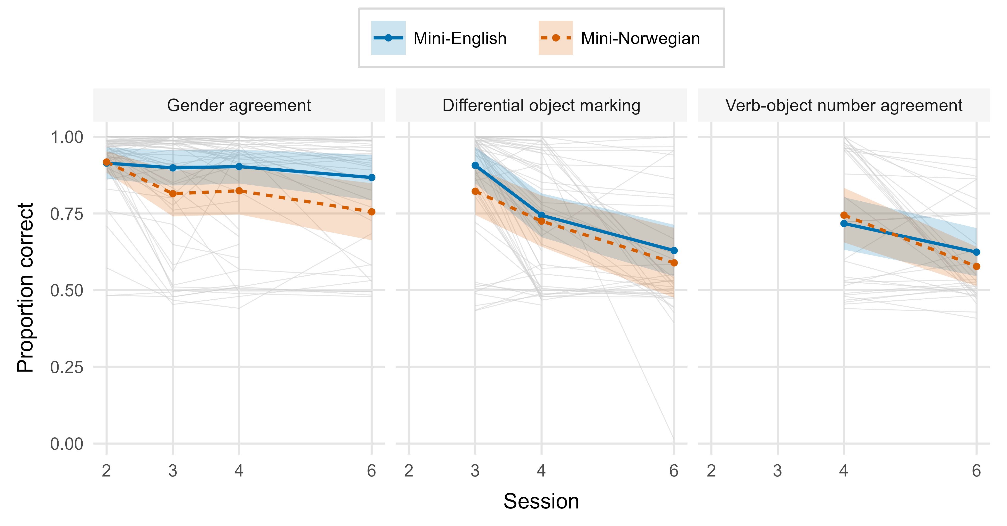
Note. Thin lines are individual participants, and the ribbon is a 95% confidence interval computed between participants, the sampling unit being participants and not trials. This is the raw trajectory the joint model summarises, and the direct check on the linear-in-session assumption. No judgements were collected at Session 5. The segment from Session 4 to Session 6 spans the unrehearsed retention interval of about four months, whereas Sessions 2 to 4 were one week apart, so the axis is not proportional to elapsed time.

Figure 3
Pearson Correlations Among the Baseline Predictors
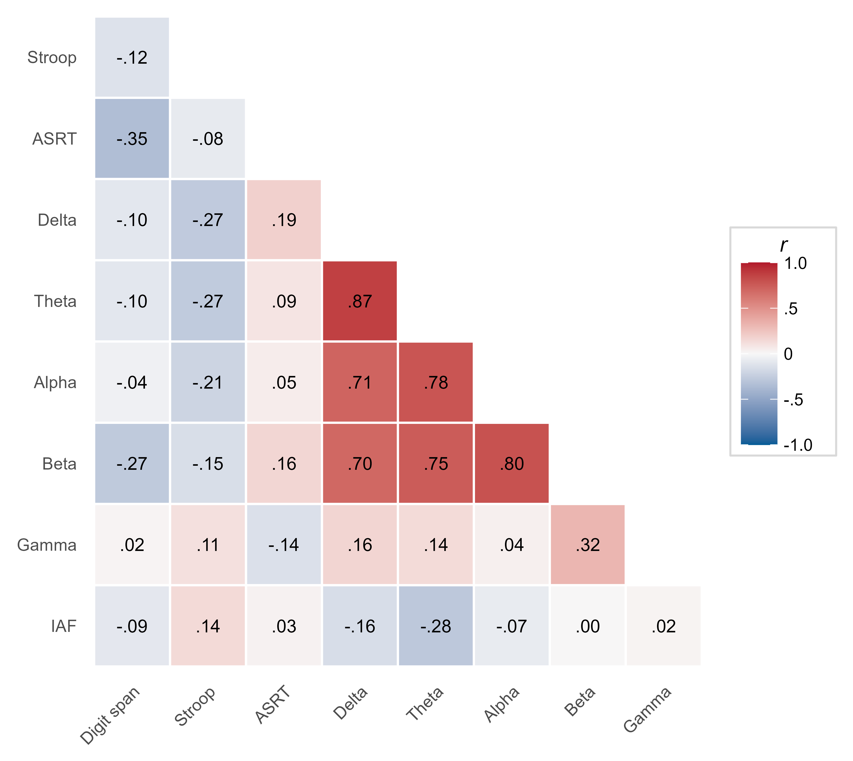
Note. Correlations are computed on the z-scored predictors, over the participants who have both a baseline cognitive battery and an eyes-closed resting-state spectrum, pairwise-complete, so the n behind each cell varies slightly. Only the lower triangle is shown, the redundant mirror and the unit diagonal being omitted. The resting-state band powers are expected to be positively intercorrelated through the shared aperiodic 1/f background, which motivates the specparam robustness check and is why the projpred ranking must be read against this structure.

Table 1
Descriptive Statistics for the Baseline Predictors
Predictor | $n$ | $M$ | $SD$ | $Mdn$ | Min | Max
Working memory: digit span (items correct) | 58 | 25.86 | 7.03 | 25.00 | 10.00 | 43.00
Inhibitory control: Stroop interference (ms) | 57 | 116.27 | 76.51 | 101.63 | -41.72 | 306.64
Statistical learning: ASRT difference (ms) | 58 | 44.65 | 55.14 | 15.04 | -2.38 | 198.43
Delta power (microvolts squared) | 58 | 8.88 | 5.92 | 6.91 | 2.34 | 31.07
Theta power (microvolts squared) | 58 | 9.03 | 11.42 | 4.62 | 1.33 | 65.16
Alpha power (microvolts squared) | 58 | 48.28 | 49.85 | 30.66 | 1.29 | 224.41
Beta power (microvolts squared) | 58 | 9.52 | 6.14 | 8.09 | 2.26 | 37.60
Gamma power (microvolts squared, not interpreted) | 58 | 0.66 | 0.52 | 0.50 | 0.14 | 3.10
Individual alpha frequency (Hz) | 58 | 10.18 | 1.09 | 10.50 | 7.00 | 12.00
Note. The frame is the participants who have both a baseline cognitive battery and an eyes-closed resting-state spectrum, which is wider than the sample any Part A model is fitted to, and the $n$ column gives the number contributing to each row. Each row carries its own unit. Because a band power is the spectral density integrated over the band, its unit is squared microvolts, without the per-hertz denominator of a density.

Part A: Predictors of the learning trajectory
Each predictor enters twice: as a main effect, indexing the overall level of accuracy, and in interaction with session, indexing the learning rate. Because session is standardised, the main effect is the association at the pooled-frame mean session (see Method). Working memory was the clearest predictor. Higher baseline digit span went with higher overall accuracy, credibly so for the fully sampled gender-agreement property ($b=0.43$, 95% CrI $[0.09,0.74]$, $p_{d}=99.5\%$) and positively, though with an interval that narrowly included zero, in the pooled model ($b=0.290$, 95% CrI $[−0.004,0.563]$, $p_{d}=97.3\%$). Inhibitory control ($b=0.06$, 95% CrI $[−0.17,0.28]$, $p_{d}=68.9\%$) and statistical learning ($b=0.01$, 95% CrI $[−0.25,0.27]$, $p_{d}=53.4\%$) were not credibly related to accuracy, in line with their weak-to-null evidence base.
Of the baseline resting-state measures, the band powers yielded no credible coefficient (Figure 4), but that null must be read against how strongly they are intercorrelated. Entering the bands simultaneously means each coefficient is the unique contribution of that band with the others held constant, and the four low-frequency bands share a great deal of variance (Figure 3). Their variance inflation factors, computed over the 57 participants with complete predictor data in the descriptive frame, are 4.5 to 6.8, which widens their posterior intervals by roughly 2.1 to 2.6 times relative to an orthogonal predictor. Their null coefficients are therefore weakly identified and uninformative about whether those rhythms relate to learning. Two of the neural predictors escape this: gamma (VIF 1.51) and the individual alpha frequency (VIF 1.29) are nearly uncorrelated with the rest, so their estimates stand on their own. The one suggestive signal was the individual alpha frequency, whose association with gender-agreement accuracy was $b=0.27$, 95% CrI $[−0.04,0.58]$, $p_{d}=95.3\%$. The cross-check the Method promised points the same way without settling it. In the aperiodic re-parameterisation of the same stratum, fitted to a smaller sample, the specparam-estimated individual alpha frequency was $b=0.24$, 95% CrI $[−0.10,0.57]$, $p_{d}=91.7\%$, and the aperiodic exponent, the quantity the decomposition adds, was $b=0.07$, 95% CrI $[−0.30,0.43]$, $p_{d}=64.7\%$. The learning-rate interactions were uniformly weak (for working memory, $b=−0.10$, 95% CrI $[−0.27,0.07]$, $p_{d}=87.6\%$), consistent with priors that placed their small informative mass on the main effects and shrank the rate terms towards zero. The largest was the statistical-learning-by-session term in the gender-agreement model ($b=0.11$, 95% CrI $[−0.02,0.23]$, $p_{d}=95.3\%$), with the adjusted-alpha-by-session term of the aperiodic refit of that stratum comparable ($b=0.18$, 95% CrI $[−0.02,0.37]$, $p_{d}=96.1\%$). Neither is interpreted, for the reason given below.
Under weakly informative priors, the regularising priors on the resting-state bands are seen to have shrunk them towards zero and tightened their intervals (across all coefficients, the weakly informative intervals were about 54% wider at the median). No band-power predictor was credible under either prior. The individual alpha frequency, however, is prior-sensitive. Under the weakly informative prior, its gender-agreement interval excluded zero ($b=0.47$, 95% CrI $[0.01,0.94]$), whereas under the regularising prior it did not ($b=0.27$, 95% CrI $[−0.04,0.58]$). The regularised estimate is treated as primary, and we read the association as suggestive. The working-memory main effect was, if anything, larger under the weakly informative prior, and its pooled interval then excluded zero ($b=0.418$, 95% CrI $[0.003,0.836]$). The predictor-by-session interactions likewise remained non-credible under weakly informative priors (largest $p_{d}$ = .96), so the level-not-rate asymmetry is a property of the data and does not depend on the prior specification.
To establish which predictors account for the reference model’s predictive performance, projection-predictive selection was run on both the pooled and the gender-agreement reference models and on the aperiodic re-parameterisation, and it returned the same parsimonious answer throughout. In the raw-band model, the suggested size was 6: the design scaffold (by-participant intercept and session slope, session, grammatical property and their interaction) together with working memory (digit span). Digit span was the first individual-difference predictor selected, entering at step 6 of the forward search, exactly the suggested size. Inhibitory control (step 8), statistical learning (step 10) and the resting-state band predictors entered only beyond the suggested size, so they are not among the terms the search retained. The forward search was capped at projpred’s default path length, so the lowest-ranked terms, including the individual alpha frequency, reported above as a suggestive baseline signal, fell below that cap and were not positively ruled out in that stratum.
The gender-agreement stratum, fitted to that property alone, gives the same answer: a suggested size of 4, with working memory again the first individual-difference predictor to enter, at step 4, and inhibitory control and statistical learning entering beyond it (steps 6 and 8). That search ran over the full candidate set rather than projpred’s default path length, so gamma power and the individual alpha frequency were evaluated and not truncated away, and they rank last of all (steps 18 and 20). The full-length search was run only for this stratum, the one the individual-difference claim rests on. There, neither term added anything the retained predictors had missed, and how far beyond the suggested size a term lands is not interpreted.
The aperiodic re-parameterisation reproduced this ordering (suggested size 6), with the aperiodic exponent and offset entering at steps 12 and 14, well beyond the suggested size, so the $1/f$ background added no predictive information the raw bands had missed. The same path cap left the adjusted beta power and the specparam individual alpha frequency unreached, with the same caveat.
The two parameterisations were also compared by PSIS-LOO on the sample they share. Because the specparam re-parameterisation is defined for 50 of the 56 participants, the raw-band model was refit on that common subsample so the two are compared on identical observations. The aperiodic-minus-raw difference in expected log predictive density was 0.2 (SE 0.5) in the pooled stratum and -0.1 (SE 1.0) for gender agreement, in each case smaller than twice its standard error (Vehtari et al., 2017). As noted in the Method, this leave-one-trial-out criterion cannot detect participant-level predictors, so the near-zero difference is not read as evidence that the two characterisations are equivalent.
We then ran the participant-grouped comparison directly, refitting both models on the common sample under the 10-fold participant-blocked scheme described in the Method. The aperiodic-minus-raw difference was -56.5 in the pooled stratum and -20.9 for gender agreement. These are reported with standard errors clustered on participants (51.3 and 31.4), which exceed the naive independent-observation standard errors by factors of 6.5 and 4.3, since the pointwise contributions are dependent within a participant. Neither difference reaches twice its clustered standard error, so neither characterisation predicts a held-out participant’s trajectory detectably better than the other, and although both differences favour the raw bands in direction we draw no conclusion from the sign. At these standard errors only a difference beyond about 103 nats in the pooled stratum and 63 for gender agreement would be read as decisive, so this tie bounds the comparison without establishing equivalence.
Model-implied end-of-training attainment was 0.63 (95% CrI [0.57, 0.70]) pooled and 0.88 (95% CrI [0.83, 0.92]) for gender agreement. The by-participant level at the pooled-frame mean session (the intercept) was estimated with high reliability (pooled .84, gender-only .79). The learning-rate slope was estimated less reliably (pooled .75, gender-only .42), and because the gender-only rate is the least reliably estimated of these quantities we do not interpret rate-based individual-difference claims from that model.
Table 2 gives these outcome reliabilities in full, and Table B1 the internal consistency of the three baseline cognitive indices. Both matter, because the association between a predictor and an outcome is bounded by the reliability of each. Two of the three cognitive indices are moreover difference scores, a form whose reliability is typically lower than that of its components (Draheim et al., 2019; Hedge et al., 2018).

Figure 4
Part A Predictor Effects on Overall Accuracy and Learning Rate
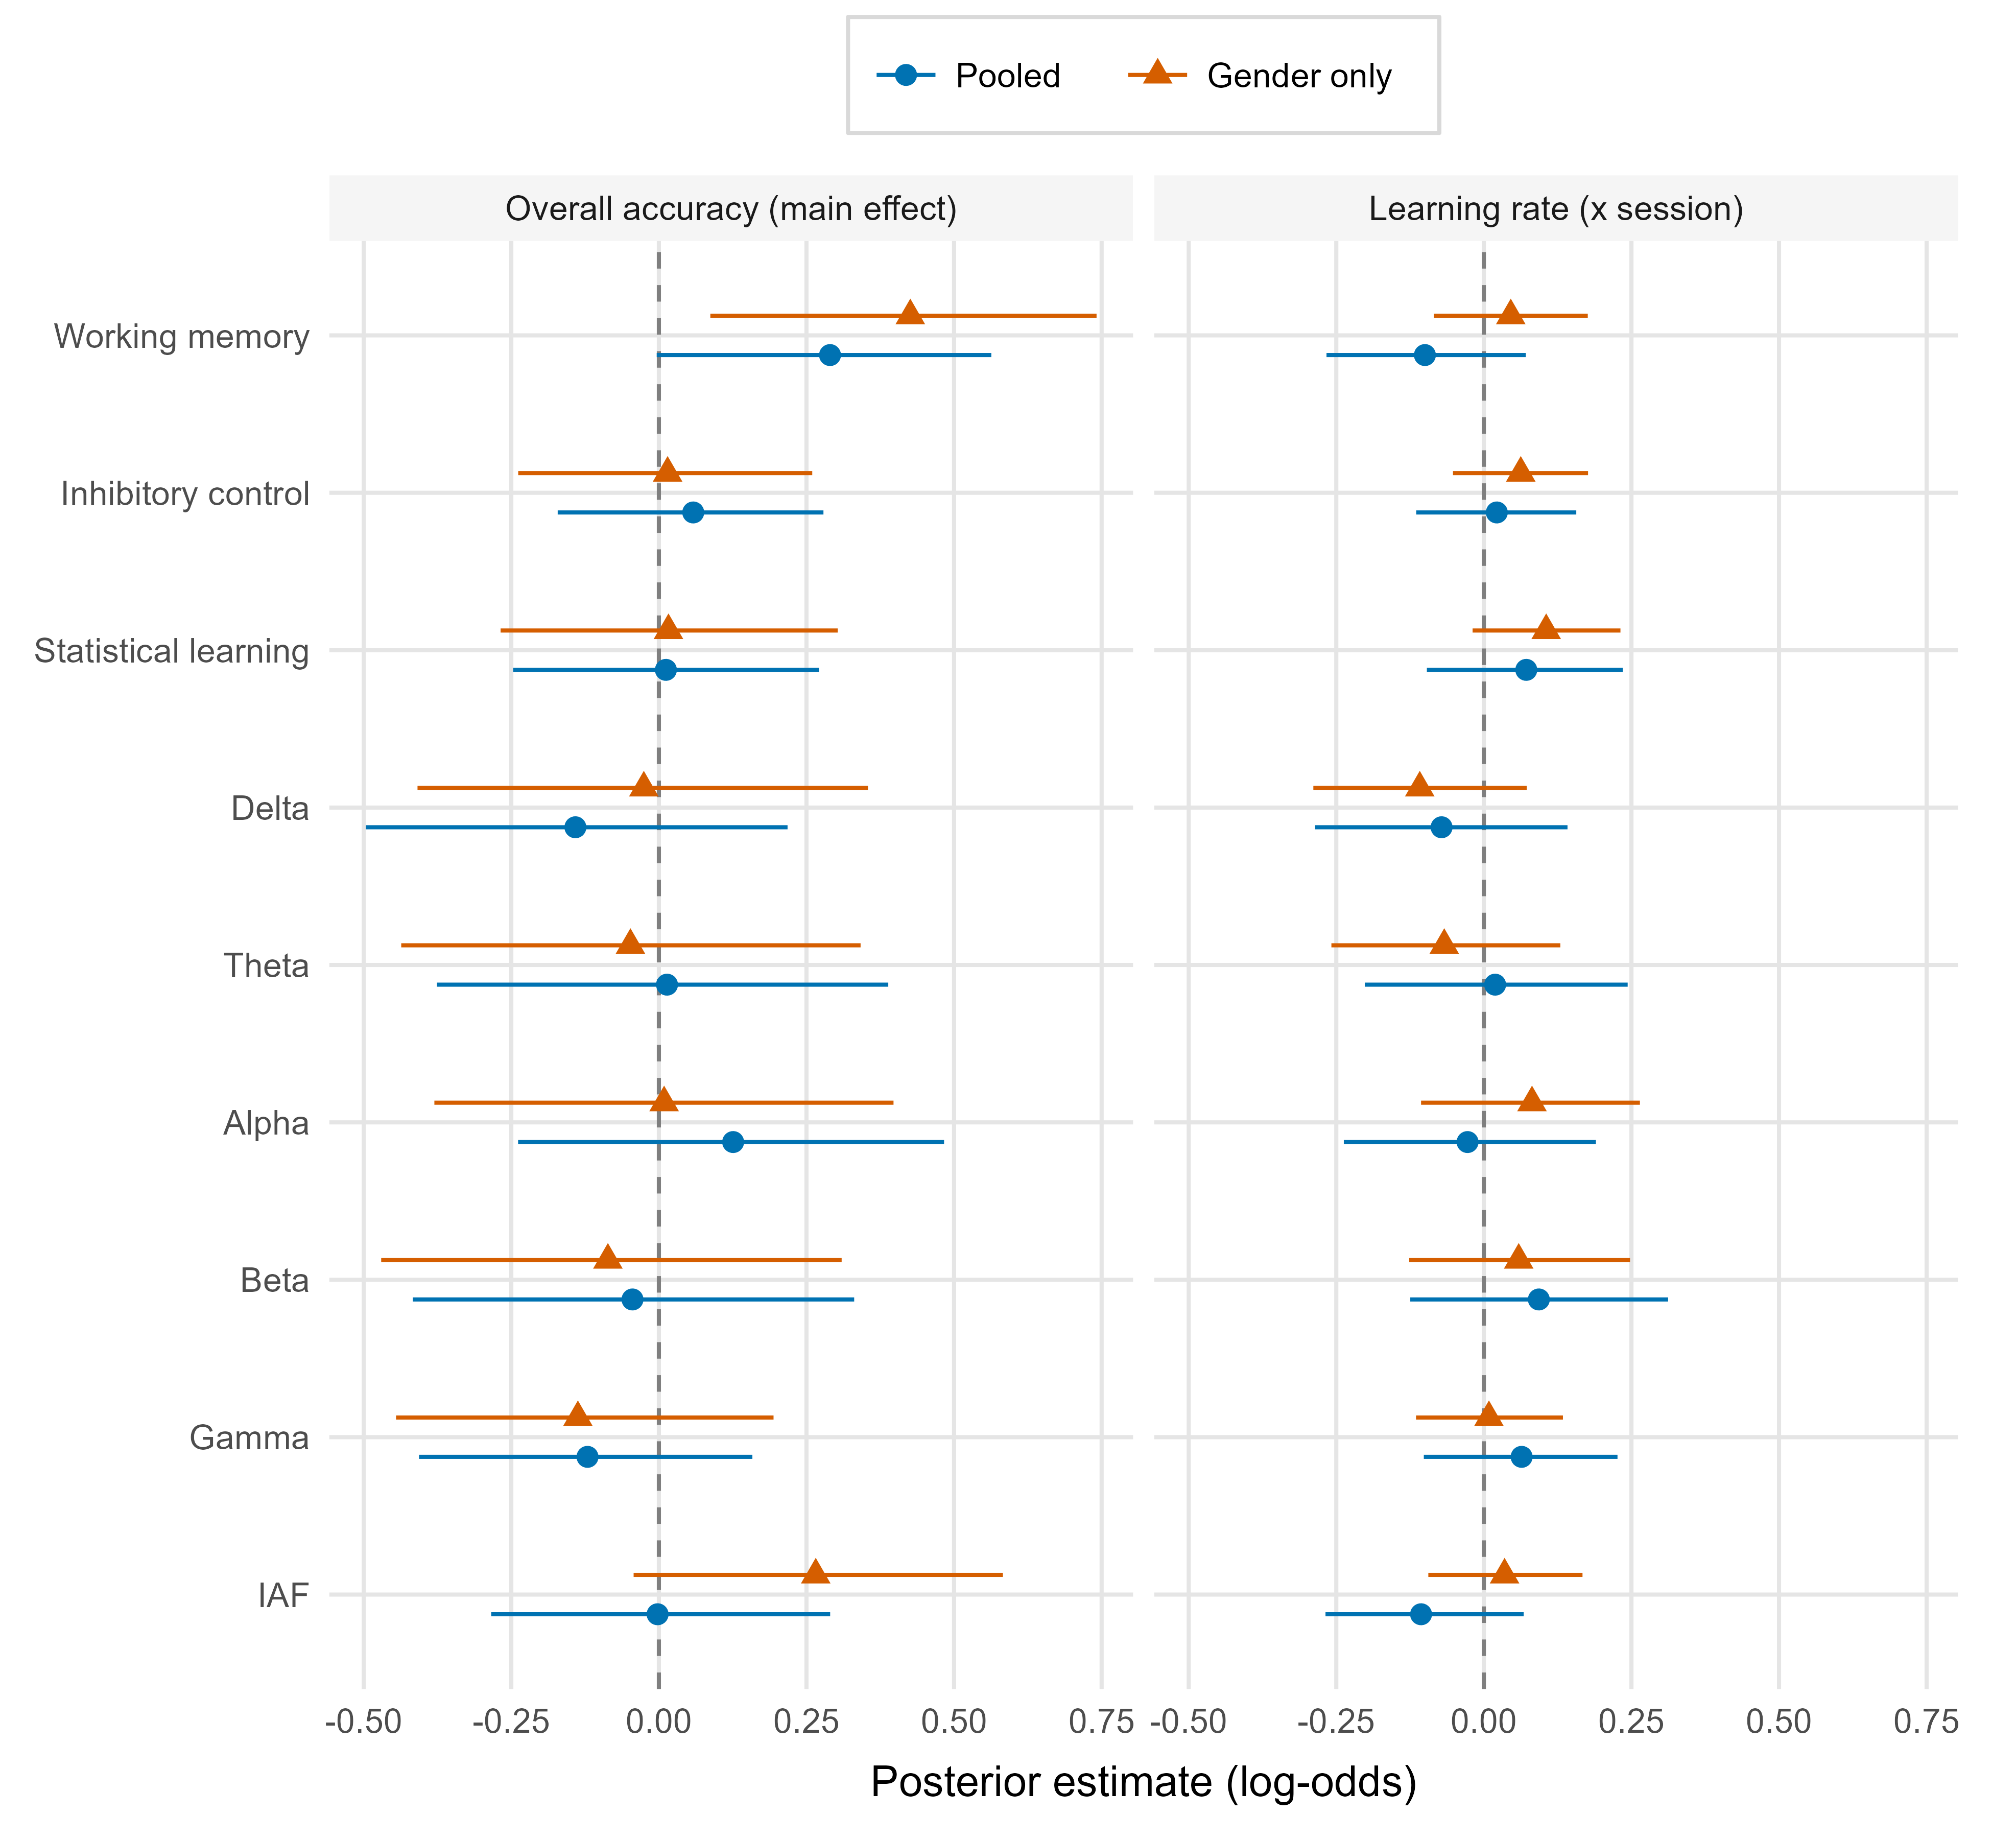
Note. Points are posterior medians with 95% equal-tailed credible intervals for each baseline predictor’s association with overall accuracy (the main effect, the association at the average session) and with learning rate (the predictor-by-session interaction), in the pooled and gender-agreement-only models. Estimates are on the logit scale: main effects are the change in log-odds of a correct response per SD of the predictor, interaction terms the change in the per-session slope per SD. The two panels share a common x axis so the families are directly comparable, and the rate-interaction terms carry deliberately tighter priors than the main effects. Predictors are ordered working memory, inhibitory control and statistical learning (for the Stroop-based inhibitory-control predictor, higher scores mean poorer inhibition), then the resting-state measures. Intervals excluding zero indicate effects whose direction is well determined.

Table 2
By-Participant Reliability of the Learning Trajectory
Model | Quantity | Group SD | Mean posterior SE | Reliability
Pooled | Overall accuracy (intercept) | 1.30 | 0.47 | .84
Pooled | Learning rate (session) | 0.71 | 0.33 | .75
Gender only | Overall accuracy (intercept) | 1.47 | 0.59 | .79
Gender only | Learning rate (session) | 0.39 | 0.28 | .42
Note. Columns give the group standard deviation, mean posterior standard error, and reliability of the intercept (a participant’s level at the mean session of the pooled standardisation frame) and of the session (rate) slope, for the pooled and gender-agreement-only models. The reliability column is the empirical-Bayes form, the variance of the shrunken by-participant posterior means over the model’s between-participant variance. The group SD and mean posterior SE columns are shown for context and are not the terms of a formula.

Part B: Change in executive function over training
Comparing the first and fifth sessions, working-memory span increased over training, $b=0.29$, 95% CrI $[0.09,0.48]$, $p_{d}=99.8\%$. The Stroop interference effect ($b=−0.14$, 95% CrI $[−0.49,0.22]$, $p_{d}=78.4\%$) and the statistical-learning effect ($b=−0.13$, 95% CrI $[−0.47,0.21]$, $p_{d}=78.4\%$) showed no credible change. In the joint model that lets each index control the others, the pattern pointed the same way. The joint-model digit-span change was $b=0.29$, 95% CrI $[−0.05,0.64]$, $p_{d}=95.3\%$, an interval that, unlike the single-index model’s, includes zero. The estimate is less precise in the joint specification, which shares one residual standard deviation across the three measures and adds a by-participant change slope. Relative to that change, the pre/post shift was smaller for the Stroop interference effect ($b=−0.43$, 95% CrI $[−0.92,0.06]$, $p_{d}=95.7\%$) and for the statistical-learning effect ($b=−0.42$, 95% CrI $[−0.92,0.05]$, $p_{d}=95.7\%$). These specificity contrasts have credible intervals that include zero (probabilities of direction 95.7% and 95.7%), so the evidence that the gain is working-memory-specific is suggestive without being decisive. Figure 5 shows these effects.
Two features of the comparison qualify it further. First, the digit-span-versus-Stroop contrast is inflated by the polarity opposition described in the Method, since a generic improvement pushes digit span up and Stroop interference down. Refitting the joint model with the Stroop index reversed before standardisation, so that a positive change means improvement on all three indices, gives a digit-span change of $b=0.30$, 95% CrI $[−0.04,0.64]$, $p_{d}=95.7\%$, a Stroop contrast of $b=−0.15$, 95% CrI $[−0.62,0.33]$, $p_{d}=72.9\%$ and a statistical-learning contrast of $b=−0.44$, 95% CrI $[−0.91,0.05]$, $p_{d}=96.2\%$, so much of the separation in the reported Stroop contrast reflects the polarity opposition. The statistical-learning contrast is unaffected by the alignment, since a higher ASRT score already means better performance. Second, the Stroop index has very low internal consistency here (see Limitations and future directions), which leaves it a noisy control. In task units, the digit-span change was from 26.0 items correct at Session 1 to 28.4 at Session 5, against 112.6 to 99.3 ms of Stroop interference and 43.0 to 35.5 ms of ASRT learning.

Figure 5
Pre/Post (Session 1 to 5) Change in the Executive-Function Indices
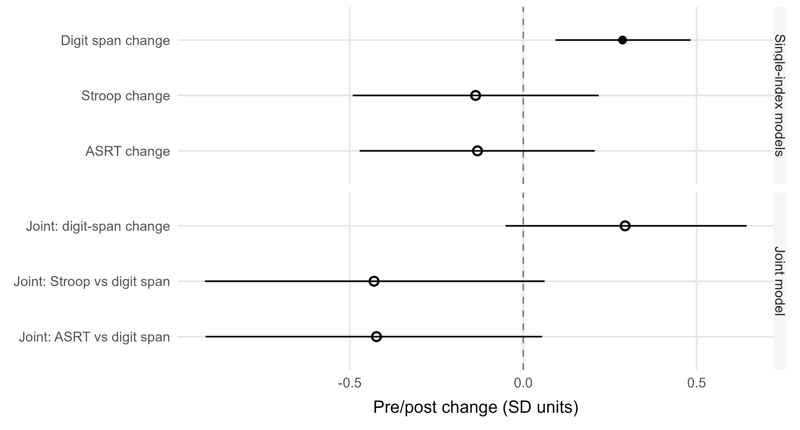
Note. Points are single-index session effects and, for the joint model, the digit-span change and the contrasts of each measure’s change against digit span (the reference level). Filled points mark effects whose 95% credible interval excludes zero; open points do not.

Discussion
This study asked two questions: whether baseline cognitive and neural measures predict how well adults learn a new grammar (Part A), and whether executive function changes over the training period (Part B). The answer to the first is selective. Working memory was associated with learners’ overall level of accuracy, while inhibitory control, statistical learning and the resting-state measures added little, and the predictors were associated with that level, with no detectable association with the rate of change. The answer to the second falls on the same capacity: working-memory span was the one index that rose over training.

Predictors of overall accuracy and learning rate
Working memory was the clearest cognitive predictor of overall accuracy. In the primary pooled model its interval narrowly included zero, and in the gender-agreement model, the one property sampled at every judgement session, the association was credible. This fits the literature placing working memory as the best-evidenced domain-general cognitive correlate of second-language outcomes (Linck et al., 2014). Inhibitory control and statistical learning, whose evidence base is weak or contested (Chen et al., 2022; Huensch, 2024; Linck & Weiss, 2015; Zhou et al., 2024), added little. Digit span taps storage, whereas the executive or complex span carries most of the working-memory–language association (Linck et al., 2014), and it is the weaker of the phonological short-term memory tasks for vocabulary outcomes (Kurokawa, 2026), so whether a complex-span measure would have shown a larger association here is untested.
The baseline resting-state measures yielded no credible predictor, and for the four low-frequency bands, which enter the model simultaneously and share most of their variance, the joint model had little precision with which to resolve one (see Results). Only the individual alpha frequency hinted at a positive association with overall accuracy, in the direction the cross-sectional literature would suggest (see Introduction), and only in the gender-agreement model. It stands as a lead for confirmatory work, and one to be held lightly, the more so as a larger test of that literature found the frequency unrelated to working memory and general ability (Ociepka et al., 2022). In the same stratum, the projection-predictive search ranked the individual alpha frequency last, and the estimate is prior-sensitive (see Priors). In a small number of recordings, that measure is also a boundary value with no resolved peak behind it (see Cognitive and neural indices). The null for the band powers contrasts with reports that resting beta and low-gamma power predict L2 learning rate (Prat et al., 2016, 2019). The band-by-session interactions are in the model and none was credible, though under weakly informative priors their intervals do not exclude effects of the published size, and the divergence may reflect our posterior reduction where theirs was right-temporoparietal, our regularising priors or our lower precision, which these data do not separate. The low-gamma half of that precedent is untested here, because the gamma predictor is not a valid measure (see Cognitive and neural indices). The aperiodic re-parameterisation sharpens the neural null. Had the flat band coefficients merely reflected the conflation of oscillatory power with the $1/f$ background (Donoghue et al., 2020), de-confounding them should have uncovered signal, and it did not, a test that bears on the adjusted alpha power, the one adjusted band with a fitted peak in most recordings. The aperiodic exponent and offset entered the selection well beyond the suggested size, and under participant-grouped cross-validation neither characterisation predicted a held-out learner’s trajectory detectably better than the other. Against a largely cross-sectional literature relating the aperiodic exponent to cognitive function, in which associations with specific abilities are inconsistent and the clearest signal is a small one with general ability (Euler et al., 2024), this is a longitudinal test that such designs cannot run, and it bounds the question without answering it. The exponent carried no detectable incremental signal at this sample size, and the band-power nulls are therefore not obviously attributable to periodic/aperiodic conflation, though a comparison this blunt (see the minimum detectable difference in the Results) cannot establish that the two characterisations are equivalent.
The predictors were associated with learners’ overall level of accuracy, with no detectable association with the rate, an asymmetry with a precedent in the study that established the resting-EEG result, where working memory, executive function and fluid intelligence were likewise uncorrelated with learning rate (Prat et al., 2016). The one interaction approaching credibility, the statistical-learning-by-session term in the gender-agreement model, and its adjusted-alpha counterpart in the aperiodic refit of that stratum, come from the model whose rate is the least reliably estimated quantity here (reliability .42), so we do not interpret either. The asymmetry is not an artefact of priors that shrink the rate terms towards zero, since it held when those terms were re-fit under weakly informative priors (see Results).
The overall pattern is consistent with a circumscribed advantage. Had a broad aptitude driven learning, it should also have appeared in the statistical-learning index, which is reliably measured and was assessed and modelled identically, and it did not. In the event, the signal was concentrated in working memory, and the projection-predictive selection retained nothing beyond it. The pattern does not, however, exclude a broad advantage, since the statistical-learning interval still admits an association as large as the one attributed to working memory (see Limitations and future directions). The neural and inhibitory-control comparisons carry less weight in that argument, since the low-frequency bands are weakly identified, the gamma predictor is not a valid measure and the Stroop index is too unreliable to have registered an association (see Limitations and future directions), so the contrast the data can draw is between working memory and statistical learning, the two indices measured well enough to be compared.
Because the by-participant intercept and slope were estimated inside one multilevel model, the uncertainty that a two-stage slope analysis would discard is carried into the predictor estimates (Gelman, 2005; Humberg et al., 2024). The by-participant level was estimated more reliably than the learning rate (.84 against .75 pooled, and .42 for the gender-only rate), and that asymmetry bears on how aptitude findings indexed by a per-learner slope should be read. If the rate is in general the less reliably estimated quantity, as it was here even under trial-level joint modelling, the most favourable case, then slope-indexed correlations will be attenuated, and the coefficients unstable, in proportion to that unreliability, and disagreement among them is to be expected (Hedge et al., 2018; Humberg et al., 2024).
One feature of the outcome qualifies the words learning and rate throughout. Mean accuracy was highest at each property’s first session and lower at its last, and the session term was credibly negative for the reference property in the pooled model and within gender agreement (see Descriptive overview). The companion paper reports the same fall in the same judgements and shows that discrimination between grammatical and ungrammatical items is present, and for gender agreement improving, where the level falls. Three features of the design bear on it. Properties accumulate across sessions, so a later judgement is made against a grammar with more manipulated properties. The final session follows about four months without exposure, over which some forgetting is expected, and the model codes it one step after Session 4. A drift in response criterion cannot be separated from either, because no condition holds task demands constant while sessions advance. The predictors are therefore associated with the level at which a learner sustains accuracy across training, and the rate terms are slopes of that trajectory, whichever way it runs. Separating acquisition from decline would need a retention test scored apart from the training sessions.

Change in executive function over training
A behavioural change also emerged over training. Working-memory span rose between the first and fifth sessions, while inhibitory control and statistical learning did not. This comparison lacks a no-training control group, so on its own a pre/post gain is open to the familiar threats of an uncontrolled retest: practice effects, regression to the mean, maturation and expectancy (Barnett et al., 2005; Calamia et al., 2012; Shadish et al., 2002). One feature of the analysis bounds those threats, since of three indices measured and retested identically only working memory moved. In the joint model, the pre/post change was larger for digit span than for the co-administered statistical-learning measure (probability of direction 95.7%, and 96.2% with the Stroop index sign-aligned). The digit-span-versus-Stroop contrast is weaker evidence, since aligning the Stroop polarity lowered its probability of direction from 95.7% to 72.9% (see Results) and the index is in any case too unreliable here to serve as a comparator. The specificity argument therefore rests on the statistical-learning comparator, as in Part A. That contrast does not clear the credibility threshold, since its 95% interval includes zero, and the joint-model digit-span change does not either, so the concentration remains provisional. The threats of an uncontrolled retest act broadly across a battery, so a change concentrated in a single index is not what they predict. The same working-memory measure was also the one baseline predictor of overall accuracy, so the predictive and pre/post analyses converge on it, but a practice effect on digit span would arise whether or not digit span predicted learning, so the convergence does not discriminate a training-related account from one. None of this licenses a causal claim. Practice effects are not uniform across tasks (Scharfen et al., 2018), and even active control conditions do not fully rule out differential expectancy (Boot et al., 2013; Simons et al., 2016), so attributing the gain to the multilingual training specifically would require a matched no-training group. In an 11-week randomised trial in older adults, language learning produced no working-memory gain over a relaxation control (Berggren et al., 2020), and a three-week randomised course found no gain on updating or working memory over a waitlist (Grossmann et al., 2023). The result is consistent with a training-related, working-memory-specific change, and no more than that.

Limitations and future directions
The first limitation is precision. Although the models are fitted to tens of thousands of trials, the predictor effects are between-participant quantities, so their effective sample size is the number of participants. Only 56 participants contribute between-participant variance to the raw-band model and 50 to the aperiodic variant, and 18 between-participant coefficients (nine main effects and nine interactions with time) are estimated from them. That is why even the clearest predictor effect carries a wide interval. Effects that do clear a 95% interval at this sample size are also, on average, overestimates of their true magnitude (Gelman & Carlin, 2014), so the working-memory coefficient should be read as evidence of a positive association whose size remains uncalibrated.
A second limitation is that the study is silent on neural plasticity. Resting-state EEG was recorded only at baseline, so the rs-EEG measures bear only on the prediction question. Establishing whether intensive multilingual training reshapes resting-state activity would need a matched post-training recording, of the kind that has shown resting network organisation shifting after language training in older adults (Kliesch et al., 2022). A change in working-memory span is a change in what the task measures, and says nothing about whether the resting rhythms underlying that capacity have shifted.
A third limitation is the reliability of the predictors themselves, which bounds any association they can enter into. We estimated the internal consistency of each baseline index by permutation split-half with a Spearman–Brown correction. The result separates two measures that are usually discussed together as difference scores (Hedge et al., 2018). Statistical learning is estimated highly reliably (.95) and working-memory span adequately so (.76), but Stroop interference is not. Its split-half reliability is .16, which is close to zero. That is in keeping with the finding, across 24 published inhibition tasks, that trial noise is about eight times the size of the true variability between individuals (Rouder et al., 2023). Almost none of its between-participant variance is systematic, so the inhibitory-control null in Part A is uninformative however large the true effect, and the index is a noisy internal control in Part B. The statistical-learning null carries no such excuse. The ASRT is estimated highly reliably, so its near-zero coefficient cannot be put down to measurement error. The ASRT figure is in line with the acceptable internal consistency the task reaches in a large sample when learning scores are computed from reaction times over 25 blocks, although such estimates move with pre-processing choices (Farkas et al., 2024). Within-session split-half estimates also run well above the test-retest reliability of serial reaction-time learning (Oliveira et al., 2023), so the figure bears on the precision of the baseline index and does not by itself establish it as a stable trait. Nor can the null be attributed with any confidence to timing. In the two training studies that tracked their predictors by session, statistical learning contributed most in the earliest exposure (Chen et al., 2022; Kenanidis et al., 2026). A contribution that fades across sessions would register here as a statistical-learning-by-session interaction, and those interactions were weak (see Predictors of overall accuracy and learning rate), although a linear term would not capture a contribution confined to the first grammar session alone. Even so, a null detection leaves the absence of an association undemonstrated. Under a prior centred above zero, the pooled estimate is $b=0.01$, 95% CrI $[−0.25,0.27]$, $p_{d}=53.4\%$. The interval’s upper bound is close to the working-memory median we treat as our clearest effect, so these data cannot exclude a statistical-learning association of the size they attribute to working memory. What they establish is that no such association was detected on a well-measured index, which is why it serves as the comparator the specificity argument rests on where the neural and inhibitory-control nulls cannot.
A further scope condition is that no language-specific aptitude test was administered, so the contrast our data can draw is between a single circumscribed capacity and a broad domain-general advantage. Whether an aptitude measure of the Modern Language Aptitude Test (MLAT) and LLAMA tradition (S. Li, 2015) would outpredict working memory here is an open question.
Finally, the artificial-language design trades ecological validity for control. Because the grammar is new to every participant, prior exposure cannot confound the learning curve. The cost is that the three properties enter at different points and differ in difficulty, so the pooled trajectory averages over learners who are at different stages of different problems. The pooled analysis is therefore best read alongside the gender-only one, restricted to the single property sampled from the first grammar session onwards, which the predictor pattern survived. Two further scope conditions apply. The outcome is a single grammaticality-judgement task, so nothing here speaks to production or to comprehension under time pressure, and the sample is first-language-Norwegian, second-language-English bilinguals (see Transparency and preregistration), to whom the findings are confined.

Conclusion
Two lines of evidence point to working memory. It was the one baseline index that predicted learners’ overall accuracy on the new grammar, and the one index that rose across the training period. Statistical learning, measured at least as reliably, did neither, and the inhibitory-control measure was too unreliable here to test either way. Both results therefore converge on working memory. Neither establishes that the capacity is a specific one, since the statistical-learning interval admits an association of similar size and the evidence that the pre/post gain is confined to working memory stops short of being decisive.

Data and code availability
The data that support the findings of this study are openly available in the Open Science Framework at https://osf.io/tq7vy. All extraction, modelling and reporting scripts, the computational environment specification and the machine-written summary tables that populate this manuscript are archived in the same repository, together with the online supplementary material. The raw electroencephalographic recordings are held there too, being too large to distribute through an ordinary version-control repository. The paper’s analysis code and other open materials are also available at https://github.com/pablobernabeu/LESS-cognitive-predictors. The supplement holds the baseline predictor distributions and the resting-state spectra, which are descriptive companions to the analyses reported here and are not needed to interpret them. The environment specification has two parts, because no single artefact covers the whole of it: an renv lockfile pinning the R packages of the fitting library, snapshotted on the cluster, and a provenance record written at fit time. The compiler and the optimisation pin described in the supplementary material belong to neither, being properties of the cluster module, which is why they are stated in prose. The provenance record covers the software versions in force when the Part A predictor models were fitted, so those fits can be traced to the environment that produced them. The pre/post models, the projection-predictive selection and the cross-validation comparisons run from the same environment, but they write no record of their own. The Part A models were fitted before that mechanism was in place, so the record was recovered from the fitted objects on 2026-09-06: the versions of brms, rstan, StanHeaders, cmdstanr and CmdStan are the stamps brms stores in each fitted object at fit time, the R version is the one stamped in each object’s serialisation header, and the versions of projpred, loo, posterior and bayesplot, which leave no such stamp, are those of the pinned project library the fits were produced from. The fitted objects were written between 2026-06-15 and 2026-07-11. The record supplies the version fields under Sampler, diagnostics and inference.

Supplementary material
For supplementary material accompanying this paper, visit [URL assigned by the journal]. The supplement comprises the trimming rules and minimum trial counts of the cognitive indices, the acquisition and preprocessing of the resting-state EEG, the transmission analysis behind the gamma-band judgement, the settings of the aperiodic decomposition, the predictive comparison and the projection in full, the prior specification in full, the computational environment, Figure S1 (distributions of the baseline predictors) and Figure S2 (grand-average resting-state power spectral density over the eight occipito-parietal electrodes).

References
Anwyl-Irvine, A. L., Massonnié, J., Flitton, A., Kirkham, N., & Evershed, J. K. (2020). Gorilla in our midst: An online behavioral experiment builder. Behavior Research Methods, 52(1), 388–407. https://doi.org/10.3758/s13428-019-01237-x
Barnett, A. G., van der Pols, J. C., & Dobson, A. J. (2005). Regression to the mean: What it is and how to deal with it. International Journal of Epidemiology, 34(1), 215–220. https://doi.org/10.1093/ije/dyh299
Barr, D. J., Levy, R., Scheepers, C., & Tily, H. J. (2013). Random effects structure for confirmatory hypothesis testing: Keep it maximal. Journal of Memory and Language, 68(3), 255–278. https://doi.org/10.1016/j.jml.2012.11.001
Berggren, R., Nilsson, J., Brehmer, Y., Schmiedek, F., & Lövdén, M. (2020). Foreign language learning in older age does not improve memory or intelligence: Evidence from a randomized controlled study. Psychology and Aging, 35(2), 212–219. https://doi.org/10.1037/pag0000439
Bernabeu, P., Athanasiadi, C., Pischinger, S. L., Silva, G., Hoang, M. N. G., DeLuca, V. F., Rothman, J., Ivanova, I., Poch, C., & González Alonso, J. (2026). The neurocognition of longitudinal L3 morphosyntactic transfer: A Bayesian single-trial ERP study of three grammatical properties in two artificial languages [Manuscript submitted for publication].
Boot, W. R., Simons, D. J., Stothart, C., & Stutts, C. (2013). The pervasive problem with placebos in psychology: Why active control groups are not sufficient to rule out placebo effects. Perspectives on Psychological Science, 8(4), 445–454. https://doi.org/10.1177/1745691613491271
Brauer, M., & Curtin, J. J. (2018). Linear mixed-effects models and the analysis of nonindependent data: A unified framework to analyze categorical and continuous independent variables that vary within-subjects and/or within-items. Psychological Methods, 23(3), 389–411. https://doi.org/10.1037/met0000159
Bürkner, P.-C. (2017). brms: An R package for Bayesian multilevel models using Stan. Journal of Statistical Software, 80(1), 1–28. https://doi.org/10.18637/jss.v080.i01
Bürkner, P.-C. (2018). Advanced Bayesian multilevel modeling with the R package brms. The R Journal, 10(1), 395–411. https://doi.org/10.32614/RJ-2018-017
Calamia, M., Markon, K., & Tranel, D. (2012). Scoring higher the second time around: Meta-analyses of practice effects in neuropsychological assessment. The Clinical Neuropsychologist, 26(4), 543–570. https://doi.org/10.1080/13854046.2012.680913
Carpenter, B., Gelman, A., Hoffman, M. D., Lee, D., Goodrich, B., Betancourt, M., Brubaker, M., Guo, J., Li, P., & Riddell, A. (2017). Stan: A probabilistic programming language. Journal of Statistical Software, 76(1), 1–32. https://doi.org/10.18637/jss.v076.i01
Catalina, A., Bürkner, P.-C., & Vehtari, A. (2021). Latent space projection predictive inference. arXiv. https://doi.org/10.48550/arXiv.2109.04702
Chen, Y., Li, L., Wang, M., & Wang, R. (2022). Which cognitive factors predict L2 grammar learning: Cognitive control, statistical learning, working memory, or attention? Frontiers in Psychology, 13, 943988. https://doi.org/10.3389/fpsyg.2022.943988
Corcoran, A. W., Alday, P. M., Schlesewsky, M., & Bornkessel-Schlesewsky, I. (2018). Toward a reliable, automated method of individual alpha frequency (IAF) quantification. Psychophysiology, 55(7), e13064. https://doi.org/10.1111/psyp.13064
Depaoli, S., & van de Schoot, R. (2017). Improving transparency and replication in Bayesian statistics: The WAMBS-checklist. Psychological Methods, 22(2), 240–261. https://doi.org/10.1037/met0000065
Dick, A. S., Garcia, N. L., Pruden, S. M., Thompson, W. K., Hawes, S. W., Sutherland, M. T., Riedel, M. C., Laird, A. R., & Gonzalez, R. (2019). No evidence for a bilingual executive function advantage in the ABCD study. Nature Human Behaviour, 3(7), 692–701. https://doi.org/10.1038/s41562-019-0609-3
Donoghue, T., Haller, M., Peterson, E. J., Varma, P., Sebastian, P., Gao, R., Noto, T., Lara, A. H., Wallis, J. D., Knight, R. T., Shestyuk, A., & Voytek, B. (2020). Parameterizing neural power spectra into periodic and aperiodic components. Nature Neuroscience, 23(12), 1655–1665. https://doi.org/10.1038/s41593-020-00744-x
Draheim, C., Mashburn, C. A., Martin, J. D., & Engle, R. W. (2019). Reaction time in differential and developmental research: A review and commentary on the problems and alternatives. Psychological Bulletin, 145(5), 508–535. https://doi.org/10.1037/bul0000192
Euler, M. J., Vehar, J. V., Guevara, J. E., Geiger, A. R., Deboeck, P. R., & Lohse, K. R. (2024). Associations between the resting EEG aperiodic slope and broad domains of cognitive ability. Psychophysiology, 61(6), e14543. https://doi.org/10.1111/psyp.14543
Farkas, B. C., Krajcsi, A., Janacsek, K., & Nemeth, D. (2024). The complexity of measuring reliability in learning tasks: An illustration using the Alternating Serial Reaction Time Task. Behavior Research Methods, 56(1), 301–317. https://doi.org/10.3758/s13428-022-02038-5
Gabry, J., Simpson, D., Vehtari, A., Betancourt, M., & Gelman, A. (2019). Visualization in Bayesian workflow. Journal of the Royal Statistical Society Series A: Statistics in Society, 182(2), 389–402. https://doi.org/10.1111/rssa.12378
Gao, R., Peterson, E. J., & Voytek, B. (2017). Inferring synaptic excitation/inhibition balance from field potentials. NeuroImage, 158, 70–78. https://doi.org/10.1016/j.neuroimage.2017.06.078
Gelman, A. (2005). Two-stage regression and multilevel modeling: A commentary. Political Analysis, 13(4), 459–461. https://doi.org/10.1093/pan/mpi032
Gelman, A. (2006). Prior distributions for variance parameters in hierarchical models (comment on article by Browne and Draper). Bayesian Analysis, 1(3), 515–534. https://doi.org/10.1214/06-BA117A
Gelman, A., & Carlin, J. (2014). Beyond power calculations: Assessing Type S (sign) and Type M (magnitude) errors. Perspectives on Psychological Science, 9(6), 641–651. https://doi.org/10.1177/1745691614551642
Gelman, A., & Hill, J. (2006). Data analysis using regression and multilevel/hierarchical models. Cambridge University Press. https://doi.org/10.1017/CBO9780511790942
Gelman, A., Jakulin, A., Pittau, M. G., & Su, Y.-S. (2008). A weakly informative default prior distribution for logistic and other regression models. The Annals of Applied Statistics, 2(4), 1360–1383. https://doi.org/10.1214/08-AOAS191
Gerster, M., Waterstraat, G., Litvak, V., Lehnertz, K., Schnitzler, A., Florin, E., Curio, G., & Nikulin, V. (2022). Separating neural oscillations from aperiodic 1/f activity: Challenges and recommendations. Neuroinformatics, 20(4), 991–1012. https://doi.org/10.1007/s12021-022-09581-8
González Alonso, J., Bernabeu, P., Silva, G., DeLuca, V., Poch, C., Ivanova, I., & Rothman, J. (2025). Starting from the very beginning: Unraveling third language (L3) development with longitudinal data from artificial language learning and EEG. International Journal of Multilingualism, 22(1), 119–142. https://doi.org/10.1080/14790718.2024.2415993
Grandy, T. H., Werkle-Bergner, M., Chicherio, C., Lövdén, M., Schmiedek, F., & Lindenberger, U. (2013). Individual alpha peak frequency is related to latent factors of general cognitive abilities. NeuroImage, 79, 10–18. https://doi.org/10.1016/j.neuroimage.2013.04.059
Grandy, T. H., Werkle-Bergner, M., Chicherio, C., Schmiedek, F., Lövdén, M., & Lindenberger, U. (2013). Peak individual alpha frequency qualifies as a stable neurophysiological trait marker in healthy younger and older adults. Psychophysiology, 50(6), 570–582. https://doi.org/10.1111/psyp.12043
Grossmann, J. A., Aschenbrenner, S., Teichmann, B., & Meyer, P. (2023). Foreign language learning can improve response inhibition in individuals with lower baseline cognition: Results from a randomized controlled superiority trial. Frontiers in Aging Neuroscience, 15, 1123185. https://doi.org/10.3389/fnagi.2023.1123185
Heathcote, A., Brown, S., & Mewhort, D. J. K. (2000). The power law repealed: The case for an exponential law of practice. Psychonomic Bulletin & Review, 7(2), 185–207. https://doi.org/10.3758/BF03212979
Hedge, C. (2021). Qualitative individual differences are useful, but reliability should be assessed and not assumed. Journal of Cognition, 4(1), 48. https://doi.org/10.5334/joc.169
Hedge, C., Powell, G., & Sumner, P. (2018). The reliability paradox: Why robust cognitive tasks do not produce reliable individual differences. Behavior Research Methods, 50(3), 1166–1186. https://doi.org/10.3758/s13428-017-0935-1
Howard, J. H., & Howard, D. V. (1997). Age differences in implicit learning of higher order dependencies in serial patterns. Psychology and Aging, 12(4), 634–656. https://doi.org/10.1037/0882-7974.12.4.634
Huensch, A. (2024). Clarifying the role of inhibitory control in L2 phonological processing: A preregistered, close replication of Darcy et al. (2016). Studies in Second Language Acquisition, 46(5), 1392–1412. https://doi.org/10.1017/S0272263124000238
Humberg, S., Grund, S., & Nestler, S. (2024). Estimating nonlinear effects of random slopes: A comparison of multilevel structural equation modeling with a two-step, a single-indicator, and a plausible values approach. Behavior Research Methods, 56(7), 7912–7938. https://doi.org/10.3758/s13428-024-02462-9
Kenanidis, P., Llompart, M., Pili-Moss, D., & Dąbrowska, E. (2026). Cognitive abilities underlying the earliest stages of second language acquisition: An artificial language study. Language, Cognition and Neuroscience, 41(1), 110–135. https://doi.org/10.1080/23273798.2025.2576908
Kliesch, M., Becker, R., & Hervais-Adelman, A. (2022). Global and localized network characteristics of the resting brain predict and adapt to foreign language learning in older adults. Scientific Reports, 12(1), 3633. https://doi.org/10.1038/s41598-022-07629-y
Kliesch, M., Giroud, N., & Meyer, M. (2021). EEG resting-state and event-related potentials as markers of learning success in older adults following second language training: A pilot study. Brain Plasticity, 7(2), 143–162. https://doi.org/10.3233/bpl-200117
Klimesch, W. (1999). EEG alpha and theta oscillations reflect cognitive and memory performance: A review and analysis. Brain Research Reviews, 29(2-3), 169–195. https://doi.org/10.1016/S0165-0173(98)00056-3
Kruschke, J. K. (2021). Bayesian analysis reporting guidelines. Nature Human Behaviour, 5(10), 1282–1291. https://doi.org/10.1038/s41562-021-01177-7
Kruschke, J. K., & Liddell, T. M. (2018). The Bayesian New Statistics: Hypothesis testing, estimation, meta-analysis, and power analysis from a Bayesian perspective. Psychonomic Bulletin & Review, 25(1), 178–206. https://doi.org/10.3758/s13423-016-1221-4
Kurokawa, S. (2026). Revisiting the effects of phonological short-term memory on second language vocabulary acquisition: A meta-analysis. ITL – International Journal of Applied Linguistics. Advance online publication. https://doi.org/10.1075/itl.25009.kur
Lewandowski, D., Kurowicka, D., & Joe, H. (2009). Generating random correlation matrices based on vines and extended onion method. Journal of Multivariate Analysis, 100(9), 1989–2001. https://doi.org/10.1016/j.jmva.2009.04.008
Li, P., Legault, J., & Litcofsky, K. A. (2014). Neuroplasticity as a function of second language learning: Anatomical changes in the human brain. Cortex, 58, 301–324. https://doi.org/10.1016/j.cortex.2014.05.001
Li, P., Zhang, F., Yu, A., & Zhao, X. (2020). Language History Questionnaire (LHQ3): An enhanced tool for assessing multilingual experience. Bilingualism: Language and Cognition, 23(5), 938–944. https://doi.org/10.1017/S1366728918001153
Li, S. (2015). The associations between language aptitude and second language grammar acquisition: A meta-analytic review of five decades of research. Applied Linguistics, 36(3), 385–408. https://doi.org/10.1093/applin/amu054
Linck, J. A., Osthus, P., Koeth, J. T., & Bunting, M. F. (2014). Working memory and second language comprehension and production: A meta-analysis. Psychonomic Bulletin & Review, 21(4), 861–883. https://doi.org/10.3758/s13423-013-0565-2
Linck, J. A., & Weiss, D. J. (2015). Can working memory and inhibitory control predict second language learning in the classroom? SAGE Open, 5(4), 2158244015607352. https://doi.org/10.1177/2158244015607352
Makowski, D., Ben-Shachar, M. S., Chen, S. H. A., & Lüdecke, D. (2019). Indices of effect existence and significance in the Bayesian framework. Frontiers in Psychology, 10, 2767. https://doi.org/10.3389/fpsyg.2019.02767
Mårtensson, J., Eriksson, J., Bodammer, N. C., Lindgren, M., Johansson, M., Nyberg, L., & Lövdén, M. (2012). Growth of language-related brain areas after foreign language learning. NeuroImage, 63(1), 240–244. https://doi.org/10.1016/j.neuroimage.2012.06.043
Marwick, B., Boettiger, C., & Mullen, L. (2018). Packaging data analytical work reproducibly using R (and friends). The American Statistician, 72(1), 80–88. https://doi.org/10.1080/00031305.2017.1375986
McLatchie, Y., Rögnvaldsson, S., Weber, F., & Vehtari, A. (2025). Advances in projection predictive inference. Statistical Science, 40(1), 128–147. https://doi.org/10.1214/24-STS949
Misyak, J. B., & Christiansen, M. H. (2012). Statistical learning and language: An individual differences study. Language Learning, 62(1), 302–331. https://doi.org/10.1111/j.1467-9922.2010.00626.x
Morgan-Short, K., Faretta-Stutenberg, M., Brill-Schuetz, K. A., Carpenter, H., & Wong, P. C. M. (2014). Declarative and procedural memory as individual differences in second language acquisition. Bilingualism: Language and Cognition, 17(1), 56–72. https://doi.org/10.1017/S1366728912000715
Murre, J. M. J., & Chessa, A. G. (2011). Power laws from individual differences in learning and forgetting: Mathematical analyses. Psychonomic Bulletin & Review, 18(3), 592–597. https://doi.org/10.3758/s13423-011-0076-y
Nissen, M. J., & Bullemer, P. (1987). Attentional requirements of learning: Evidence from performance measures. Cognitive Psychology, 19(1), 1–32. https://doi.org/10.1016/0010-0285(87)90002-8
Nosek, B. A., Ebersole, C. R., DeHaven, A. C., & Mellor, D. T. (2018). The preregistration revolution. Proceedings of the National Academy of Sciences, 115(11), 2600–2606. https://doi.org/10.1073/pnas.1708274114
Ociepka, M., Kałamała, P., & Chuderski, A. (2022). High individual alpha frequency brains run fast, but it does not make them smart. Intelligence, 92, 101644. https://doi.org/10.1016/j.intell.2022.101644
Oliveira, C. M., Hayiou-Thomas, M. E., & Henderson, L. M. (2023). The reliability of the serial reaction time task: Meta-analysis of test–retest correlations. Royal Society Open Science, 10(7), 221542. https://doi.org/10.1098/rsos.221542
Ouyang, G., Hildebrandt, A., Schmitz, F., & Herrmann, C. S. (2020). Decomposing alpha and 1/f brain activities reveals their differential associations with cognitive processing speed. NeuroImage, 205, 116304. https://doi.org/10.1016/j.neuroimage.2019.116304
Paap, K. R., & Greenberg, Z. I. (2013). There is no coherent evidence for a bilingual advantage in executive processing. Cognitive Psychology, 66(2), 232–258. https://doi.org/10.1016/j.cogpsych.2012.12.002
Piironen, J., Paasiniemi, M., & Vehtari, A. (2020). Projective inference in high-dimensional problems: Prediction and feature selection. Electronic Journal of Statistics, 14(1). https://doi.org/10.1214/20-EJS1711
Piironen, J., & Vehtari, A. (2017). Comparison of Bayesian predictive methods for model selection. Statistics and Computing, 27(3), 711–735. https://doi.org/10.1007/s11222-016-9649-y
Prat, C. S., Madhyastha, T. M., Mottarella, M. J., & Kuo, C.-H. (2020). Relating natural language aptitude to individual differences in learning programming languages. Scientific Reports, 10(1), 3817. https://doi.org/10.1038/s41598-020-60661-8
Prat, C. S., Yamasaki, B. L., Kluender, R. A., & Stocco, A. (2016). Resting-state qEEG predicts rate of second language learning in adults. Brain and Language, 157–158, 44–50. https://doi.org/10.1016/j.bandl.2016.04.007
Prat, C. S., Yamasaki, B. L., & Peterson, E. R. (2019). Individual differences in resting-state brain rhythms uniquely predict second language learning rate and willingness to communicate in adults. Journal of Cognitive Neuroscience, 31(1), 78–94. https://doi.org/10.1162/jocn_a_01337
R Core Team. (2025). R: A language and environment for statistical computing. R Foundation for Statistical Computing. https://www.R-project.org/
Rivera, M., Paolieri, D., Iniesta, A., Pérez, A. I., & Bajo, T. (2023). Second language acquisition of grammatical rules: The effects of learning condition, rule difficulty, and executive function. Bilingualism: Language and Cognition, 26(4), 639–652. https://doi.org/10.1017/S1366728922000815
Roberts, D. R., Bahn, V., Ciuti, S., Boyce, M. S., Elith, J., Guillera-Arroita, G., Hauenstein, S., Lahoz-Monfort, J. J., Schröder, B., Thuiller, W., Warton, D. I., Wintle, B. A., Hartig, F., & Dormann, C. F. (2017). Cross-validation strategies for data with temporal, spatial, hierarchical, or phylogenetic structure. Ecography, 40(8), 913–929. https://doi.org/10.1111/ecog.02881
Rouder, J. N., & Haaf, J. M. (2019). A psychometrics of individual differences in experimental tasks. Psychonomic Bulletin & Review, 26(2), 452–467. https://doi.org/10.3758/s13423-018-1558-y
Rouder, J. N., Kumar, A., & Haaf, J. M. (2023). Why many studies of individual differences with inhibition tasks may not localize correlations. Psychonomic Bulletin & Review, 30(6), 2049–2066. https://doi.org/10.3758/s13423-023-02293-3
Rubin, M. (2021). When to adjust alpha during multiple testing: A consideration of disjunction, conjunction, and individual testing. Synthese, 199(3-4), 10969–11000. https://doi.org/10.1007/s11229-021-03276-4
Schad, D. J., Betancourt, M., & Vasishth, S. (2021). Toward a principled Bayesian workflow in cognitive science. Psychological Methods, 26(1), 103–126. https://doi.org/10.1037/met0000275
Scharfen, J., Peters, J. M., & Holling, H. (2018). Retest effects in cognitive ability tests: A meta-analysis. Intelligence, 67, 44–66. https://doi.org/10.1016/j.intell.2018.01.003
Schielzeth, H. (2010). Simple means to improve the interpretability of regression coefficients. Methods in Ecology and Evolution, 1(2), 103–113. https://doi.org/10.1111/j.2041-210X.2010.00012.x
Shadish, W. R., Cook, T. D., & Campbell, D. T. (2002). Experimental and quasi-experimental designs for generalized causal inference. Houghton Mifflin.
Simons, D. J., Boot, W. R., Charness, N., Gathercole, S. E., Chabris, C. F., Hambrick, D. Z., & Stine-Morrow, E. A. L. (2016). Do “brain-training” programs work? Psychological Science in the Public Interest, 17(3), 103–186. https://doi.org/10.1177/1529100616661983
Sóskuthy, M. (2017). Generalised additive mixed models for dynamic analysis in linguistics: A practical introduction. arXiv. https://doi.org/10.48550/arXiv.1703.05339
Stroop, J. R. (1935). Studies of interference in serial verbal reactions. Journal of Experimental Psychology, 18(6), 643–662. https://doi.org/10.1037/h0054651
Vehtari, A., Gelman, A., & Gabry, J. (2017). Practical Bayesian model evaluation using leave-one-out cross-validation and WAIC. Statistics and Computing, 27(5), 1413–1432. https://doi.org/10.1007/s11222-016-9696-4
Vehtari, A., Gelman, A., Simpson, D., Carpenter, B., & Bürkner, P.-C. (2021). Rank-normalization, folding, and localization: An improved $\hat{R}$ for assessing convergence of MCMC (with discussion). Bayesian Analysis, 16(2), 667–718. https://doi.org/10.1214/20-BA1221
Voytek, B., Kramer, M. A., Case, J., Lepage, K. Q., Tempesta, Z. R., Knight, R. T., & Gazzaley, A. (2015). Age-related changes in 1/f neural electrophysiological noise. The Journal of Neuroscience, 35(38), 13257–13265. https://doi.org/10.1523/JNEUROSCI.2332-14.2015
Wagenmakers, E.-J., Wetzels, R., Borsboom, D., van der Maas, H. L. J., & Kievit, R. A. (2012). An agenda for purely confirmatory research. Perspectives on Psychological Science, 7(6), 632–638. https://doi.org/10.1177/1745691612463078
Welch, P. D. (1967). The use of fast Fourier transform for the estimation of power spectra: A method based on time averaging over short, modified periodograms. IEEE Transactions on Audio and Electroacoustics, 15(2), 70–73. https://doi.org/10.1109/TAU.1967.1161901
Winter, B., & Wieling, M. (2016). How to analyze linguistic change using mixed models, growth curve analysis and generalized additive modeling. Journal of Language Evolution, 1(1), 7–18. https://doi.org/10.1093/jole/lzv003
Zhou, H., Boeve, S., & Bogaerts, L. (2024). A meta-analysis of 97 studies reveals that statistical learning and language ability are only weakly correlated. L’Année Psychologique, 124(3), 283–316. https://doi.org/10.3917/anpsy1.243.0283

Appendix A

Convergence diagnostics
Every model whose posterior estimates are reported in the main text was assessed against the same convergence criteria. Table A1 gives the realised per-model values behind the summary in the Results. The common-sample refits behind the cross-validation comparisons are not listed. They exist only to score the two parameterisations on identical observations, carry no reported coefficient and do not pass through the diagnostic artefact.

Table A1
Convergence Diagnostics for Every Model Whose Posterior Estimates Are Reported
Model | Maximum $\hat{R}$ | Minimum bulk ESS | Minimum tail ESS
Part A: pooled | 1.002 | 1711 | 3338
Part A: pooled (weak priors) | 1.001 | 7296 | 13915
Part A: gender agreement | 1.003 | 2058 | 3412
Part A: gender agreement (weak priors) | 1.001 | 7865 | 14510
Part A: gender agreement, excluding the two floor-pinned IAF recordings | 1.000 | 7333 | 14202
Part A: pooled, aperiodic | 1.001 | 7399 | 12996
Part A: gender agreement, aperiodic | 1.001 | 6642 | 11246
Part B: digit span | 1.001 | 5206 | 9883
Part B: Stroop interference | 1.001 | 6068 | 10580
Part B: ASRT learning | 1.001 | 4827 | 8724
Part B: joint across the three indices | 1.001 | 11240 | 15912
Part B: joint across the three indices, sign-aligned | 1.001 | 7486 | 10552
Note. Columns give the maximum rank-normalised split $\hat{R}$ and the minimum bulk and tail effective sample sizes (ESS), each taken over all parameters. Part A models come first, then the Part B pre/post models. The weak-prior rows are the prior-sensitivity refits described under Priors.

Appendix B

Reliability of the baseline predictors
Table B1 gives the split-half internal consistency of the three baseline cognitive indices, each index having been split 500 times. The values, and what they imply for the inhibitory-control null, are discussed under Limitations and future directions.

Table B1
Internal-Consistency Reliability of the Three Baseline Cognitive Predictors at Session 1
Predictor | Participants | Mean half-test $r$ | Reliability (Spearman–Brown)
Working memory (digit span) | 63 | .61 | .76
Inhibitory control (Stroop interference) | 62 | .09 | .16
Statistical learning (ASRT) | 63 | .90 | .95
Note. Reliability is estimated by permutation split-half: each participant’s trials are repeatedly split in half, the index is recomputed on each half, the halves are correlated across participants, and the mean correlation is corrected to full test length by the Spearman–Brown formula. Each index was split the number of times given in the text. Two of the three indices (Stroop interference, ASRT learning) are difference scores.

