Instalando Yii

composer create-project --prefer-dist yiisoft/yii2-app-basic basic.

This will install the latest stable version of Yii application template in a directory named basic. You can choose a different directory name if you want.

php yii serve --port=8888

De esta manera, tu aplicación habrá habilitado Gii, y puedes acceder al módulo a través de la siguiente URL:

http://hostname/index.php?r=gii

para crear una página en Yii:

**Creating the Hello World in Yii2**

Open your Yii2 directory and go to the **views** folder. Move to the site folder within it, create a new file and name it **hello.php.** Paste the following code in it.

1. <?php $this->title = 'Hello World'; ?>
2. <div class="site-about">
3. <h1>Hello World</h1>
4. <p>
5. This is the hello page.
6. </p>
7. </div>

Now that the Hello World page has been created successfully, it is time to call it in the **SiteController.** Go to the Controllers folder, open SiteController and **create a new action, Hello** in it .

1. public function actionHello(){
2. return $this->render('hello');
3. }

In the **actionHello** function you will render the newly created **hello page**. Now head to the browser and open Yii2 **“basic/web”** page and  include **“/index.php?r=site/hello”** in it. The complete URL will be:  **“basic/web** **/index.php?r=site/hello”.** When the page loads, the Hello

<http://localhost:8888/index.php?r=site/hello>

## Showing Message in a Page From Browser

Now go to the views folder, and then into the site folder. Create a new file and name it **hello2.php**. Now paste the following code in it.

1. <?php use yii\helpers\Html; ?>
2. <div class="site-index">
3. <div class="col-md-12">
4. <h1><?= Html::encode($message) ?></h1>
5. </div>
6. </div>

[**HTML is a Yii2 helper class**](http://www.yiiframework.com/doc-2.0/yii-helpers-html.html) which helps you in generating commonly used HTML tags easily. I will use the **encode()** function which will encode the incoming **message (from the controller) in HTML.** Now call this in the controller. Head to the Controllers folder and open SiteController. Paste the following code:

1. <?php
2. public function actionHello2($message)
3. {
4. return $this->render('hello2', [ 'message' => $message, ]);
5. }

We have created a new action, Hello2, with a variable named $message which will come from the browser. Inside the function, I have called the newly created page **hello2** in render and have also passed the variable $message to an array. Now let’s call this action in browser by **?r=site/hello2** and send message along with it by add **&message=My+First+Browser+Message**.

<https://www.youtube.com/watch?v=eAg0LIrZDdk&list=PLRd0zhQj3CBmusDbBzFgg3H20VxLx2mkF&index=27>

Clase Empleados/_form.php.

<?php

use yii\helpers\Html;

use yii\widgets\ActiveForm;

use yii\helpers\ArrayHelper;

use app\models\Departamentos;

use app\models\Cargos;

use app\models\localizacion;

use app\models\Areas;

use app\models\Grupo;

use app\models\Turno;

/* @var $this yii\web\View */

/* @var $model app\models\Empleados */

/* @var $form yii\widgets\ActiveForm */

?>

<div class="empleados-form">

<?php $form = ActiveForm::begin(); ?>

<?= $form->field($model, 'cedula')->textInput() ?>

<?= $form->field($model, 'nombres')->textInput(['maxlength' => true]) ?>

<?= $form->field($model, 'apellidos')->textInput(['maxlength' => true]) ?>

<!-- //Departamentos -->

<?= $form->field($model, 'depto_id')->dropDownList(

ArrayHelper::map(Departamentos::find()->all(),'depto_id','nombre'),

['prompt'=>'Select Depto.']

) ?>

<!-- //Cargos -->

<?= $form->field($model, 'cargo_id')->dropDownList(

ArrayHelper::map(Cargos::find()->all(),'cargo_id','cargo_nombre'),

['prompt'=>'Seleccionar cargo.']

) ?>

<?= $form->field($model, 'genero')->textInput(['maxlength' => true]) ?>

<?= $form->field($model, 'nacionalidad')->textInput(['maxlength' => true]) ?>

<!-- <?= $form->field($model, 'estado_civil')->textInput(['maxlength' => true]) ?> -->

<?= $form->field($model, 'estado_civil')->dropDownList(

['S' => 'Soltero', 'c' => 'Casado', 'd' => 'Divorciado', 'l' => 'Unión Libre'],

['prompt'=>'Seleccionar Estado Civil ']

            ); ?>

<?= $form->field($model, 'direccion')->textInput(['maxlength' => true]) ?>

<?= $form->field($model, 'código_postal')->textInput(['maxlength' => true]) ?>

<?= $form->field($model, 'código_empleado')->textInput(['maxlength' => true]) ?>

<?= $form->field($model, 'nss')->textInput(['maxlength' => true]) ?>

<?= $form->field($model, 'telefono')->textInput(['maxlength' => true]) ?>

<?= $form->field($model, 'celular')->textInput(['maxlength' => true]) ?>

<?= $form->field($model, 'email')->textInput(['maxlength' => true]) ?>

<?= $form->field($model, 'licencia')->textInput(['maxlength' => true]) ?>

<?= $form->field($model, 'caducidad_licencia')->textInput() ?>

<?= $form->field($model, 'fecha_ingreso')->textInput() ?>

<?= $form->field($model, 'fecha_salida')->textInput() ?>

<!-- //Localización -->

<?= $form->field($model, 'localizacion_id')->dropDownList(

ArrayHelper::map(Localizacion::find()->orderBy('localizacion_nombre')

->all(),'localizacion_id','localizacion_nombre'),

['prompt'=>'Seleccionar localizacion.']

) ?>

<!-- //Area -->

<?= $form->field($model, 'area_id')->dropDownList(

ArrayHelper::map(areas::find()->all(),'area_id','area_nombre'),

['prompt'=>'Seleccionar area.']

) ?>

<!-- //Grupo -->

<?= $form->field($model, 'grupo_id')->dropDownList(

ArrayHelper::map(grupo::find()->all(),'grupo_id','grupo_nombre'),

['prompt'=>'Seleccionar grupo.']

) ?>

<?= $form->field($model, 'tipo_contrato')->textInput(['maxlength' => true]) ?>

<!-- //Turno -->

<?= $form->field($model, 'turno_id')->dropDownList(

ArrayHelper::map(turno::find()->all(),'turno_id','turno_nombre'),

['prompt'=>'Seleccionar turno.']

) ?>

<div class="form-group">

<?= Html::submitButton('Save', ['class' => 'btn btn-success']) ?>

</div>

<?php ActiveForm::end(); ?>

</div>

Empleados:

<?php

use yii\helpers\Html;

use yii\grid\GridView;

use yii\bootstrap\Modal;

use yii\helpers\Url;

/* @var $this yii\web\View */

/* @var $searchModel app\models\EmpleadosSearch */

/* @var $dataProvider yii\data\ActiveDataProvider */

$this->title = 'Empleados';

$this->params['breadcrumbs'][] = $this->title;

?>

<div class="empleados-index">

<h1><?= Html::encode($this->title) ?></h1>

<p>

<?= Html::a('Crear Empleados', ['value'=>Url::to('index.php?r=empleados/create'),'class' => 'btn btn-success','id'=>'modalButton']) ?>

</p>

<?php // echo $this->render('_search', ['model' => $searchModel]); ?>

<?php

Modal::begin([

'header'=>'<h4>Empleados</h4>',

'id'=>'modal',

'size'=>'modal-lg>',

]);

echo "<div id='modalContent' ></div>";

Modal::end();

?>

<?= GridView::widget([

'dataProvider' => $dataProvider,

'filterModel' => $searchModel,

'columns' => [

['class' => 'yii\grid\SerialColumn'],

'cedula',

'nombres',

'apellidos',

'depto_id',

'cargo_id',

//'genero',

//'nacionalidad',

//'estado_civil',

//'direccion',

//'código_postal',

//'código_empleado',

//'nss',

//'telefono',

//'celular',

//'email:email',

//'licencia',

//'caducidad_licencia',

//'fecha_ingreso',

//'fecha_salida',

//'localizacion_id',

//'area_id',

//'grupo_id',

//'tipo_contrato',

//'turno_id',

['class' => 'yii\grid\ActionColumn'],

],

]); ?>

</div>

**Para cambiar el template de YII.**

1.- copiar los css, fonts, js a la carpeta: app/web/

Ej: C:\Seguridad\web.

C:\Seguridad\web

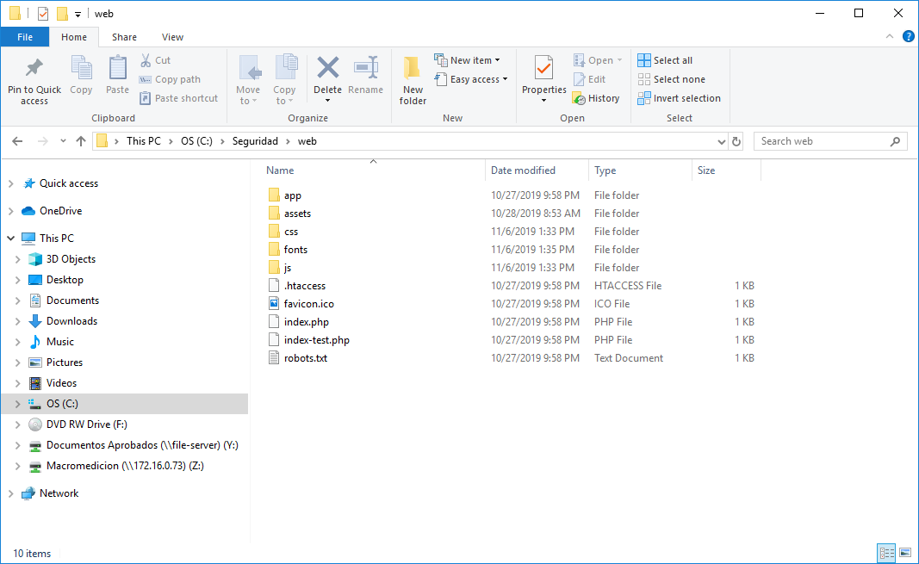

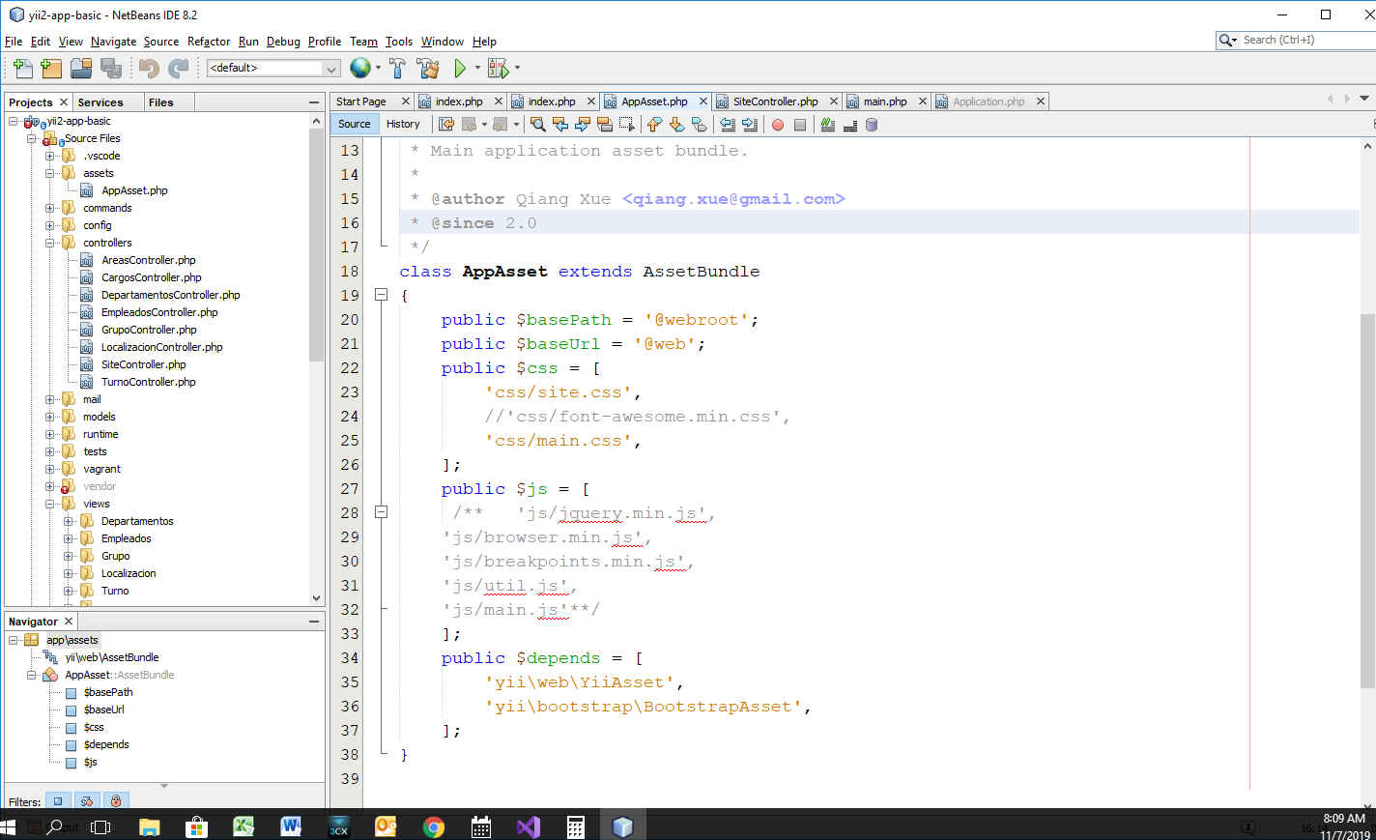2.- Actualice el archivo /assets/AppAsset.php: agregar los atributos para css, js, etc.

class AppAsset extends AssetBundle

{

    public $basePath = '@webroot';

    public $baseUrl = '@web';

    public $css = [

        'css/site.css',

         'css/font-awesome.min.css',

        'css/main.css'

    ];

    public $js = [

    'js/jquery.min.js',

    'js/browser.min.js',

    'js/breakpoints.min.js',

    'js/util.js',

    'js/main.js'

    ];

    public $depends = [

        'yii\web\YiiAsset',

        'yii\bootstrap\BootstrapAsset',

    ];

}

Para agregar a validaciones a un formulario:

En la carpeta Model localizar la función rules().

public function rules()

    {

        return [

            [['depto_id'], 'required'],

            [['depto_id'], 'string', 'max' => 3],

            [['nombre'], 'required','message'=>'Debes llenar el nombre'],      [['nombre'], 'string', 'max' => 200],

            [['depto_id'], 'unique'],

        ];

    }

Para forzar al usuario a loguerase:

En la carpeta controllers, actualice la función behaviors:

public function behaviors()

    {

        return [

            'access'=>[

                'class'=>AccessControl::classname(),

                'only'=>['create','update'],

                'rules'=>[

                    [

                        'allow'=>true,

                        'roles'=>['@']

                    ],

                ]

            ],

            'verbs' => [

                'class' => VerbFilter::className(),

                'actions' => [

                    'delete' => ['POST'],

                ],

            ],

        ];

    }

Para agregarla fecha al cargar el formulario:

*/

    public function actionCreate()

    {

        $model = new Departamentos();

        if ($model->load(Yii::$app->request->post()) ) {

            $model->fecha = date('Y-m-d');

            $model->save();

            return $this->redirect(['view', 'id' => $model->depto_id]);

        }

        return $this->render('create', [

            'model' => $model,

        ]);

    }

Para cambiar color de una fila dependiendo de una condición.

En la vista views\empleados\index.php

<?php

use yii\helpers\Html;

use yii\grid\GridView;

use yii\widgets\Pjax;

/* @var $this yii\web\View */

/* @var $searchModel app\models\EmpleadosSearch */

/* @var $dataProvider yii\data\ActiveDataProvider */

$this->title = 'Empleados';

$this->params['breadcrumbs'][] = $this->title;

?>

<div class="empleados-index">

    <h1><?= Html::encode($this->title) ?></h1>

    <p>

        <?= Html::a('Create Empleados', ['create'], ['class' => 'btn btn-success']) ?>

    </p>

    <?php // echo $this->render('_search', ['model' => $searchModel]); ?>

    <?php Pjax::begin();?>

    <?= GridView::widget([

        'dataProvider' => $dataProvider,

        'filterModel' => $searchModel,

        'rowOptions'=>function($model){

            if($model ->estado_civil=='Casado')

            {

                return['class'=>'danger'];

            } else if($model ->estado_civil=='Soltero')

            {

                return['class'=>'success'];

            }

        },

        'columns' => [

            ['class' => 'yii\grid\SerialColumn'],

            'cedula',

            'nombres',

            'apellidos',

            'depto_id',

            'cargo_id',

            //'genero',

            //'nacionalidad',

            //'estado_civil',

            //'direccion',

            //'código_postal',

            //'código_empleado',

            //'nss',

            //'telefono',

            //'celular',

            //'email:email',

            //'licencia',

            //'caducidad_licencia',

            //'fecha_ingreso',

            //'fecha_salida',

            //'localizacion_id',

            //'area_id',

            //'grupo_id',

            //'tipo_contrato',

            //'turno_id',

            ['class' => 'yii\grid\ActionColumn'],

        ],

    ]); ?>

    <?php Pjax::end();?>

</div>

Example Controller de Tutorials Point:

<?php

   namespace app\controllers;

   use yii\web\Controller;

   class ExampleController extends Controller {

       public $defaultAction = "hello-world";

      public function actions() {

         return [

            'greeting' => 'app\components\GreetingAction',

         ];

      }

      public function actionIndex() {

         $message = "index action of the ExampleController";

         return $this->render("example",[

            'message' => $message

         ]);

      }

      public function actionHelloWorld() {

         return "Hello world!";

      }

      public function actionOpenGoogle() {

   // redirect the user browser to http://google.com

        return $this->redirect('http://google.com');

        }

      public function actionTestParams($first, $second) {

        return "$first $second";

        }

   }

?>

Para ejecutar cada acción se debe separar por guión:

<http://localhost:8888/index.php?r=example/test-params&first=hello&second=Pablo%20Bo>

<http://localhost:8888/index.php?r=example/hello-world>