

Functional Safety Concept Lane Assistance

**Document Version: [Version]**

**Template Version 1.0, Released on 2017-06-21**



# Document history

**[Instructions: Fill in the date, version and description fields. You can fill out the Editor field with your name if you want to do so. Keep track of your editing as if this were a real world project.**

**For example, if this were your first draft or first submission, you might say version 1.0. If this is a second submission attempt, then you'd add a second line with a new date and version 2.0]**

|  |  |  |  |
| --- | --- | --- | --- |
| Date | Version | Editor | Description |
| 20-11-2017 | 1.0 | Pablo Elizalde | First draft |
| 28-11-2017 | 1.1 | Pablo Elizalde | Improve functional safety requirements definition |
|  |  |  |  |
|  |  |  |  |
|  |  |  |  |

# Table of Contents

**[Instructions: We have provided a table of contents. If you change the document structure, please update the table of contents accordingly. The table of contents should show each section of the document and page numbers or links. Most word processors can do this for you. In** [**Google Docs**](https://support.google.com/docs/answer/116338?co=GENIE.Platform%3DDesktop&hl=en)**, you can use headings for each section and then go to Insert > Table of Contents.** [**Microsoft Word**](https://support.microsoft.com/en-us/help/285059/how-to-create-a-table-of-contents-by-marking-text-in-word) **has similar capabilities]**

Document history

Table of Contents

Purpose of the Functional Safety Concept

Inputs to the Functional Safety Analysis

Safety goals from the Hazard Analysis and Risk Assessment

Preliminary Architecture

Description of architecture elements

Functional Safety Concept

Functional Safety Analysis

Functional Safety Requirements

Refinement of the System Architecture

Allocation of Functional Safety Requirements to Architecture Elements

Warning and Degradation Concept

# Purpose of the Functional Safety Concept

**[Instructions: Answer what is the purpose of a functional safety concept?]**

The ultimate goal of the functional safety is to reduce the risk to acceptable levels. For that, and with the system architectural design we define functional safety requirements and the allocate them to its appropriate place in the system item architecture.

# Inputs to the Functional Safety Concept

## Safety goals from the Hazard Analysis and Risk Assessment

**[Instructions:**

**REQUIRED:**

**Provide the lane departure warning and lane keeping assistance safety goals as discussed in the lessons and derived in the hazard analysis and risk assessment.**

**OPTIONAL:**

**If you expanded the hazard analysis and risk assessment to include other safety goals, include them here.**

**]**

|  |  |
| --- | --- |
| **ID** | **Safety Goal** |
| Safety_Goal_01 | 1. The oscillating steering torque from the lane departure warning function shall be limited. |
| Safety_Goal_02 | 1. The lane keeping assistance function shall be time limited, and the additional steering torque shall end after a given time interval so that the driver cannot misuse the system for autonomous driving. |
| Safety_Goal_03 | 1. The oscillating steering torque shall be deactivated when driving backwards. |
| Safety_Goal_04 | 1. The lane keeping assistance function shall be deactivated when there is a problem with the camera subsystem responsible of the lane tracking. |

## Preliminary Architecture

**[Instructions: Provide a preliminary architecture for the lane assistance item. Hint: See Lesson 3: Item Definition]**

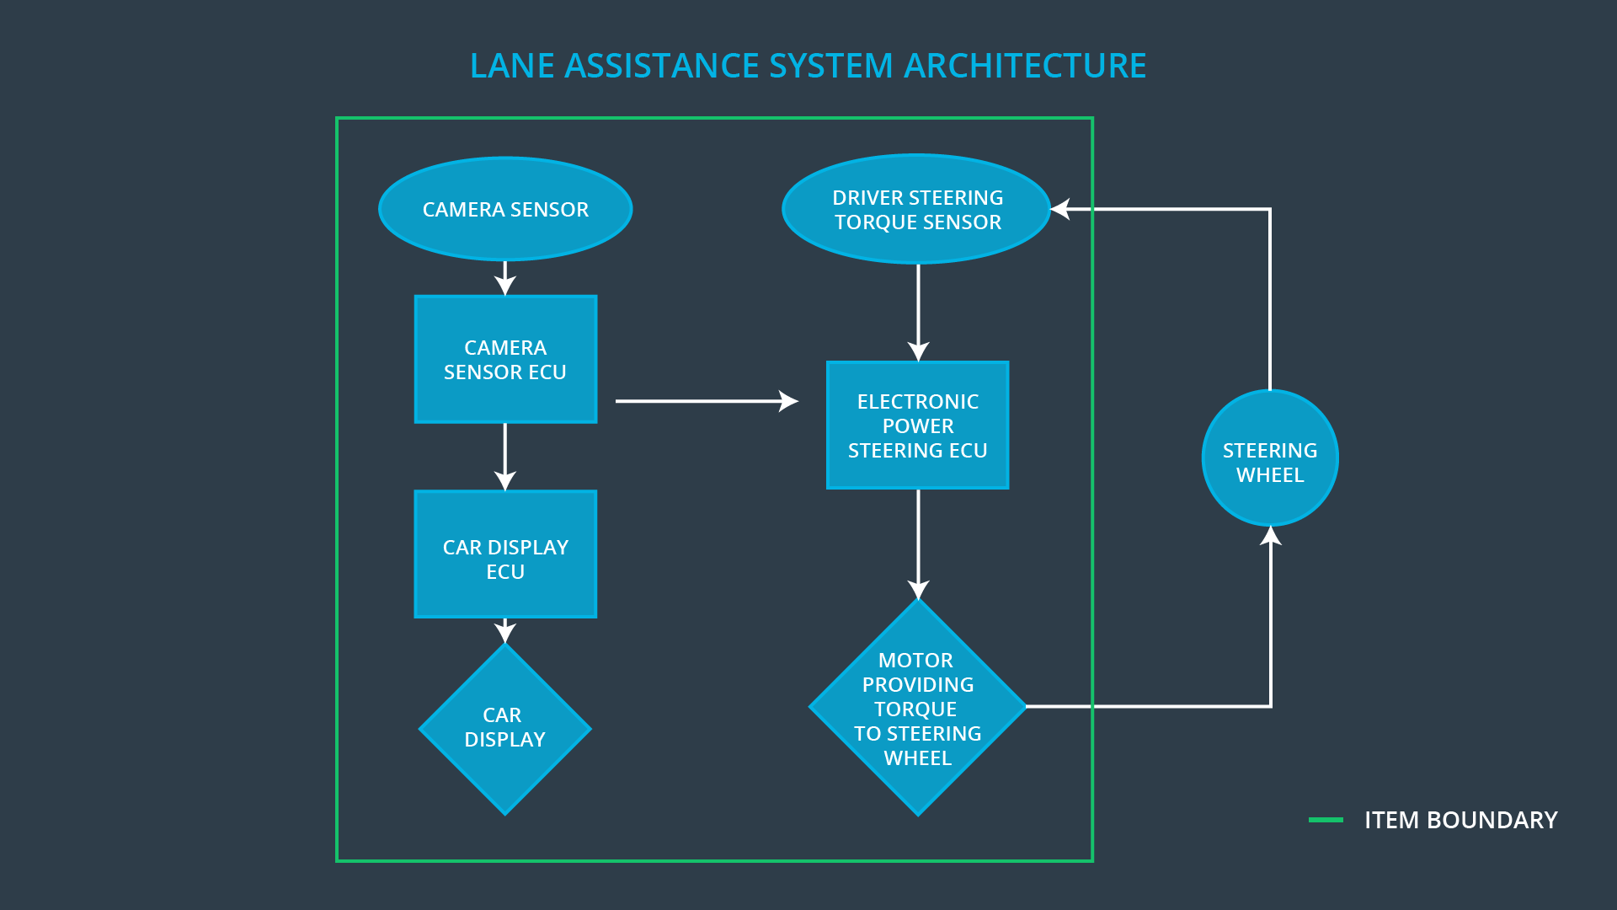

### Description of architecture elements

**[Instructions: Provide a description for each of the item elements; what is each element's purpose in the lane assistance item? ]**

|  |  |
| --- | --- |
| **Element** | **Description** |
| Camera Sensor | The camera sensor reads in images from the road. |
| Camera Sensor ECU | The camera sensor ECU identifies when the vehicle has accidentally departed its lane, and sends the appropriate messages to the Car Display ECU and the Electronic Power Steering ECU. |
| Car Display | The car display shows to the user information coming from the Car Display ECU. |
| Car Display ECU | The car display ECU receives input from the camera sensor ECU and makes the Car Display informs the driver. |
| Driver Steering Torque Sensor | The Driver Steering Torque Sensor informs to the Electronic Power Steering ECU about the amount of torque that the driver is applying. |
| Electronic Power Steering ECU | The Electronic Power Steering ECU receives input from the Camera Sensor ECU and the Driver Steering Torque Sensor. It will calculate the amount or torque that need to be apply and inform the motor. |
| Motor | The motor is in charge to provide the torque coming from the Electronic Power Steering ECU to the steering wheel. |

# Functional Safety Concept

The functional safety concept consists of:

* Functional safety analysis
* Functional safety requirements
* Functional safety architecture
* Warning and degradation concept

## Functional Safety Analysis

**[Instructions: Fill in the functional safety analysis table below.]**

|  |  |  |  |
| --- | --- | --- | --- |
| **Malfunction ID** | **Main Function of the Item Related to Safety Goal Violations** | **Guidewords (NO, WRONG, EARLY, LATE, MORE, LESS)** | **Resulting Malfunction** |
| Malfunction_01 | Lane Departure Warning (LDW) function shall apply an oscillating steering torque to provide the driver a haptic feedback | MORE | The lane departure warning function applies an oscillating torque with very high torque amplitude (above limit) |
| Malfunction_02 | Lane Departure Warning (LDW) function shall apply an oscillating steering torque to provide the driver a haptic feedback | MORE | The lane departure warning function applies an oscillating torque with very high torque frequency (above limit) |
| Malfunction_03 | Lane Keeping Assistance (LKA) function shall apply the steering torque when active in order to stay in ego lane | NO | The lane keeping assistance function is not limited in time duration which leads to misuse as an autonomous driving function. |

## Functional Safety Requirements

**[Instructions: Fill in the functional safety requirements for the lane departure warning ]**

Lane Departure Warning (LDW) Requirements:

|  |  |  |  |  |
| --- | --- | --- | --- | --- |
| **ID** | **Functional Safety Requirement** | **ASIL** | **Fault Tolerant Time Interval** | **Safe State** |
| Functional  Safety  Requirement  01-01 | **The EPS ECU shall ensure that the lane departure warning torque amplitude is below is Max_Torque_Amplitude.** | C | 50ms | Set oscillating torque to 0. |
| Functional  Safety  Requirement  01-02 | **The EPS ECU shall ensure that the lane departure warning torque frequency is below is Max_Torque_Frequency.** | C | 50ms | Set oscillating torque to 0. |

Lane Departure Warning (LDW) Verification and Validation Acceptance Criteria:

|  |  |  |
| --- | --- | --- |
| **ID** | **Validation Acceptance**  **Criteria and Method** | **Verification Acceptance**  **Criteria and Method** |
| Functional  Safety  Requirement  01-01 | Choose a reasonable value for Max_Torque_Amplitude | Verify that the system turns off within 50ms when the torque amplitude crosses the limit. |
| Functional  Safety  Requirement  01-02 | Choose a reasonable value for Max_Torque_Frequency | Verify that the system turns off within 50ms when the torque frequency crosses the limit. |

**[Instructions: Fill in the functional safety requirements for the lane keeping assistance]**

Lane Keeping Assistance (LKA) Requirements:

|  |  |  |  |  |
| --- | --- | --- | --- | --- |
| **ID** | **Functional Safety Requirement** | **ASIL** | **Fault Tolerant Time Interval** | **Safe State** |
| Functional  Safety  Requirement  02-01 | The electronic power steering ECU shall ensure that the lane keeping assistance torque is applied for only Max_Duration. | B | 500ms | Turns off the system. |

Lane Keeping Assistance (LKA) Verification and Validation Acceptance Criteria:

|  |  |  |
| --- | --- | --- |
| **ID** | **Validation Acceptance**  **Criteria and Method** | **Verification Acceptance**  **Criteria and Method** |
| Functional  Safety  Requirement  02-01 | Validate that the Max_Duration dissuades drivers from taking their hands off the wheel. | Verify that the system turns off if the lane keeping assistance exceeds Max_Duration. |

## Refinement of the System Architecture

**[Instructions: Include the refined system architecture. Hint: The refined system architecture should include the system architecture from the end of the functional safety lesson including all of the ASIL labels.]**

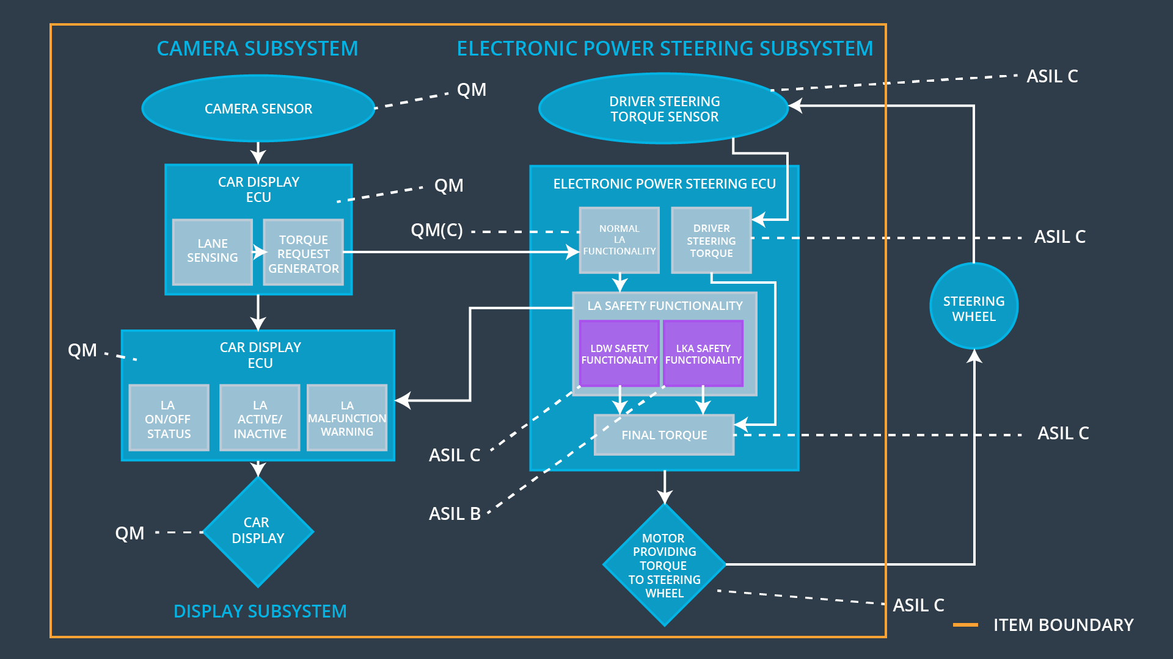

## Allocation of Functional Safety Requirements to Architecture Elements

**[Instructions: Mark which element or elements are responsible for meeting the functional safety requirement. Hint: Only one ECU is responsible for meeting all of the requirements.]**

|  |  |  |  |  |
| --- | --- | --- | --- | --- |
| **ID** | **Functional Safety Requirement** | **Electronic Power Steering ECU** | **Camera ECU** | **Car Display ECU** |
| Functional  Safety  Requirement  01-01 | The electronic power steering ECU shall ensure that the lane departure oscillating torque amplitude is below Max_Torque_Amplitude | **X** | **-** | **-** |
| Functional  Safety  Requirement  01-02 | The electronic power steering ECU shall ensure that the lane departure oscillating torque frequency is bellow Max_Torque_Frecuency | **X** | **-** | **-** |
| Functional  Safety  Requirement  02-01 | The electronic power steering ECU shall ensure that the lane keeping assistance torque is applied for only Max_Duration. | **X** | **-** | **-** |

## Warning and Degradation Concept

**[Instructions: Fill in the warning and degradation concept.]**

|  |  |  |  |  |
| --- | --- | --- | --- | --- |
| **ID** | **Degradation Mode** | **Trigger for Degradation Mode** | **Safe State invoked?** | **Driver Warning** |
| WDC-01 | Turn off functionality | The torque oscillation is applied is above Max_Torque_Amplitude or Max_Torque_Frecuency. | Yes | A light in the dashboard. |
| WDC-02 | Turn off functionality | The driver keeps its hands off the wheel for a longer time than Max_Duration. | Yes | A light in the dashboard. |