# Assignment #2

1. Implement a class Cat

**Cat class:**



**Cat Main class:**

**Cat program output:**

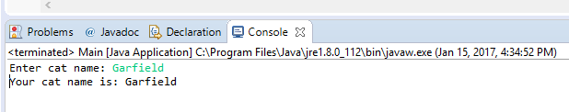

1. Design a use case diagram for a photographer. The photographer will take pictures and change flash cards – can you think of other things a photographer might do?

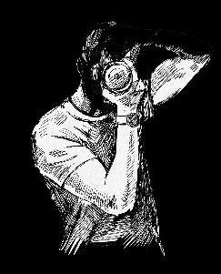Photographer can: Take a picture

Look for object to take a picture of

Develop a film

Edit photos

Use equipment

1. Write an application that inputs three integers from the user and displays the sum, average, product, smallest, and largest of the numbers

**Number class:**  


**Calculations Main class:**

**Numbers program output:**

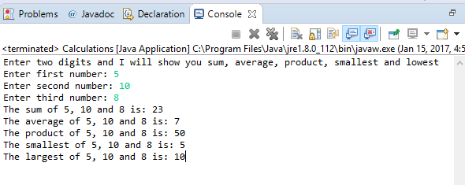

1. Write an application that inputs one number consisting of five digits from the user, separate the number into its individual digits and prints the digits separated from one another by three spaces each

**SeparateNumbers class:**



**Main class:**



Separate numbers program output:

