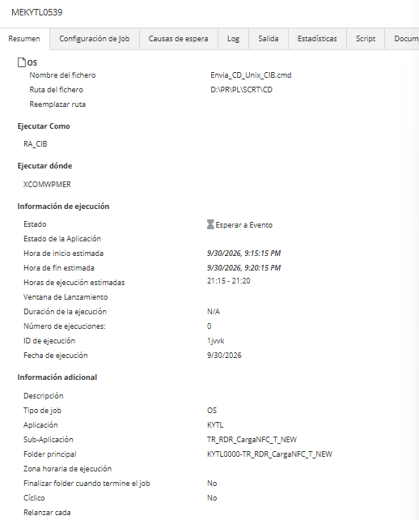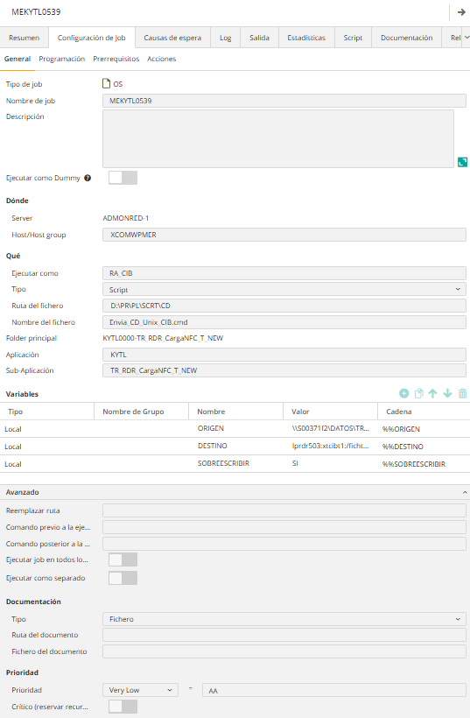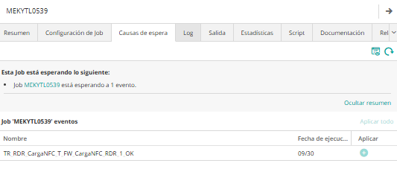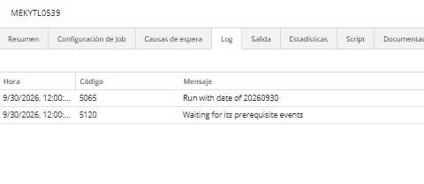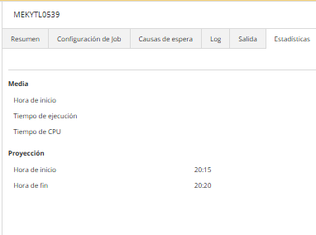

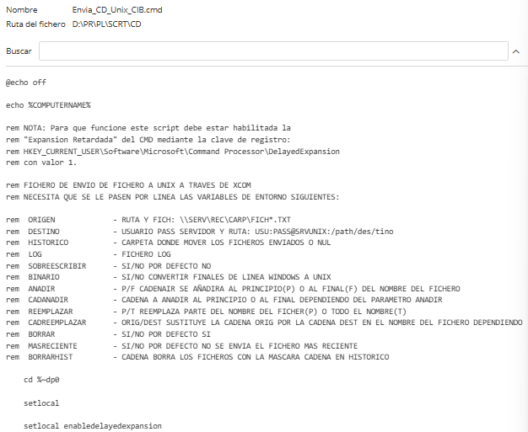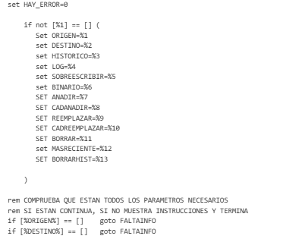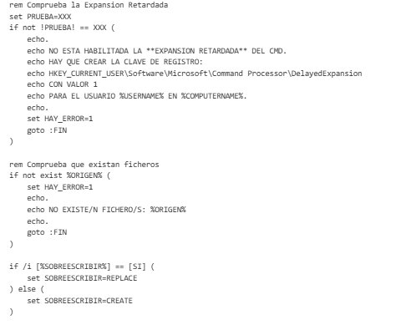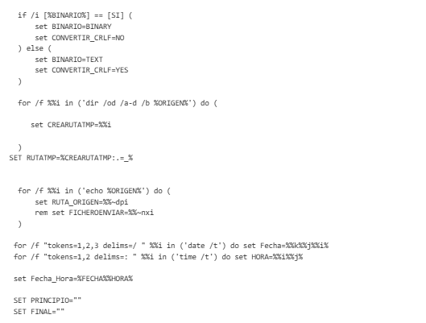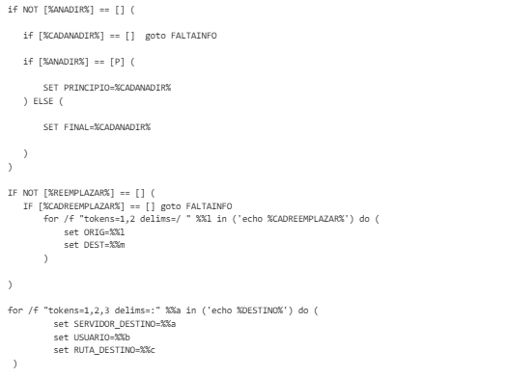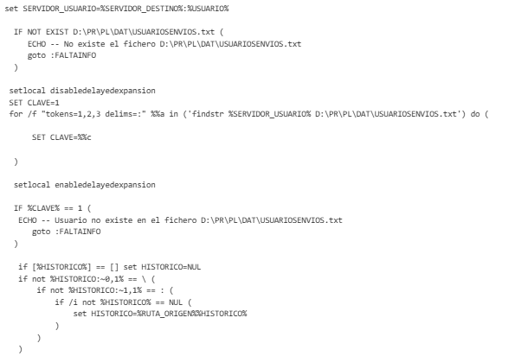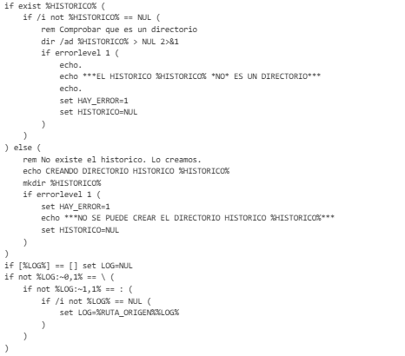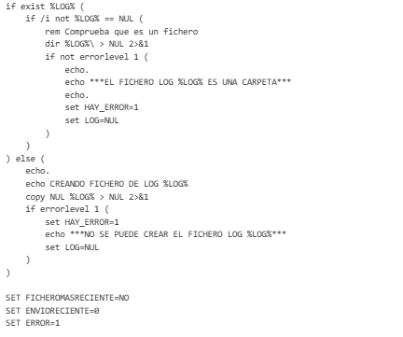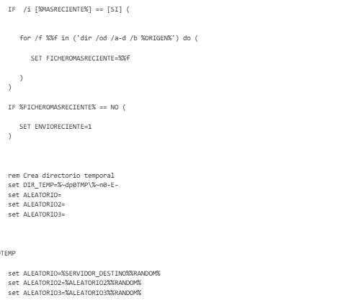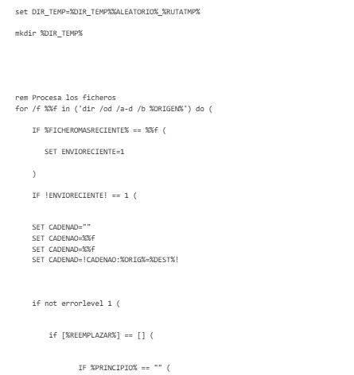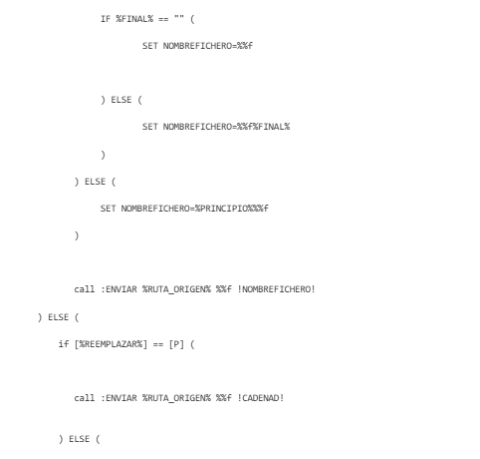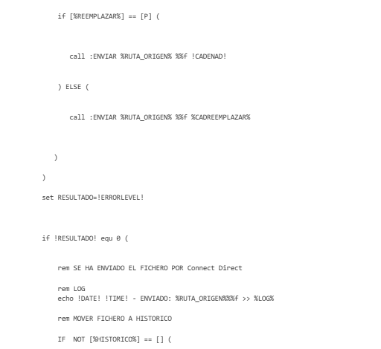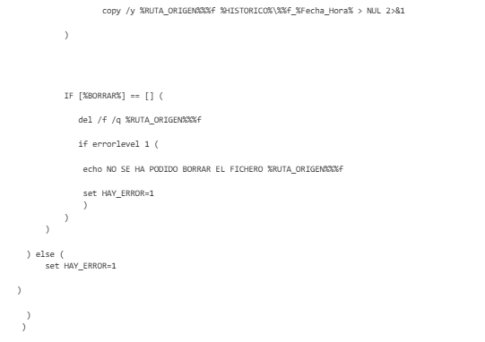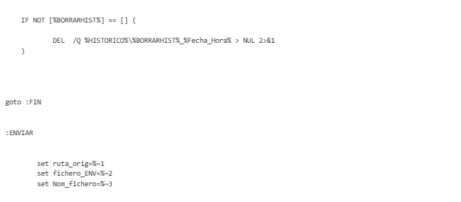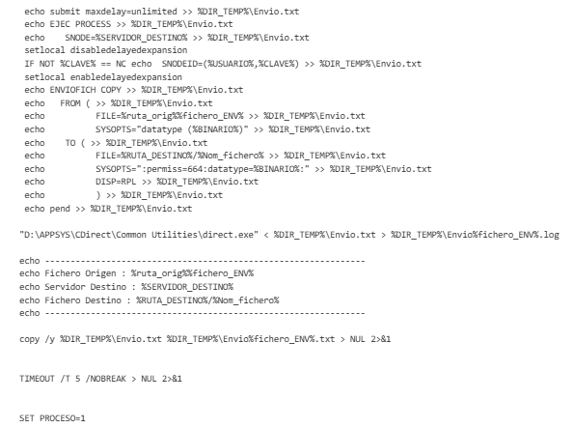
for /f "tokens=1,2,3,4 delims= " %%a in ('findstr EJEC %DIR_TEMP%\Envio%fichero_ENV%.log') do (
SET PROCESO=%%b
)
echo select statistics pnumber=%PROCESO% PNODE=%COMPUTERNAME% recids=(ctrc,rjed,rted,lsst) detail=YES; | "D:\APPSYS\CDirect\Common Utilities\direct.exe" >> %DIR_TEMP%\Envio%fichero_ENV%_1.log
SET ERROR=1
for /f "tokens=1,2,3,4 delims= " %%a in ('findstr /C:"Completion Code =>" %DIR_TEMP%\Envio%fichero_ENV%_1.log') do (
SET ERROR=%%d
)
IF NOT %ERROR% == 0 (
echo ---------------------------
echo Error al enviar el fichero
echo ---------------------------
echo select statistics pnumber=%PROCESO% PNODE=%COMPUTERNAME% detail=YES; | "D:\APPSYS\CDirect\Common Utilities\direct.exe" >> %DIR_TEMP%\Envio%fichero_ENV%_1.log
type %DIR_TEMP%\Envio%fichero_ENV%_1.log
rem rmdir /s /q %DIR_TEMP%
exit 1
